SANTIAGO HIGH ARCHITECTURE DESIGN 2A
Revit MEP 2017 Demo: Linking MEP Drawings into Architects model
Students will link Mechanical, Electrical, and Plumbing drawings into the Revit Architecture BIM model.
Create the building in Revit Architecture
Analyze the 3 Mechanical, Electrical, and Plumbing systems relationship with one another.
Coordinate the 3 systems: Mechanical, Electrical, and Plumbing
Correct clashes in systems
Make design changes based on function of the building and viability.
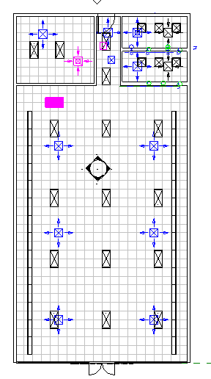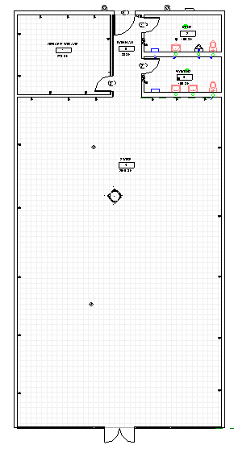

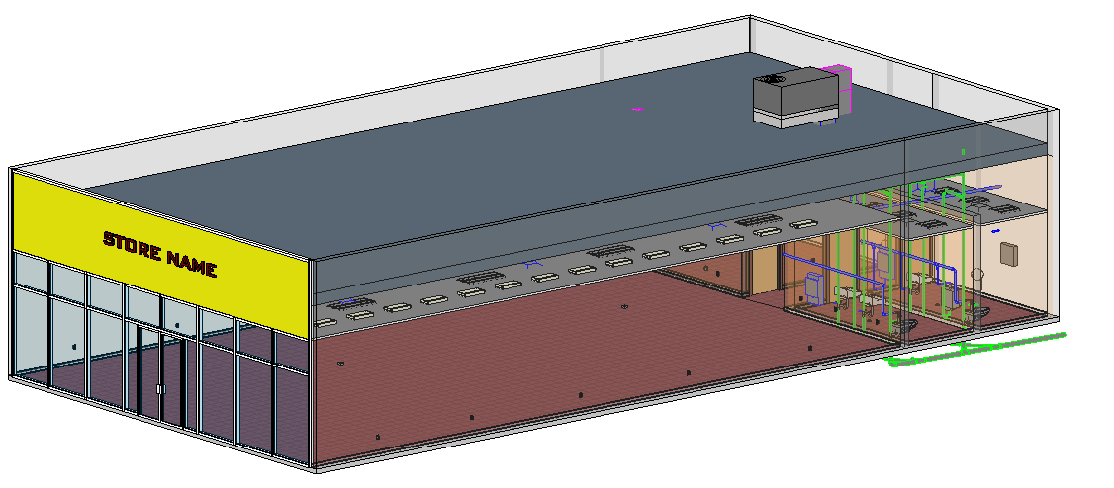
Linking the Mechanical, Electrical and Plumbing Disciplines
The Architect hires the MEP consultant to do the Mechanical, Electrical, and Plumbing systems.
The Architect provides the MEP consultant a copy of the building, drawn in Revit Architecture.
The MEP consultant links the architect’s model into their MEP file.
The MEP consultant(s) does their job, then provides the architect the Revit MEP model.
The Architect links the MEP model/file(s) into their architectural model.
The Architect coordinates the drawings….looking for construction/design problems like collision of plumbing and mechanical….structural and mechanical….etc.
The ability to know your building can be constructed as designed is very important! Changes in the field can be costly (who pays for errors??).

In Revit Architecture 2017
Open a new file in Revit. Use the Architecture Template.
Change Level 2 to 14’0”. Name it Roof.
Floor Plan Level 1
Let’s start by linking in the Architectural Model
Insert
Link Revit
Open Revit Arch Building for MEP 2017.rvt
This is the original Revit Architecture file (provided by the architect)
Origin to Origin Open
See the building? Pass your mouse over it. See the blue box? It is one “linked” file.
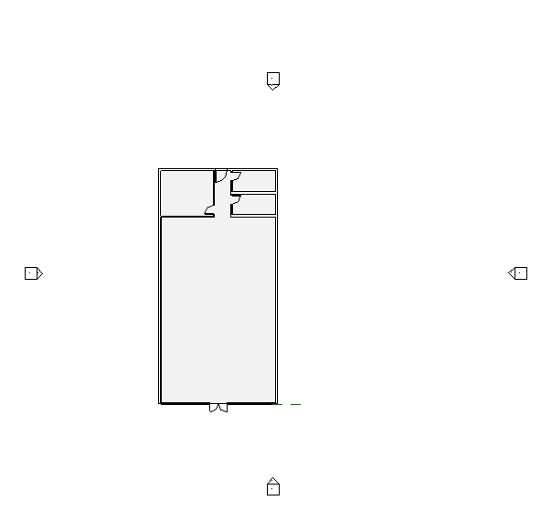

Let’s continue by linking in the Plumbing Model
Insert
Link Revit

Store Plumbing 2017.rvt Origin to Origin Open
This dialog box comes up:
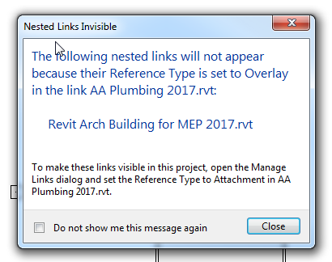
We need to do what it says…..
Manage
Manage Links
Change the Reverence Type to “Attachment”…OK
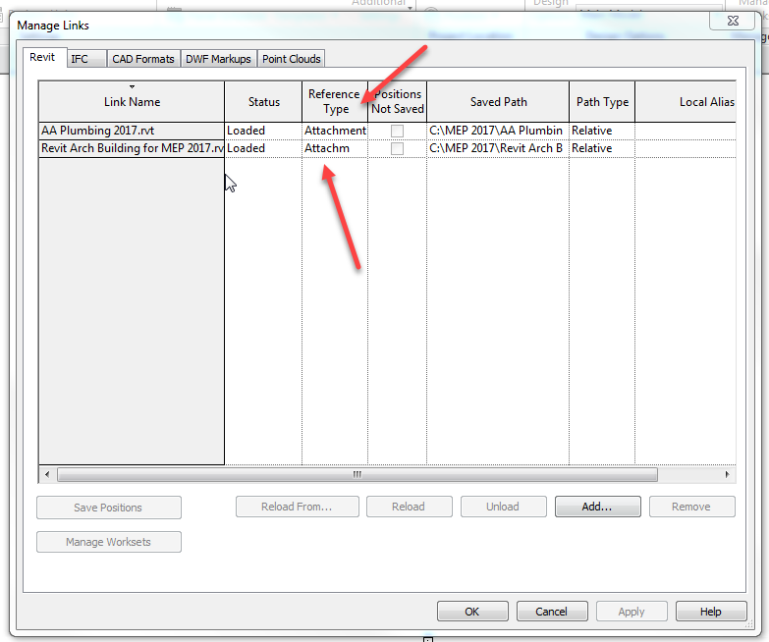
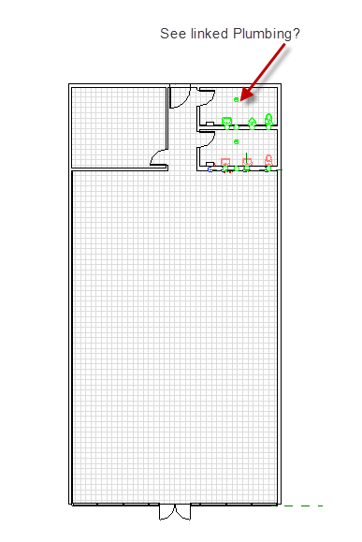
Floor Plan Level 1
Let’s continue by linking in the Mechanical
Insert
Link Revit
Store Mechanical 2017.rvt (use the revision) Origin to Origin Open
The same Nested links warning comes up. Fix it like you did the other 2!
See the Ducts, AC unit? NO???
Go to Ceiling plan Level 1….see the diffusers?
Go to 3D view
You will need to make the walls, ceiling, and roof 75% transparent
VV…..see transparent option? Set at 75% for the objects. Set to shaded.
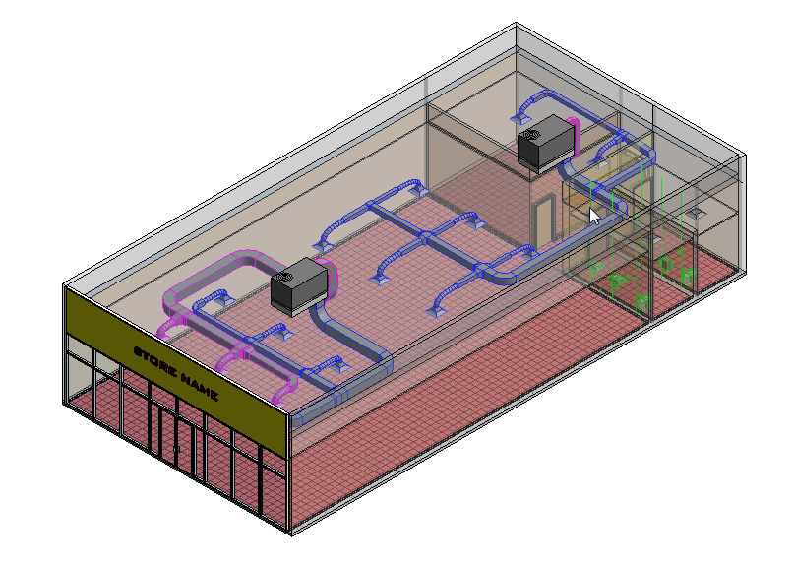

Floor Plan Level 1
Let’s continue by linking in the Electrical
Insert
Link Revit
Store Electrical.rvt Origin to Origin Open
The same Nested links warning comes up. Fix it like you did the other 3!
See the switches and outlets?
Go to Ceiling Plan Level 1
See the lights and diffusers?
Go to 3D view
Look around! Any collisions?
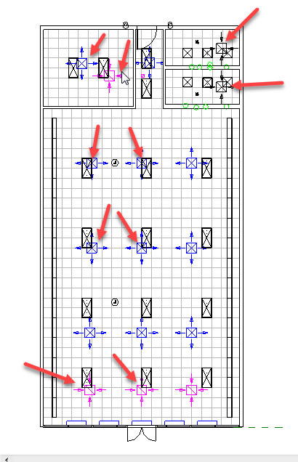
If so, you need to decide what gets moved.
Let’s say a light and a supply diffuser collide. Which moves? Probably the diffuser, since we strategically placed the lights to provide a specific amount of light to a particular area (remember footcandles in Visual software??)
Let’s say a plumbing line runs into a duct? Probably easier to move the plumbing line since the duct is bigger and harder to wiggle around things.
Let’s say a vent pipe (inside a wall) runs into an outlet? Move the outlet!
What happens if there is not enough room between the ceiling and the roof to place the ductwork?
What happens if structural members are placed so the duct runs can’t happen?
Making these decisions sometimes involves a design team of MEP consultants, structural consultants and Architects. Even the client can be involved. The idea is to work out all the building challenges BEFORE construction starts or before it is too late to make efficient changes.
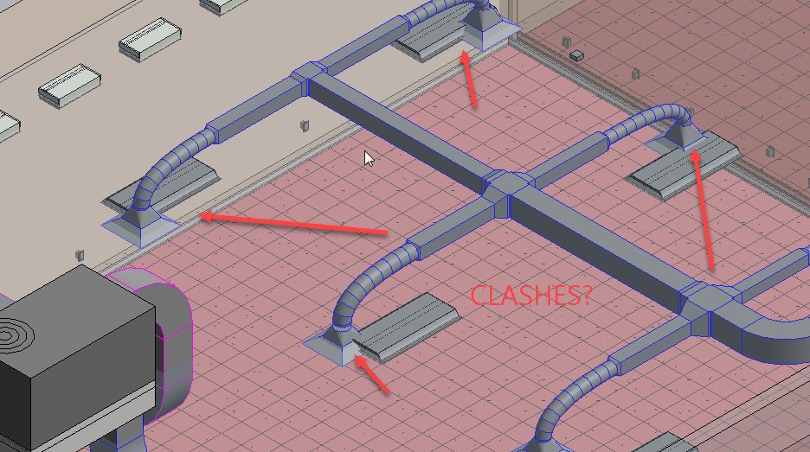
Set transparency back to normal
Save file as Linked Model 2017.rvt
Navisworks
There a two ways to this…..here is the first way:
In Revit Architecture 2017
Open Linked Model 2017.rvt
Be in the 3D View
This would be the complete Revit model with all of the disciplines involved.
You will export the Revit file to Navisworks 2017
R
Export
NWC
Save as Linked Model 2017.nwc
Before you hit save:
Navisworks Settings
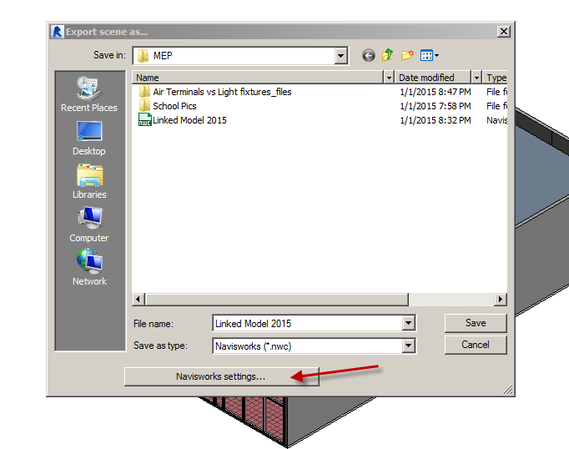
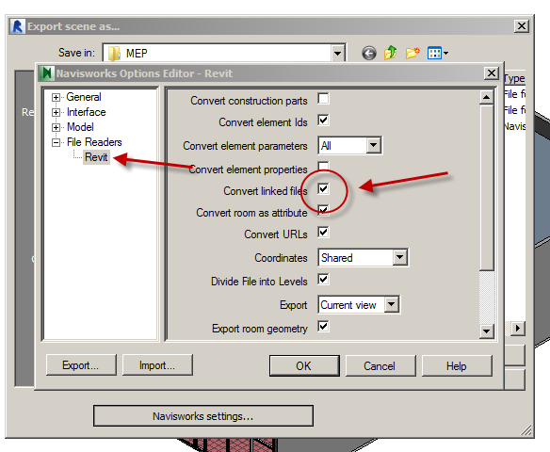
You need to check “Convert Linked Files”….OK….Save

In Navisworks Manage 2017
Open
(no files???)
Files of Type: Navisworks Cache (NWC)
Linked Model 2017.nwc
Open
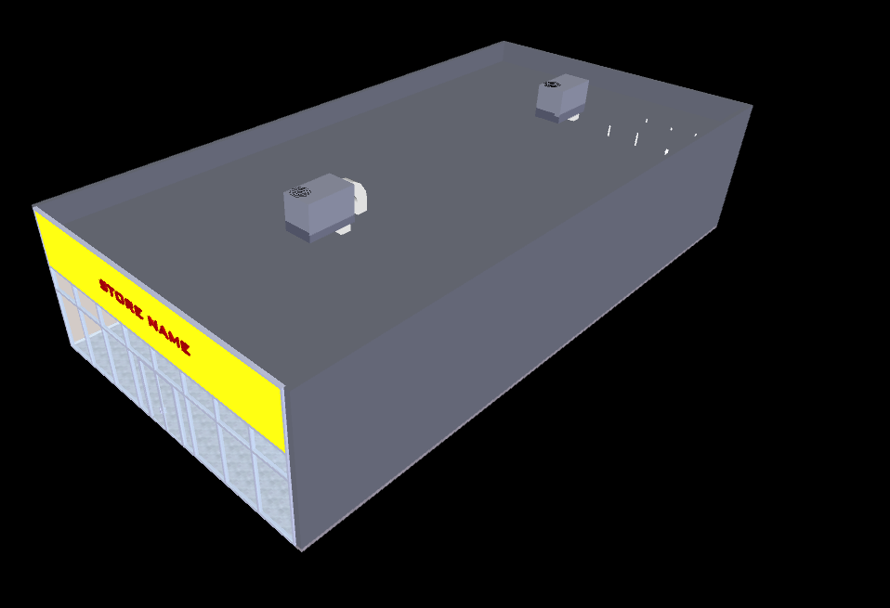
Let’s see the inside elements better.
View….Windows….Selection Tree
Pin it
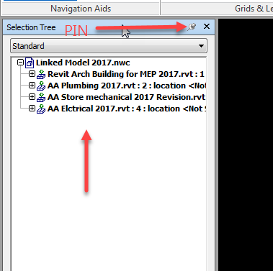

Pick Walls in selection tree
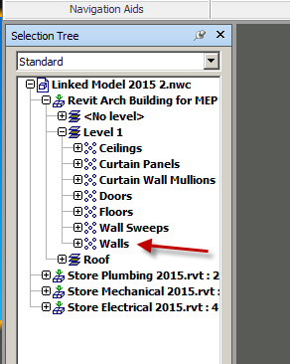
Item Tools
Transparency: 75% or so
Do the same with the Roof:
Pick Roof in selection tree
Item Tools
Transparency: 75% or so
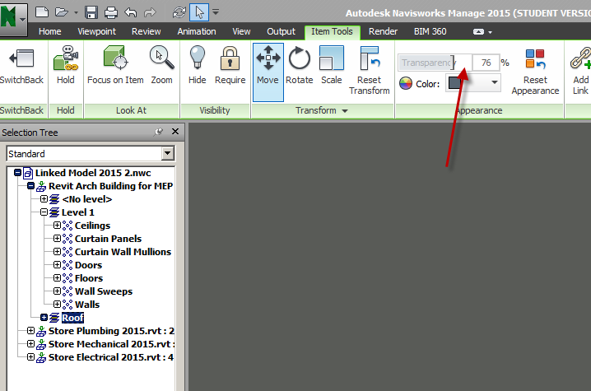

To change to Shaded Mode (you are probably seeing Render mode and we do not have render materials going)
Viewpoint
Render Style
Mode: Shaded
Should look something like this:
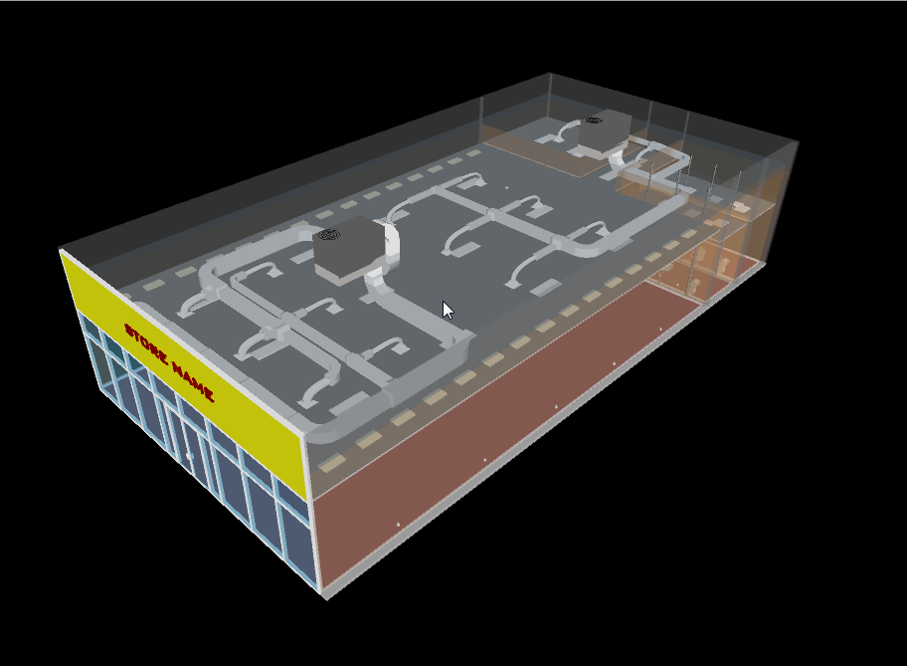
That’s good….but all the objects look the same color.
Let’s differentiate the plumbing from the electrical from the mechanical!
In selection tree, pick Store Plumbing 2017
Item tools
Color
Change to yellow
Check out the Plumbing….YELLOW!
In selection tree, pick Store Electrical 2017
Item tools
Color
Change to Purple
See the purple lights and outlets??
In selection tree, pick Mechanical
Item tools
Color
Change to Green
Open up
Note the HVAC turns green, but a big space may have turned green too.
Here’s why….spaces are under Mechanical
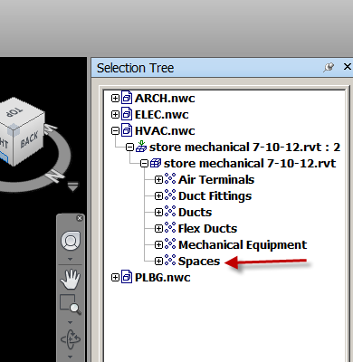
RC on Spaces
Hide
Better?
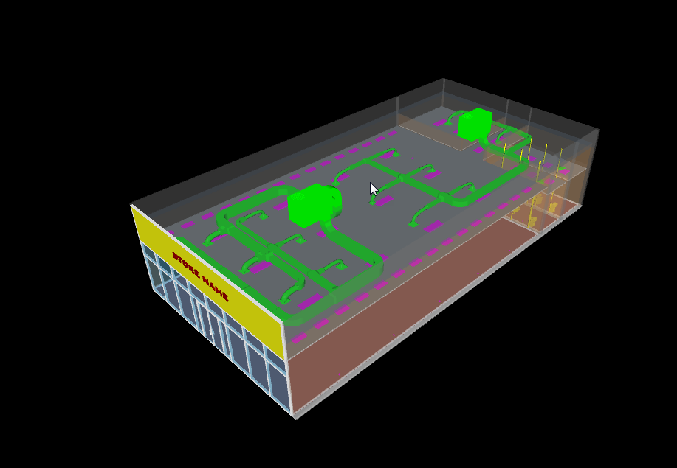
Navigating in the model

Navigation Bar
The Navigation bar is that little tool bar to the right of the window. It has all of the navigation commands on it.
Right click on the navigation bar
Global options
Interface…..Display units. Set them to feet and inches
For display units go ahead, and select the display units that you'd like to have as a default for Revit.
Go to the viewpoint tab, and you'll see we also have a navigate panel. Click the navigate button down. You can choose how to accelerate or slow down if you're going around a corner.
You'll find when you're walking through a model or flying through a model you might want to turn this stuff back or up.

Walking through your model
This is the navigation command you'll probably use the most. To start walking forward, you just hold down the pic button. That's the left button. With the left button held down, move your mouse forward. The farther you move your mouse away from you the fast you will go. You can stop, and you can pull your mouse towards you, and you will back up. Some more functionality with this command is the ability to pan up and down. To do this, you hold down your Shift button, while holding down the scroll button on your mouse. If you move your mouse towards you, with these two buttons held down, you can actually pan down the model.
Once you let go of the two buttons, you'll stop. To advance forward, hold down the pic button. The object is to try to walk into one of these rooms. Go ahead and guide yourself towards a room.
If you scroll towards you with your wheel button, you can actually look up. If you scroll away from you, you can actually look down. One other thing you can do is we can pan left or right. By holding down the same buttons, the shift button and your scroll button, move your cursor to the right. We're panning ourselves to the right.
Hold down the shift button and the scroll button. And pan yourself to the left. Now you are free to roam about the model anyway you see fit. It takes a lot of practice not to accidentally walk through walls. For some, this is going to take some time and patience.

Looking around your model
The icon is an eyeball. This tool allows you to stop and look around as if you were just standing there. What's also nice about this tool is that the spot where you stop looking is the perspective view, you will bring with you as you commence with the other navigation mode you were in.
Hit the drop-down and make sure that Collision and Gravity are turned off. By doing that, you just click the drop-down, and if they're checked on, just select it again, and it'll check it off.
Making sure they're cleared out, we can start walking. I'm going to get up to a certain point, hold my Shift key and my wheel button, and pan down, so I'm walking down the first floor. I'm going to stop in the hallway. I think right here's about a good spot to take a look around. On my navigation bar. I'm going to click the Look Around button. Notice that the icon changes. Now if I pick a point, and move my mouse away from me, I can look up. I can move to the right, I can look to the right.
Move it to the left and then I can look to the left. So now if I want to look up. And if I want to check out the ceiling as I'm walking down the hallway, I can just keep my focus looking up. Now when I start my walk command, I can walk down the hallway and not go in the actual direction that I'm looking in. The some of the other navigation commands, you can't do this. This is a great way to look through a building while you're looking at a specific item, as if you were standing there looking up walking down the hallway.

Gravity tool
The gravity tool is used in conjunction with the walk command. By turning on gravity, you're saying to Navisworks that you want to keep your feet upon the ground. You're also telling Navisworks that if a staircase or a ramp comes along, you'd like to walk up or down it. And open it up. With the Orbit tool running, spin around and look at the side of the building. Select the Walk command. Hit the drop down, and make sure Collision and Gravity are turned off. Walk right through the wall as if it wasn't there. I'm going to turn around to the right, and notice that there's a staircase there. To walk up the staircase, I need to turn my gravity on and I need to turn my collision on. Once we do this, we'll no longer be able to walk through a wall. Go ahead and click the drop down underneath the walk icon, and turn on gravity.
Click the drop down again just to verify that collision and gravity are both turned on and click off of it. Notice that when you start walking Navisworks will shove you right down to the floor. Keep walking and this is going to test your navigation skills. I am going to come around the corner. I am going to come over to my stairs. And I am going to start walking up them.

Home
Clash Detective
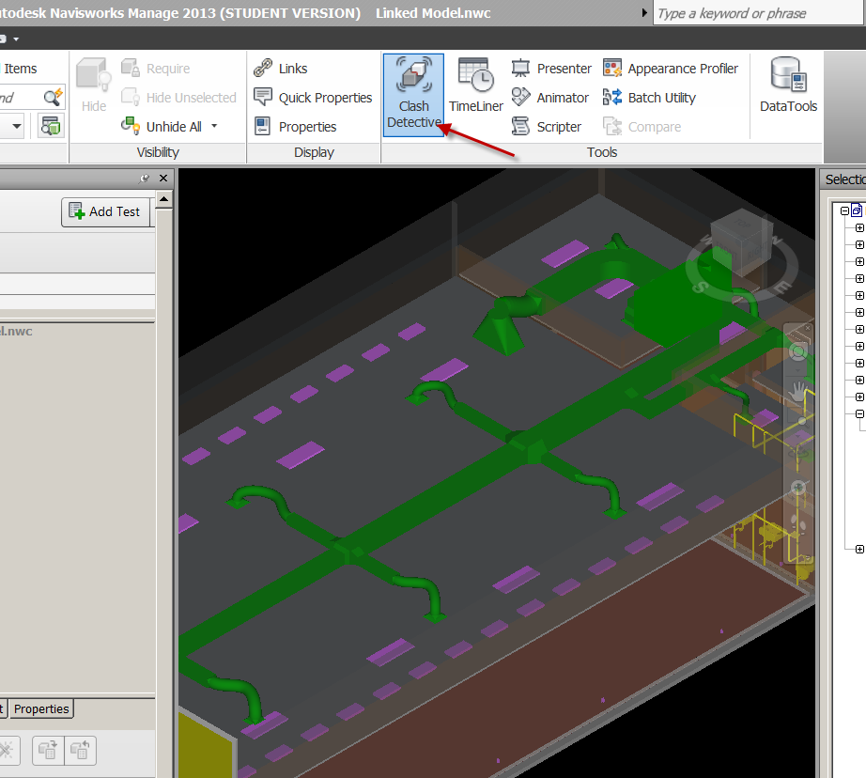
Add Test
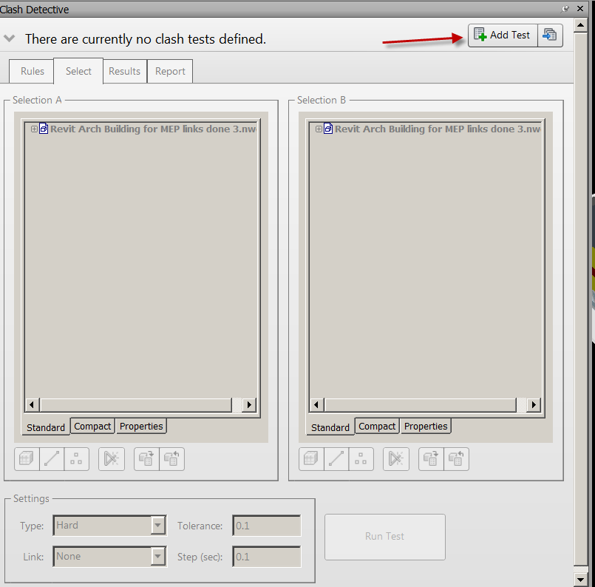

Let’s run a check for Air Terminals (Diffusers) vs Lights to see if any of our ceiling lights are hitting diffusers.
Name it Air Terminals vs Light fixtures
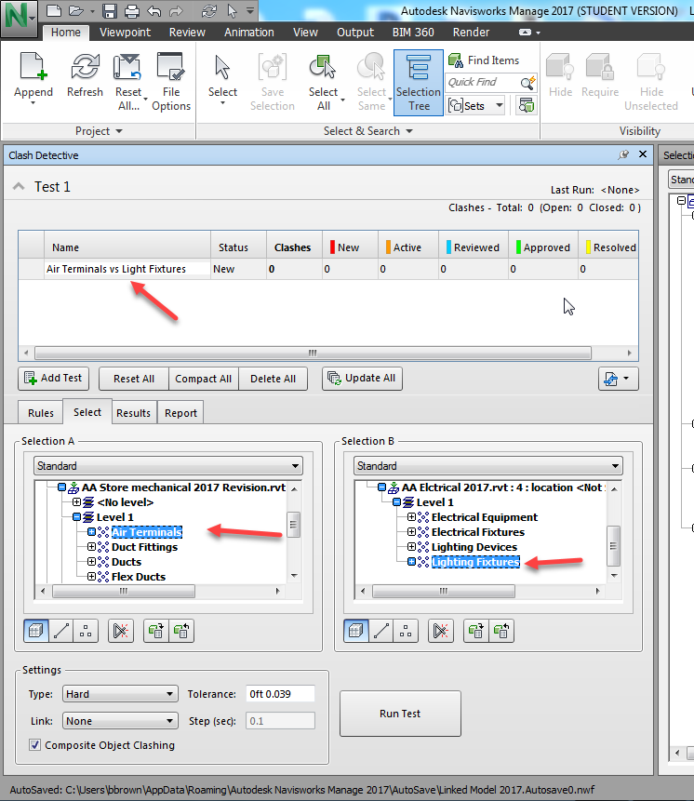
So the categories are picked. Hint: Don’t do everything vs everything….it’s a nightmare to look at!
Run Test

Just 11 in my model….
Note: There will be repetition….but the collisions are shown!
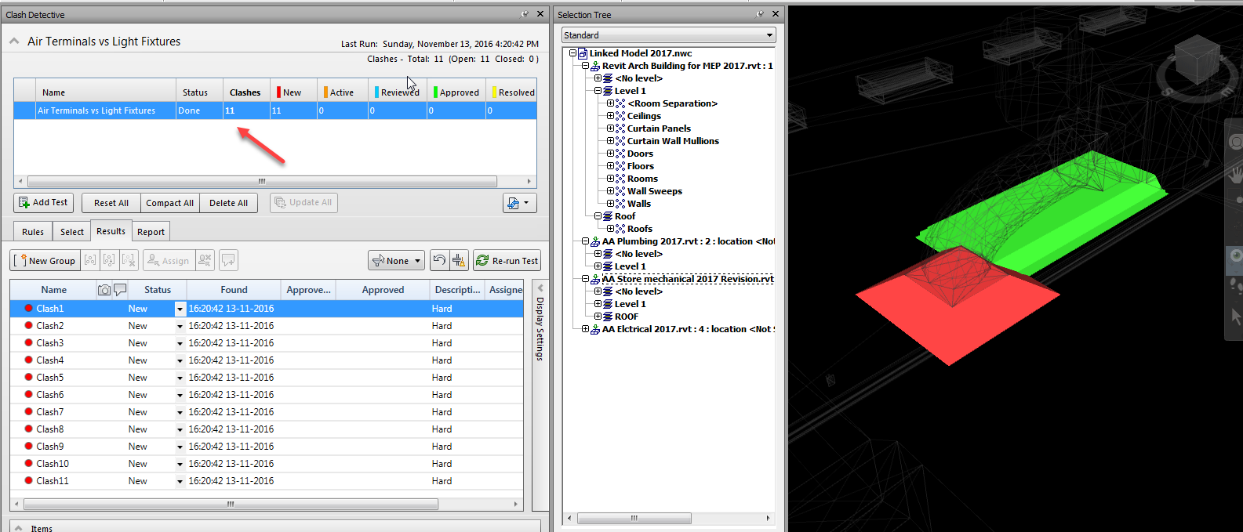
Zoom out a little to see where you are in the building!
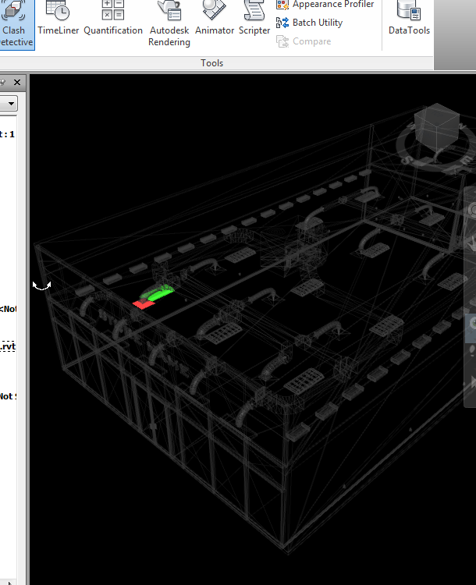

Select the other clashes…see where they are! Hint: Use “Page Up” on keyboard to zoom all.

Clash Reports
You can create a clash report. This could be brought into a collaboration meeting to “discuss” who is going to fix what.
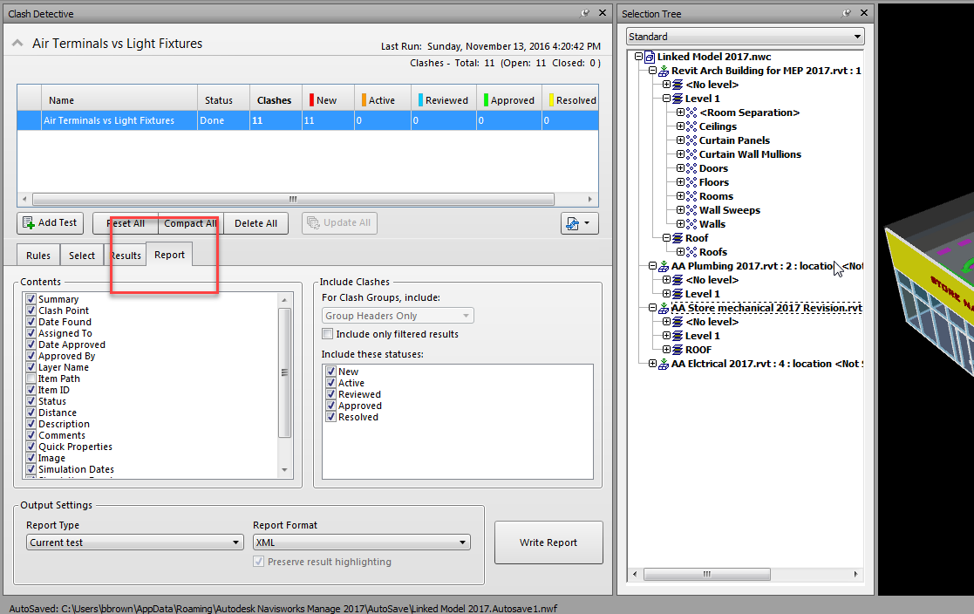

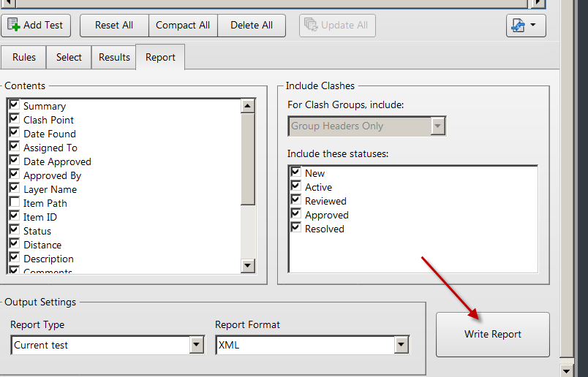
The report is an .xml file (just like the revit file we exported into EnergyPro). Save

You can also create a report as a text file:
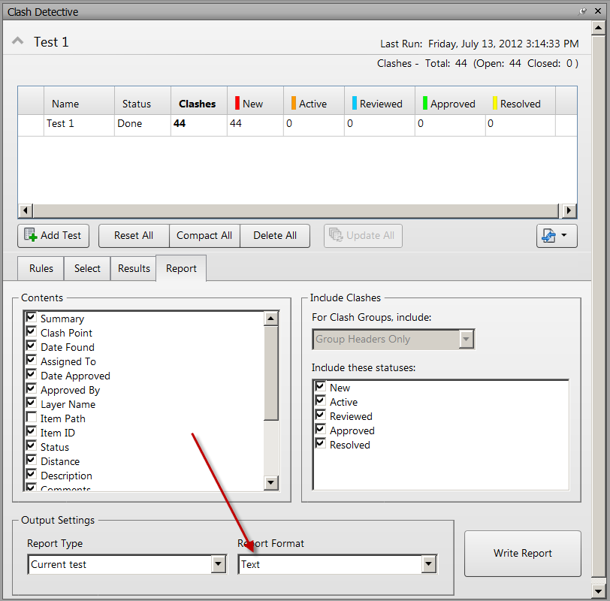
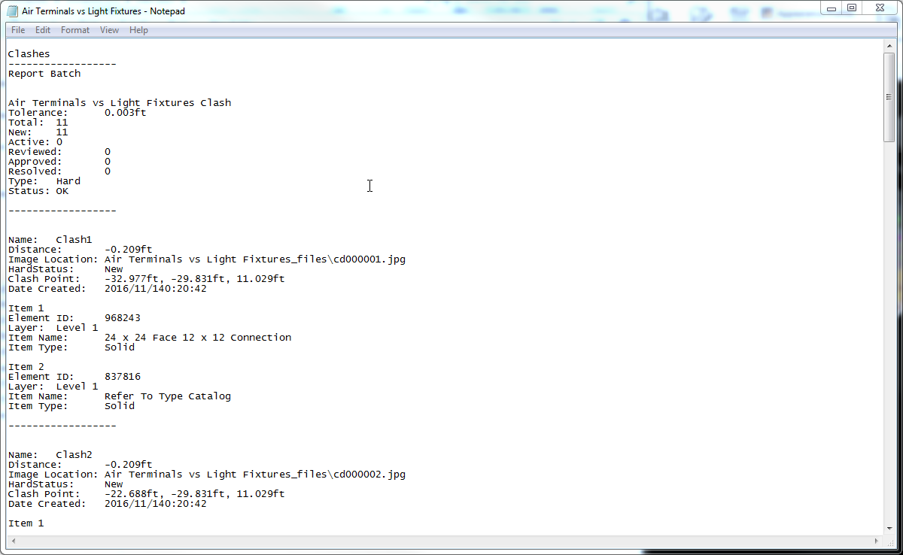

Viewpoints Report
This is a really cool way to show the errors:
Report
Report Format: As Viewpoints
Write Report
Check Preserve result highlighting

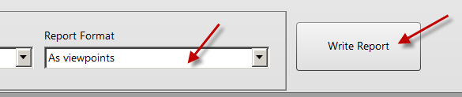
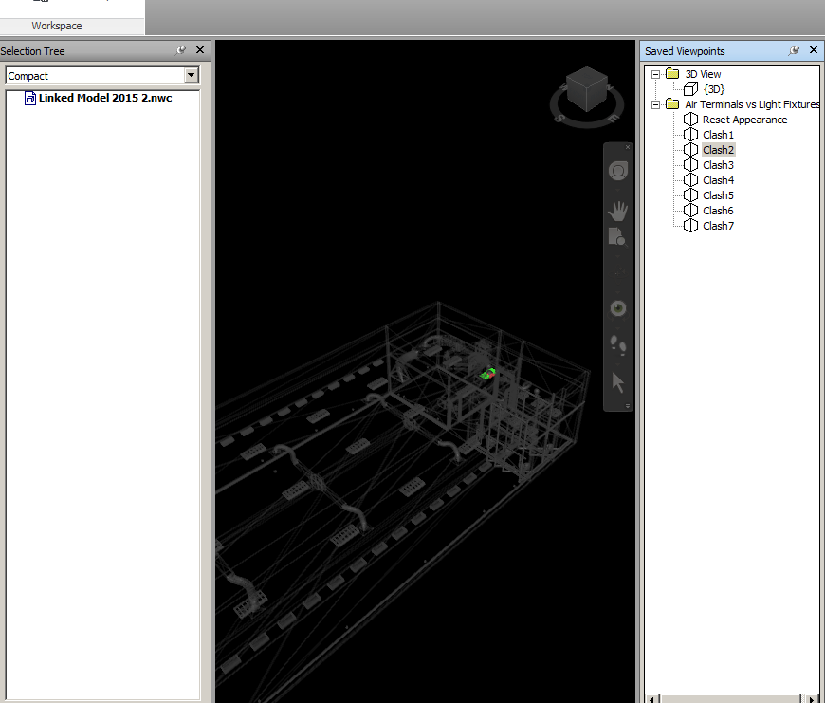

Open the + sign on Air Terminals vs Lights?
You can pick on each clash!!!
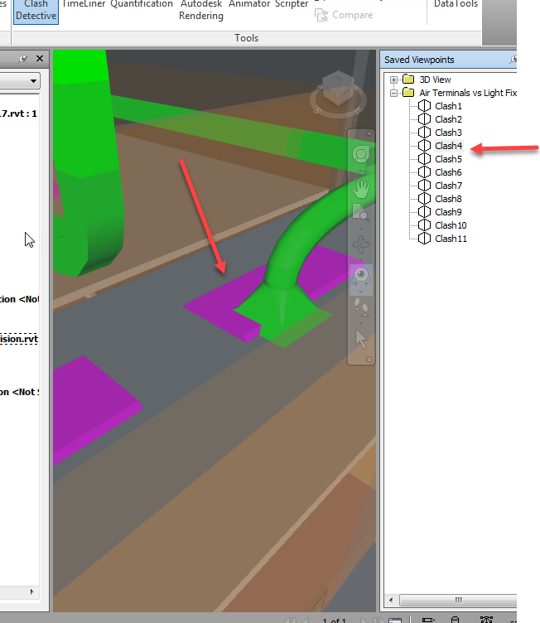

Another way to bring Revit file in Navisworks
In Revit Architecture 2017
Open Linked Model 2017.rvt
This is the linked file with the building, mechanical, electrical, and plumbing.
We are going to separate the disciplines….
Make 4 copies of 3D view
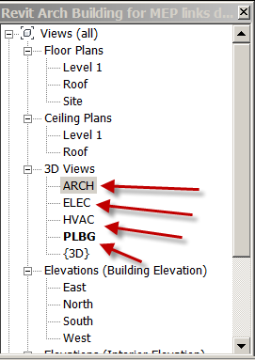
We will start with Plumbing
VV
Revit Links
Turn Off the other 3 links
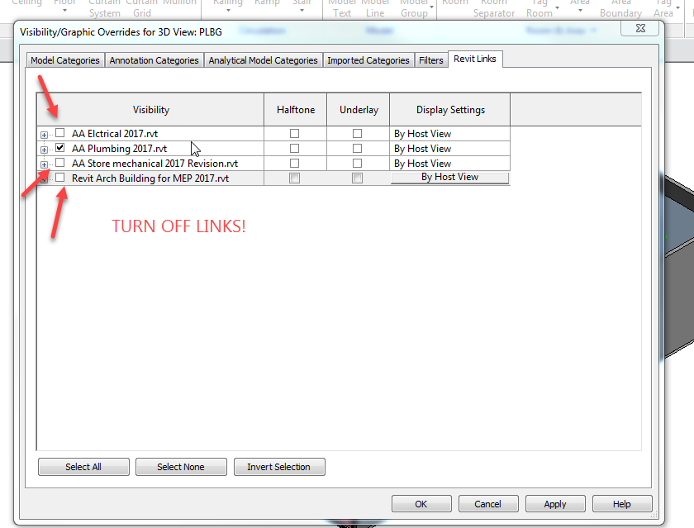
Model Categories tab…uncheck Show model categories in this view
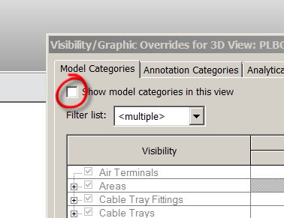
Revit Links
Display Settings
Host to Custom
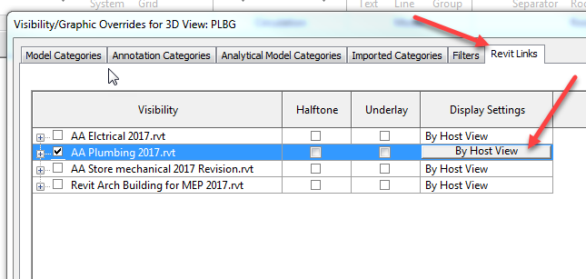
Model Category (in Revit Links)
Custom
Show Model
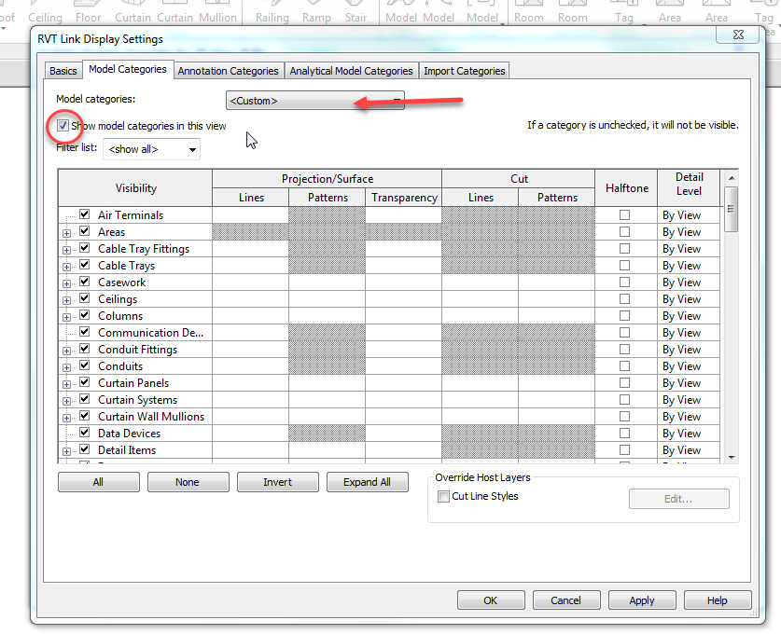
OK….OK
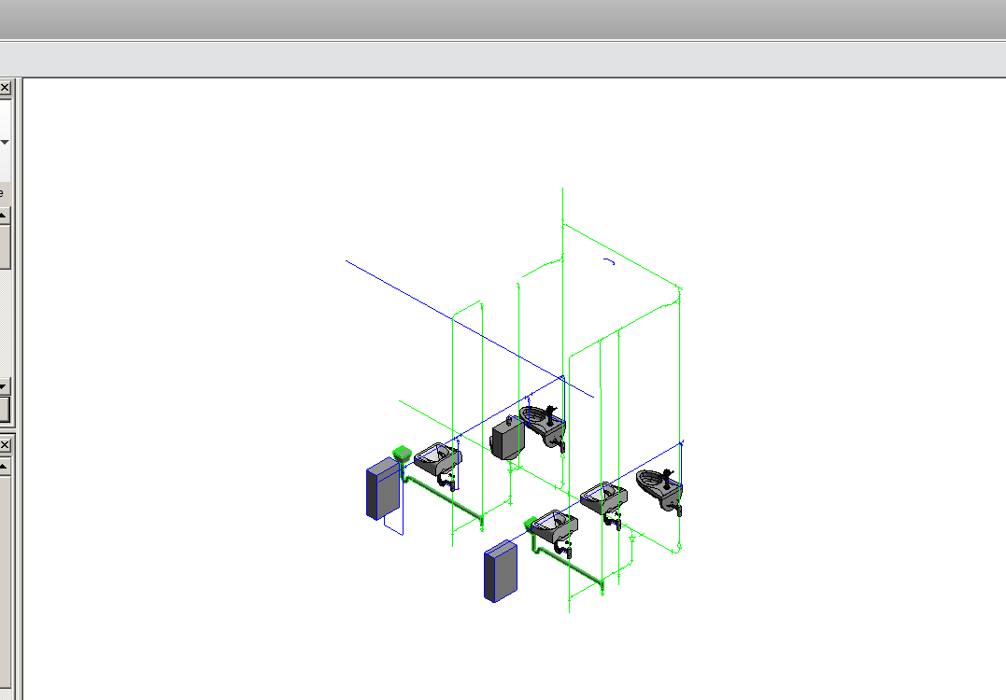
Just the plumbing shows from the link!

We will continue with the Electrical
Select ELEC in Browser
VV
Revit Links
Turn Off the other 2 links (Arch, Mech and Plumbing)
Model Categories tab…uncheck Show model categories in this view
Revit Links
Display Settings
Host to Custom
Model Category (in Revit Links)
Custom
Show Model categories in this View (check)
OK…OK
Just the electrical shows from the link!
We will continue with the Mechanical
Select HVAC in Browser
VV
Revit Links
Turn Off the other 3 links (Arch, Elect and Plumbing)
Model Categories tab…uncheck Show model categories in this view
Revit Links
Display Settings
Host to Custom
Model Category (in Revit Links)
Custom
Show Model categories in this view
OK…OK
Just the Mechanical shows from the link!
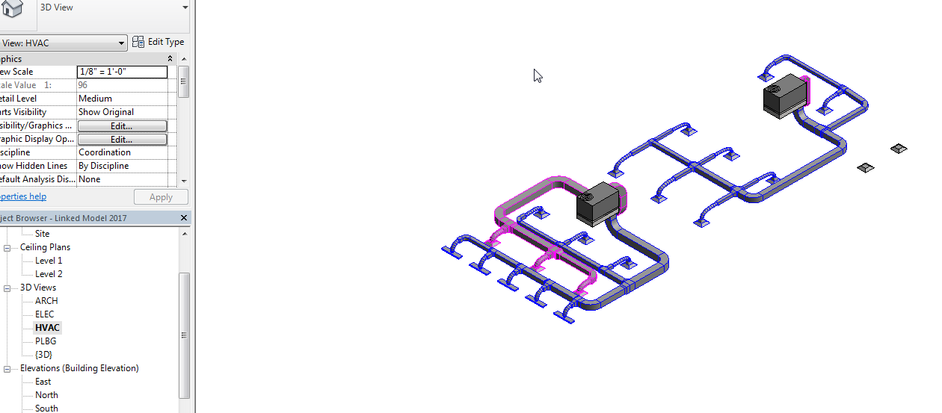
We will continue with the just the Building
Select ARCH in Browser
VV
Revit Links
Turn Off the other 3 links (Mech, Elect and Plumbing)
OK…OK
Just the building shows from the link!
Save as: Linked Model 2017 2nd way.rvt
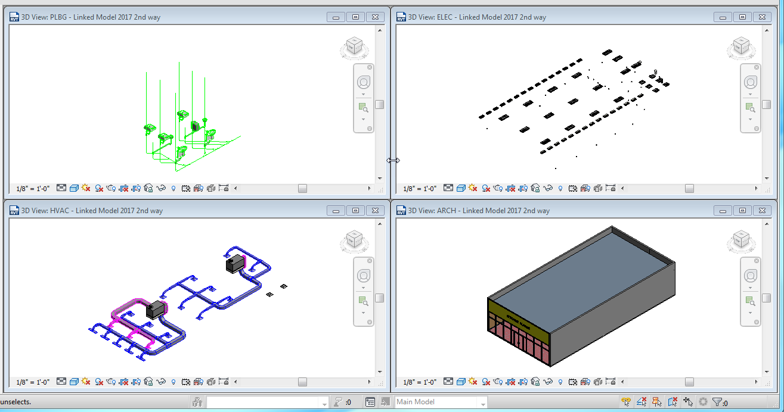

The strategy is to export EACH of the 3D views to Navisworks files.
In 3D View Plumbing (close the other 3D views)
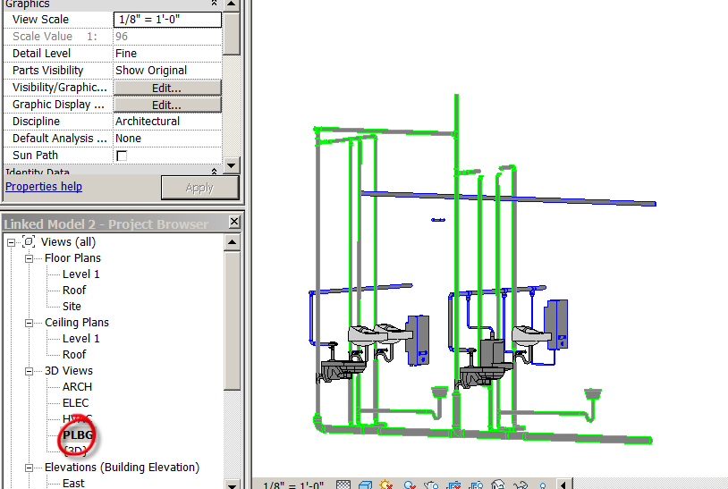
R
Export
NWC
Name it PLUMB 2017 for Navis
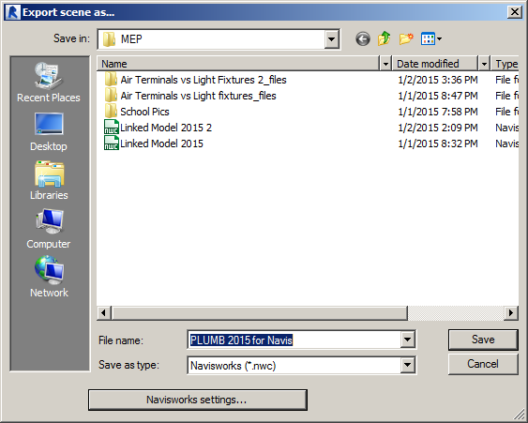
Navisworks Settings

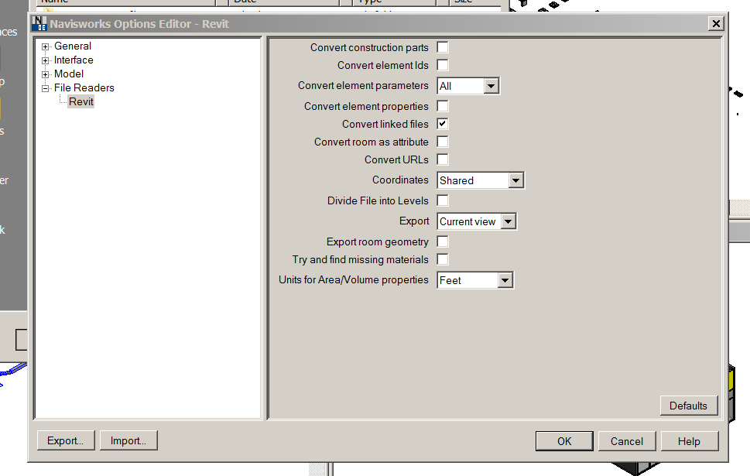
Save
Do that with each of the four 3D views.
Name them:
ELEC 2017for Navis
MECH 2017 for Navis
Arch 2017 for Navis

In Navisworks 2017
Home
Append
Append (put in)
.nwc
Pick all 4 files
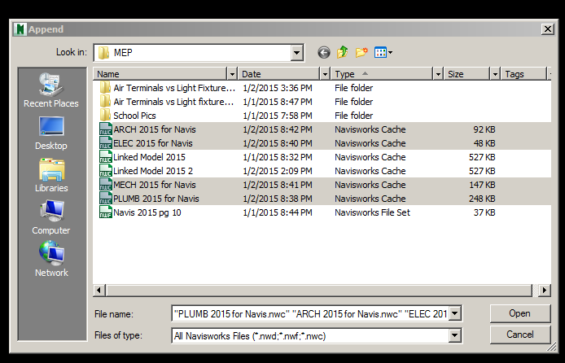
Open
Save as Navis 2017 Clash 2.nwf

View
Windows
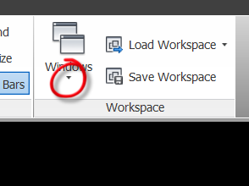
Check Selection Tree
Check Saved View Points
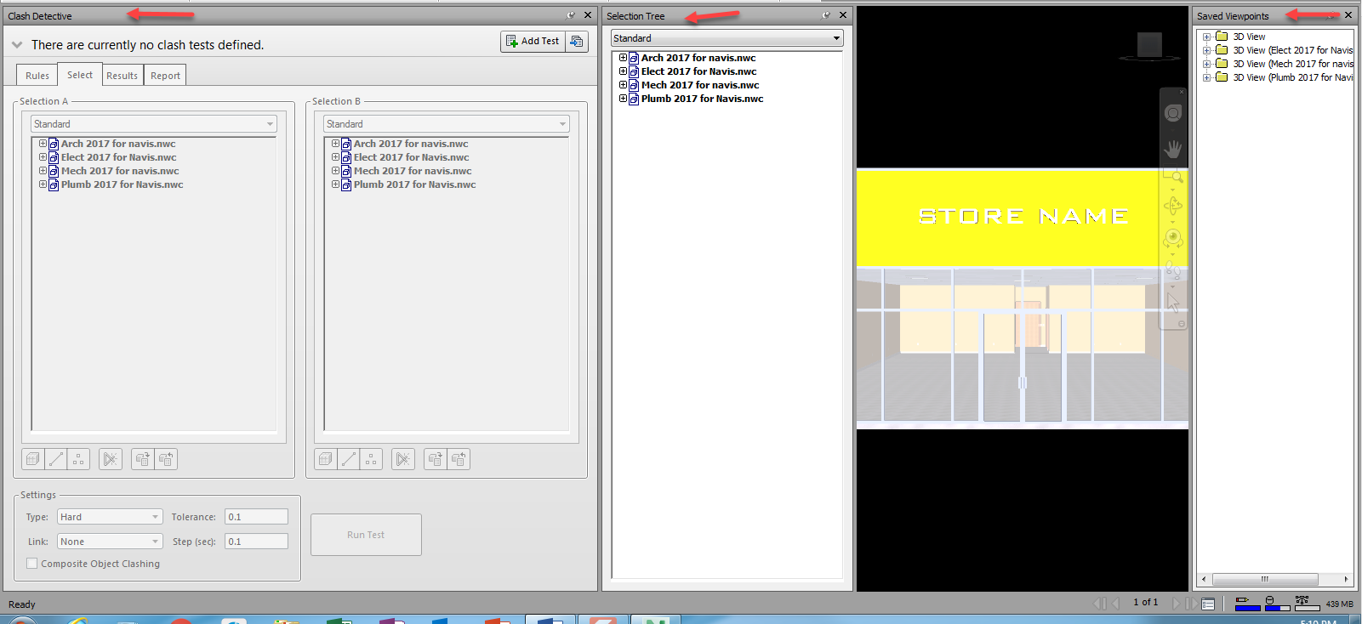

Setting Colors to the Systems
You can set Mechanical, Electrical, and Plumbing to different colors …..it’s much easier to see the systems that way! (a little repetition here…..hope that’s OK!)
Selection Tree
Pick ELEC
Item Tools
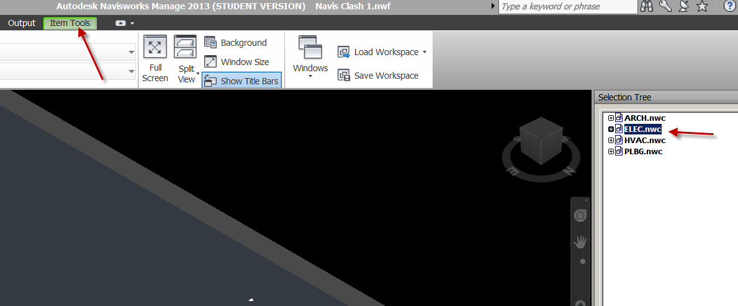
Pick Color
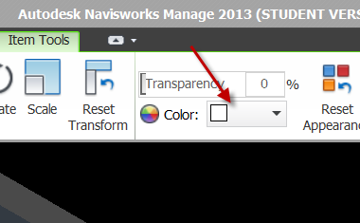
Try red
Can’t see the lights???

Pick ARCH2017 for Navis (the building)
Item Tools
Transparency
Set to 75% or so
Set color to Shaded:
Viewpoint…..Render Style….Mode….
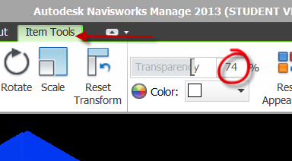
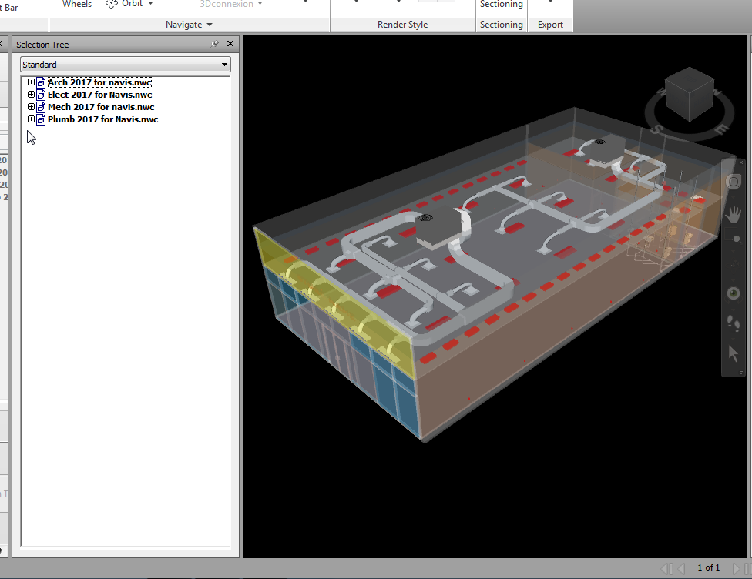
Pick MECH2017 for Navis
Item Tools
Color…pick Green

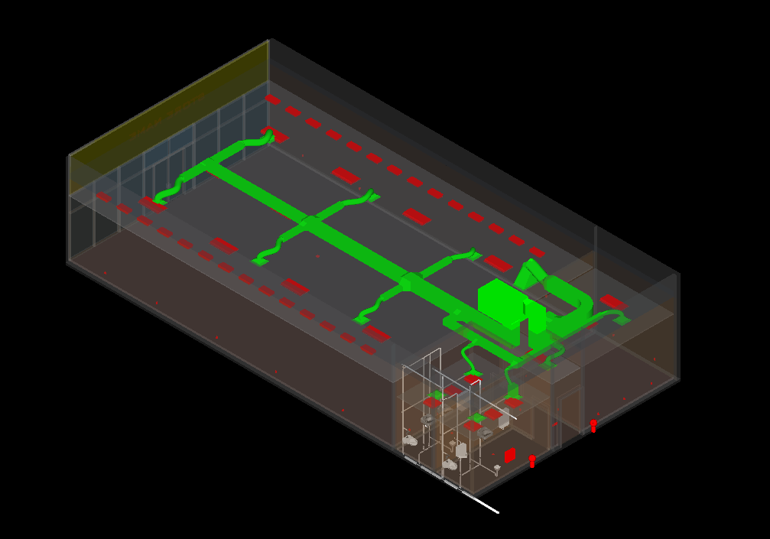

Now the Plumbing
PLBG 2017 for Navis
Item Tools
Color
Yellow
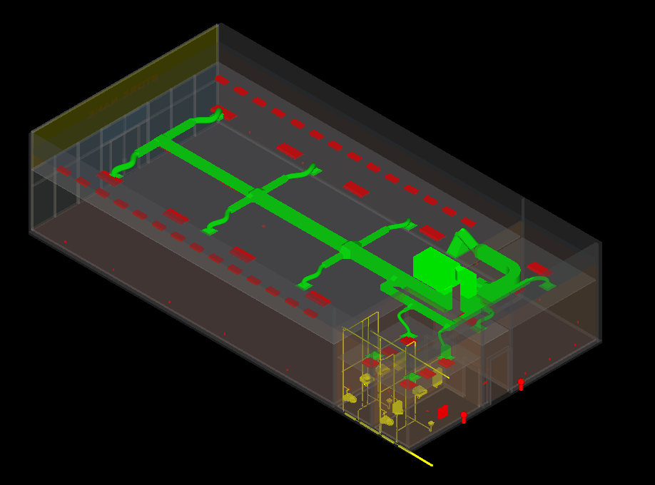

Now go to the Clash Detective and run your tests!
This time we will do all of the MECH vs ELEC again (should get the same results???)
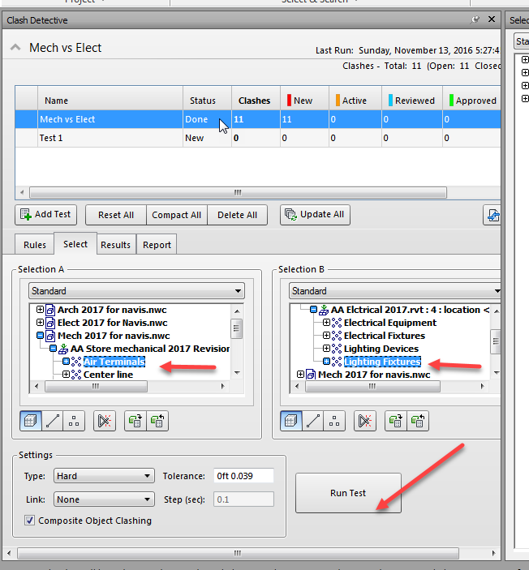
Same 11 Clashes?
Set up a report as viewpoints.
Write Report (button)
Save file as Navis Clash 2.nwf
Let’s add another test
Let’s do Arch vs Plumbing
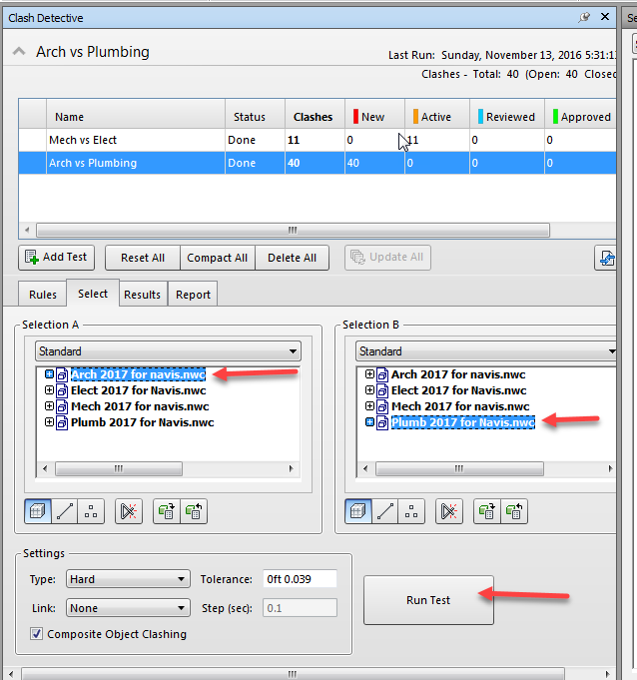
Wow….a bunch of clashes! Let’s see where they are!
Set up a report as viewpoints.
Write Report (button)
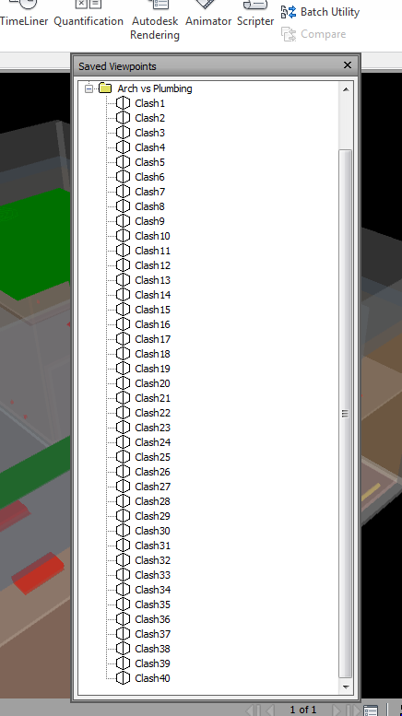

Write Report as an HTML
Open it. Pretty Cool. Ready for a coordination meeting!
