Norco College ARE25 and Santiago High Arch Design 2A/2B
Revit MEP Demo: Plumbing

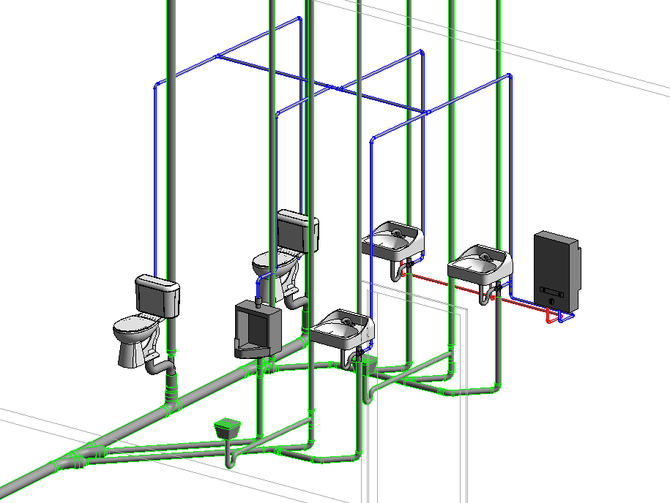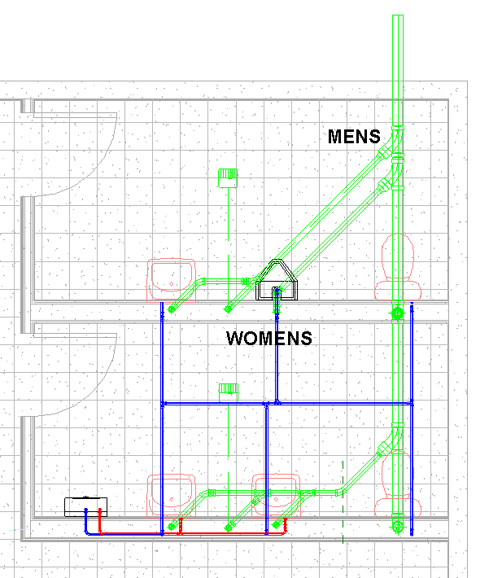
Students will create a plumbing plan of the Retail Store. In order, we will:
Create the building in Revit Architecture.
Link our Revit Architecture model into Revit MEP
Place the Plumbing Fixtures
Place the Sanitary pipes and vents
Place the water lines

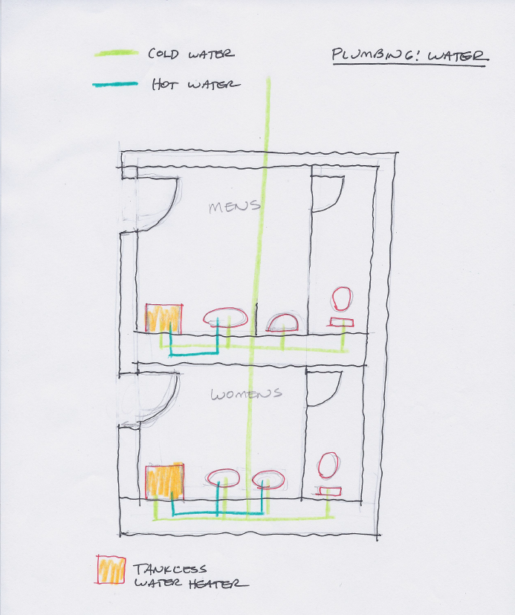
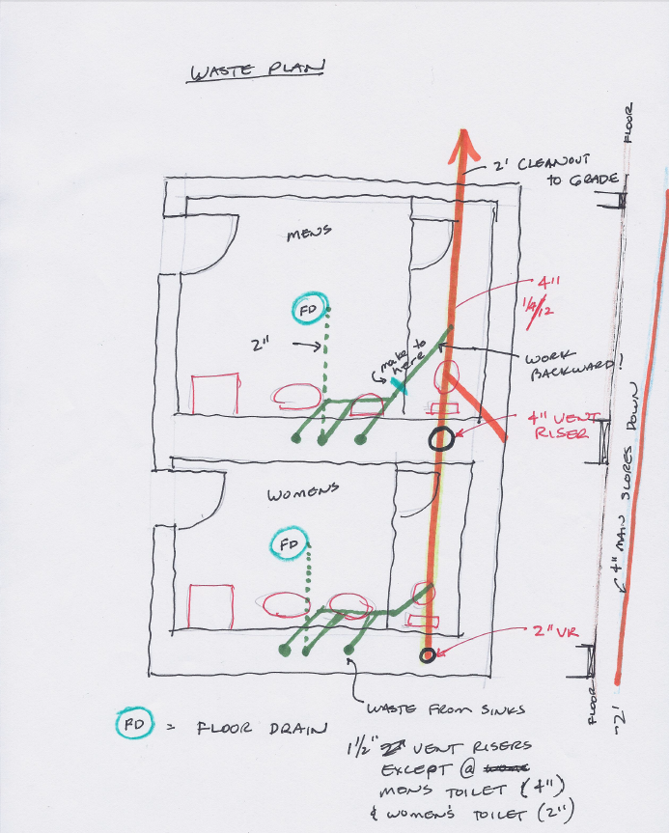

Create Building per Sketch in Revit Architecture
It should have walls, storefront, ceilings, doors, 3D Text sign, foundation, and tile flooring. No plumbing or electrical fixtures. We will do that in Revit MEP.
Some details:
Double Glass Curtain door
14’ Level 2 (name it Roof)
11’ 2X2 ACT Ceilings everywhere but Restroooms
9’ 2X2 ACT Ceilings in Restrooms
Ext walls will have a 4’ parapet, making them 18’ total
Make Roof a Generic 12 to start, at the Roof Level (14’)
5” Slab Foundation with footings
Put ¼” ceramic tile on the floor in all rooms. Offset ¼” to go on top of Foundation slab
Paint on walls. You will have to split some walls and “Split Face” some walls.
Place base molding
Save as: Revit Arch Building for MEP.rvt
Linking the Building into Revit MEP
Generally the architect designs the building, then hands it off to the Mechanical Engineer (you) to do the Mechanical, Electrical, and Plumbing plans. We will try to use that workflow….
Open Revit
Mechanical Template
File: Save as Store MEP-Plumbing.rvt
In Level 1 Floor Plan view
Insert
Link Revit
Revit Arch Building for MEP.rvt
Position: Auto Origin to Origin…..Open
The building should be there. Discuss Linked Files
Note the new Browser setup
Discuss layout by Discipline
Show Properties….Discipline…Electrical….Plumbing, etc
Show subdiscipline….Lighting…..
Plumbing Floor Plan 1-Plumbing
VV
Note Lighting, Electrical equipment, Ducts, Air Terminals OFF. Plumbing Fixtures, Pipe ON
East Elevation Plumbing
VV
Note Pipe and plumbing fixtures ON, but Lighting, ducts, air terminals OFF
Get it??
Go to Elevation View. The linked building and the template need to have the Levels aligned.
Drag the levels away from each other.
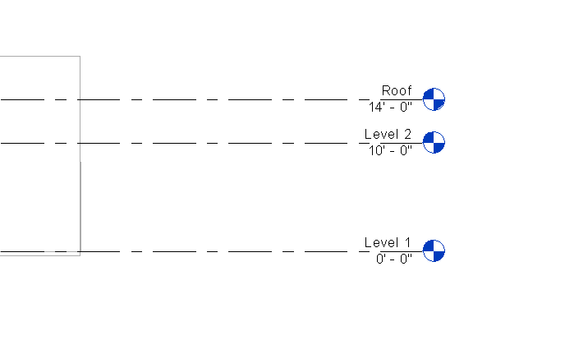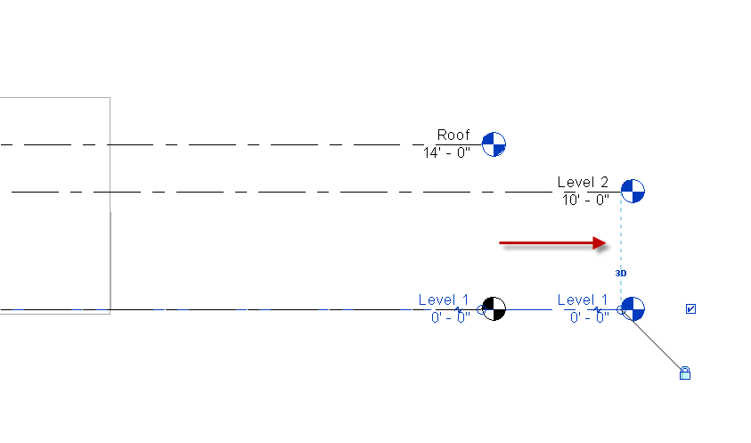
Note Level 1’s are OK
Rename Level 2 to Roof and move it to the other “ROOF” level using the Align command
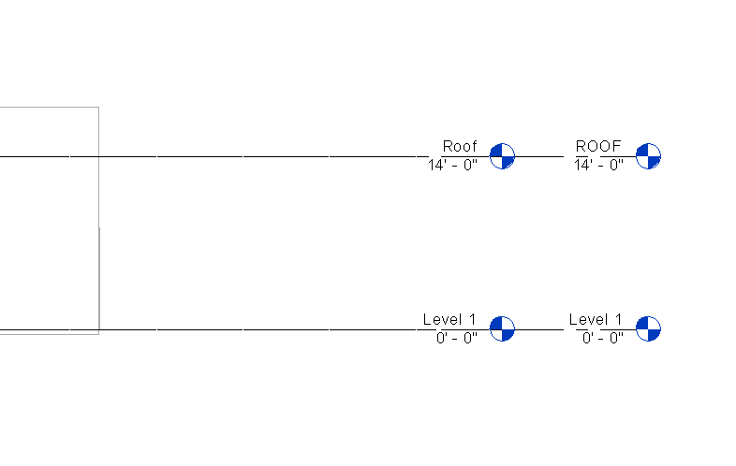
Save as: Store MEP-Plumbing.rvt
Plumbing Waste Plan
Placing Fixtures
See sketch “Waste Plan”
Place toilets, urinal, sinks, floor drains, in the Floor Plan Plumbing Level 1

Systems
Plumbing Fixture
Load Family….Yes
O:/Arch Design 2A-2B 2014/MEP Families/Plumbing Families
SHS Floor Mount Toilet
Place them. Align and Lock them vertically. (We want them to align with the main line later)

Systems
Plumbing Fixture
Load Family
SHS Urinal Use the ¾” Flush Valve type
Open
Place on Vertical face

Systems
Plumbing Fixture
Load Family
SHS wall Sink (provided) Use the L-1 type
Open
Place 2 in the Women’s, one in Men’s per sketch

Systems
Plumbing Fixture
Load Family
SHS Floor Drain (provided) Use the 2” type
Place on Face
Use space bar to rotate as you place
Save as: Store MEP-Plumbing.rvt
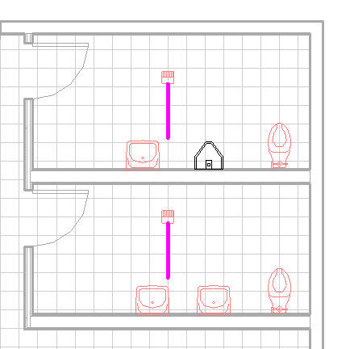
Change scale to ¼”=1’0”. It will make visualization easier.
Set Detail Level to Fine

Sanitary Waste

You will need to be in Section view so you can see the pipe in the wall as you draw it. Keep the pipe close to the fixture side of the wall so there is room to place the water pipes later.
Use these settings for your Section views:
Detail Level : Fine
Turn OFF Lineweights
Visual Style: Wireframe
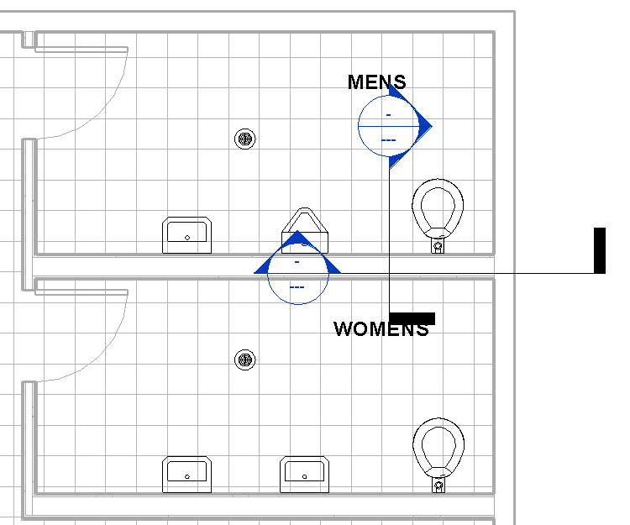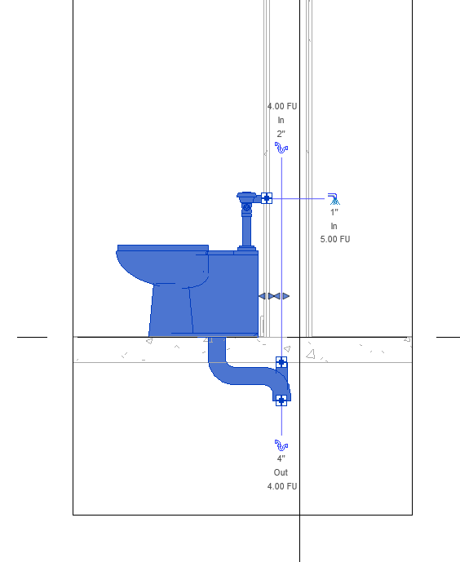

Systems
Pipe
Pipe Types: Standard
Diameter: 4”
Properties…..System Type: SANATARY
Create pipe about 3’ below level 1 …to about 2’ above Level: Roof
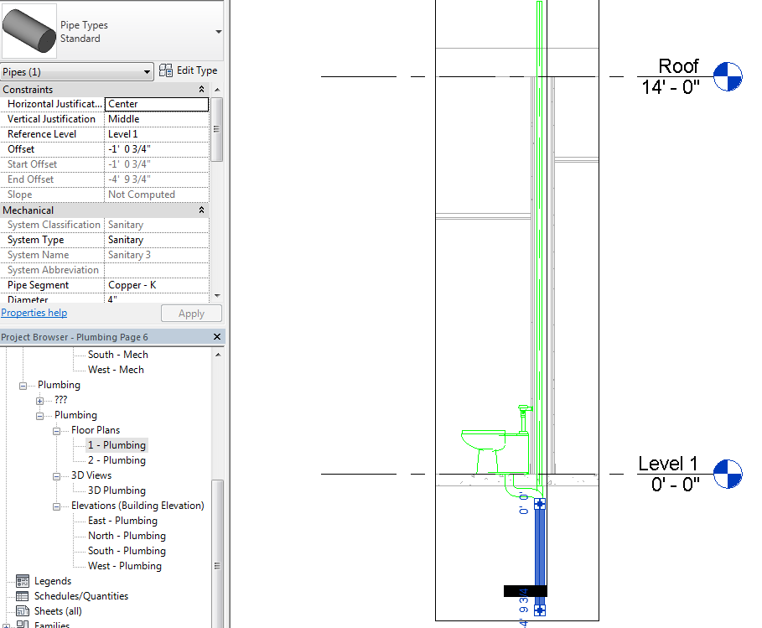

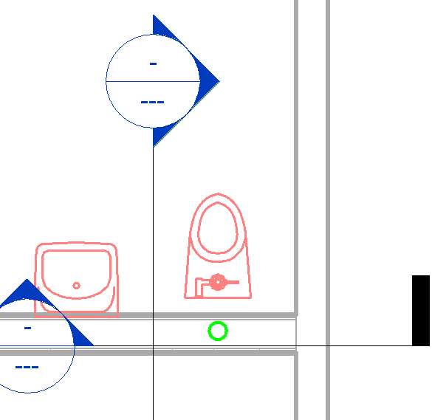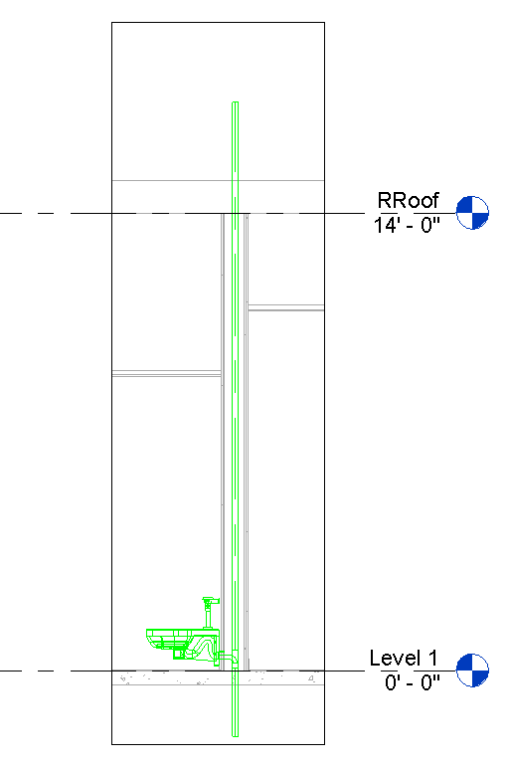
Did stuff turn Green? That’s showing it is a Waste Line “circuit”
Make another (vent) pipe (this one 2”) from Women’s toilet wall
Move Section lines to view space near Women’s toilet SHOW MOVING SECTIONS TOGETHER
Try this:
Instead of: Systems PipePipe Types: Standard Diameter: 2” Properties…..System Type: SANATARY
Pick on toilet…..see the blue square? See the 4” Out?
RC….Draw Pipe…down about 3” below Level 1
Create (vent) pipe about 3’ below level 1 …to about 2’ above Level: Roof
Pick on toilet again…..see the blue square for the vent pipe going up? See the 2” In?
RC…Draw Pipe…up to about 3’ above Roof
So you have more than one way to draw the pipe from the fixture. I like the RC…draw pipe.

Floor Plan Plumbing Level 1
Set View Range to the following (so we can see underground pipes)
Top: Associated Level 1 10’
Cut: Associated Level 1 4’
Bottom: Associated Level 1 -10
Depth: Associated Level 1 -10’
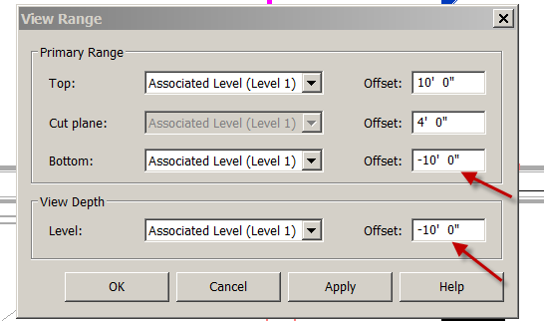
Note: If you are not seeing your pipe from Plan view, check to see if pipe is set to System Type: Sanitary in the Properties box

Create 2” vent pipes and waste pipes off the 4 other plumbing fixtures. Use the Vertical Section already created to keep your drawing uncluttered.
Note: There should be 6 vent pipes. Five 2” pipes and one 4” pipe.
Note: You may have to flip the Urinal . Use the spacebar.
Again, keep the waste pipes toward the fixture side of the wall to allow room for the water lines later.
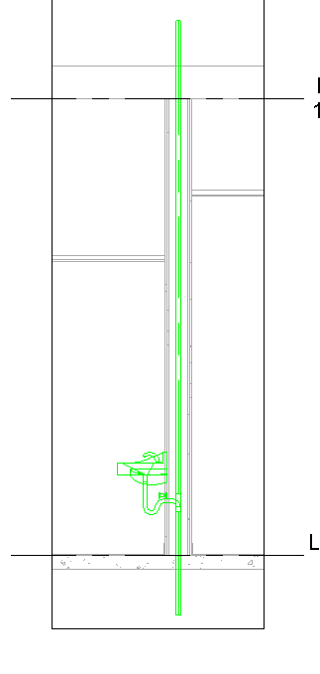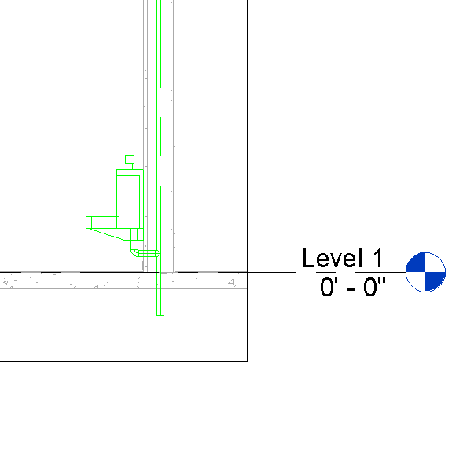
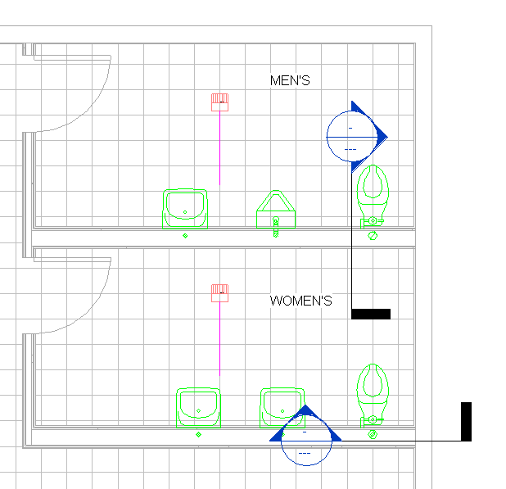

Main Waste Line
See “Waste Plan” Sketch
Starting from Women’s Plumbing Wall
Pipe….Sanitary….4”….Slope down…..1/4”=12”
Finish pipe a few feet past the North wall
Go to Section view to confirm waste pipe is sloping properly.
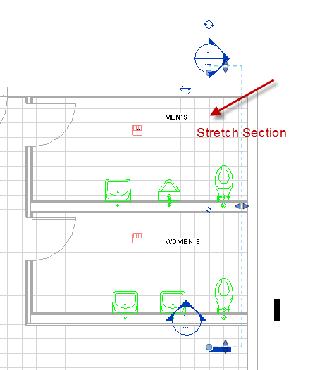

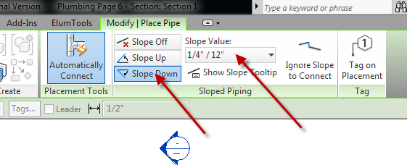

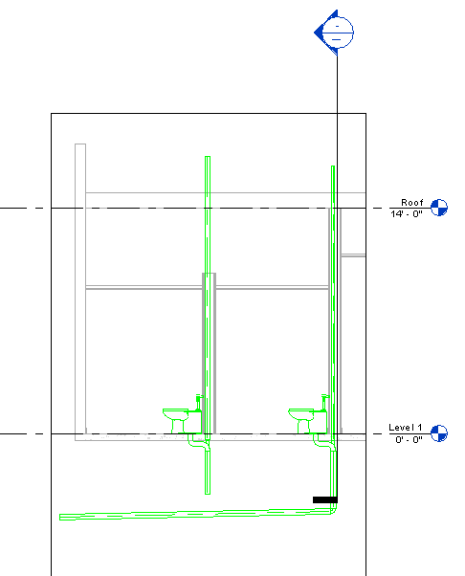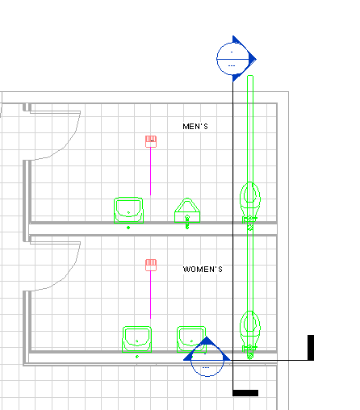
Use Trim/extend single element to join 4” vent w/4” Main Waste line (or just pull it down)
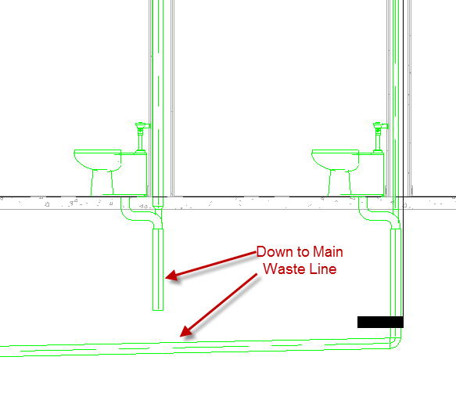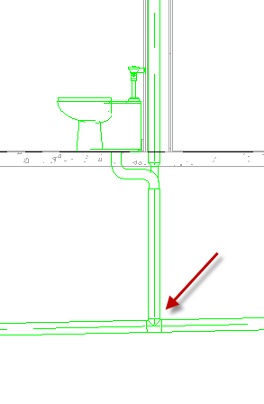

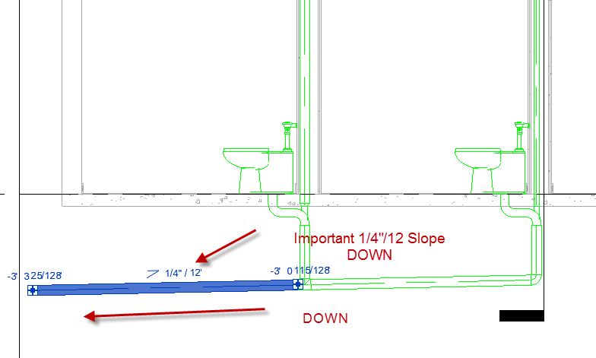
Make it look like this. OK to pull main waste up/down by dragging.
Note: You need a vertical vent pipe at all fixtures, including floor drains.

Creating Floor drain waste pipe.
I have a Floor Drain family (thanks Design West Eng) that has some cool elements to help us connect the drains…
Create Floor drain waste pipe 2” STARTING from 4” Main Waste Pipe. YOU HAVE TO WORK BACKWARDS!! Slope UP ¼”=12” 45 degrees off Main Waste Pipe…go about ½ way to wall. You will eventually align this with the Floor drain line.
Note: You may have to RC…Create Similar on the pipe to connect it properly.
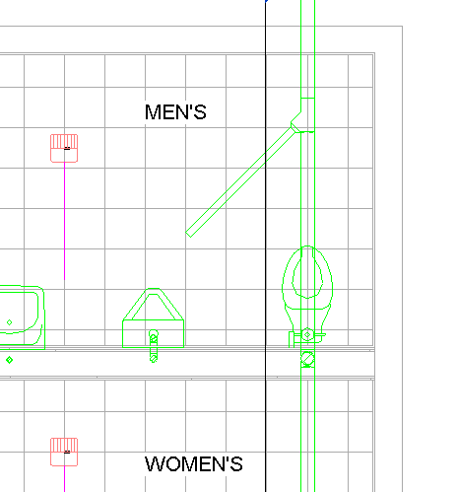
Move your Vertical Section next to the floor drains (avoid cropping other vent pipes)
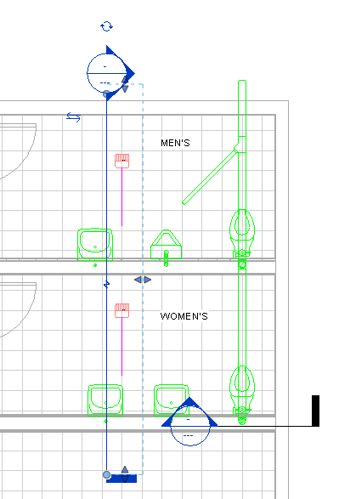
Drag floor drain connector toward wall (use the blue arrow above + sign)
Set WasteDepth at 1’6”
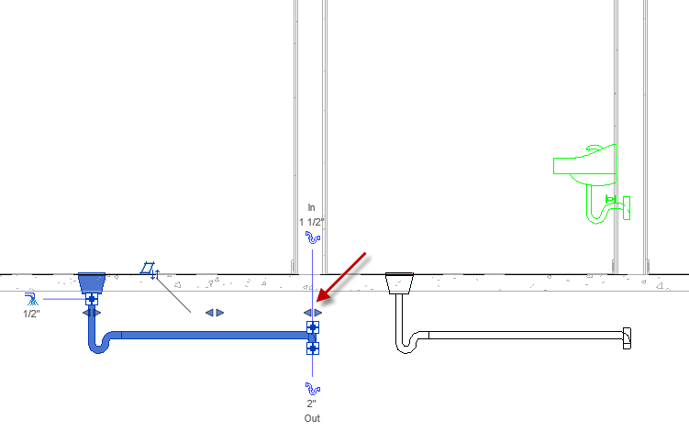
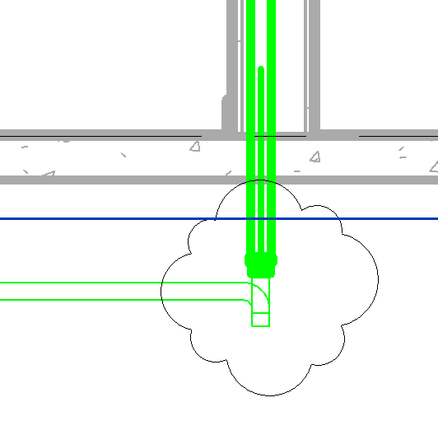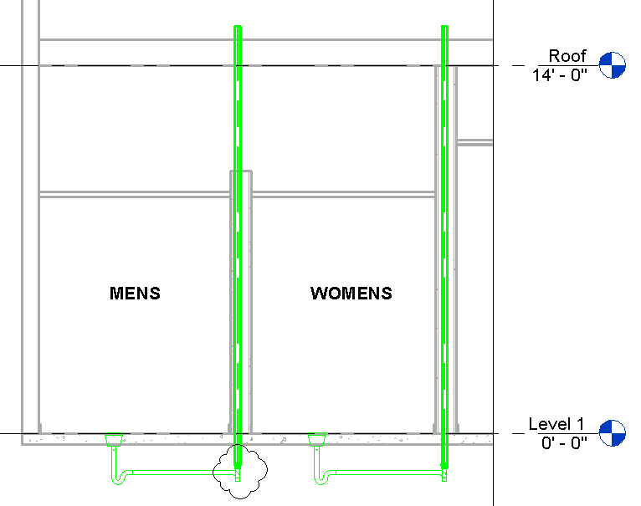
RC on Upper + on connector. Draw pipe 2” sanitary vent up to roof.
Do the same with the other drain. They should look like this above:

Now we have to create a 45 degree line from the vent pipe to the main line. Waste pipes need to be 45 degrees….no weird turns….
We will need a 45 degree section line to see our pipe assembly correctly….like an auxiliary view.
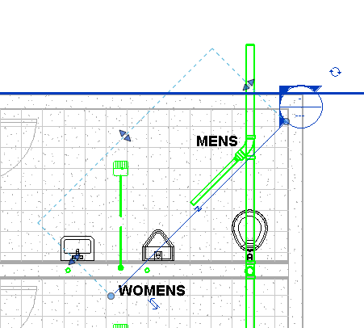
From the section view, pick on end of pipe fitting. Draw pipe down about a foot….we need something to T off. Now T off the pipe with your 45 degree 2” pipe. Slope DOWN ¼ /12
Align the pipe of the vent w/ the pipe off the main line (pick main line pipe first)
Note: You may have to move the waste line a bit to allow for aligning…
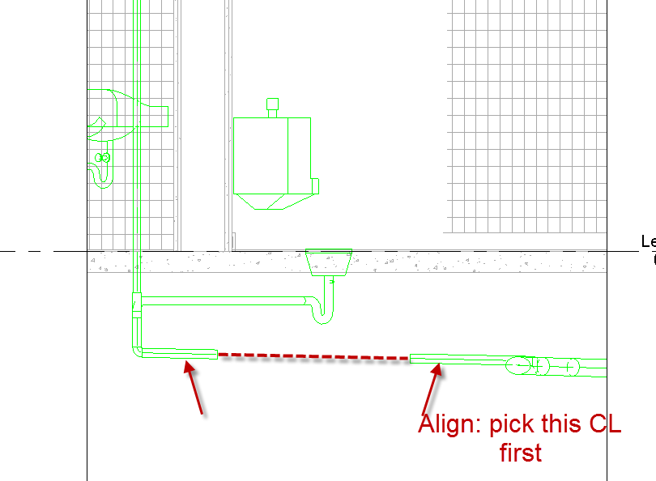
Floor Plan Plumbing level 1
Align Pipes from top. Pick pipe as shown below. Move to align with pipe from vent
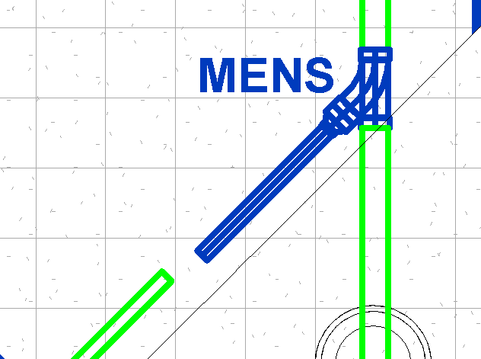
So they will be aligned from the top AND the 45 degree section. The next step will not work if both are not aligned….
Delete the pipe coming from the Drain…we only want one pipe…..the one coming from the Main.
Also delete the elbow fitting.
TRIM the pipe (pick the sloped pipe first)from the main line into the connector at the vent. DONE!!
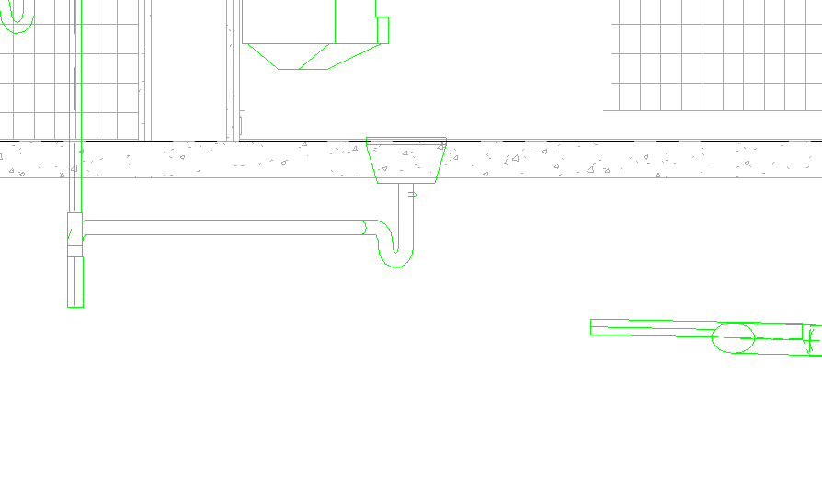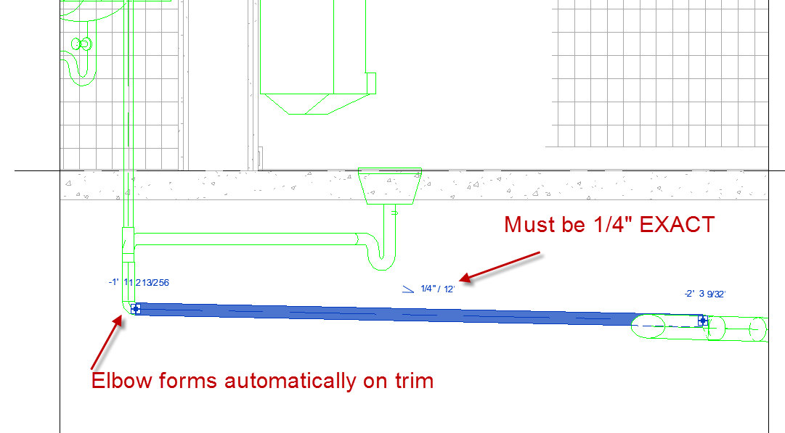

Repeat for Women’s Room drain…..but a different way
Set it up just like we did in Men’s Room
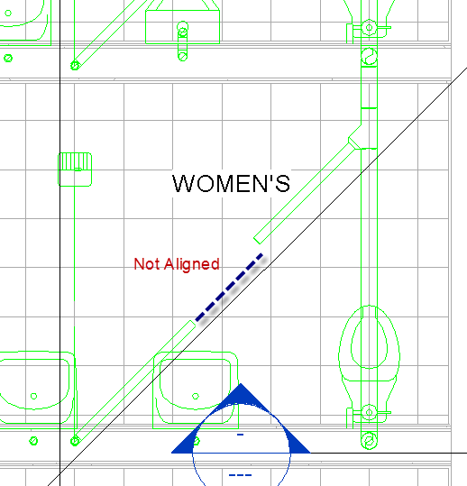
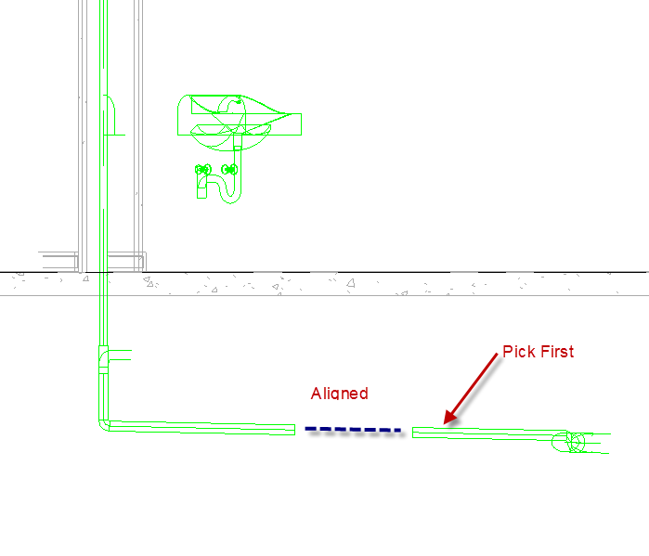
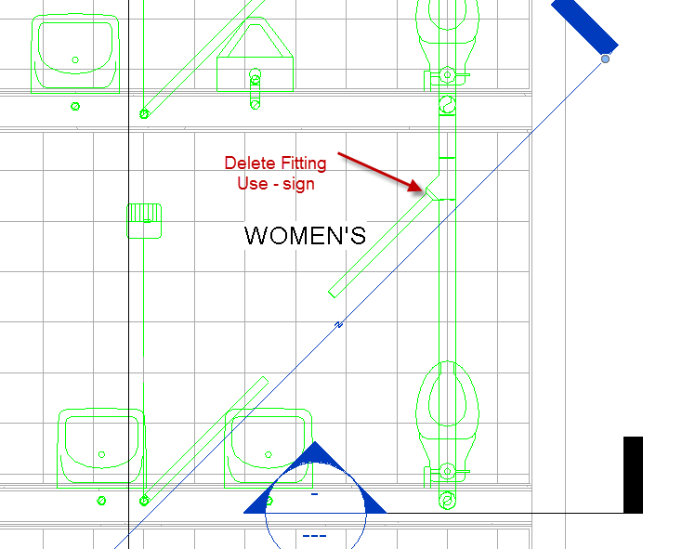

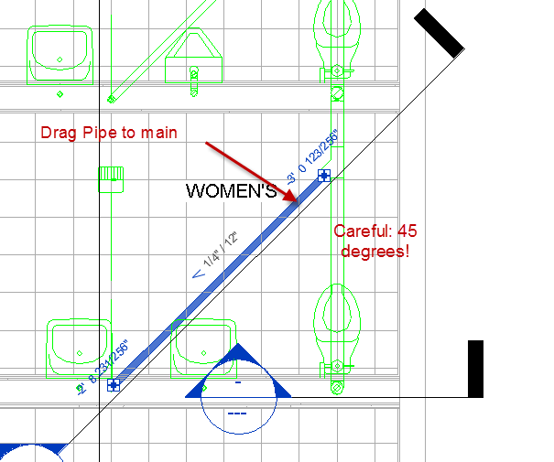
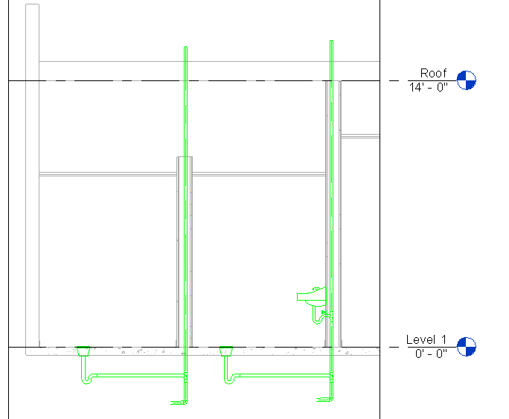
Check out (in section view) where the vent pipe, floor drain, and waste pipe come together.
Again, let’s set WasteDepth to 1’6”

Watch out for this:
Make sure to slope UP 45 degrees on 2” line coming from the 4” main line
Sometimes connecting can be difficult!
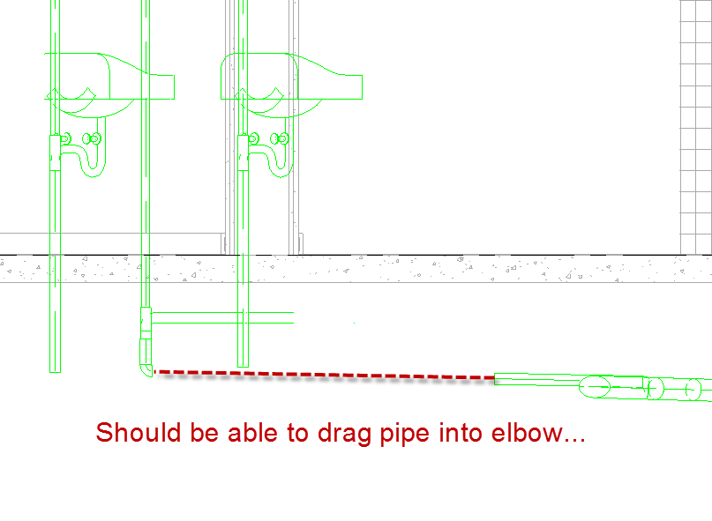
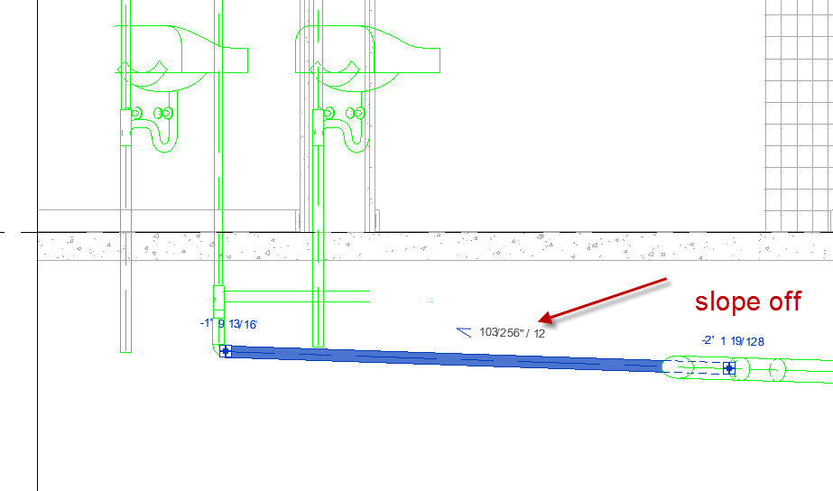
Make sure pipes are aligned in Plan View or you have NO HOPE of making them connect! Check it!!
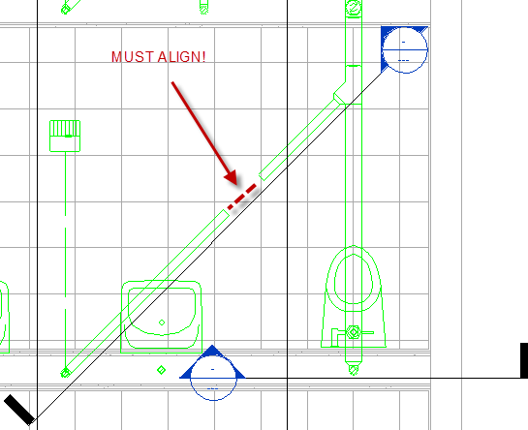

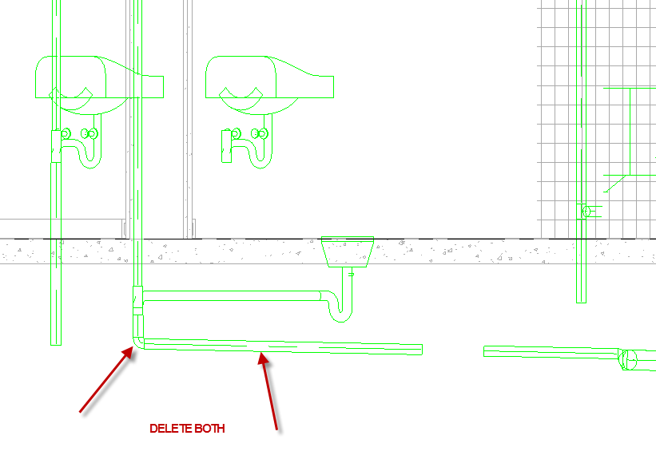
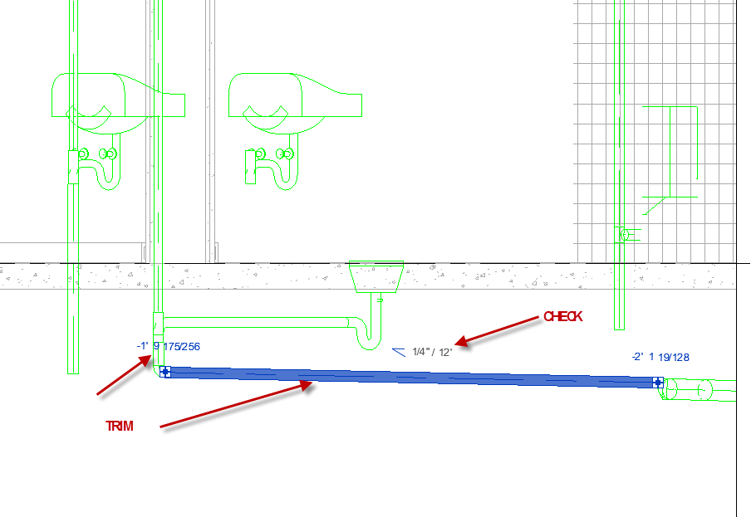
Checking your system
Pick one of your waste pipes in the circuit
Use tab key to cycle
If all of the elements turn blue, they are in the circuit…..and you are good. If not, try dragging that 4” pipe off the toilet ….going to the connector….and get a better connection.
It should look like this:
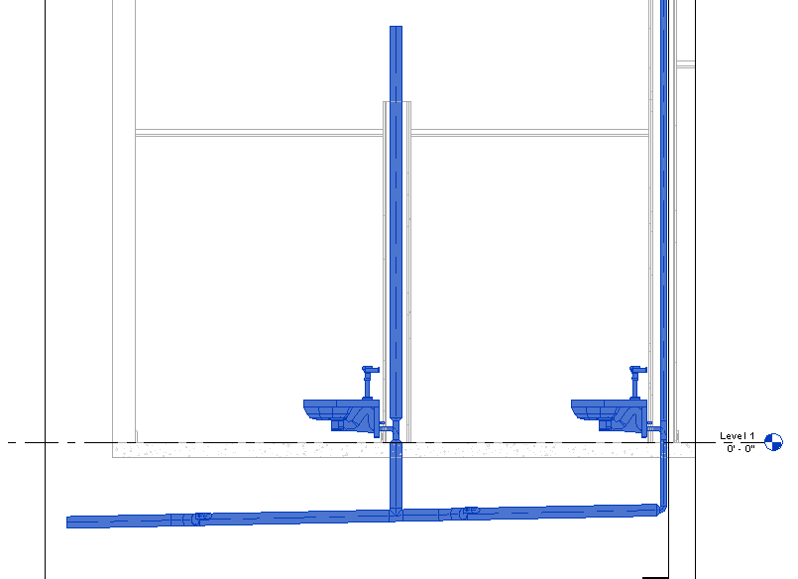

Go to 3D view
Pick on Waste Pipe
Tab…Tab…
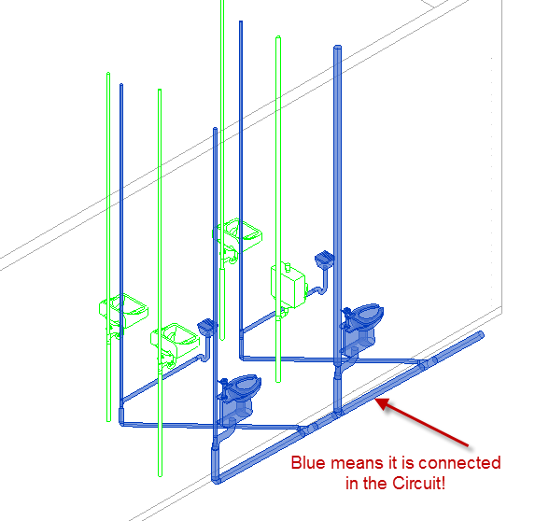

Note the lavatories and urinal will not turn blue! They are not connected yet.

Urinal
Load SHS Urinal
Place per sketch
Just like with the toilet, we will start the circuit from the 4” Main…..remember…WORK BACKWARDS!
RC on 4” Main
Create similar
2” pipe
SLOPE UP…..1/4”/12
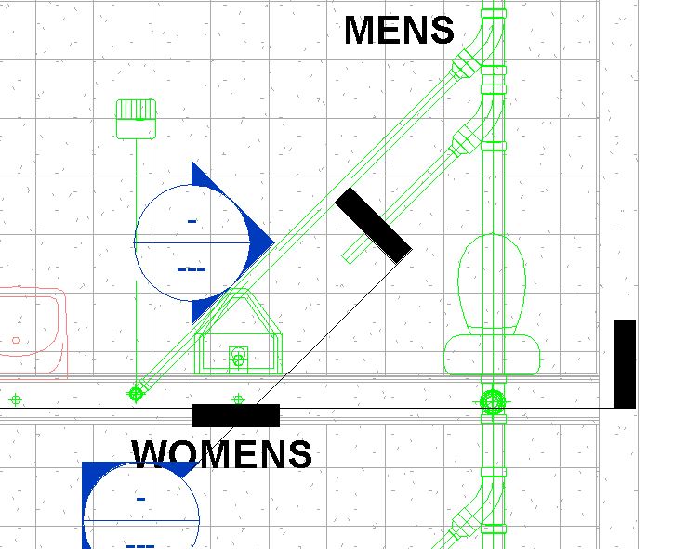

Go to section view @ Urinal
Select Urinal….+ Draw pipe
Go down about 3’ below ground (we will trim later)
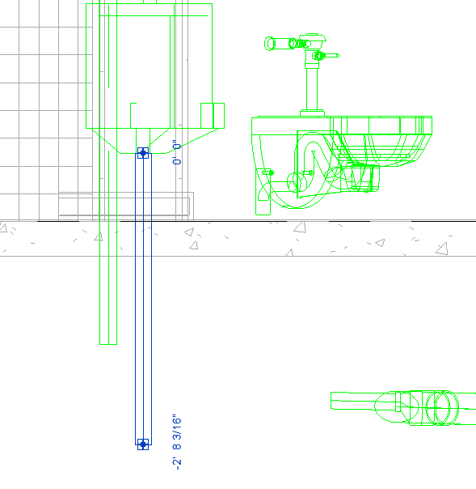
In plan view, make a 45 degree section
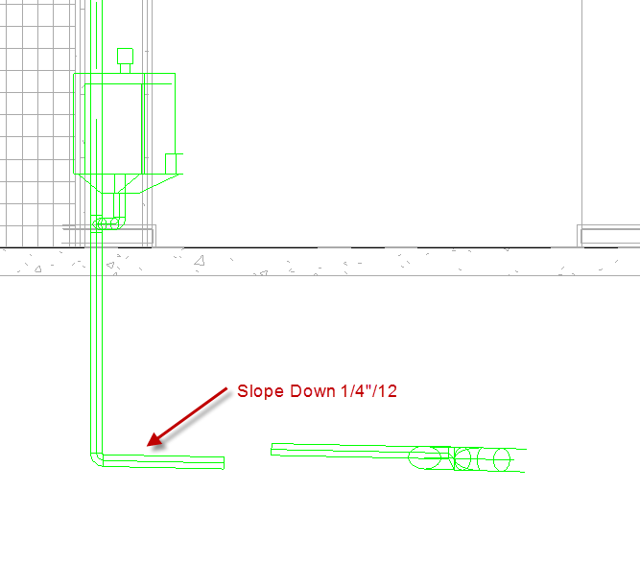

Align Pipe in Plan view…just like we did with the toilets. The pipe coming off the 4” main will move.
In the 45 degree section
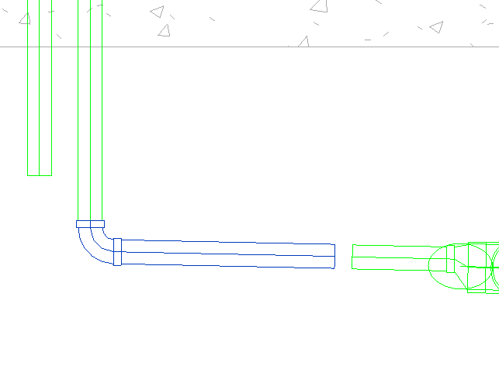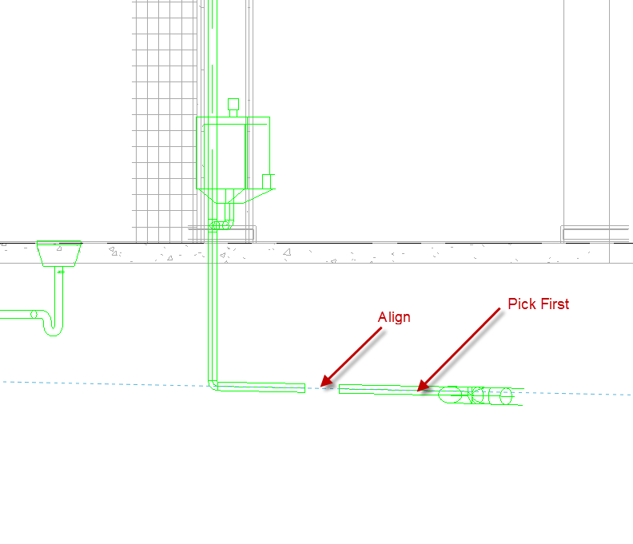

Align the pipe from the urinal to the pipe from the 4” main.
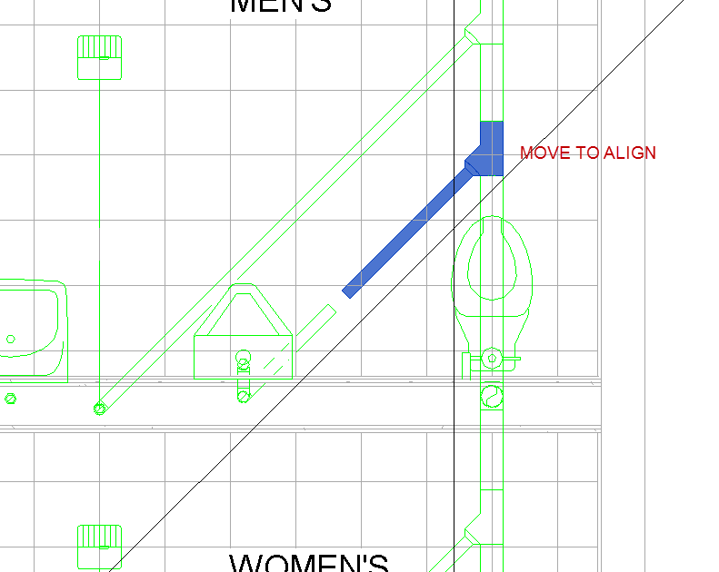

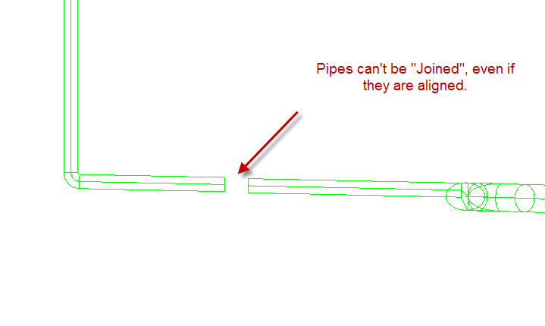

Use the trim command to join the 2 pipes. It’s easier than trying to drag the pipe into the bend fitting!
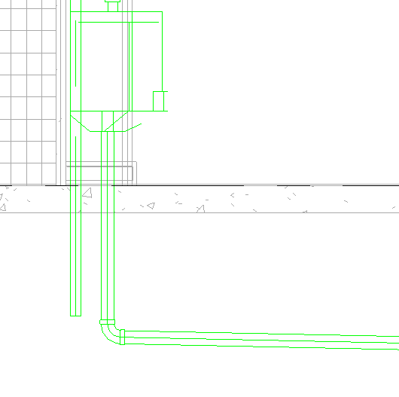
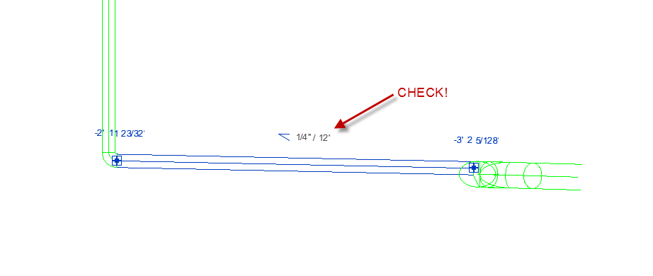Check 3D view. Set to Display: Fine
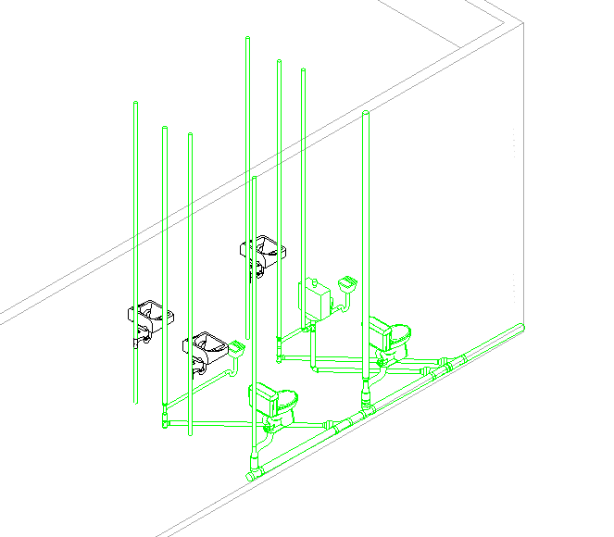
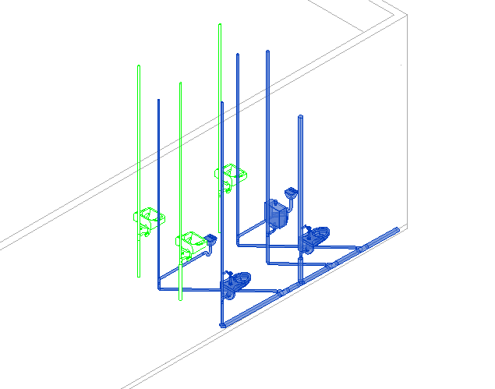
TAB to check system connections.
Notice the lavatories are not blue yet!!
Waste Line: Sinks/Lavs
See sketch
We will work backwards from 4” Main, just like we did with the Toilets….
In Women’s bath
RC on 4” Main….create similar…..SLOPE UP….2”
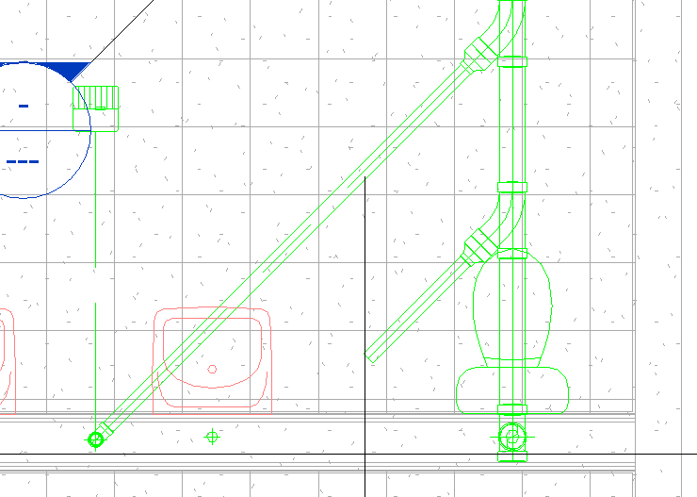
Create Section View at Lav
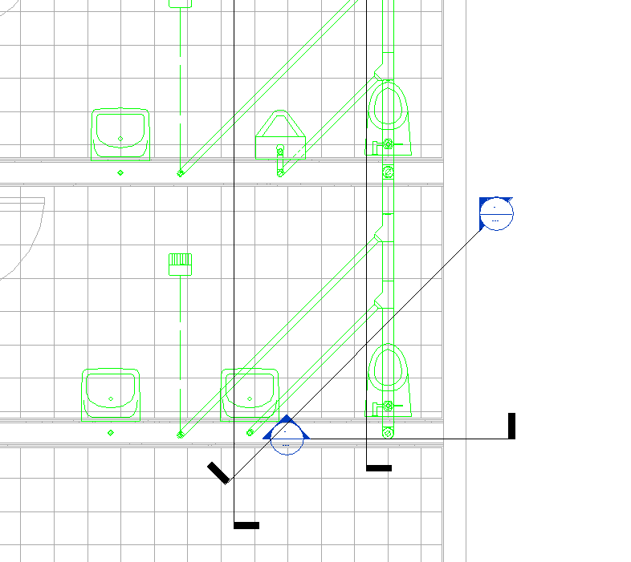
As you can see, it’s going to start to get crowded with all those separate lines going from fixture to the main waste line. Let’s consider a “re-route”!

RE-Route will save on pipe and keep it simpler! It will look like this:
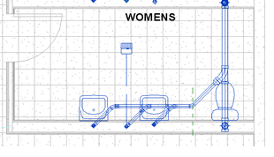
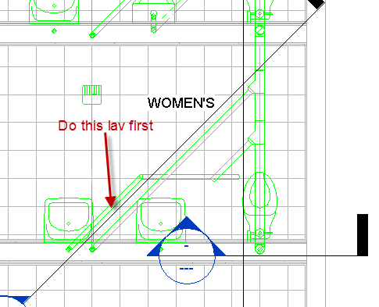

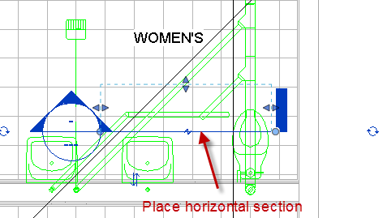
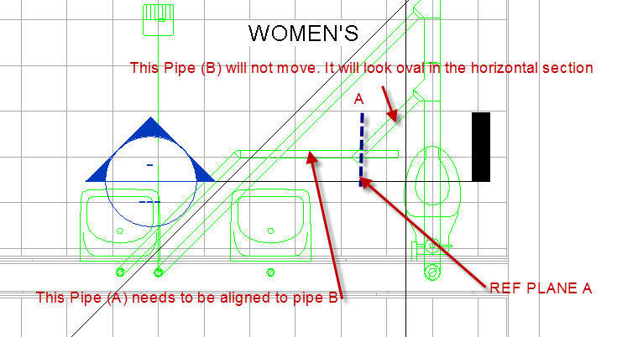
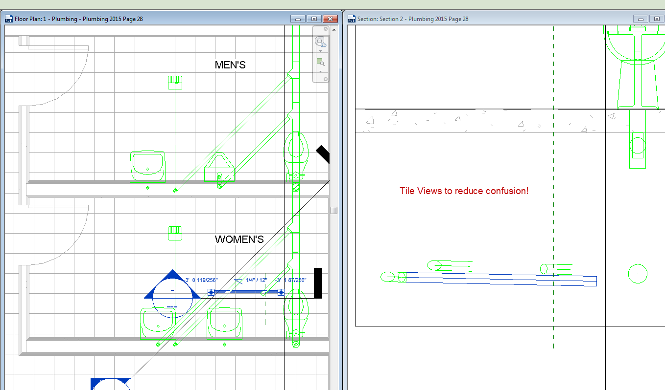

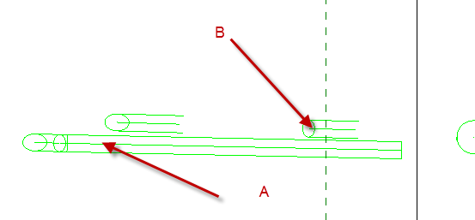
Align A with B….Pick B first. It’s important not to mess up “B” coming from the main line!
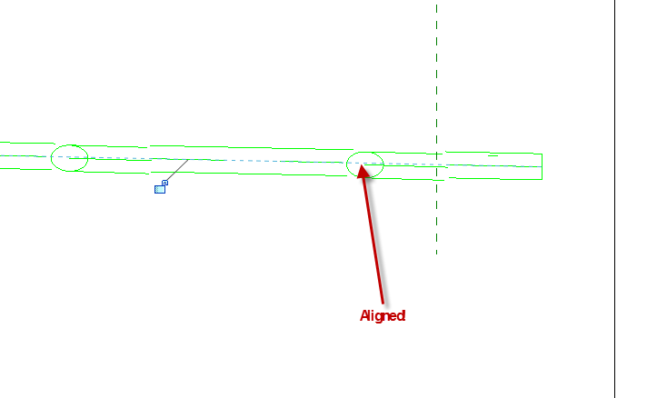

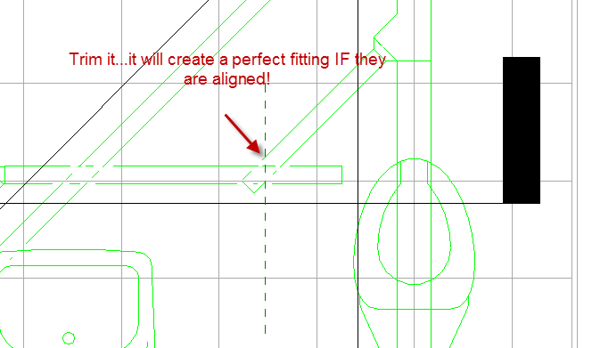
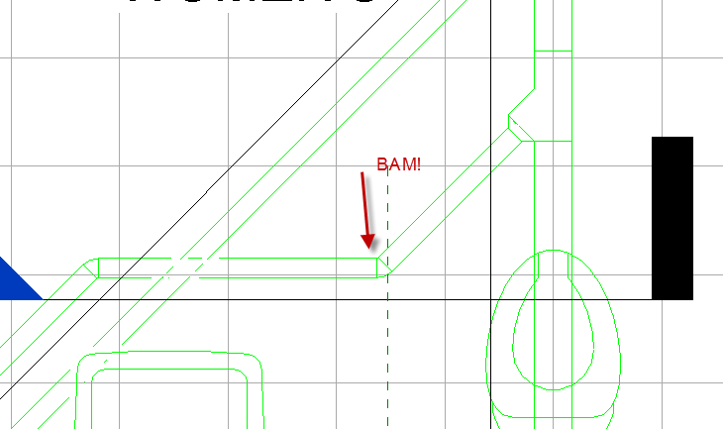

Note: It’s always a 45 degree section at join area. No weird angles. No 90 degree angles.

Note: Ever hear the saying “** it always flows downhill”? Ha…Now you know where it came from!
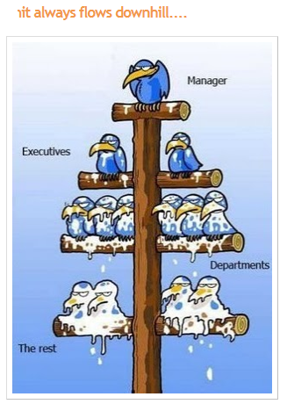

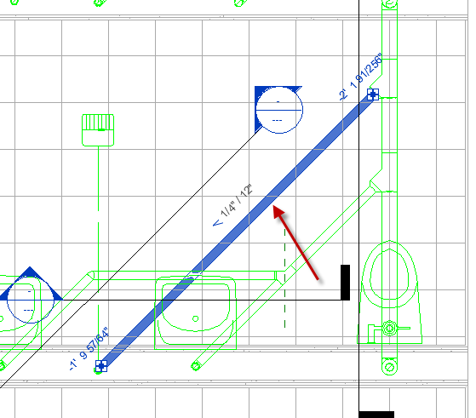
Now we will go after the floor drain:

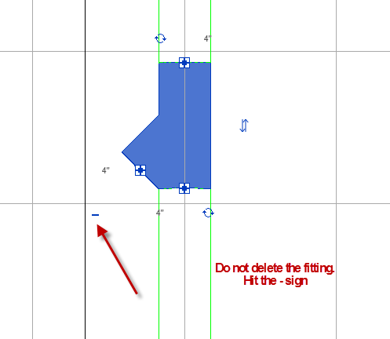

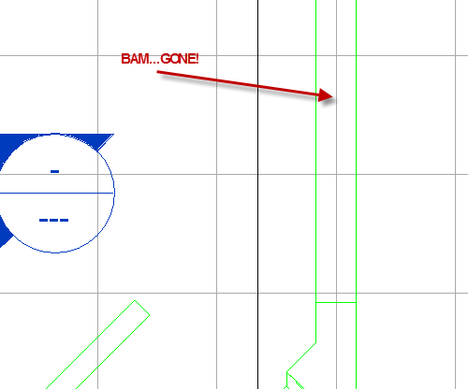
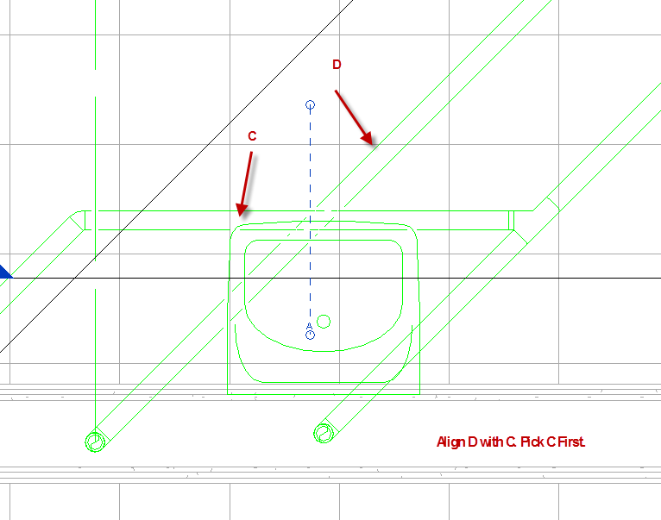
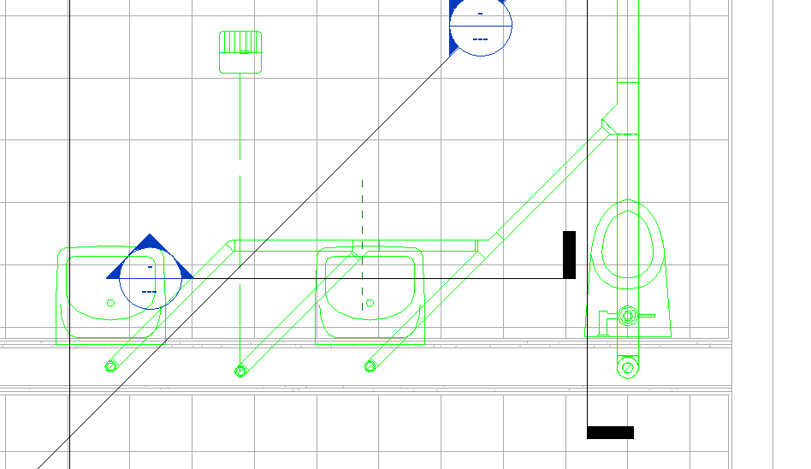

Drag back carefully. The pipes will properly connect!
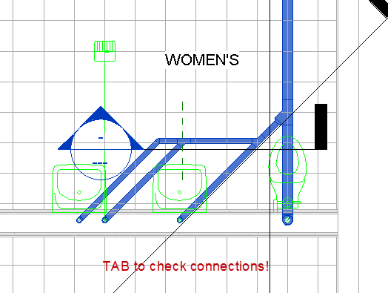
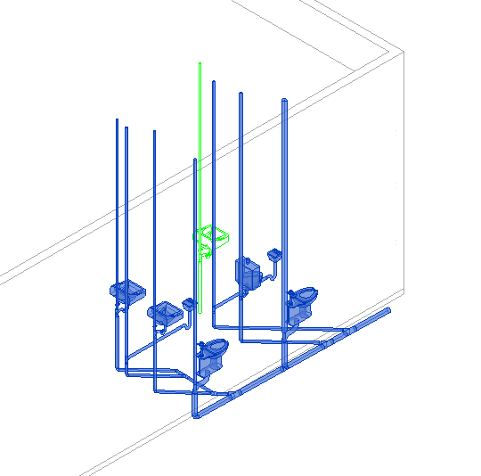
Connectors
Note: Sometimes Connectors are the wrong Type. Example: this connector should be a 90 degree bend, not a TEE.
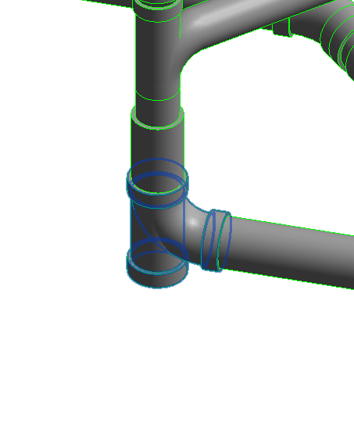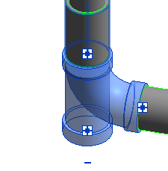
Pass your mouse over – sign. See “elbow”? Pick it. Ahhhhhhhhhhh! It changes!!

A great way to get rid of connectors is with the – sign when you pick the connector
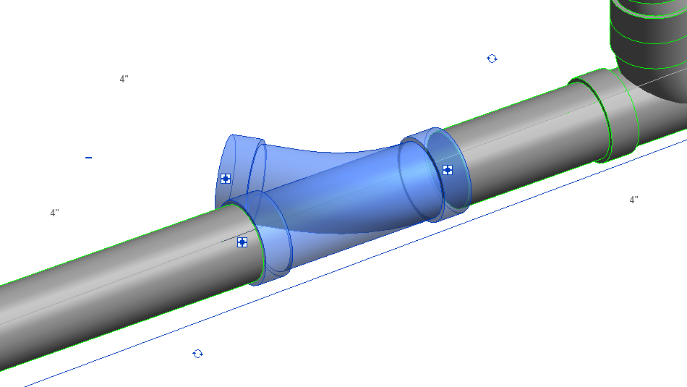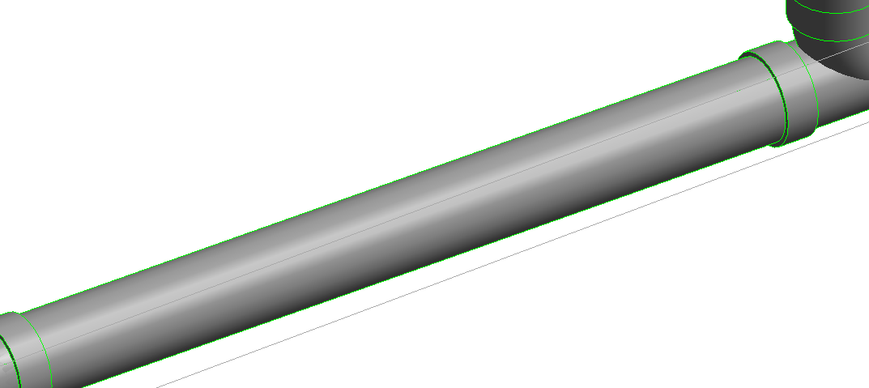
Now we need to work backwards from that spot where we 45’d in……
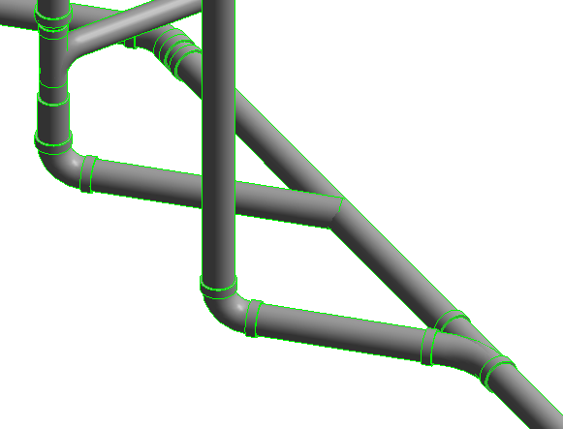
Let’s try aligning the pipe, so they join properly….
45 degree section….Align…pick pipe from main…..pick pipe from lav
In plan view, still not connected. Drag the 45 degree pipe back, then slide into horizontal pipe.
Done….REROUTED!
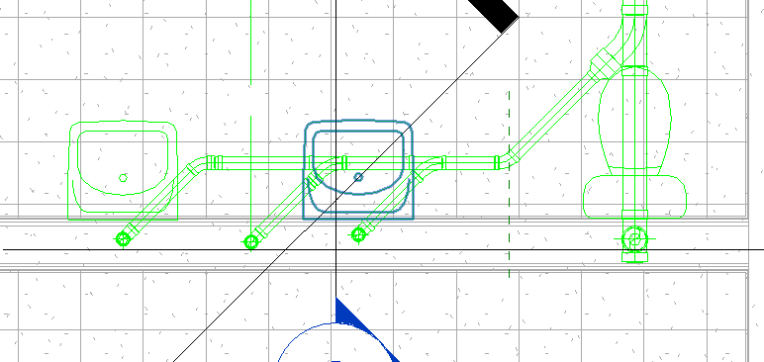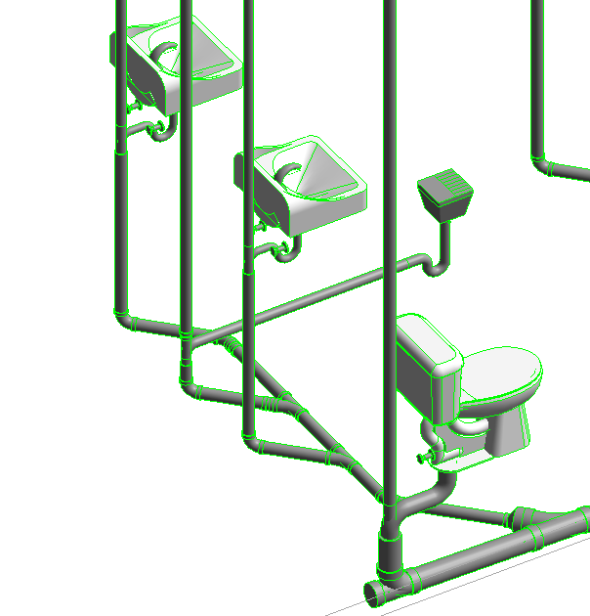

Plumbing Assignment
Men’s Restroom Re-Routing
We have a similar pipe-crossing issue in the Men’s room…..
Your assignment is to create a solution to the Men’s Room plumbing and model it.
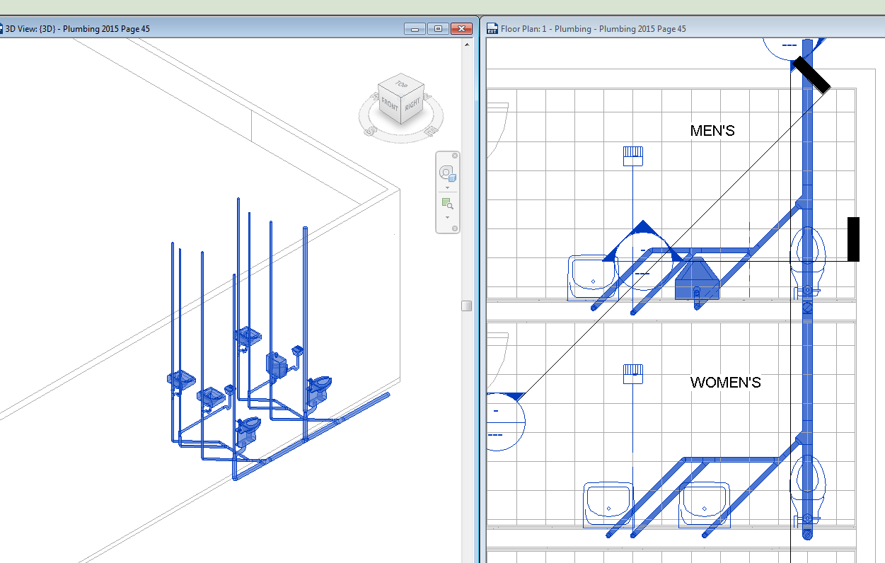

Checking your System
Tab to check circuit….pick on pipe…tab…tab…tab…tab

Try the “System Inspector” to check your circuit. Pick on a pipe…System Inspector….Inspect.
The arrows show flow and connectors. You may need to tweak things a bit…..
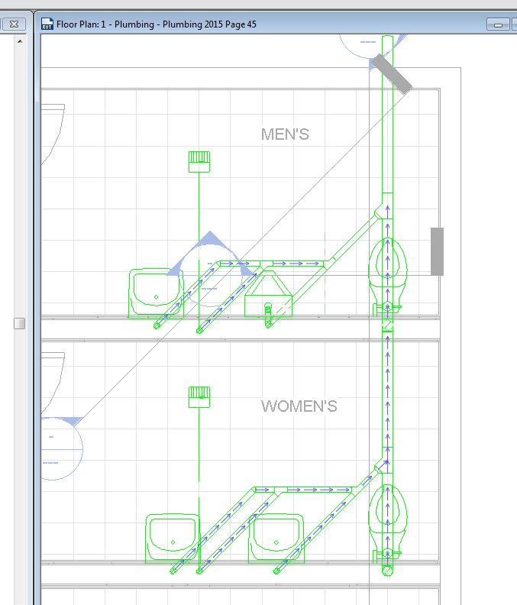
Save as: FirstLastStore MEP-Plumbing.rvt Try moving a lavatory (horizontally)…..see what happens with the pipe….

Vent Pipes
Those vent pipes will not all go through the roof. We will join them together between the ceiling and the roof….and exit out ONE pipe that is at least 10’0” from the HVAC.
(don’t want HVAC sucking in poopy air!)
The HVAC unit is adjacent to the Women’s Restroom, so we will want to exit the main vent toward the NE corner of the building….near the Men’s Toilet.
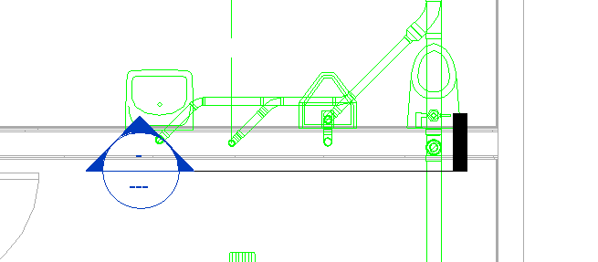
Slope UP from the main vent on the right. 2” pipe

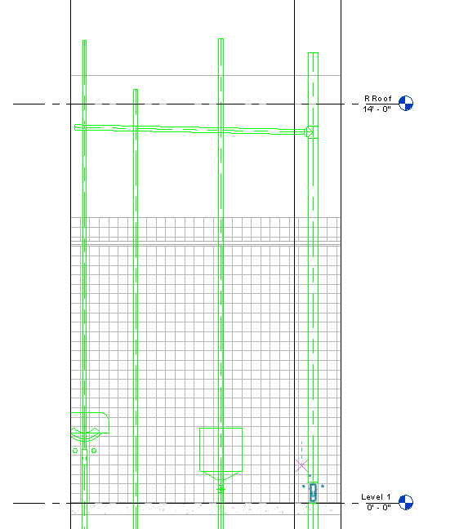
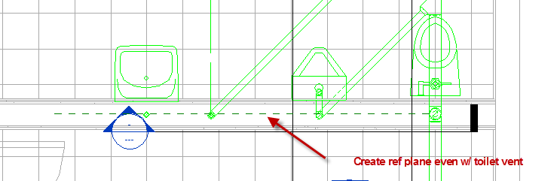
Make sure they are all PERFECTLY Aligned…or the joining will not work!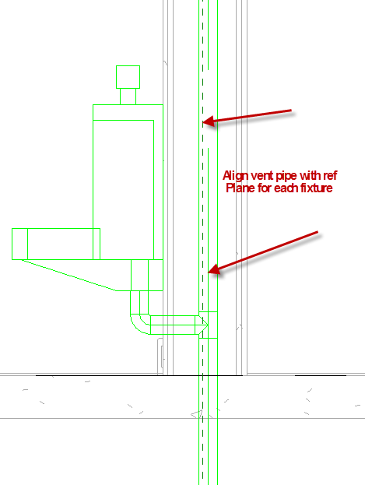
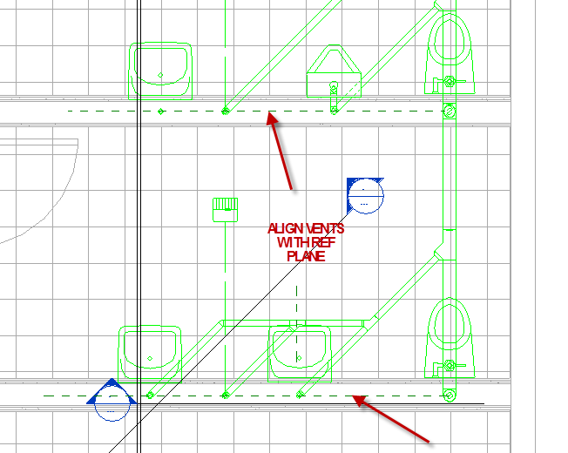
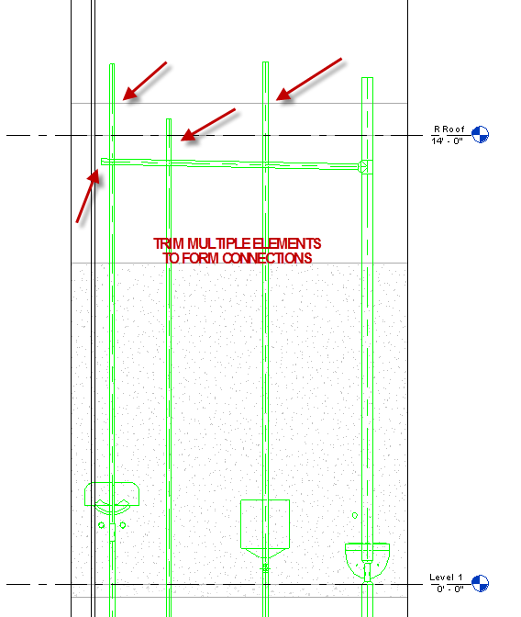
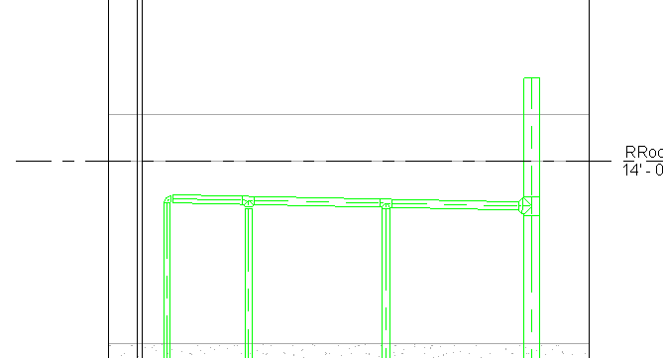
Now you do the Women’s Room Vent connections the same way.

Now we need to connect the Women’s vent to the main vent at the Men’s Room.
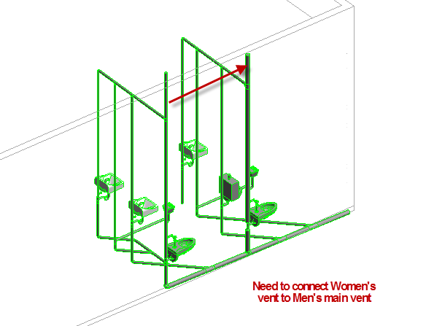
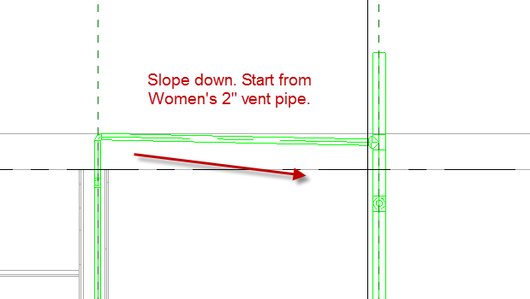

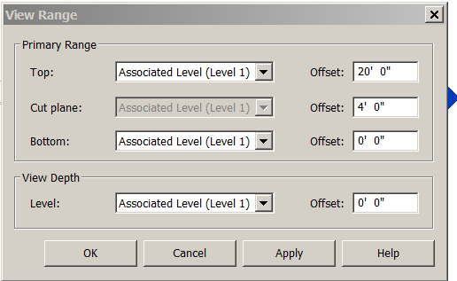

Now the below ground stuff is gone….and we can see the higher pipes.

Note slope….so water that may come into the pipe from the roof goes down to the sewer…not into the vent pipes…..We will slope the vent pipes in the wall toward the right….
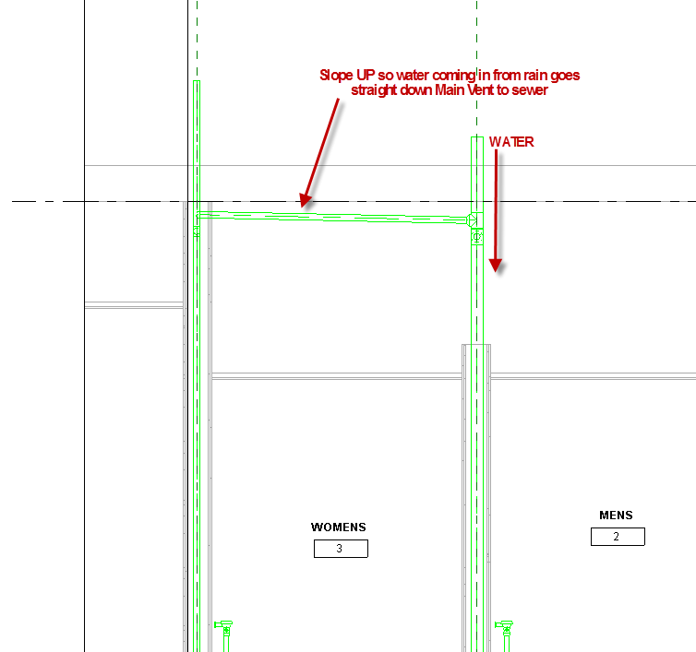
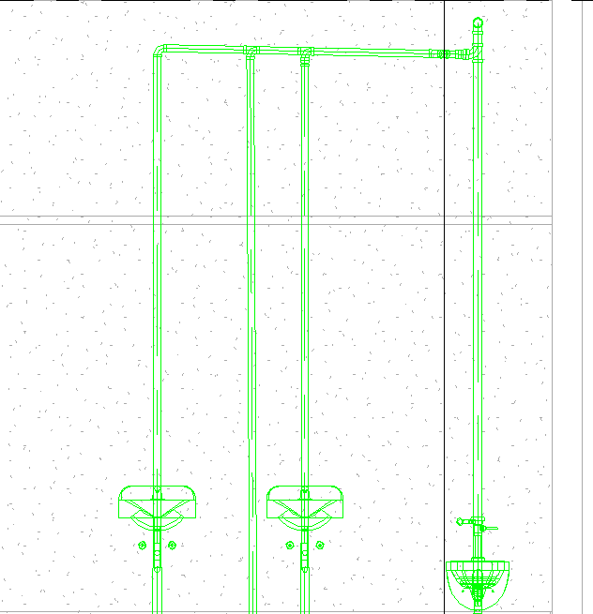
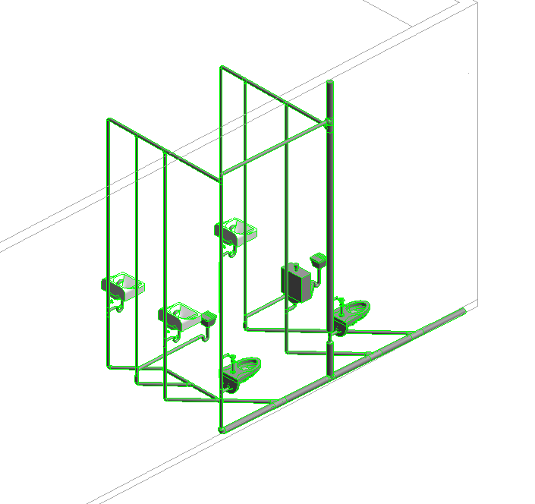
Completed Sanitary Waste Plan

Hot and Cold Water Piping
The water pipe is a lot easier than the Waste piping because there are NO sloping pipes! No working backwards!!
Before we start, we are going to put in the SHS Tankless Waterheater. See sketch….
Systems
Mechanical Equipment
SHS Tankless
Place on Vertical Face (place per sketch)
We will start by adding a 10’ high, 2-1/2” DIA main cold water line to feed the bathrooms. The water line would exit toward the back of the building.
Create a 2” Main cold water 5’0” Offset. Note I am putting it outside the wall for now…because of the toilet drain issue. We can move it into the wall (easily) later.
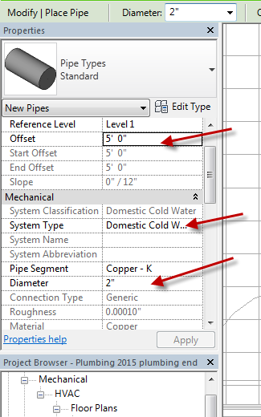
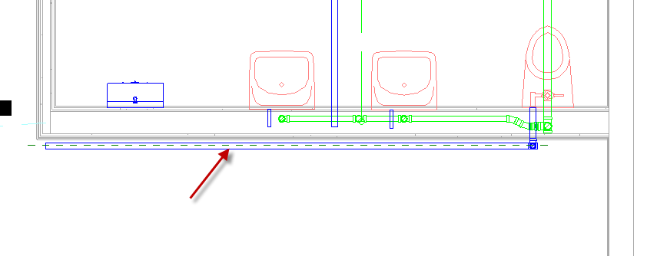

Connect the Toilet 1-1/2” to the 2” main
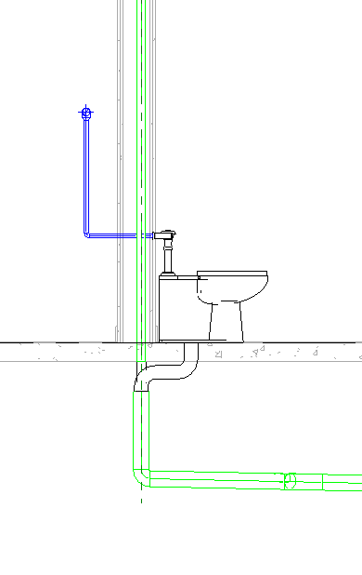

Connect the Urinal 3/4” to the 2” main
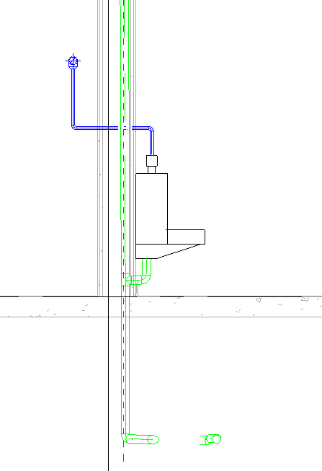

Connect the Sink 3/4"” to the 2” main
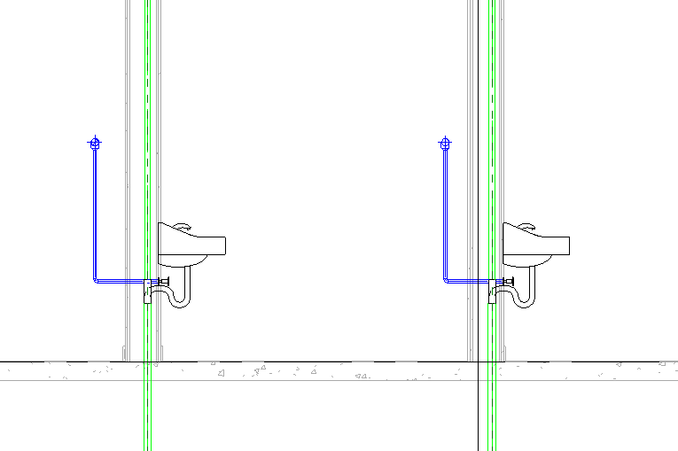
Connect the Tankless ½” to the 2” main. Watch out…it might need to be flipped! The (cold) water line comes in the bottom of the unit. Make sure you are connecting to the cold water IN (SHOW IN PLAN VIEW)
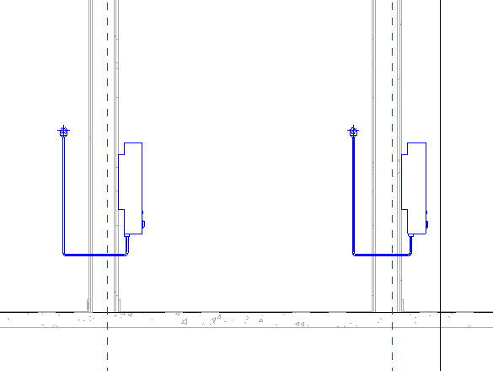

Pipe Size
This chart gives you an idea of how a MEP firm sizes their piping:
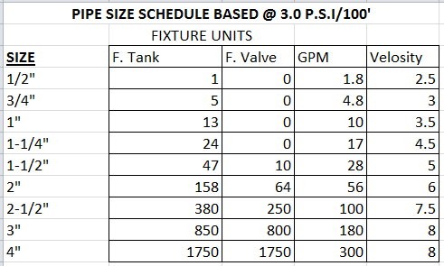
We need a 2” Main pipe because we have a toilet that requires 1-1/2” pipe all by itself…..what if someone flushes and someone is washing hands???
Hot water
We will now add hot water (manually). See sketch for plan.
It’s the same strategy we used for the cold water…..we just need to make sure we are not running into the cold water lines, vent pipes, or waste lines.
Plan View
Pick on tankless.
See ½” Hot Out …on right?
Place vertical section so you see hot, but not cold
Select Tankless….RC on +…..draw pipe
Connector 2 Domestic Hot…OK
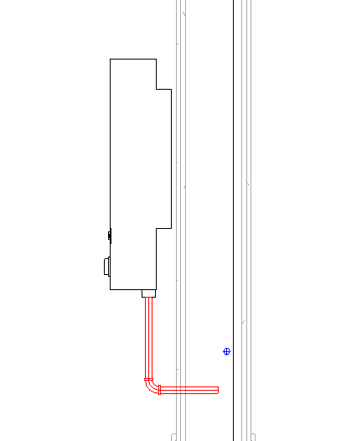
Plan View…See it? Red?
Notice I went lower as to not run into cold pipe. We can move these lines later….
Horiz section in front of tankless.
Pick on lav…see hot on right?
RC…draw pipe for each
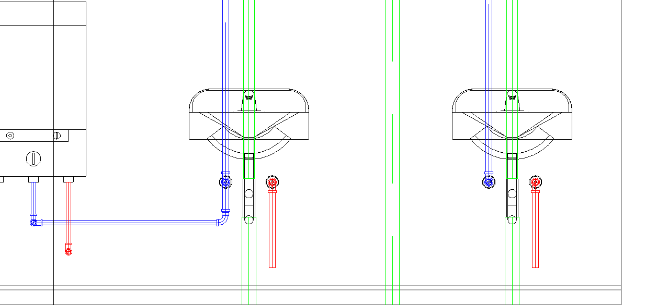
Plan View
Create a reference plane even with the cold pipe. This will allow us to align the hot pipe with your existing cold pipe.
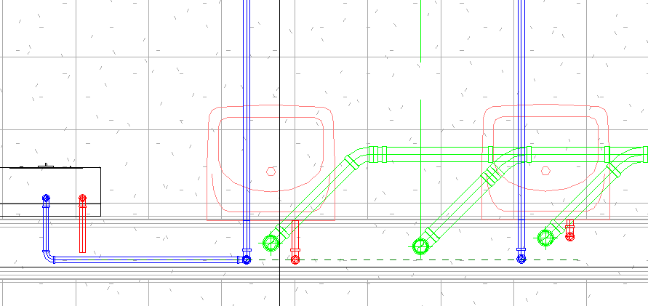
Vertical section in front of lav’s hot pipe. Drag to reference plane.
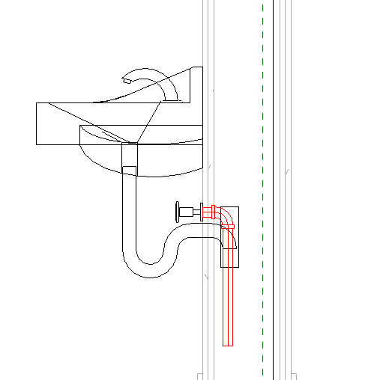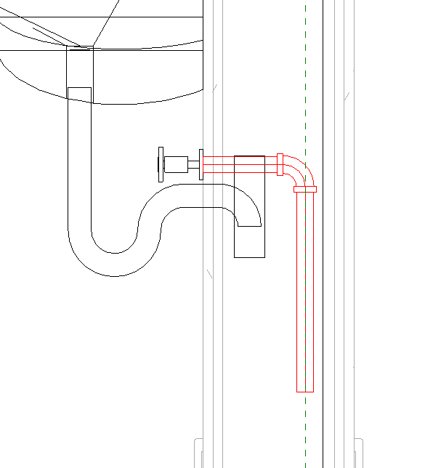
Front Section. Align and connect hot water line to tankless. It should look like this:
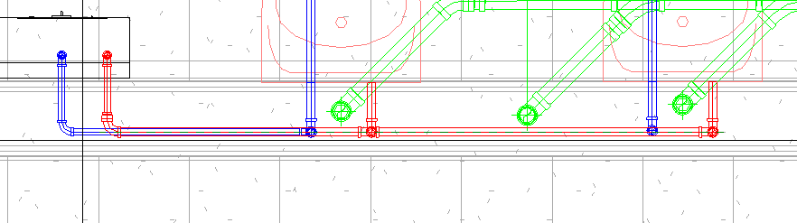
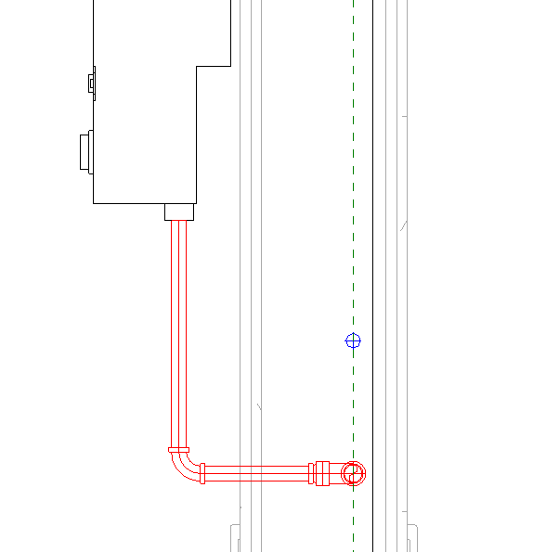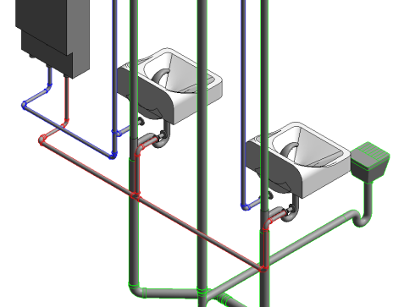
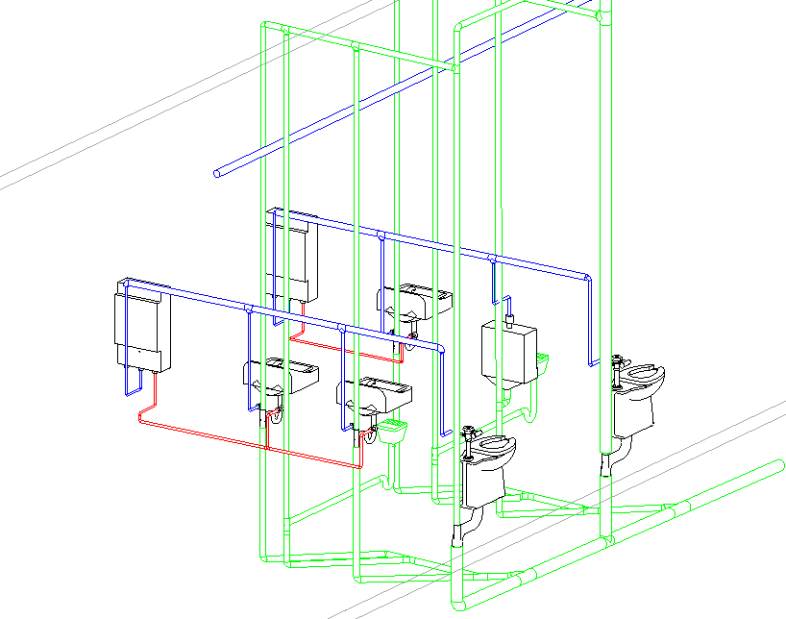

MEP Plumbing Assignment
Now you do the hot water in the Men’s Room and Connect the water lines to the main water line (at 10’)
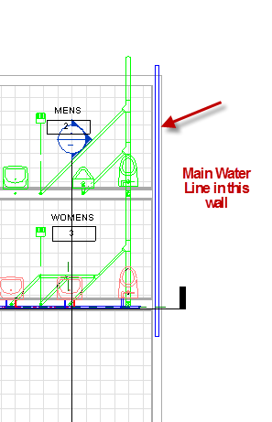
Save as: FirstlastPlumbingMEP.rvt

