Santiago High Architecture Design 2A/2B
Revit MEP 2017 Demo: Mechanical
Students will create a mechanical plan of the Retail Store. In order, we will:
Create the building in Revit Architecture.
Link our Revit Architecture model into Revit MEP
Place the Supply, Return and Exhaust Diffusers
Calculate the duct sizes
Draw the duct runs
Use EnergyPro to calculate our Heating and Cooling Loads
Find and place the proper Roof Top Air Conditioner
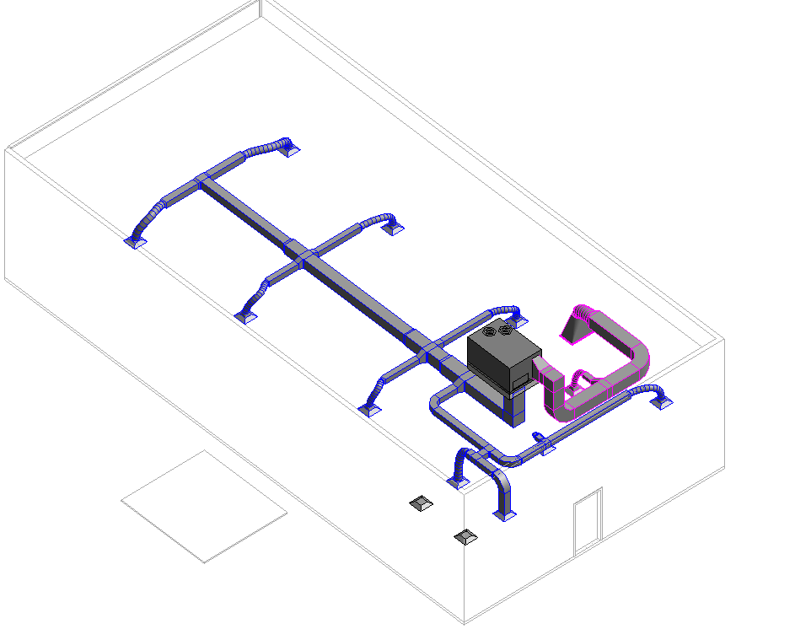
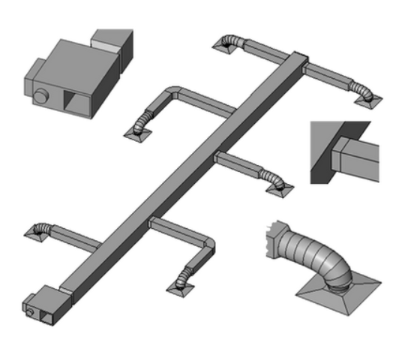
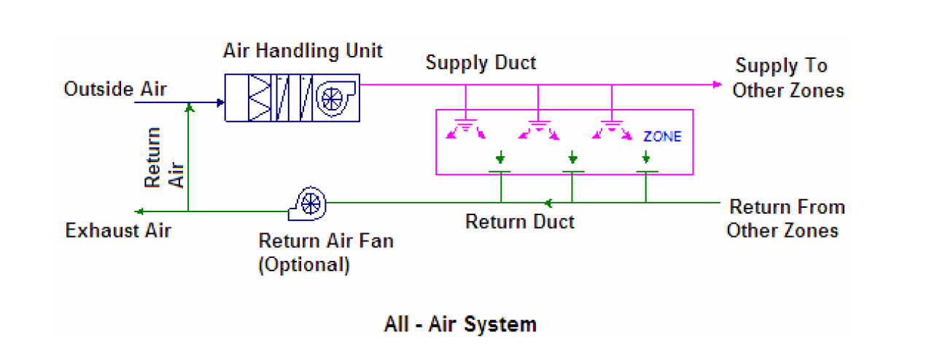
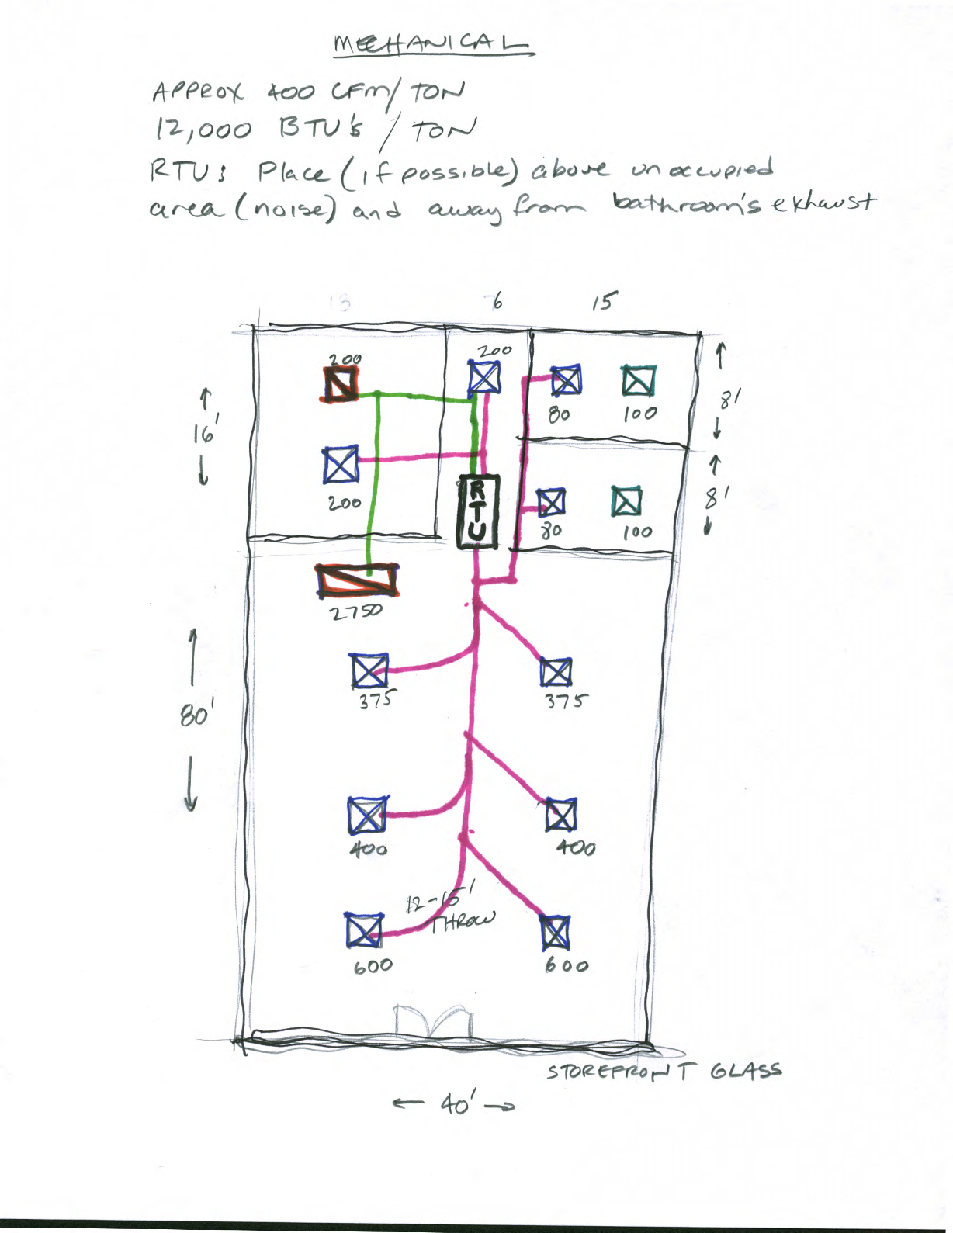
Create Building per Sketch in Revit Architecture
It should have walls, storefront, ceilings, doors, 3D Text sign, foundation, and tile flooring. No plumbing or electrical fixtures. We will do that in Revit MEP.
Some details:
Double Glass Curtain door
14’ Level 2 (name it Roof)
11’ 2X2 ACT Ceilings everywhere but Restroooms
9’ 2X2 ACT Ceilings in Restrooms
Ext walls will have a 4’ parapet, making them 18’ total
Make Roof a Generic 12 to start, at the Roof Level (14’)
5” Slab Foundation with footings
Put ¼” ceramic tile on the floor in all rooms. Offset ¼” to go on top of Foundation slab
Paint on walls. You will have to split some walls and “Split Face” some walls.
Place base molding
Save as: Revit Arch Building for MEP.rvt
Linking the Building into Revit MEP
Generally the architect designs the building, then hands it off to the Mechanical Engineer (you) to do the Mechanical, Electrical, and Plumbing plans. We will try to use that workflow….
Open Revit
Mechanical Template
File: Save as Store Mechanical 2017.rvt
In Floor Plan 1-Mech
Insert
Link Revit
Revit Arch Building for MEP.rvt …WAIT…don’t hit OK….see next step!
Position: Auto Origin to Origin…..Open (this is important)
The building should be there. Discuss Linked Files
Note the new Browser setup
Discuss layout by Discipline
Show Properties….Discipline…Mechanical….Plumbing, etc
Show subdiscipline….HVAC…..
Mechanical 1-Mech
VV
Note Lighting, Electrical equipment OFF, but Ducts, Air Terminals ON.
East Elevation Plumbing
VV
Note Pipe and plumbing fixtures ON, but Lighting, ducts, air terminals OFF
Get it??
Go to Elevation View. The linked building and the template need to have the Levels aligned.
Drag the levels away from each other.
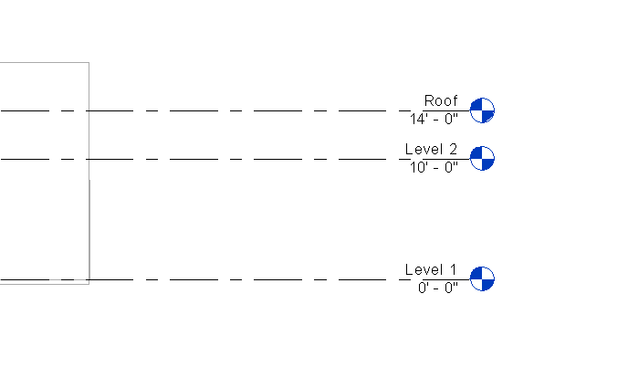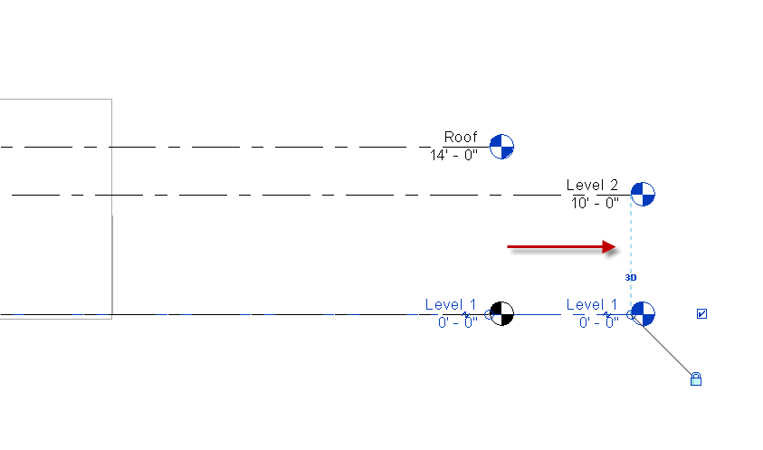
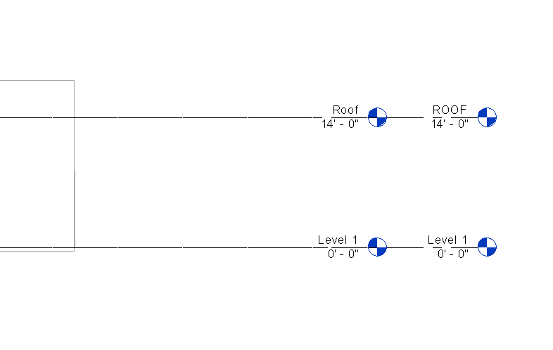
Note Level 1’s are OK
Rename Level 2 to ROOF and move it to the other “Roof” level using the Align command
Save as Store Mechanical 2017.rvt

Creating the Mechanical System: Leveraging EnergyPro data
Before we start throwing in Air Conditioners, ducts, supplies, returns, etc, we need to know what the building requires! We created an energy model in EnergyPro to give us load information of the Store.
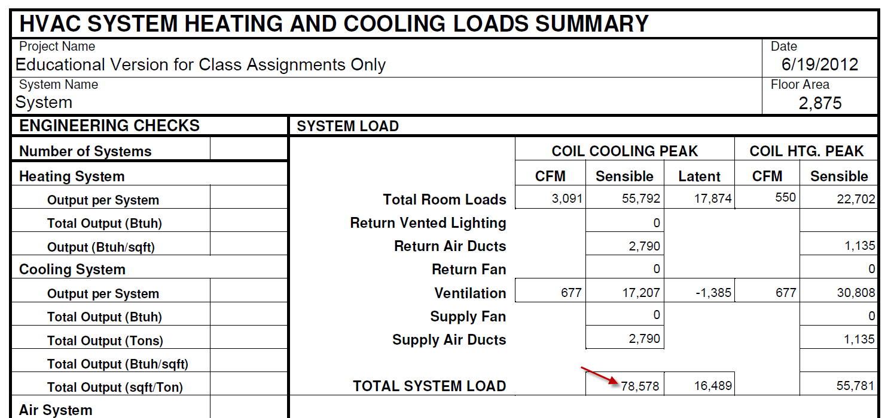
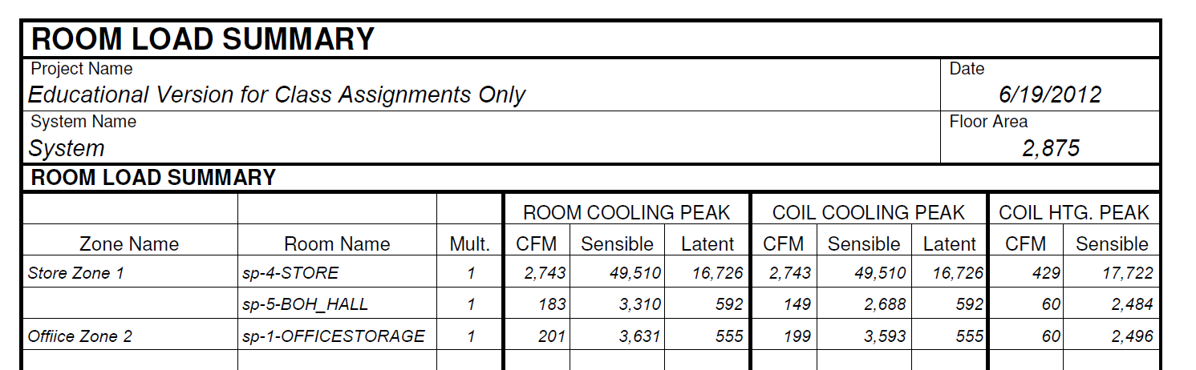
So we have a sensible load of 78,500 BTU. We know that sensible load is about 70% of the Actual Load…
So 78,500/.7=112,000 BTU 12,000BTU in a ton 112000/12000=9.3 tons
Now that does NOT mean we necessarily need a 9.3 ton unit…but that is a good size to start with when looking at cut sheets. We really need a unit that gives us 78,500 Sensible BTU’s. We could even use 2 units at about 9.3/2=4.65 tons….if needed….discuss advantages.

Carrier’s website for our Rooftop Unit
http://www.commercial.carrier.com/commercial/hvac/carrier/0,3068,CLI1_DIV12_ETI12668_MID4403,00.html
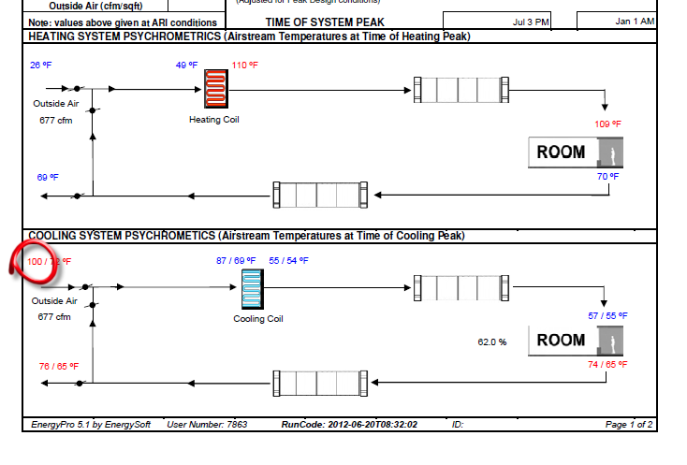
Ambient temperature from EnergyPro. We need this when we look at the cut sheet
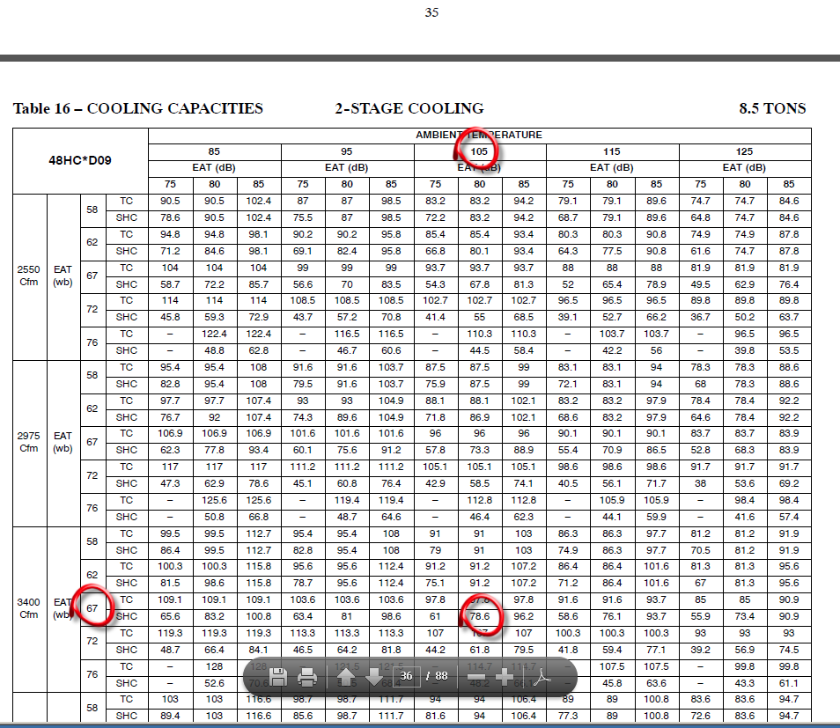
This is page 47 in the document…..
TC=Total Cooling
SHC= Sensible
EAT=Entering Air Temp
EAT (wb) = Entering Air Temp wet bulb
EAT (db) = Entering Air Temp dry bulb
The Ambient (dry bulb) temp is 100 (from EnergyPro report above)…..so we will use 105
The wet bulb will be 67.
Our Sensible load was 78,500……see the 78.6? Looks like a perfect match!
Looks like our first RTU option is the Carrier 48HC*D09 8.5 Ton Unit. The 9.3 ton was a ballpark number….this unit is pretty efficient……got us down to 8.5 tons.
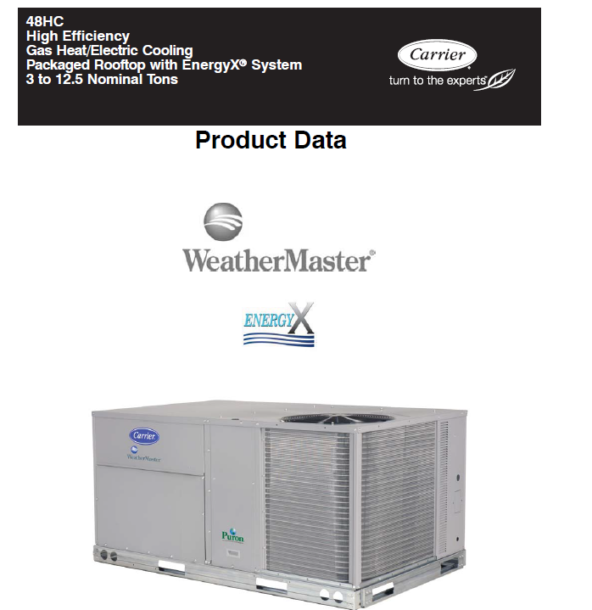
Revit file
Here is the site that has the Revit family:
http://www.commercial.carrier.com/commercial/hvac/general/0,3055,CLI1_DIV12_ETI13197,00.html

Before we place the family, we will set the Plan view so we can see it:
Floor plan Mech 1..Underlay: Roof
Underlay Orientation: Plan
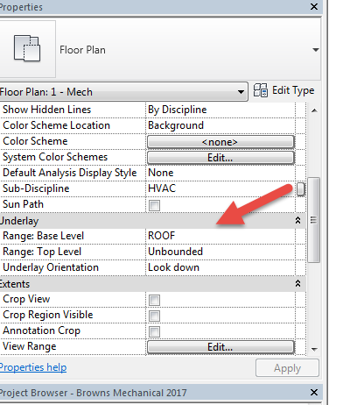

Load the family:
Systems…..Mech Equip….Load Family
X:/Labs/Brown/Readonly/ArchDesign 2A-2B 2014/MEP Families/
Carrier unit you downloaded
Level: Roof
Offset: 2’2” (there will be a platform it sits on) Roof 12”+ 14”Platform=26” (2’2”)
Place it per sketch.
Save as: STORE_MECHANICAL_2017.rvt
Create 2 sections as shown:
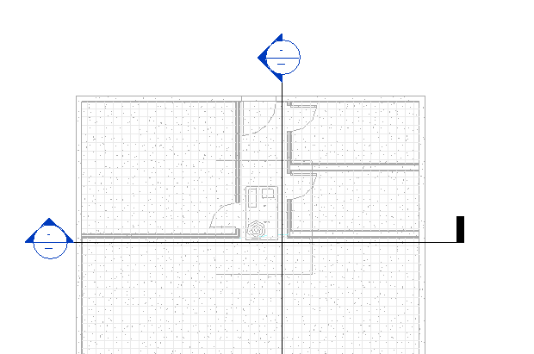
Display: Wireframe
Display: Fine (so we can see the complete objects)
Set Scale to ¼”=1’0”
In Vertical Section, pick RTU
Set Display to Fine. Turn off lineweights. HL
Set Scale to ¼”=1’0”
See Supply “OUT” w + sign

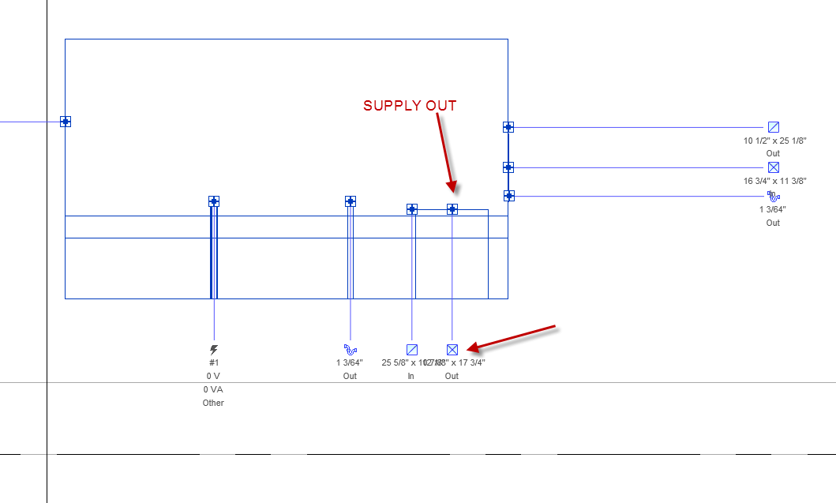
RC…Draw Duct
W: 20” H: 21” (we’ll discuss how we got this size in a bit…)
Draw the duct down, into the space between ceiling and roof
Make a left turn and head toward storefront (see sketch)
We’ll call that “Main Duct Run”
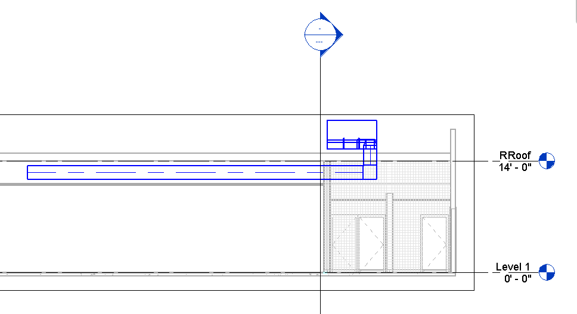
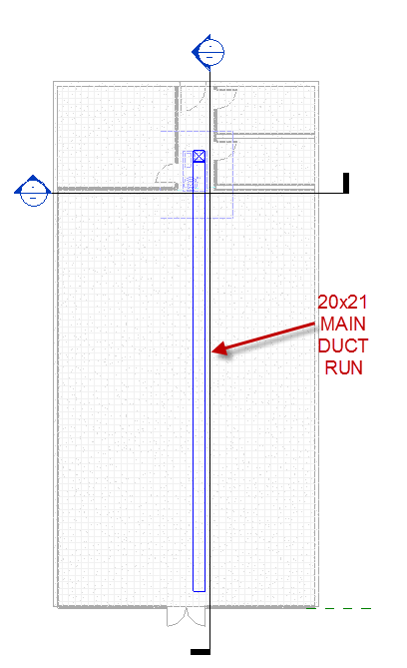
Adding Supply Air Terminals
Ceiling plan Mech Level 1
Systems
Air Terminals
Offset: 11’ (our ceiling height)
See sketch
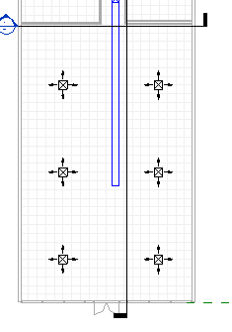
Place 6 supply air terminals in STORE
Should look like above….

We need 2743 CFM
2743/6=457…so in theory we would have six 457 CFM supply diffusers…..but no so fast…
We want more Supply Air toward the front of the STORE….where that glass storefront is. It will be hotter there than anywhere else in the store….. get it??

We will assign the closest 2 to the glass to be 600 CFM
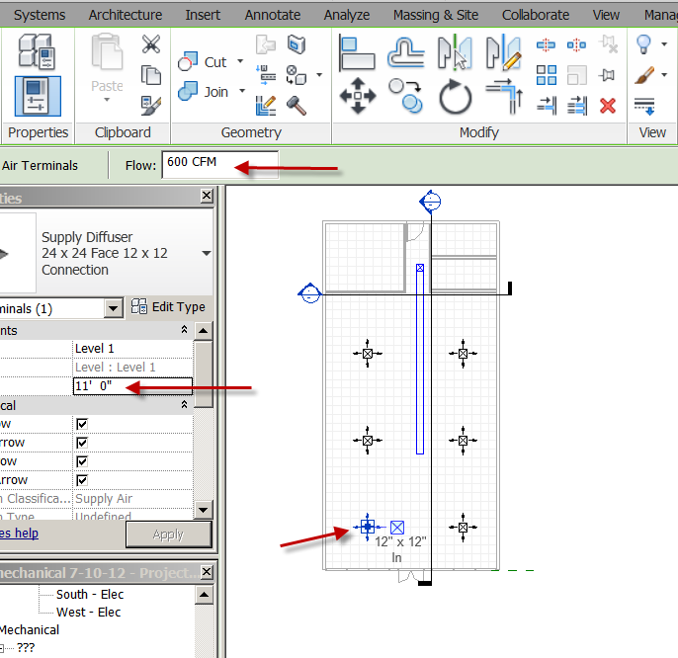
We will assign the middle 2 to the glass to be 400 CFM
We will assign the farthest 2 to the glass to be 375 CFM
That makes 1200+800+750=2750 CFM
BOH Hall required 183, so we will do 200 CFM
Office required 201, so we will do 200 CFM

Place the supply diffusers in the BOH, Office, and Restrooms per sketch and assign CFM
Note: The ceiling in the Restrooms are 9’0”. The Diffusers in there will offset 9’0”….not 11’.
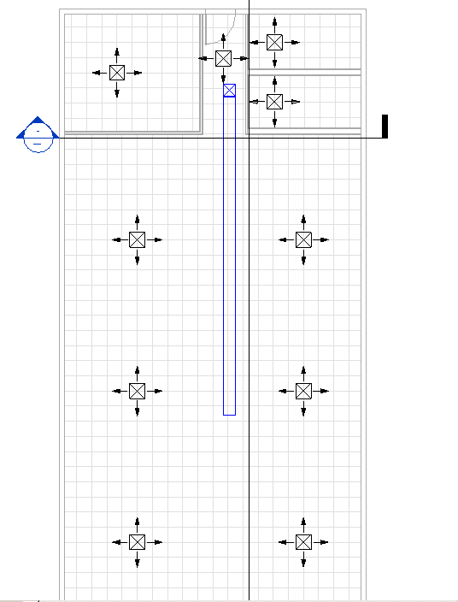
Setting up a “System”
Pick all 10 supply diffusers (you can “select all instances in view”)
Duct
Supply Air
Mech Supply Air 2
OK
Now pick on a Supply diffuser…TAB….see the “System”?

Adding Return Air Terminals
System
Air Terminal
Load Family
Mechanical…MEP…..Air Side Components….Air Terminals…
Get 2:
Return Grille Rect Hosted
Return Grille w/ Trim Ceiling Mounted
Open
Place Return Grille w/ Trim Ceiling Mounted 51X27 Face 48X24 Neck per sketch on ceiling near OFFICE/STORE wall
Place on Face
Set FLOW to 2750+200=2950 CFM
System
Air Terminal
Return Diffuser
24X24 Face 12X12 Conn
11’ Offset
Place in OFFICE….. Set CFM to 200

Adding Exhaust Air Terminals
Place Exhaust
System
Air Terminal
Exhaust Grille
24X24 Face 12X12 Conn
Offset: 9’0”
Place above toilets per sketch
Set them at 100 CFM
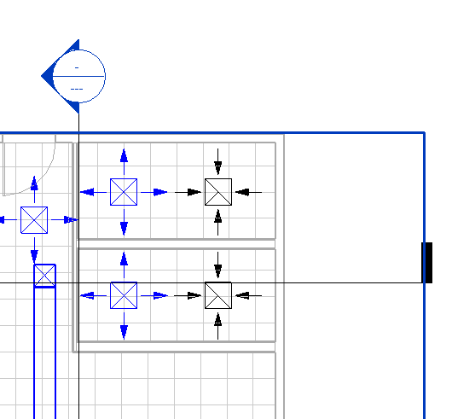

Since it has been decided to have Supply Air in the Restrooms….we have to do it right….
Important: Supply CFM must be LESS than Exhaust air (you want to suck out the poopy air). If supply air is greater, it would push the poopy air out into the BOH Hall….get it??
Let’s assign 80 CFM

Spaces
Let’s make the 5 “Spaces”
Analyse
Space
Place in rooms
Not working? Here’s why…
Pick Link
Edit Type
Check “Room Bounding”….OK
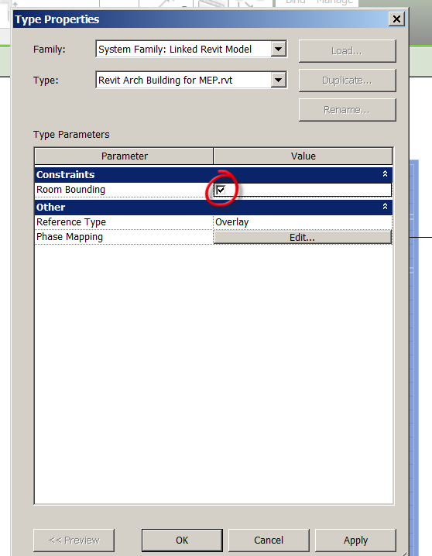
Now try…..good?
Name them: STORE, BOH HALL, OFFICE/STORAGE, MEN’S, WOMEN’S
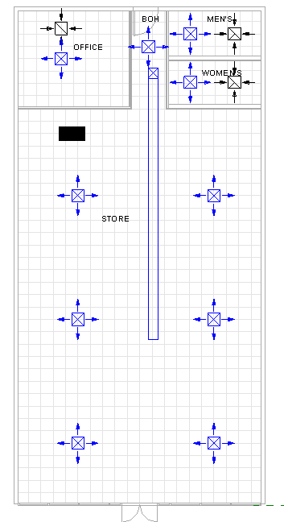
Save as: Store_Mechanical_2017.rvt

Duct Sizing
Ducts are sized by the air flow going through them (in CFM).
There are 2 ways to easily find the size of your ducts.
Ductulator
The first is a “Ductulator”. It is a hand-held rotating calculator that allows you to dial in your information and get a result.
Let’s try it!
Our air flow coming out of the RTU will be about 3150 CFM.
Friction loss will be .08/100ft of duct (that’s what Design West Engineering uses…)
Match the .08 with the 3150 CFM (the light blue area)
The result:
Looks like about 22.5 diameter duct (see black area)
Looks like about 22X20 rectangular (see green area). Note: the more square the better..but sometimes duct has to be more rectangular to fit in tight spaces)
Looks like velocity is about 1100 FPM
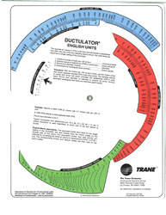
Duct Sizing Software
The second way is McQuay Ductsizing Software (it’s a free download)
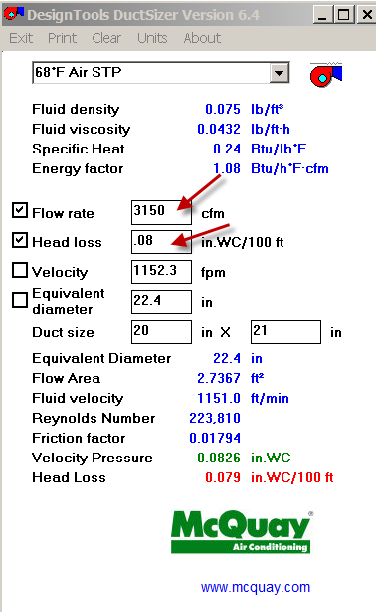
Enter 3150 for Flow Rate
Enter .08 for heat loss
Note 22.4 for diameter comes up automatically!
Now enter 20 for one of the duct sizes….see 21 in automatically?
See 1151 FPM for velocity (a little more exact)
Different tools, same result!
You will use one/both of these tools to calculate how big your duct needs to be to meet the needs of the diffusers.
Duct Shapes
Note: Round duct is more efficient than rectangular duct.
Note: Bends in duct decrease efficiency
Note: You want larger CFM toward end of circuit
Round Duct is the most efficient and economical means of conveying air. When you cannot use round duct because ceiling space is limited or interference from other obstructions, use flat oval duct, which is nearly as efficient.
Round and oval duct have lower initial installed costs than rectangular duct. Their shape results in lower pressure drops, thereby requiring less fan horsepower to move the air and, consequently, smaller equipment. The shape also has less surface area and requires less insulation when externally wrapped. Spiral round and oval duct is available in longer lengths than rectangular duct, thereby eliminating costly field joints. Spiral lock-seams add rigidity; therefore spiral duct can be fabricated using lighter gauges than longitudinal seam duct.
Operating costs are also lower. The smaller surface areas of round and oval allow less heat loss or gain and are therefore more energy efficient. Also, seams and joints are more tightly sealed resulting in less leakage and wasted energy.
The acoustic performance of round and oval duct is superior because their curved surfaces allow less breakout noise.
These ducts not only perform better, they also look better. Many architects and designers are using the aesthetically pleasing shapes of round and oval as unique and integral elements in their designs.
Finally, round and oval duct can help promote healthier indoor environments. Less surface area, no corners and better airflow reduce the chance of dirt and grime accumulating inside the duct and becoming a breeding ground for bacterial growth.
We will start with rectangular duct…then swap out for round duct later…..

Return Air
1-Mech
Pick RTU
See Return Out?
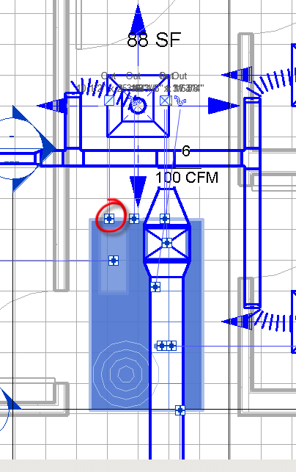

Go to the right side section
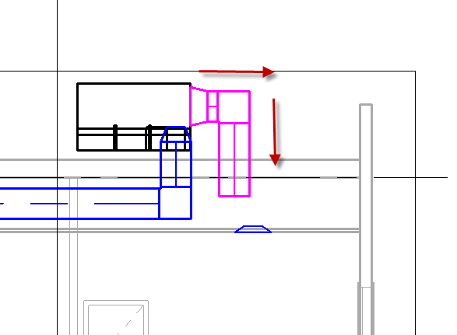
RC on the + sign
Draw Duct as shown…getting it into the proper space.
Our duct is going to 2950 CFM (total from Store and Office)
Make it: W=20” H=20”
Create a section to look at the back of the RTU…and see the end of the duct….
Set Display to Fine
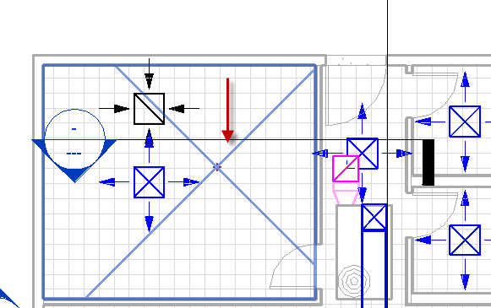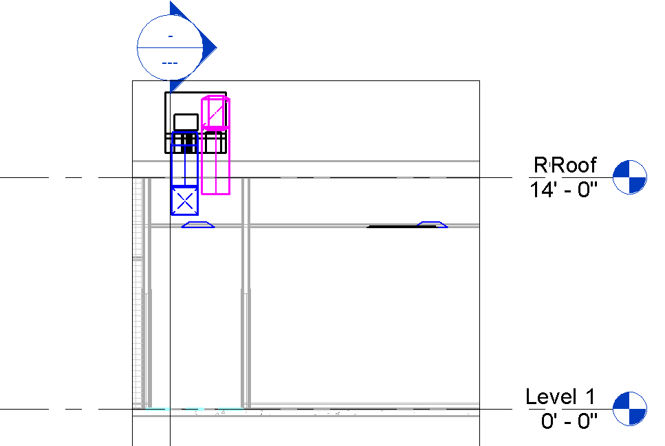
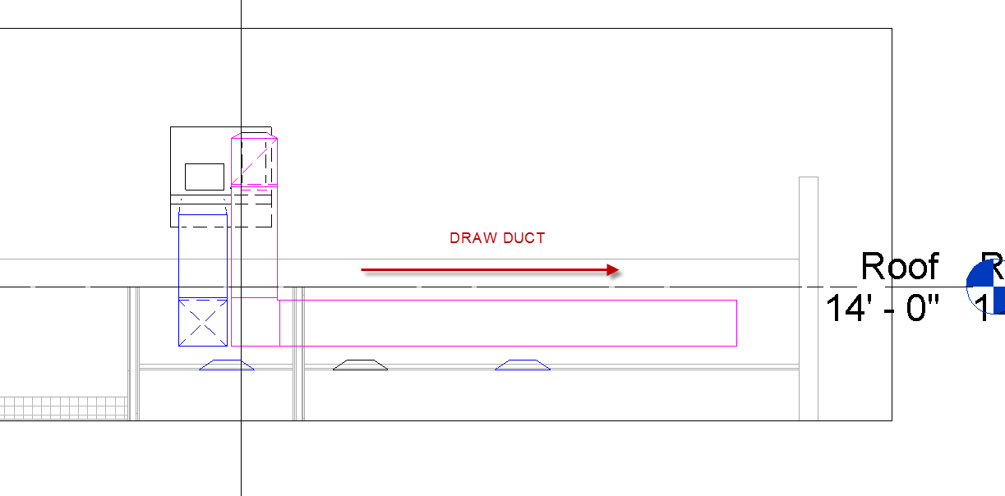

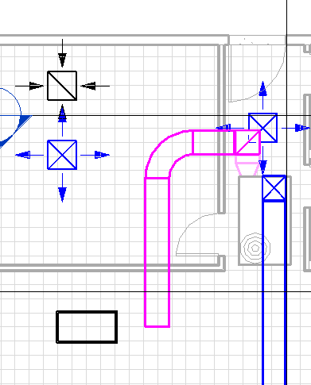
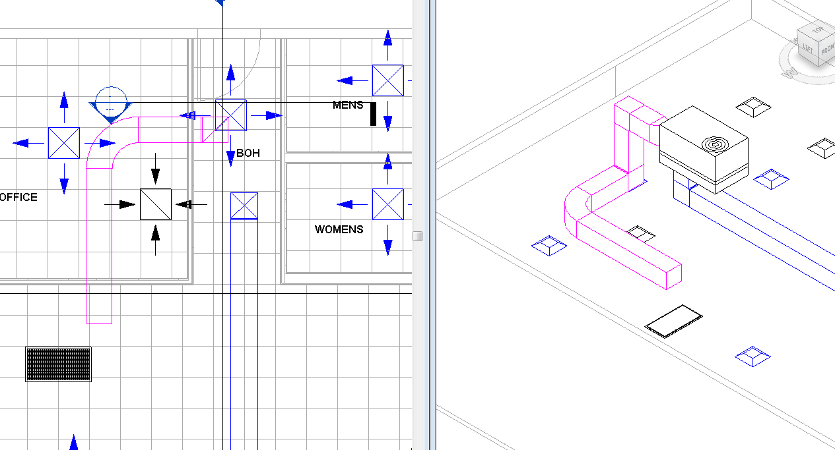
You will need to use Flex Duct to attach to the big Return Diffuser
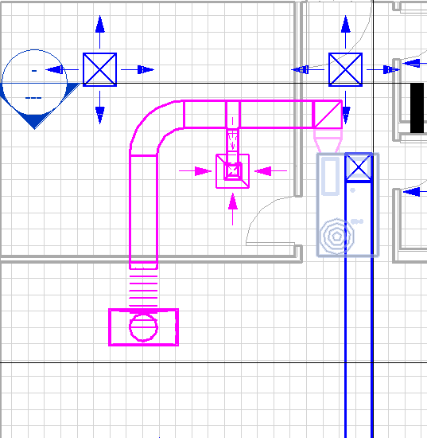
We need to continue the duct to the 200 CFM Return in the Office. We need a connector on that L turn…Rect Elbow 1.5W
Select Rectangular Duct Fitting…create similiar
8”X7” (Start at the 200 Return Diffuser and work toward the 20x20 duct.
See in 3D!
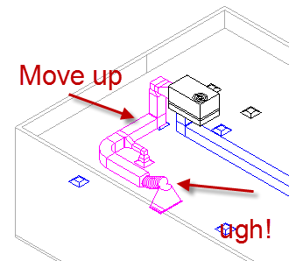
The problem is that our Return Grill is just too big at 51X27 to allow the transition to happen. Let’s change it to a 27X27 Grille…get rid of the Flex Duct…and just drag the 20X20 duct over the Return Diffuser.
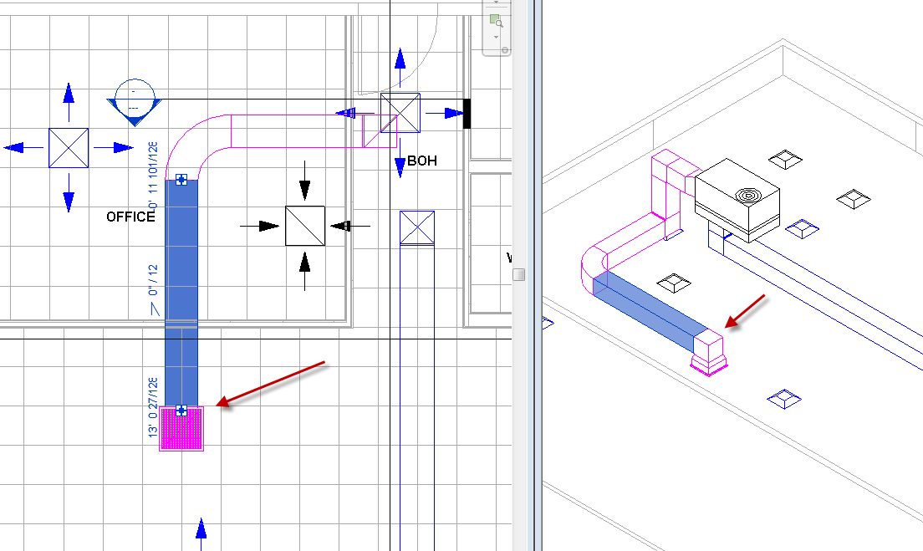
Supply Duct
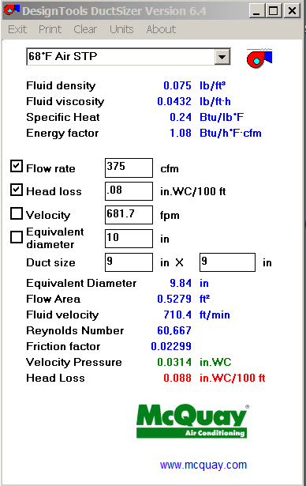
So we will use 9X9 rect duct…with Flex Duct connecting the Return Diffuser
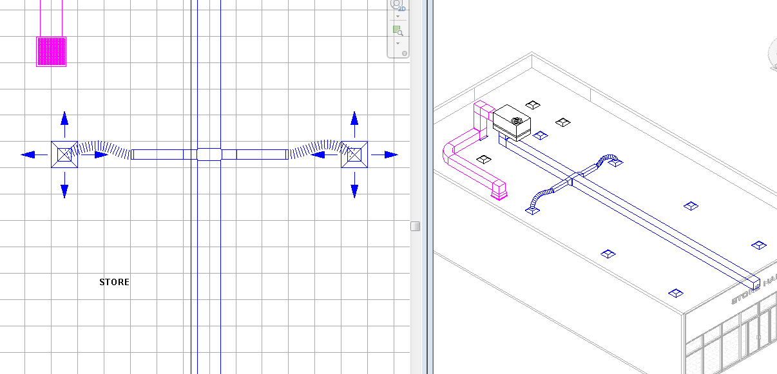
Continue per sketch….
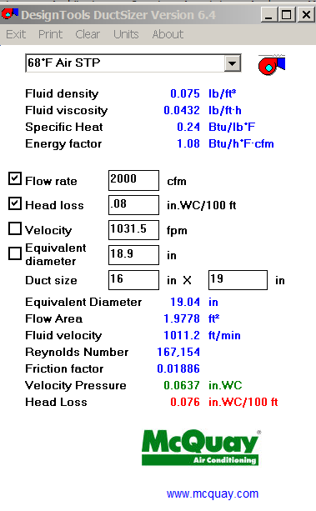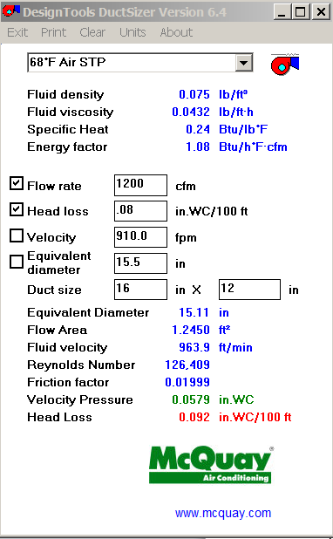
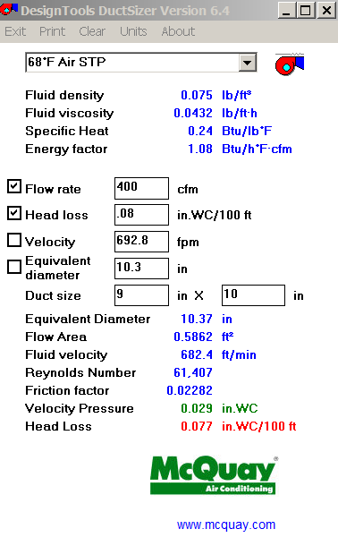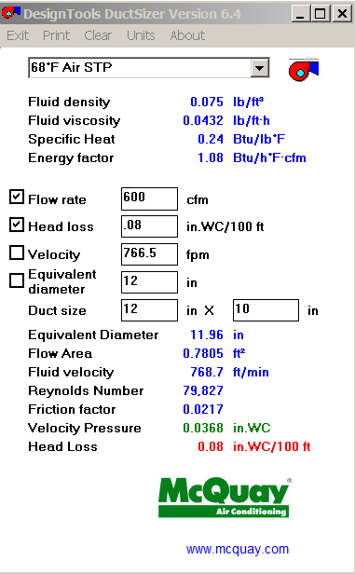

The system will look as follows:
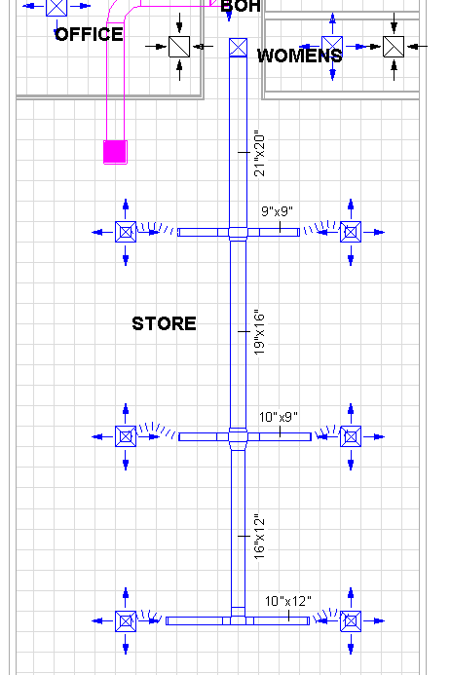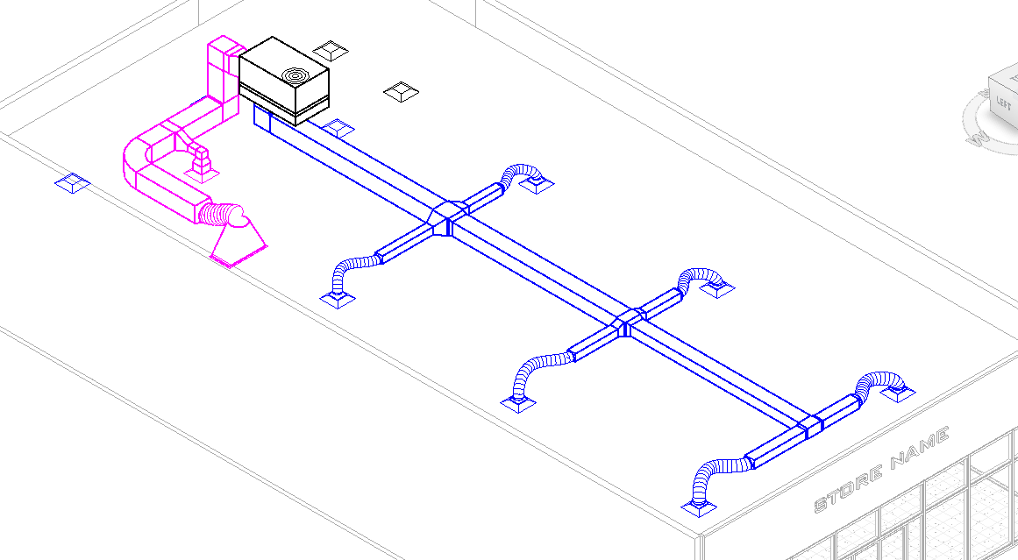

Now for the Bathrooms, BOH, and Office…. 200+200+80+80=560 to start.
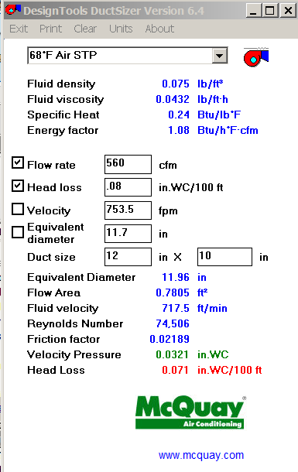
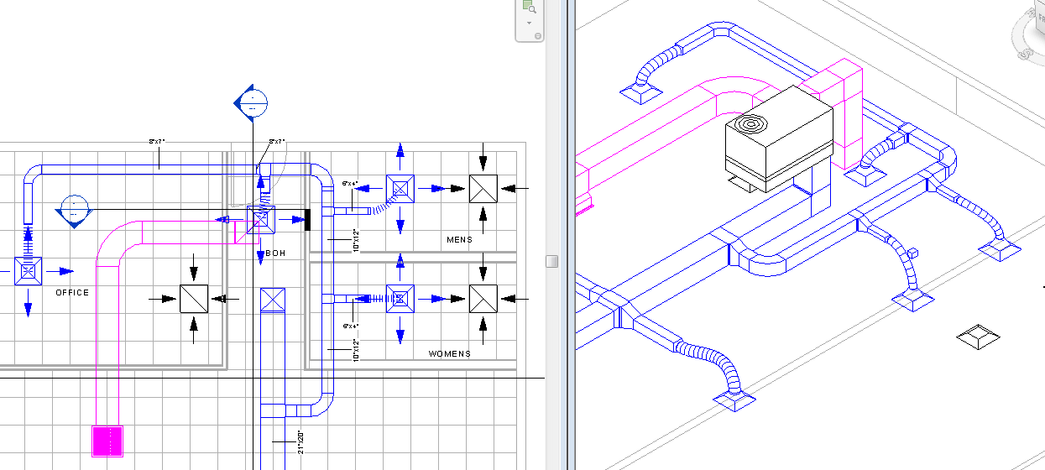

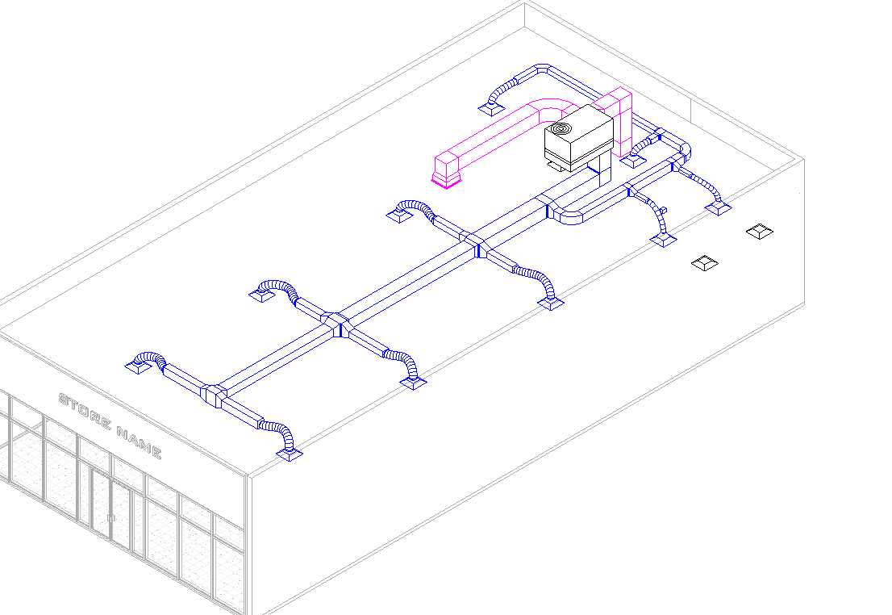

REVISION!
The mechanical engineer has called for a change in your design. See sketch.
The building will have linear supply diffusers at the storefront glass to more effectively cool the glass Storefront area.
The mechanical engineer is calling for a return diffuser near the Storefront to take the hot air out before it reaches the inner part of the store.
The client does not want to pay for AC in the bathroom. The bathroom door will be “undercut” and the air will be drawn into the bathroom from the BOH area as the Exhaust fan is turned on. The Exhaust fan will be on an Occupancy Sensor, controlled when the (occupancy controlled) light goes on.
The mechanical engineer is calling for 2 RTU Units. This will cost less, allow for smaller duct sizes (less BTU’s means smaller ducts), and make rooftop installation easier with smaller units (lighter on roof, smaller footprint).
So you will have a RTU @4.5 tons controlling the Storefront area and a 4 ton RTU controlling the back Store area, Office, and BOH. The 8.5 tons split up……
Find 2 RTU’s that meet the requirements of the building.
Replace the 8.5 Ton RTU with the 4 Ton Unit you found
Add the 4.5 Ton Unit near the front, per sketch.
Layout supply diffusers per sketch
Create proper duct design to connect the Supply diffusers
Create proper duct design to connect the Return diffusers
Watch out for collisions with Lighting and other ductwork!
Save as FirstLastMechrevision.rvt
