Norco College ARE25
Santiago High Arch Design 2A/2B
Revit MEP 2017 Demo: Electrical
Students will create an electrical plan of the Retail Store. In order, we will:
Create the building in Revit Architecture.
Use EnergyPro to calculate Lighting needs for spaces
Link our Revit Architecture model into Revit MEP
Place the Lighting Fixtures
Place the switches and outlet
Create Lighting and Power Circuits
Create a Panel Schedule
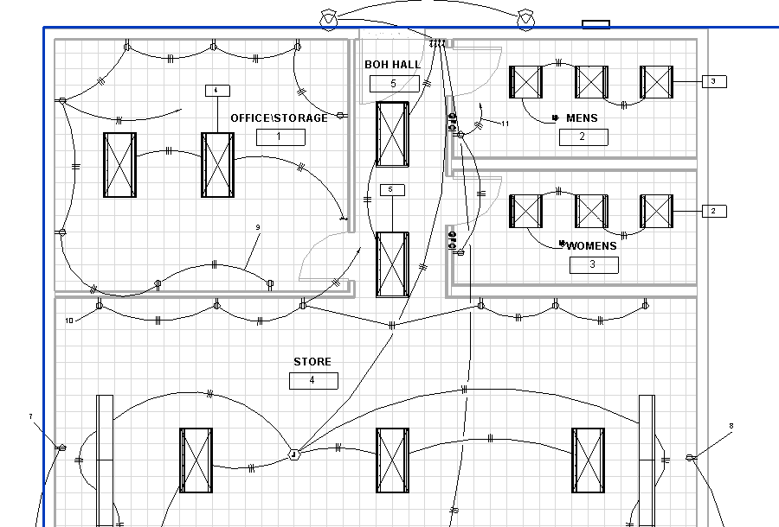
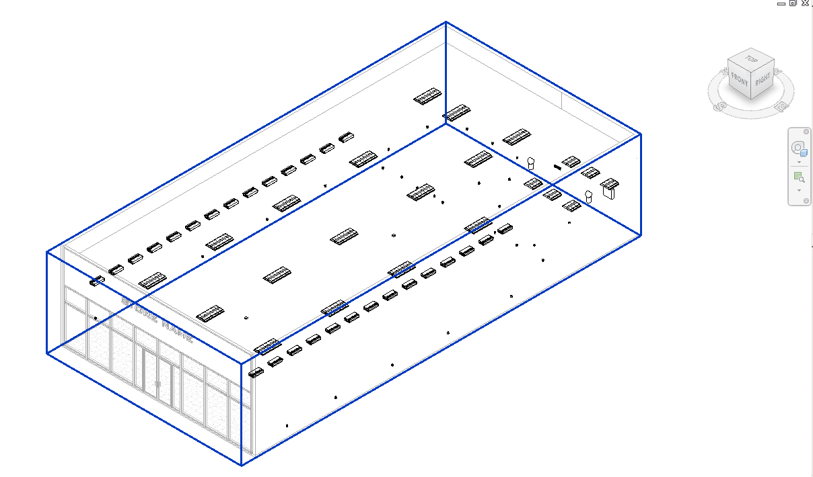
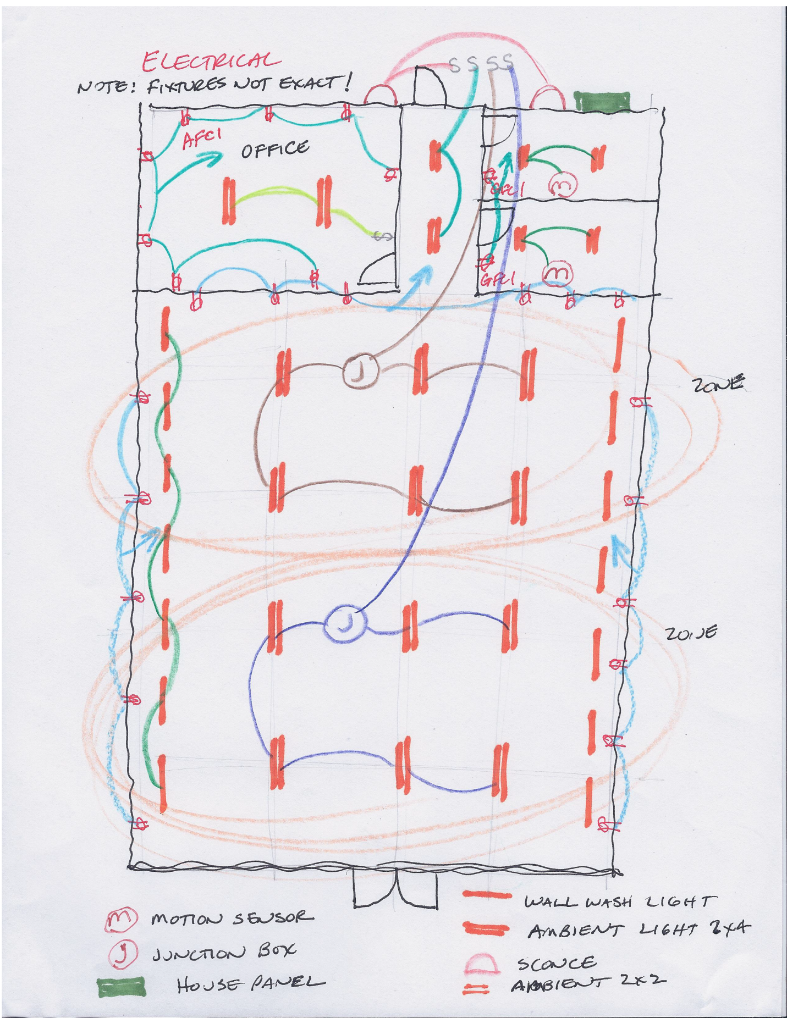
Create Building per Sketch in Revit Architecture
It should have walls, storefront, ceilings, doors, 3D Text sign, foundation, and tile flooring. No plumbing or electrical fixtures. We will do that in Revit MEP.
Some details:
Double Glass Curtain door
14’ Level 2 (name it Roof)
11’ 2X2 ACT Ceilings everywhere but Restroooms
9’ 2X2 ACT Ceilings in Restrooms
Ext walls will have a 4’ parapet, making them 18’ total
Make Roof a Generic 12 to start, at the Roof Level (14’)
5” Slab Foundation with footings
Put ¼” ceramic tile on the floor in all rooms. Offset ¼” to go on top of Foundation slab
Paint on walls. You will have to split some walls and “Split Face” some walls.
Place base molding
Save as: Revit Arch Building for MEP.rvt
Linking the Building into Revit MEP
Generally the architect designs the building, then hands it off to the Mechanical Engineer (you) to do the Mechanical, Electrical, and Plumbing plans. We will try to use that workflow….
Open Revit
New….Browse….Electrical Default….Open..OK
File: Save as Store Electrical 2017.rvt
In Floor Plan 1-Lighting view
Insert
Link Revit
Revit Arch Building for MEP 2017.rvt (note: see next line before OK!)
Position: Auto Origin to Origin…..Open
The building should be there. Discuss Linked Files
Note the new Browser setup
Discuss layout by Discipline
Show Properties….Discipline…Electrical….Plumbing, etc
Show subdiscipline….Lighting…..
Lighting Floor Plan Level 1
VV
Note Lighting, Electrical equipment ON, but Ducts, Air Terminals OFF.
East Elevation Lighting
VV
Note Pipe and plumbing fixtures, ducts, air terminals are OFF but Lighting and Electrical Fixtures are ON.
Get it??
Go to Elevation View. The linked building and the template need to have the Levels aligned.
Drag the levels away from each other.
Note Level 1’s are OK
Rename Level 2 to Roof and move it to the other “Roof” level using the Align command
Save as Store Electrical 2017.rvt

Creating the Electrical System: Leveraging EnergyPro data
Before we start throwing in Lights, Panels, etc. we need to know what the building requires! We created an energy model in EnergyPro to give us load information of the Store.
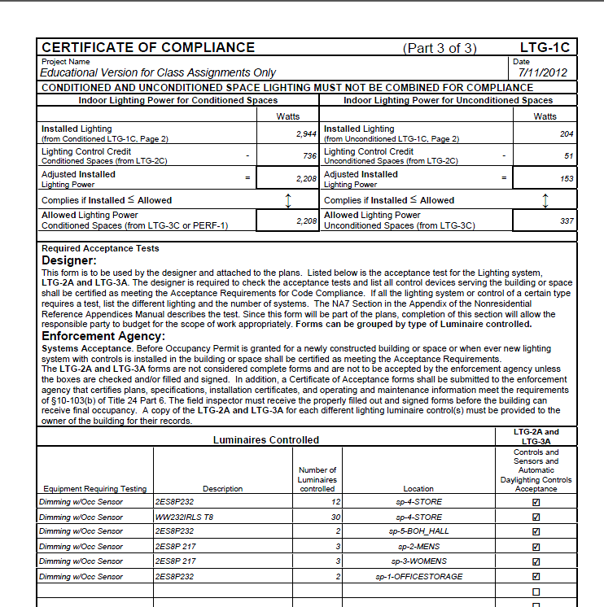
We are specifying the Lithonia 2ES8P 232 T8, WW232IRLS T8, and the 2ES8P 217 T8 Lighting Fixtures
Lighting Ceiling Plan 1-Ceiling Elec
Systems
Lighting Fixture
Load Family
X:\labs\brown\readonly\Arch Design 2A-2B MEP\Revit MEP Families
2ES8P-2X4
Open
Place on Face (not Ceiling Based)
From EnergyPro data (see above)
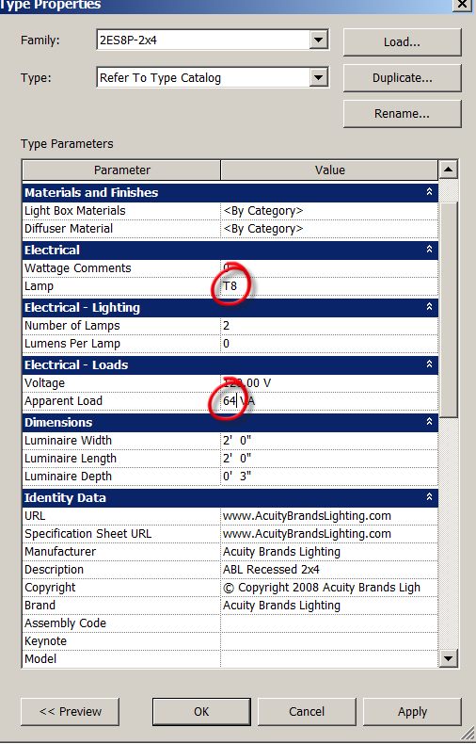
Set Lamp to T8 and Apparent Load to 64VA (that’s 64W). OK

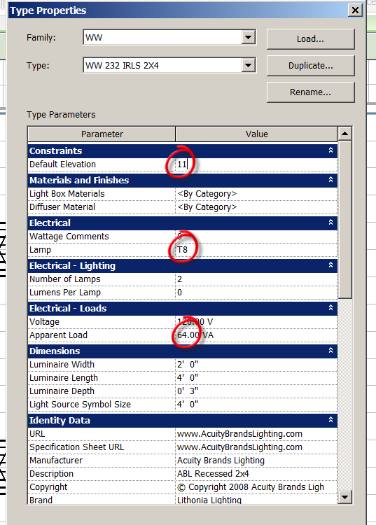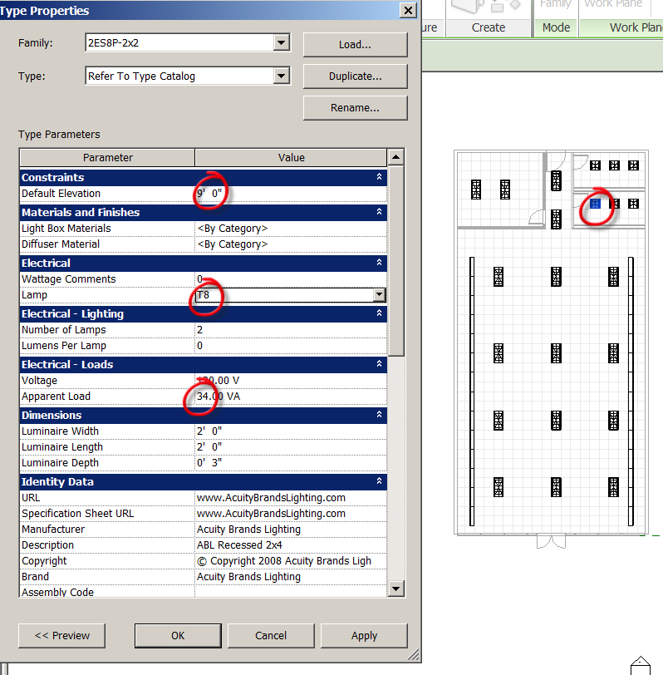
We need:
12 2ES8P 232 T8 lights in the STORE

Load the “Wall Wash” lights
Systems
Lighting Fixture
Load Family
X:\labs\brown\readonly\Arch Design 2A-2B MEP\Revit MEP Families
WW
Open
Place on Face (not Ceiling Based)

30 WW 232IRLS T8 lights along the East and West walls of Store (3’ away). 15 each side.
Now the 2X2 lights for the bathrooms:
Systems
Lighting Fixture
Load Family
X:\labs\brown\readonly\Arch Design 2A-2B MEP\Revit MEP Families
2ES8P-2X2
Open
Place on Face (not Ceiling Based)

2 lights in the Hall
2 lights in the Office
3 lights in the Men’s
3 Lights in the Women’s
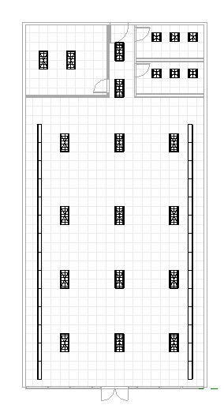
Save as: Store Electrical 2017.rvt

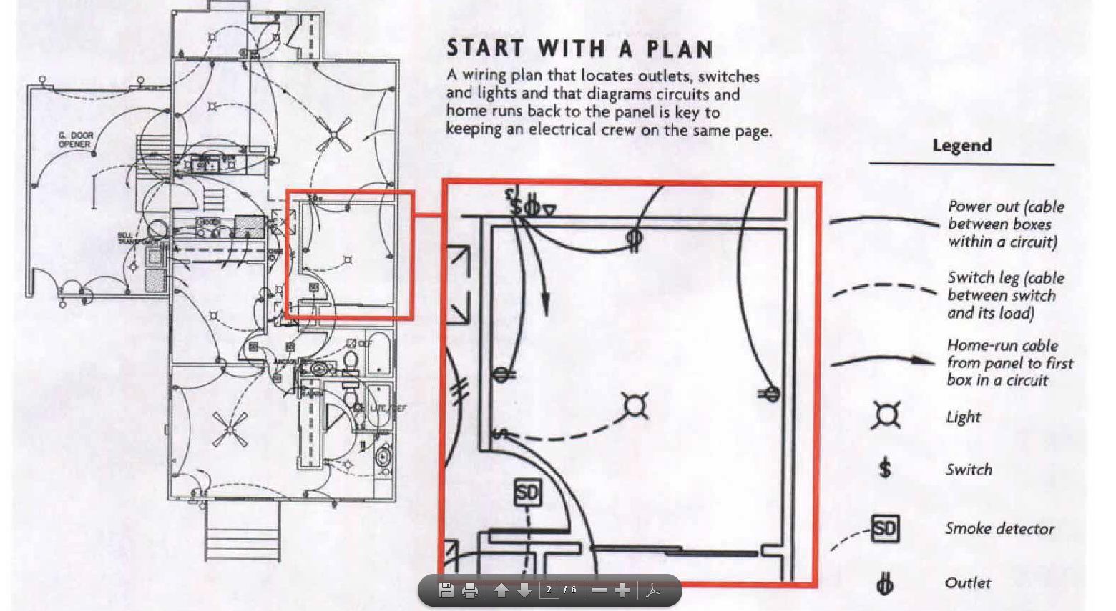
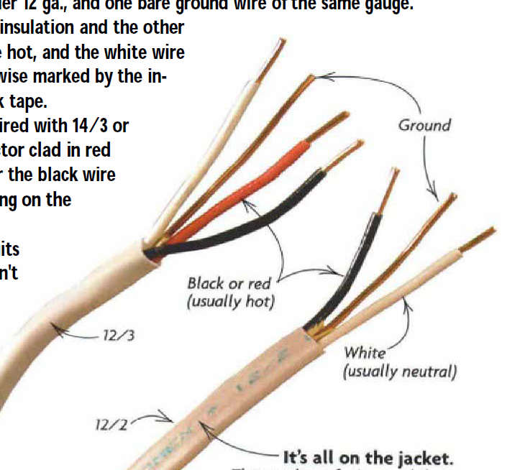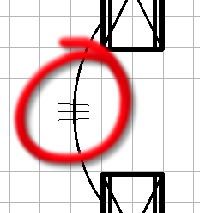

Placing Electrical Fixtures
Outlets
Power…Floor Plan….1-Power
Note that lights are ON in this view. No “trick” electrical plans!
Systems
Device
Electrical Fixture
Duplex Receptacle (Electrical…..MEP….Electrical Power….Terminals (should be pre- loaded)
Place per sketch
Place on Vertical Face…use spacebar to flip
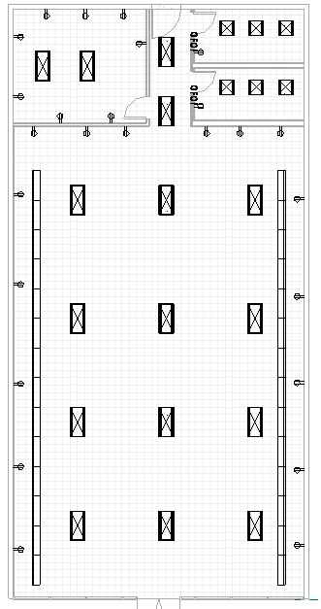

Switches
Systems
Device
Lighting
Lighting Switch Single Pole
Set scale to ¼”=1’0” to make viewing easier
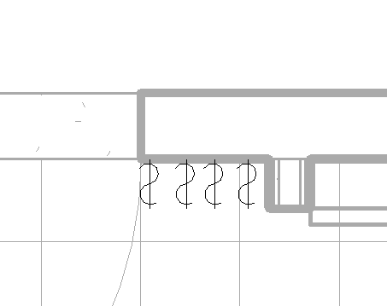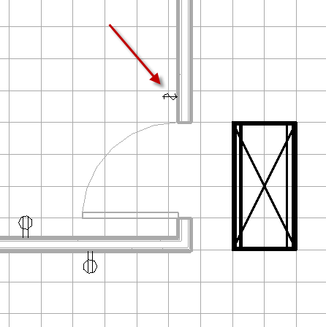

Outside Lights
Systems……Lighting Fixtures…….Load
Lighting
MEP
External
Spot Light – Ext
Offset: 6’0”
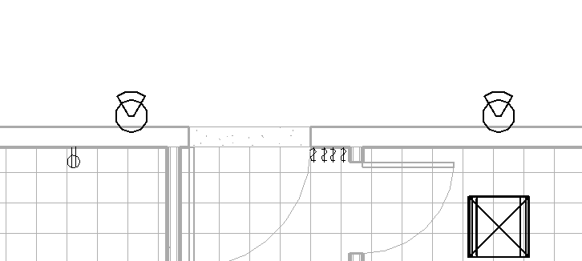
Wires
Lighting….Ceiling Plan….1-Ceiling Elect
You may want to turn off the Ceiling Pattern to allow easier snapping of wires
Systems
Wire
Arc Wire (Spline is OK too)
The connectors look like circle OSNAPS in the middle of the light fixture. The wires must connect to the lights, or your circuit will not work!
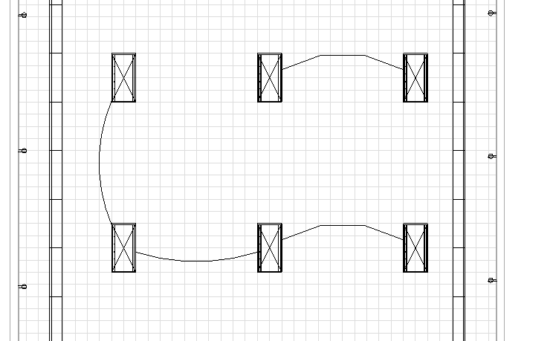
Now we need a Junction box….
Junction box
Systems
Device
Electrical Fixture
Load Family
Electrical
MEP
Electrical Power
Distribution
Junction boxes Load
Offset 12’ which put the Junction box between the ceiling and roof
Place per sketch
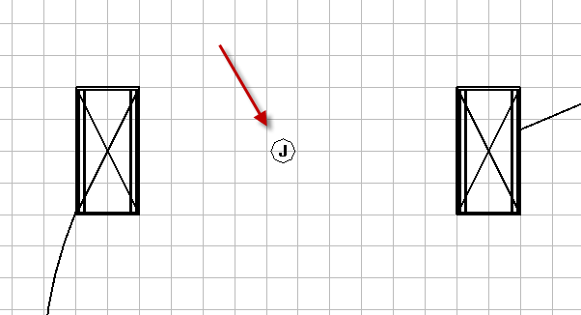
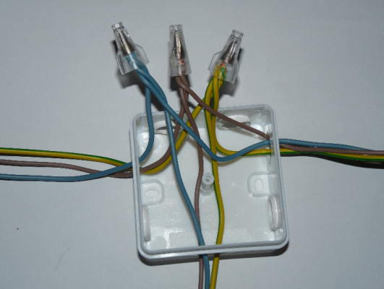 A “Junction Box” looks like this.
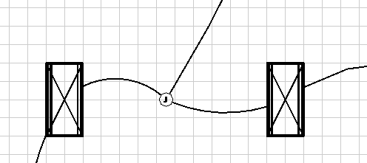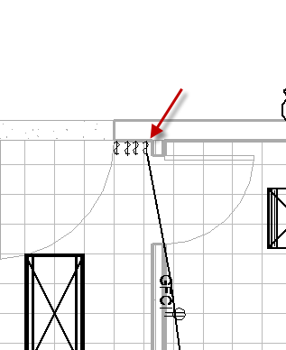
Connect the Junction Box to the switch. Note the switch has a connector toward the back …on the wall side…of the switch. They must “connect”. It’s like a circle with an X thru it OSNAP. The wire will jump to a different spot on the fixture….that’s OK, it’s connected!

Continue making the circuits per sketch.
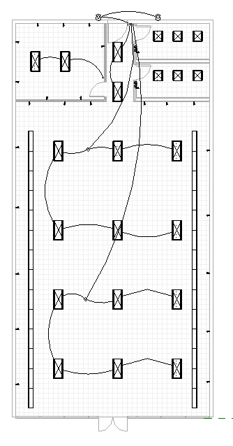
We have motion sensors controlling the bathroom lights.
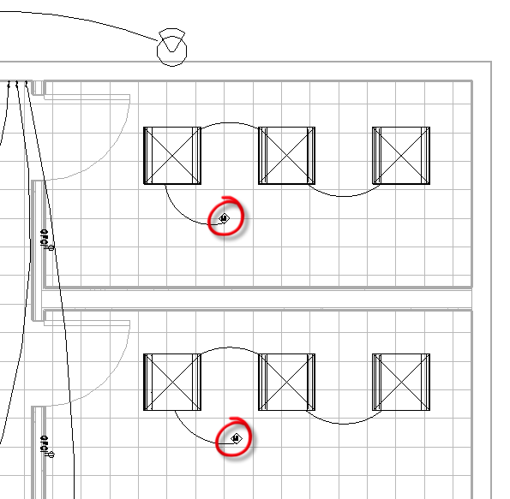
Occupancy Sensors
Systems
Device
Lighting
Load Family
Electrical
MEP
Info and communication
Building Controls
Ceiling Occupancy sensor Low Voltage
Place on Face

There are several ways this wiring diagram could go. You could put the wall wash lights on their own circuit. You could put the 12 store lights on their own circuit. On my diagram, I am splitting the circuits into front of store zone and back of store zone. What is the best strategy???
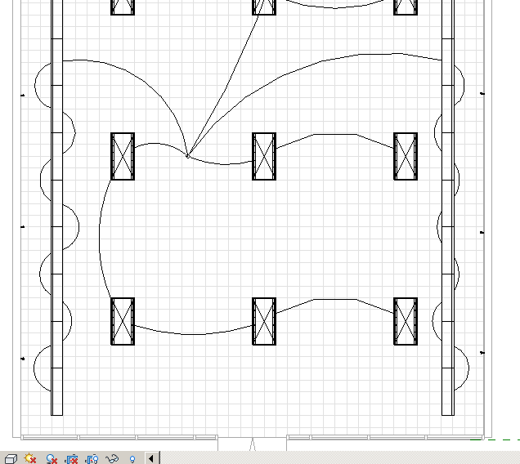
THIS DRAWING IS WRONG…..outlets NOT to junction box
The lights are wired up. May look something like this:
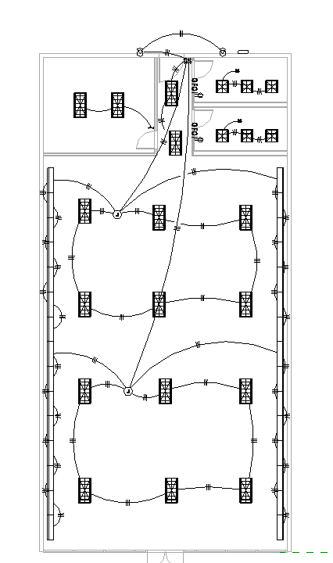
Hint: Use the tab key to see if the lights are connected! Select one light….hit TAB. See the blue?

Outlets
The outlets need to be connected with wires too. See sketch. See the arrow. That is the “Home Run”. The Home Run is the line from first point of the circuit that goes back to the circuit panel/breaker box.
Read more: http://www.doityourself.com/forum/electrical-ac-dc/247908-home-run-wiring-means-what.html#ixzz38DIZaAhI
Note the Office needs to be on its own circuit because the client wants AFCI protection. (BTW, In California, Dedicated AFCI circuits are required in residential bedrooms).
Note the restroom need GFCI protection by code.
Once the outlets are connected with wires, you will need to create circuits:
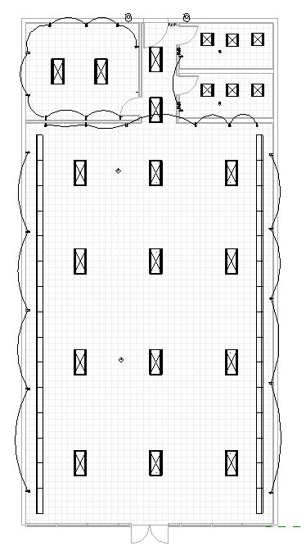

Creating an Outlet Circuit
Pick Outlet
Power
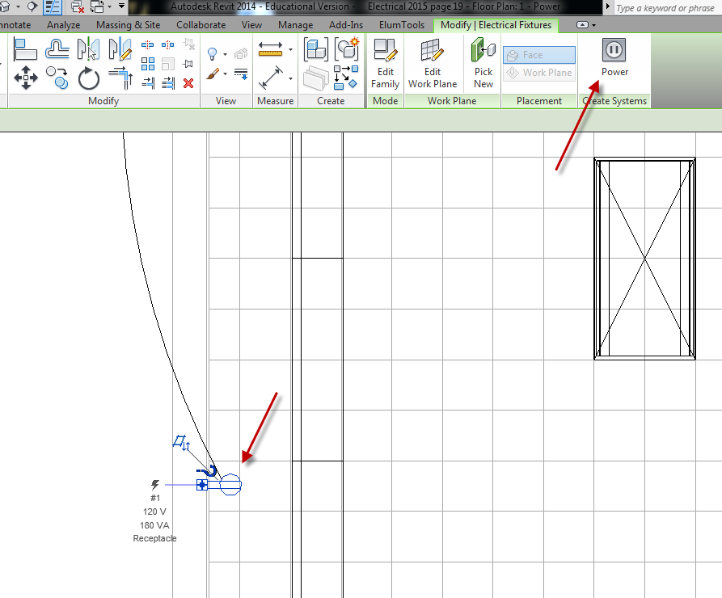
Edit Circuit
+ Add to Circuit
Pick the outlets you want on the circuit.
Ignore the warning box.
When all are black, check Finish Editing Circuit
Do that with each outlet circuit….
Creating a Lighting Circuit
Pick front lights (use filter)
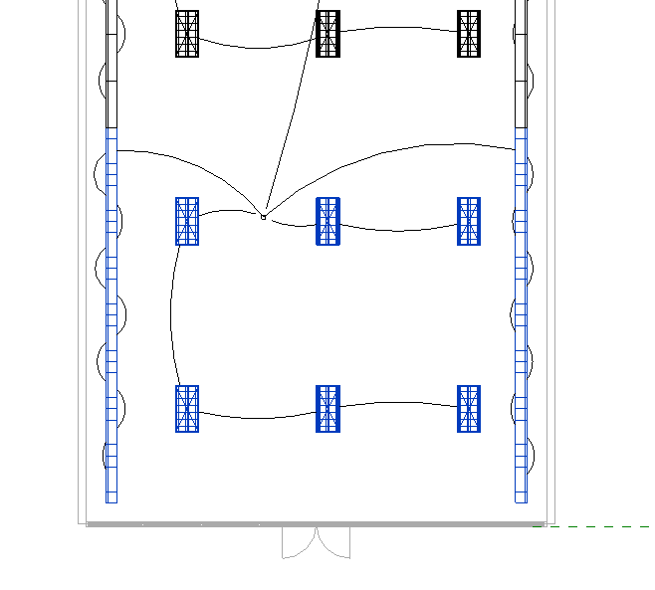
Power
Edit Circuit
Add junction box and switch
Finish Editing Circuit

Pick rear lights (use filter)
Power
Edit Circuit
Add junction box and switch
Finish Editing Circuit
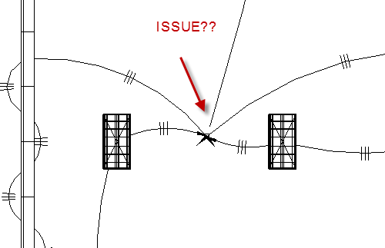
Pull wires off junction box, then re-attach to get rid of home run arrows.
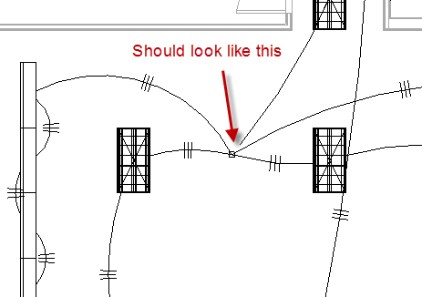
Location of Electrical Components:
Switches and Outlets
Systems
Device
Electrical
MEP
Electrical Power
Terminals
Duplex, Light Switches, Weather Proof Receptacles

Thermostats and Sensors
Systems
Device
Lighting
Load Family
Electrical
MEP
Info and communication
Building Controls

Telephone and data
Systems
Device
Lighting
Load Family
Electrical
MEP
Info and communication
Communication
Data Junction box
Telephone junction box
Data outlets
Ethernet
Telephone outlet
Speakers
Security, smoke, fire alarms
Systems
Device
Lighting
Load Family
Electrical
MEP
Info and communication
Fire Alarm
Fire Alarms
Smoke detectors
Security
Alarm

Adding a Breaker Box/Circuit Panel
Systems
Electrical Equipment
Load Family
Electrical
MEP
Electrical Power
Distribution
Lighting and Appliance Panelboard 208V MLO
Choose the 100A type
Place on back wall

Assigning a “Distribution System”
Pick on Panelboard
Distribution System: 120/208 WYE (in Option bar)

Assigning a Circuit to the Panel
Pick on light in front right of Store
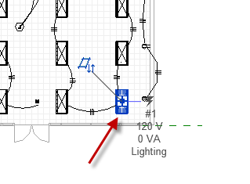

Electrical Circuits
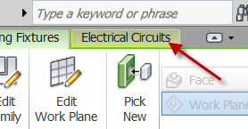
Select Panel
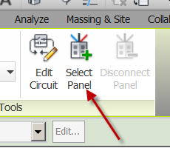
Select Panel: 100A, 120V/208V Three Phase, 4 Wires, WYE (in option bar)
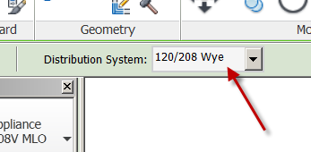
Done!

Let’s do another….
Pick a light on the next circuit
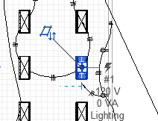
Electrical Circuits
Select Panel: 100A, 120V/208V Three Phase, 4 Wires, WYE (in option bar)
Done!

Tagging the Circuits
(not what I mean….)
Annotate……Tag by category
Pick circuit
See the tag? You should have 6 circuits.
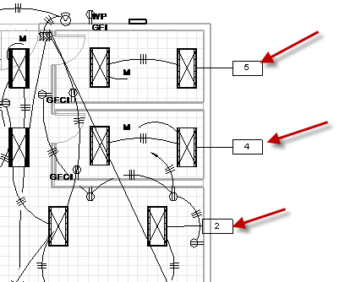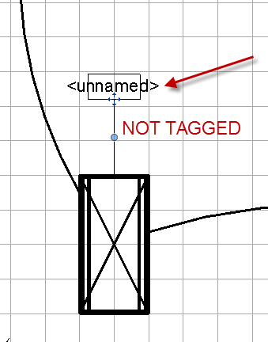

Assigning Outlets Circuits
It’s the same process as the lights!
Floor Plan 1-Power
Pick Outlet
Electrical Circuits
Select Panel
Select Panel: 100A, 120V/208V Three Phase, 4 Wires, WYE (in option bar)
Continue this for all the outlet circuits….
Now tag them.
Annotate……Tag by category
Pick outlet circuit
See the tag? You should have about 11 circuits.
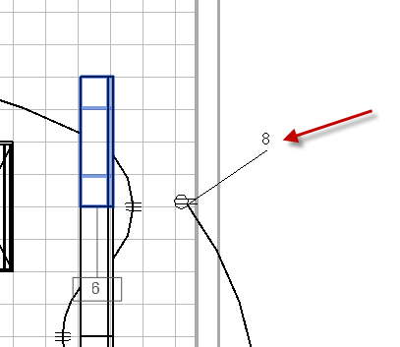
Panel Schedule
Now we will create a basic Electrical panel Schedule
Analyze
Panel Schedules
We only have one….
OK
There it is!
Note: See it in Project Browser
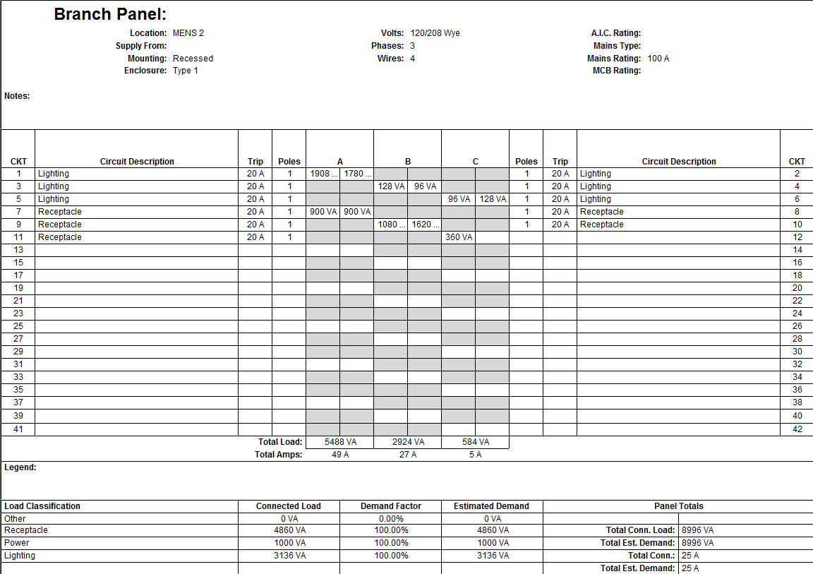

Add Space Tags
Save as FirstLast Store Electrical 2014.rvt

