Bluebeam Demo
Here is the Bluebeam University video referenced:
http://support.bluebeam.com/video-archives/#getting-started-with-revu-webinar
Interface
Command Bar
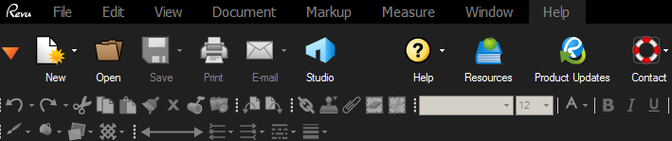
Show Markup Tools
Blue knob-panels (3) left, right, bottom button
Profiles
Profiles allow us to customize the interface
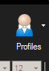 Man with the Bowtie
View….man w/bowtie icon…..construction
See options?
More than one way to get tools:
Tools are at the top in the Command bar….to the right in toolbars….and you can use keyboard shortcuts
Make a Custom Profile:
View….pick man w/bowtie icon….Manage Profiles dialog box….Add….name it: Browns Profile 1…OK….OK
View …..toolbar….see checks?
Show customize. Customize bar comes up.
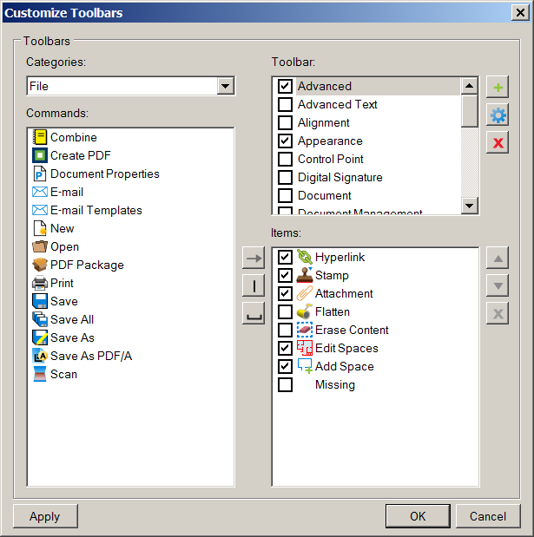
Pick toolbar…..show items (commands) checked
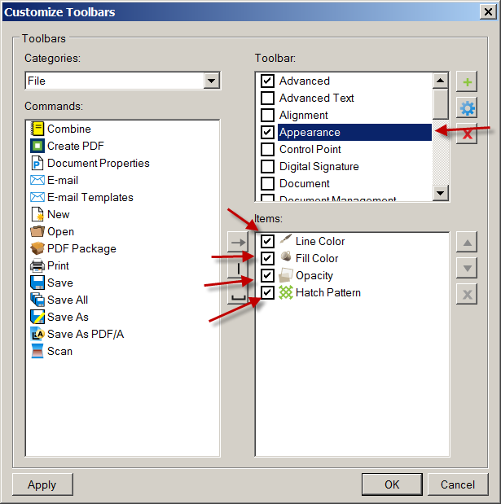
+ New Toolbar
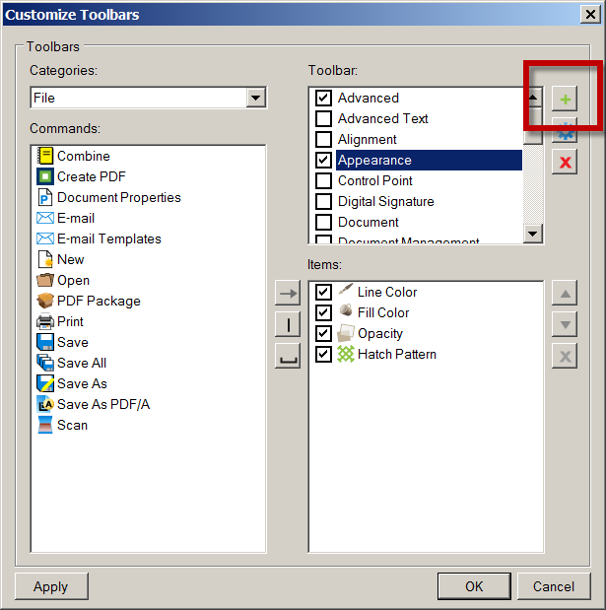
Call it SHSToolbar1…OK
Under Toolbars….Categories: (show Categories) set to ALL
To place in items
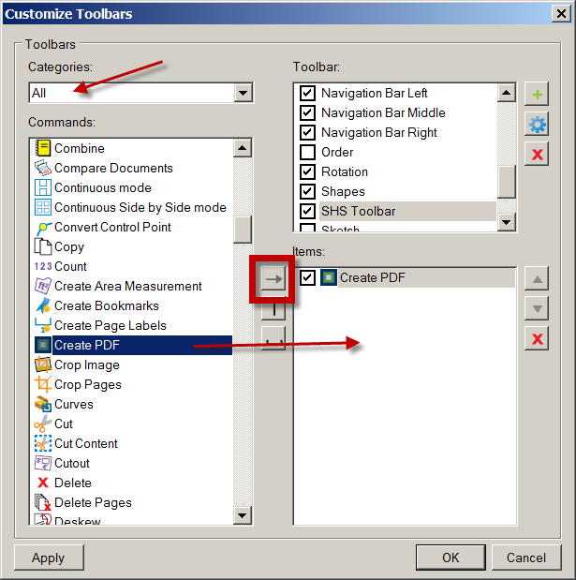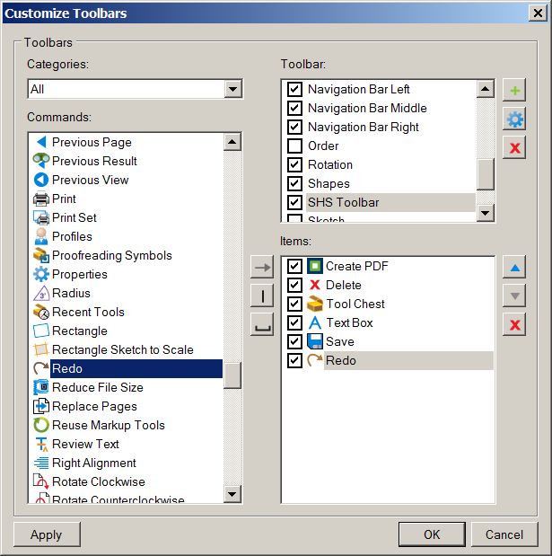
Make sure “Lasso” is one of the commands you add….we will need it later.
Show how to move toolbars
To save profile: man w/bowtie icon (side arrow)….save profile
Open C Building Layout 1.pdf
Show zoom and Pan Show Rotate View (counterclockwise)
Lower Right corner: size of drawing (see 34X44?)

Split screens
You can split the screen several times.
Lower left corner…split screen
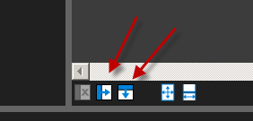
Strategy on split screens:
Open C Building rev b Layout1.pdf
Rotate counterclockwise
You have Rev A and Rev B both open (see the tabs at the top?)
Split screens
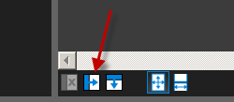
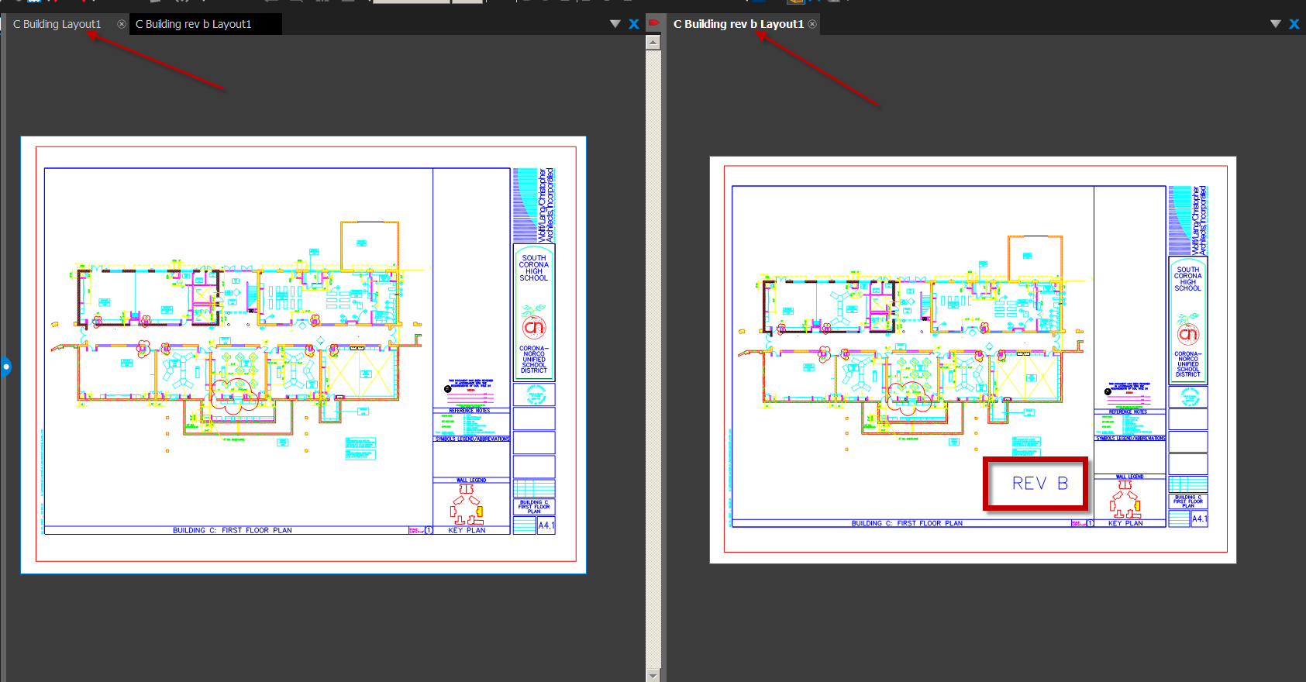
Hit SYNC button on bottom (blue highlight means it is active)
Pan….see how both move together? That’s pretty cool!!
Check for differences…can you find them?
Uncheck SYNC
Now pan around….they don’t move together….
Close the Rev B pdf

Open a Curtain Systems 2014.pdf (text) and C Building Layout 1.pdf
Split screen
Scroll wheel moves up and down on text.pdf…but in-out on drawing.pdf
Bluebeam understands when it is looking at text…and when it is looking at a drawing!

Unsplit
Icon on lower, left corner
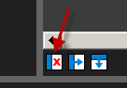

File Access
File Access is the easiest way to open .pdf files quickly.
Tab Access
See File access?
It opens a sort of .pdf browser/explorer
See pin? You can pin files so they stay on list.
If you scroll over file, preview pic comes up!
RC….pin
You can go to a file…RC on Curtain Systems…Pin….New category
Name it: Project Documentation…OK
See file inside folder….pinned?
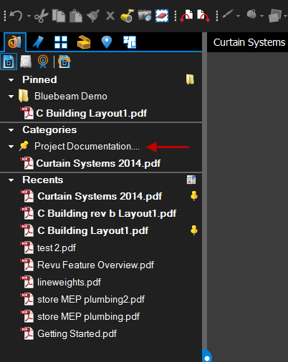
You can open multiple files at the same time. Tabs at the top to cycle through

Markups
Close the panel (blue thing)
Open C Building Layout 1.pdf
Show tools on right….text…..pen…eraser…etc
Show properties tab (hit blue tab to the left of icons)
See blue gear looking thing?
Make a cloud in the Technology Classroom C106 around the lower 5 Tables
Adjust the cloud appearance
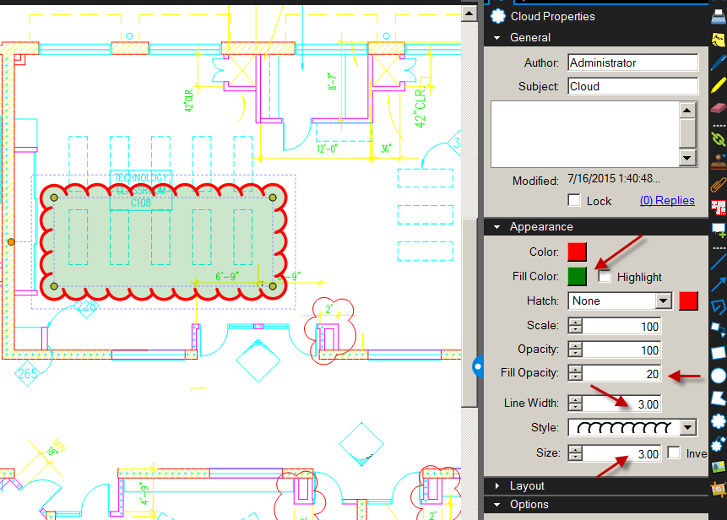

Markup Tool
Show “image” icon (green toward bottom)
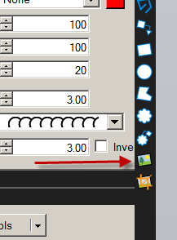
Allows putting image on sheet
Pick Technology table new.jpg
Place it near the revision cloud
Note: see that little orange ball near the pic…grab it to rotate the pic
Add a text note: “Replace 5 tables with new Technology Tables”
Show AUTOSIZE text box
Note: Hold the Shift Key down to move a Markup
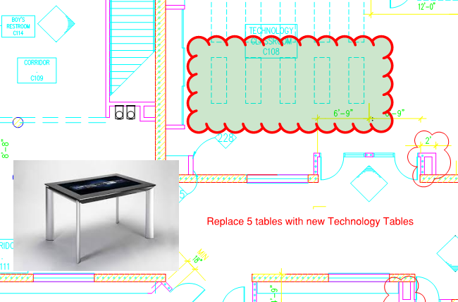
Subject Line
Markup Comments
Lasso (to group markup items)
Subject: Interiors (do by discipline for later organization) Disciplines could be : Architectural, Structural, Plumbing, Electrical, Mechanical, Civil, Interiors
Make one other comment/revision cloud to instruct placing a Science table in the Business/Keyboarding C116 lab. Assign it to Interiors.
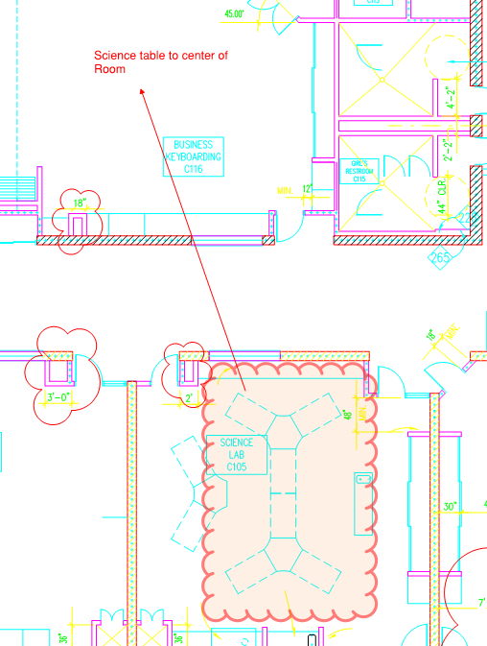
Toolchest Feature
Tab Access
Tool Chest
Tracks and stores commonly used markups (like a symbol library)
See recent tools?
Double click on tool….goes to a “properties mode”

You can create Custom Toolsets
Gear…down arrow
Show custom toolsets loaded
Color coding by discipline a good idea. Example: Blue Mechanical….Red Plumbing…Yellow Architectural….Pink Electrical
Gear…Add…..Name it: Browns Tools…OK
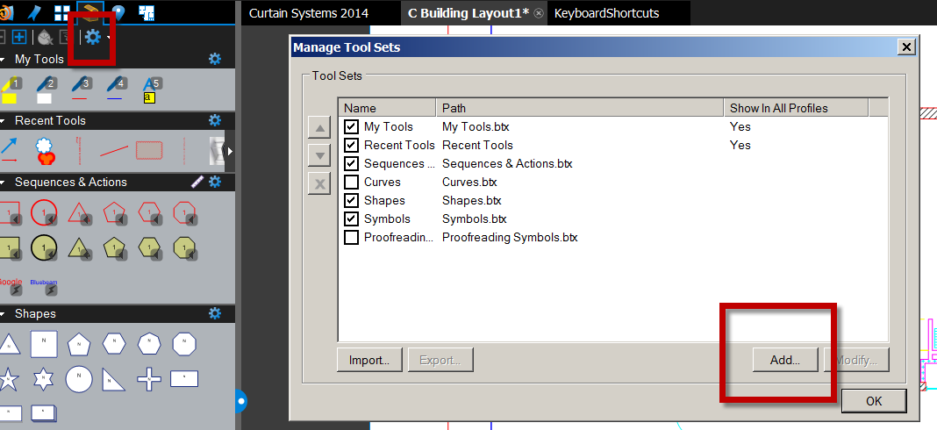
Save it….OK
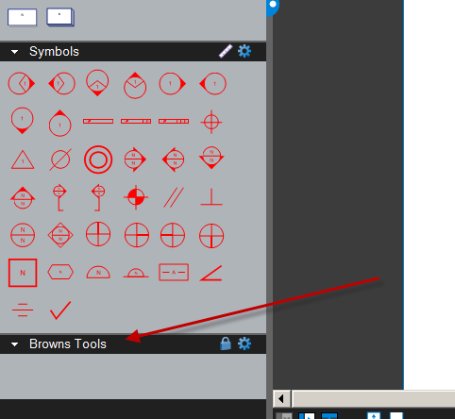
You can drag markup into toolset…SHOW
RC on markup..add to Toolchest…..pick your toolset
You can download toolsets from Bluebeam’s website
http://www.bluebeam.com/us/support/extensions-tool-sets.asp
I downloaded “Punch” to my My Documents
There is a Ceiling and a Floor Plan Toolset
Blue Gear….Import
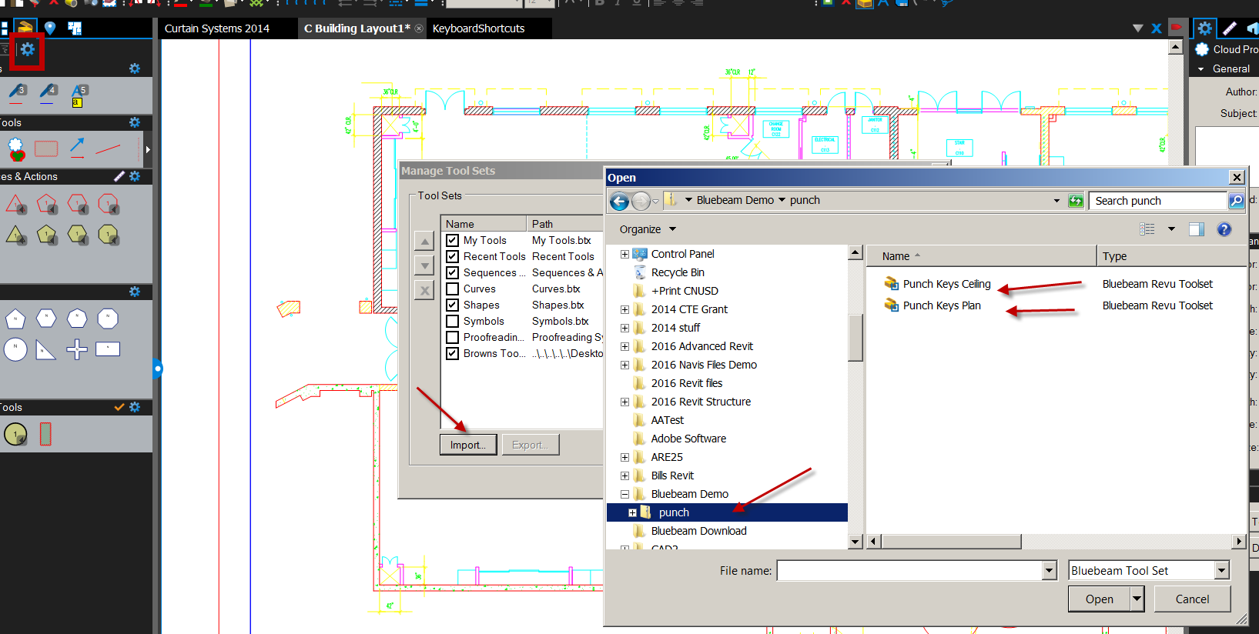
Punch Keys Plan…Open
See it?

Toolsets can be symbols too. Show Punchkey Plan. Gear on right….you have options on how you view it. Choose Detail. See comments??
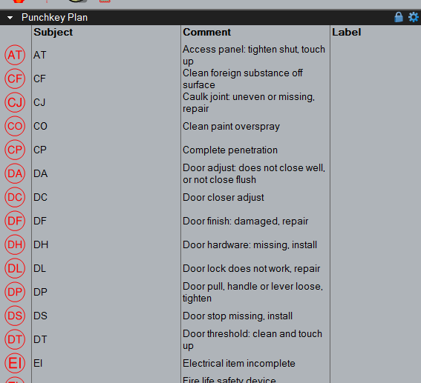
Note to Brown: I could use punchkeys to align my checklists given to students…color coded.
The punchkeys are just circles with text inside

Tracking markups
Hit the left and right blue control points to hide the toolbars
Markups at the bottom of the screen (blue button)
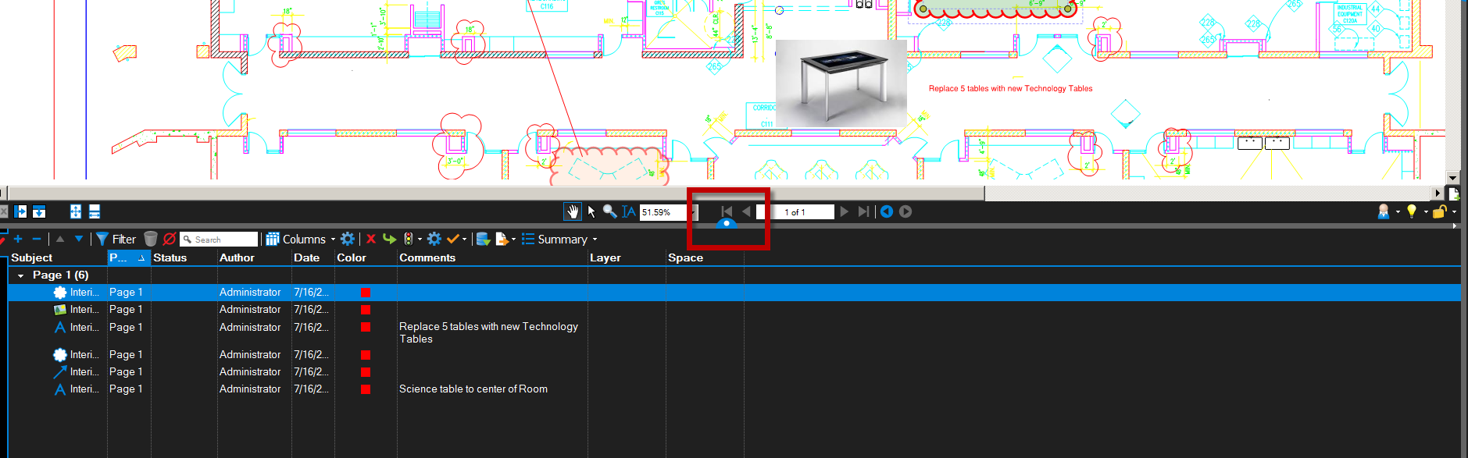
As you click on each Markup in list, it highlights in screen
You can sort by columns (like an excel spreadsheet)
Common workflow is to send the pdf to say 3 different people…Plumbing, electrical, and architectural. They markup the file…..send it back to you. You then have to combine the markups into one file. Hard if to have to do it manually!
Open Jared Bearden NAWIC.pdf

Make markups as Plumbing….Save as Jared Bearden plumbing NAWIC.pdf
Make sure Subject is Plumbing on revisions
Make cloud colors red

Make markups as Electrical….Save as Jared Bearden electrical NAWIC.pdf
Make sure Subject is Electrical on revisions
Make cloud colors blue

Make markups as Architectural….Save as Jared Bearden architectural NAWIC.pdf
Make sure Subject is Architectural on revisions
Make cloud colors yellow

Open Open Jared Bearden NAWIC.pdf ( the original file)

Solution….Import Comments
(blue icon w/green check….above Comments)
Import just markups (not the dwg)
Open the 3 files…open
See markups list? See comments (hopefully by Subject/category) Mine is on far left…
Note: You can change disciplines if you made a mistake (or consultant did)
Checkmark (if done)
Status:
Filter: stuff not selected becomes greyed out
You can pick the right side arrow to filter by Discipline names.

Reports
Summary-pdf Summary
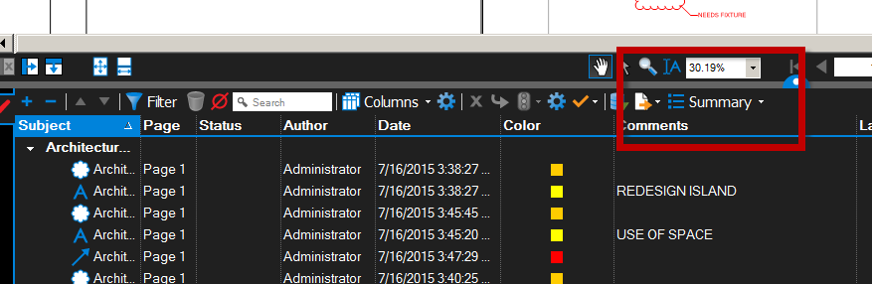
Check Append to current pdf
Title: Name it
OK
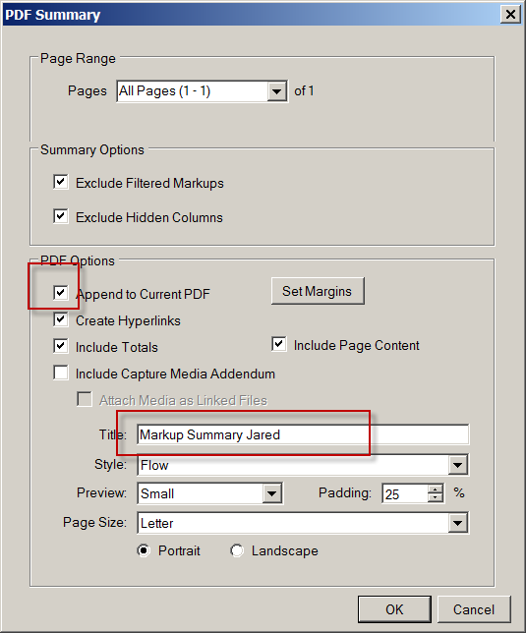
Bluebeam makes a report as a pdf
See thumbnail?
Hyperlink to pdf dwg!
Use “previous View” to get back to drawing
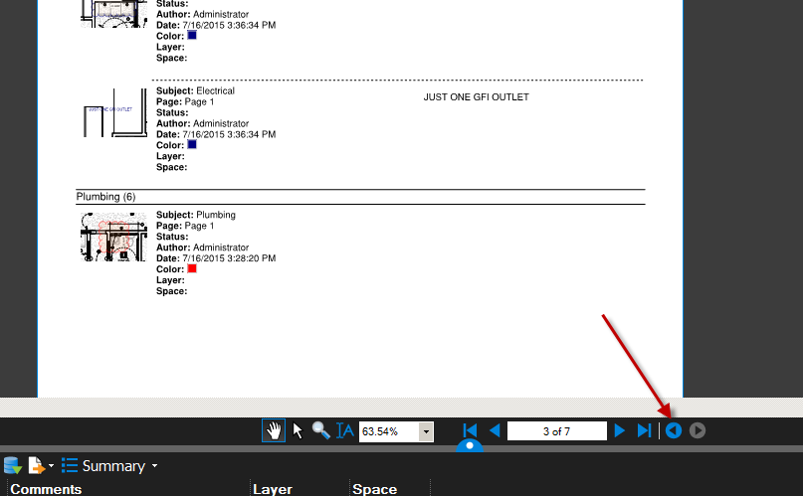
Measurements and Takeoffs
Open Jared Bearden NAWIC.pdf
Tab Access…..Measurements It will look like a Scale Toolbar.
Calibrate drawing
Calibrate
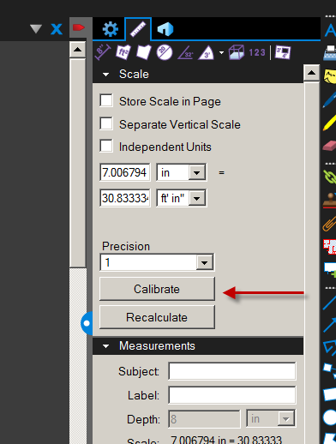
You need to know the size of something in the file (to compare to). He has a 21’0” dimension in the Garage. Use that.
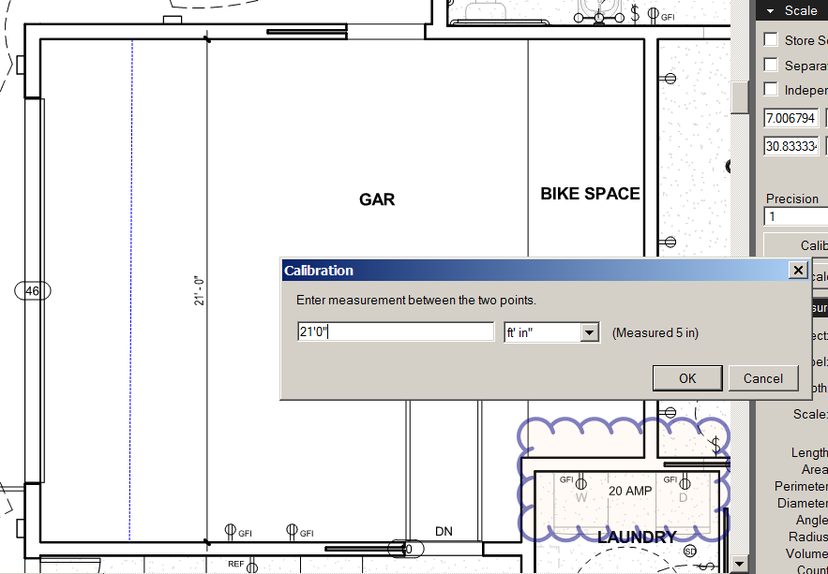
Use the length tool to verify your calibration worked.

Area Tool (second icon from left). It’s on the Scale toolbar. Try the Area of Bed 1. I got 102 SF
Hold the shift key down to move the Area tag to a better place.

Count (on toolbar)
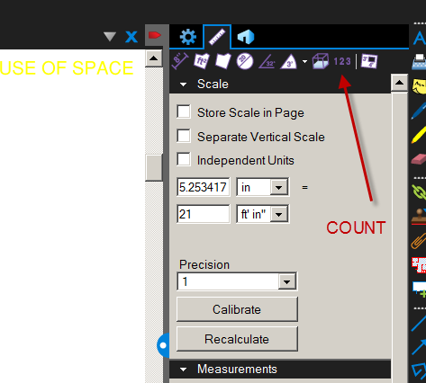
Check the elements….see result
Sequences and Actions
Place polygons w/ numbers or letters for counting

Comparing Revisions
Documents….Comparison….Compare Documents
Select file A: Jared Bearden NAWIC REVISED2.pdf
Select File B: Jared Bearden NAWIC REVISED.pdf
OK
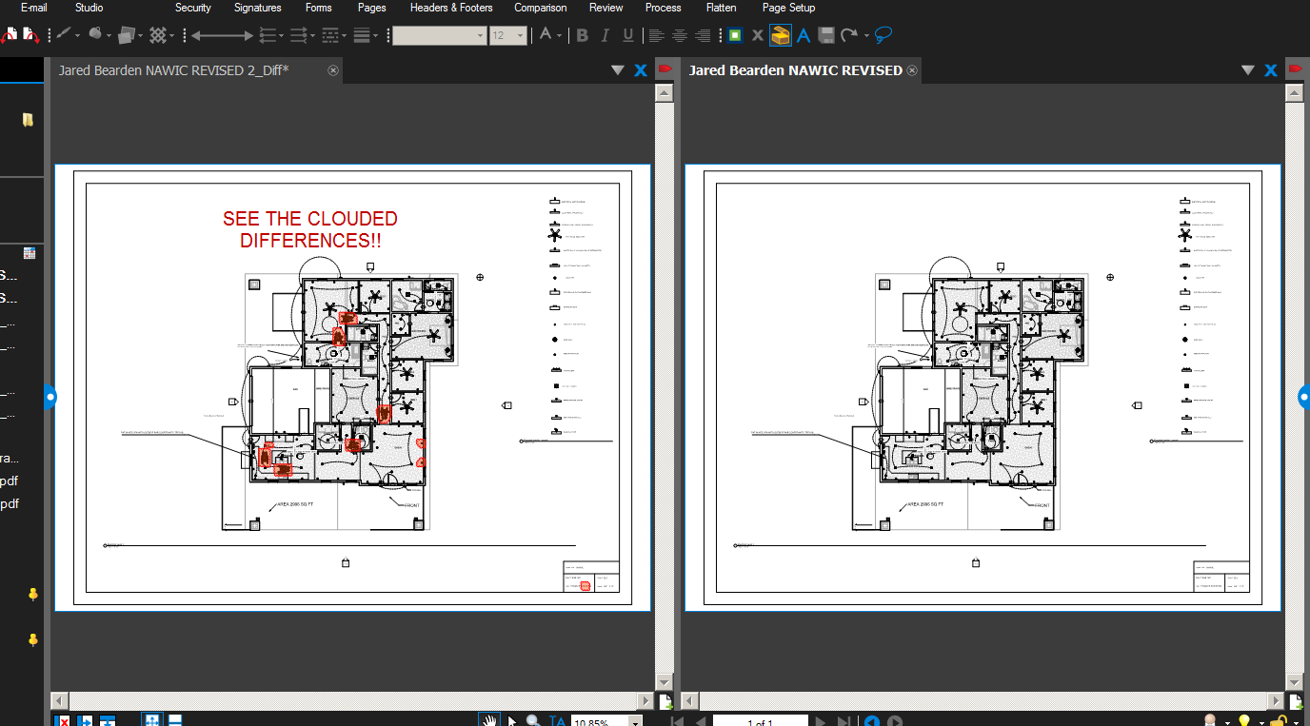
Bluebeam clouds differences!!

Batch Process the differences
File ….Batch
Compare documents
Open Set A
Open Set B

Bluebeam Tutorials
https://www.bluebeam.com/us/bluebeam-university/bluebeam-webinars/

