Santiago High School
ARCHITECTURAL DESIGN 2A/2B
CLASSNOTES 2017-17

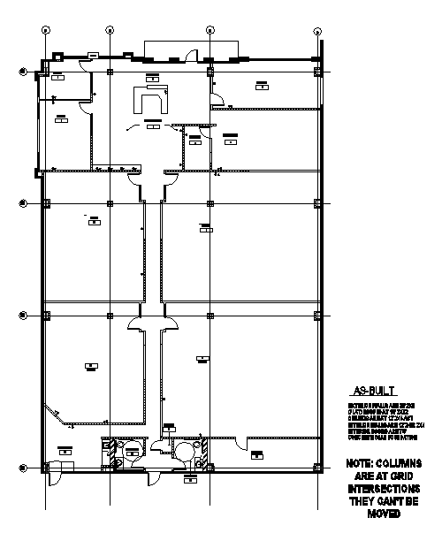
Software: REVIT

Instructor:

BILL BROWN

Table of Contents

Table of Contents 2
Sheet Naming Convention 4
Area Plans 5
Curtain Systems 23
Demo: Structural Components in Revit 44
PROJECT 1: AutoCAD to Revit 59
Keynotes 62
Creating the Keynote Legend 74
Grouping 77
Creating a “Smart” Furniture Family 81
Material as a Parameter: Family 98
Families: Steps to Creating Families 100
Phasing 101
PROJECT 2: Coffee Tech Institute (CTI) Tenant Improvement/Phasing 110
CTI Phasing for Tenant Improvements 114
Coffee Town Parameters 115
FAMILIES FOR COFFEE TOWN 116
Dimensioning in Revit 119
Creating Materials in Revit 2015: Basics 123
Material Tags: Label Your Smart Materials With Smart Tags 138
Making the Custom Material Tag 141
Applying Smart Material Patterns to Floors 144
Creating Fill Pattern 147
Scope Boxes 152
View Templates 153
Creating Custom Linestyles 154
Annotation Family 157
Create a NEW annotation family from a template 159
Sweeps 161
Drafting Views 167
Creating a Custom Title Block 169
Creating Custom/Shared Parameters 172
Note Blocks 179
Purging 183
Detailing: Referring to Your Revit Details 184
Detailing: Referring to Your AutoCAD Details 186
Key Schedule 188
Creating a Mechanical Equipment Family: Trane RTU 192
Plumbing Fixtures to LEED Standards 195
Tankless Hot Water Family: Noritz NC380 198
Solar Panel Family 199
Solar Panel Family Part 2: Creating a Custom Annotation Tag 208
Solar Panel Schedule 211
Revit Resources 212

Sheet Naming Convention

C100.00 GENERAL/ SITE
EX: COVER C101
SITE C102
SITE DETAILS
COVER SHEET
DRAWING INDEX

A100 SLAB/FOUNDATION
A200 FLOOR PLANS
ENLARGED FLOOR PLAN AREAS
TYPICAL ROOM PLANS
ELECTRICAL
A300 RCP (CEILING PLANS)
CEILING DETAILS
A400 ROOF
A500 EXTERIOR ELEVATIONS
ELEVATION DETAILS
ENLARGED ELEVATIONS
A600 BUILDING SECTIONS
WALL SECTIONS
DETAIL SECTIONS
A700 INTERIOR ELEVATIONS
FINISH SCHEDULES
MATERIAL SCHEDULES
INTERIOR DETAILS
A800 DOOR/WINDOW SCHEDULES
A900 MISC

Area Plans

Revit has an Area Analysis Tool to define and label spatial relationships. These are different than “Rooms” in Revit Architecture and “Spaces” In Revit MEP. In fact, Areas and Rooms can occupy the same place (on top of each other). Areas have different parameters than rooms….keep track of different information.

Open Area Plan 2017.rvt

Room and Area
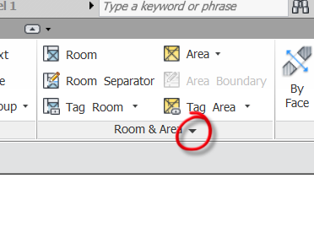
Area and Volume Computation
Area Schemes
Out of the box, there are 2 schemes. Gross Building and Rentable
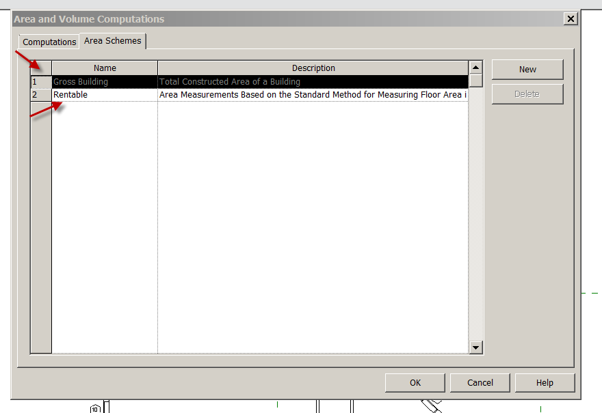
OK
Gross Building: Total Constructed Area of Building
Rentable: Area measurements based on the standard method of measuring floor area in Office Buildings.
Gross Building Area
Frequently it is necessary to find the total area of a floor plan. The “Gross Building Area Plan” is perfect for this and is really fast!
See Browser…No Gross Area Plan. We are not going to duplicate the Floor Plan Level 1.

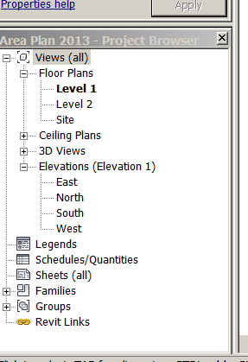

Room
Area
Area Plan
Gross Building
Level 1
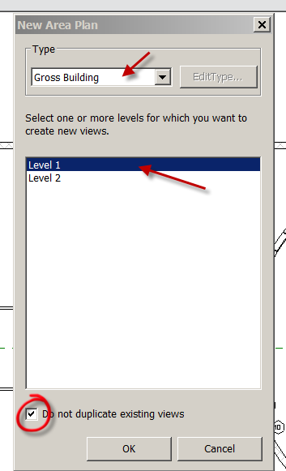
Check Do not duplicate existing views
OK
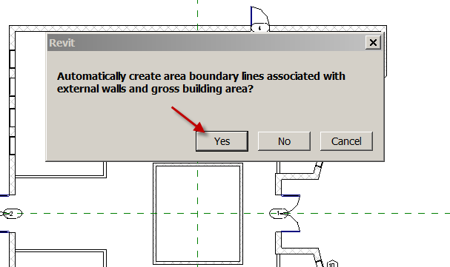
Say YES to the box. Discuss NO…..would create our own boundary lines…
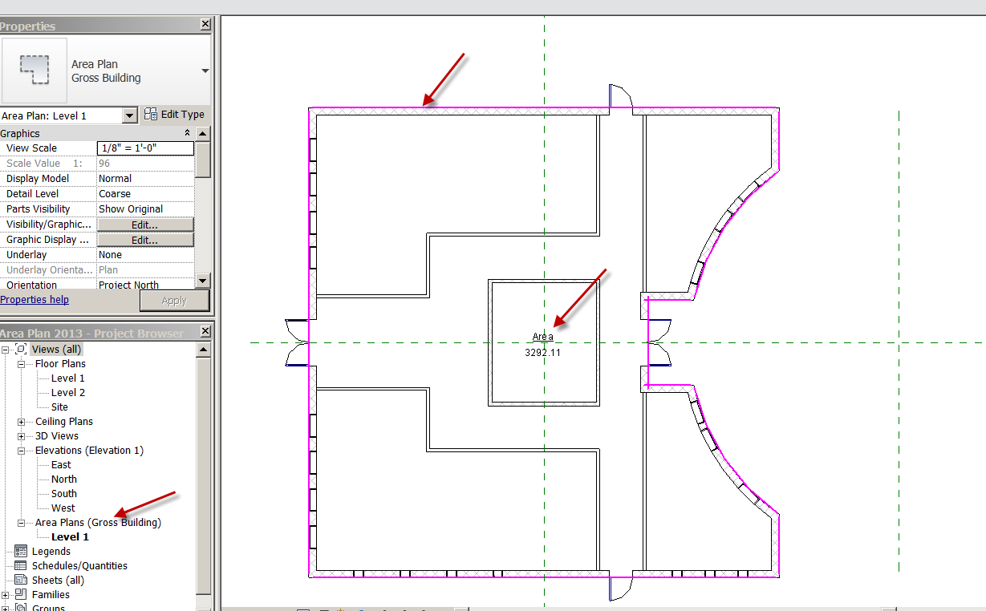

Notice the new “Area plans” in the Browser. Automatic!
The Magenta lines are “Boundary Lines. They could be moved, new ones created….but those are good.
Notice the Area Tag is there showing the Area of the Floor Plan. Nice!
On a multi-story building, it is really fast to get the area of each floor…..

Rentable Area

Architecture
Area
Area Plan
Rentable
Level 1
Do not Duplicate
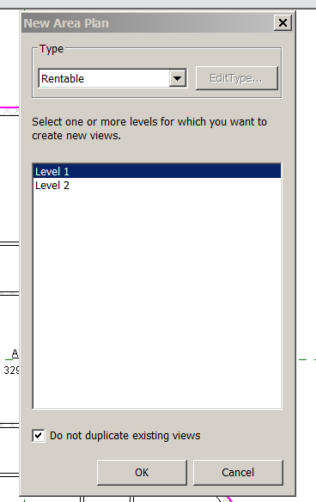

OK
Yes
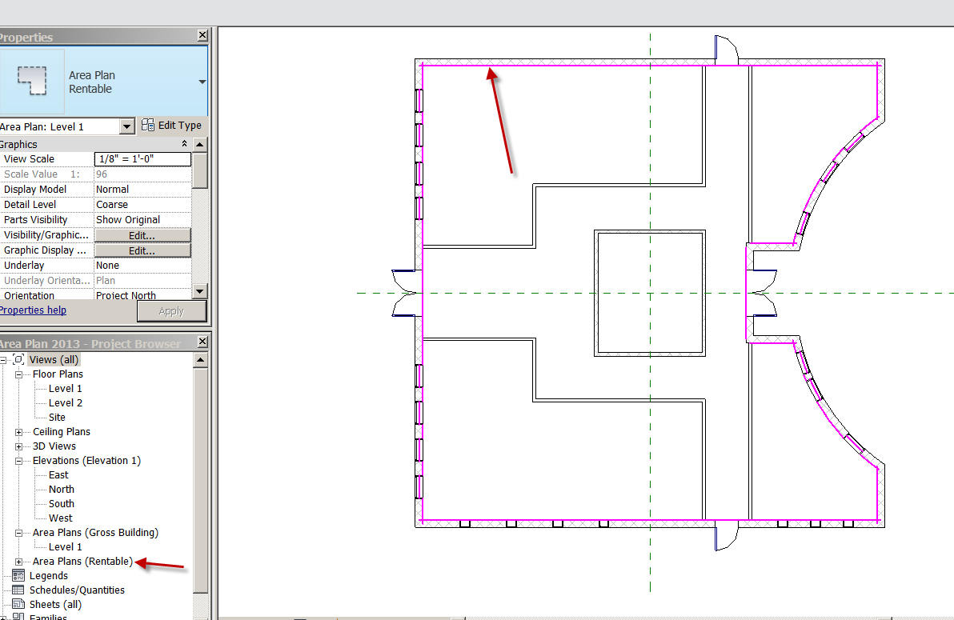

Notice the new entry in the Browser….Automatic!
Notice the magenta lines are in a different place.
Architecture
Area Boundary

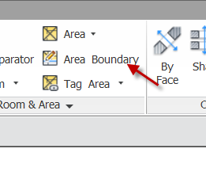
You will pick each wall (no window, sorry) so magenta lines are on each wall
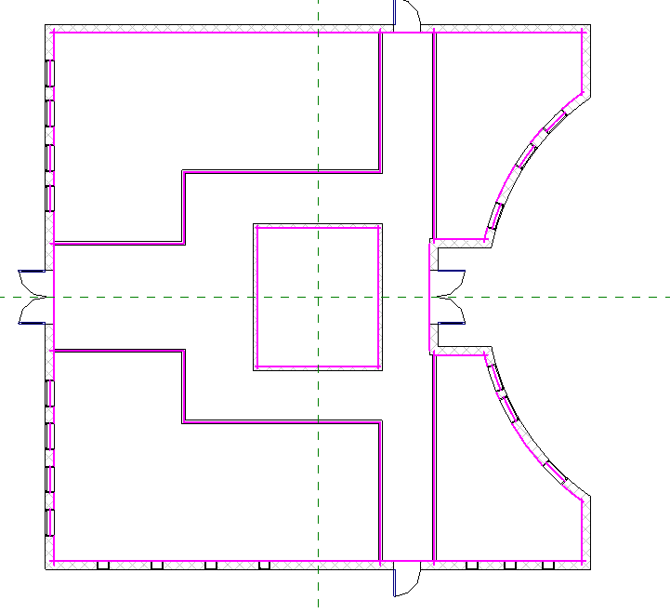
Architecture
Area
Area
Pick in lower, left corner
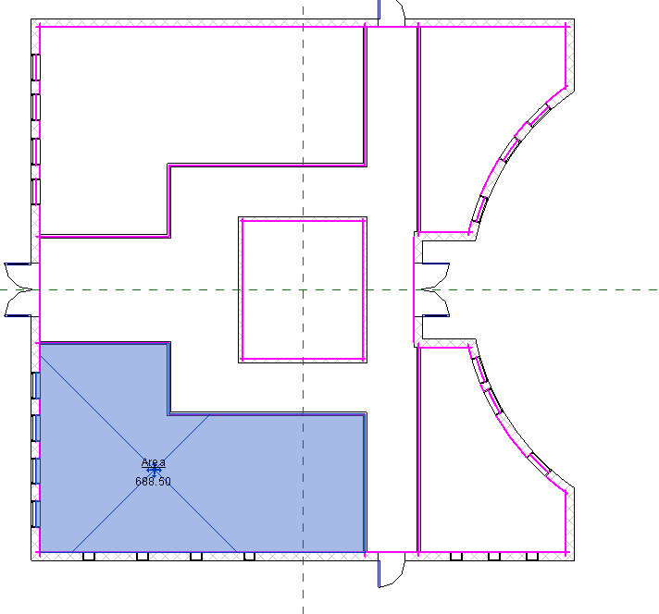
Name it Tenant 1. It should be 688.50 sq ft
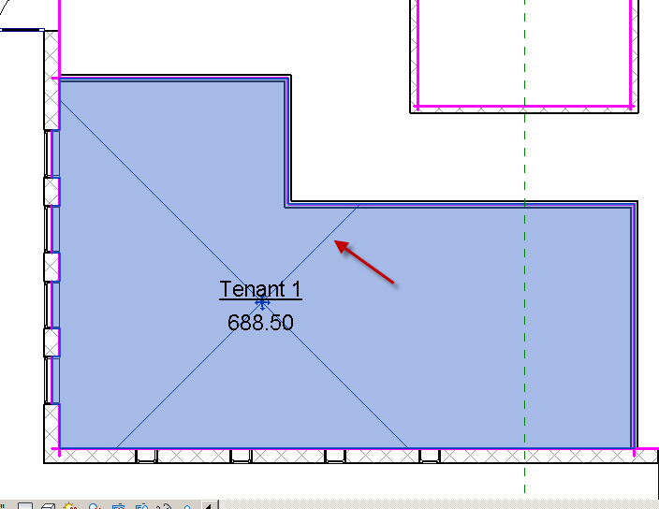

Pick on Area (see the X)

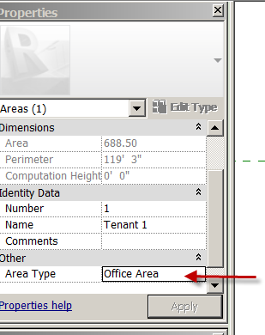

Area Type: Office Area
Done

Let’s do the same for the top, left space:
Area….Area
Pick top left space
Name it Tenant 2
Area Type: Office
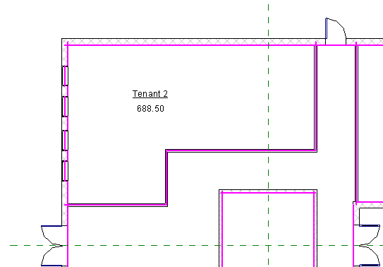

Now the Corridor
Area…Area
Name it: Corridor
Area Type: Building Common Area

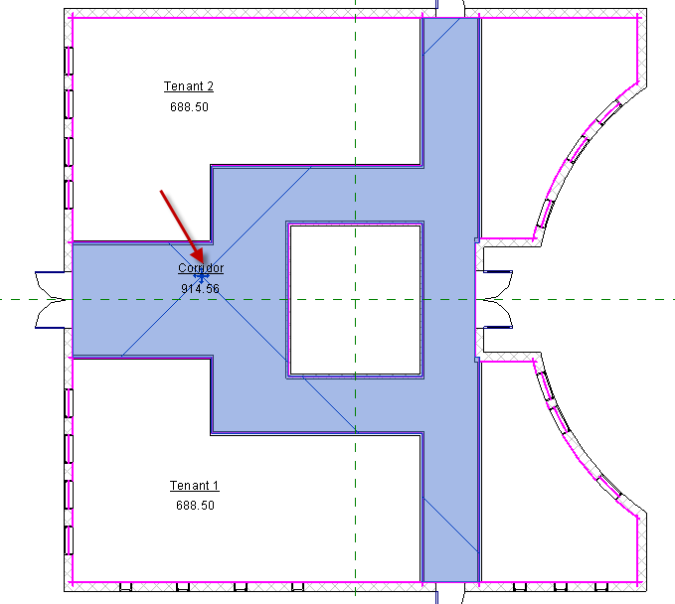

Now the Bottom Right “Store 1”
Area….Area
Name it Store 1
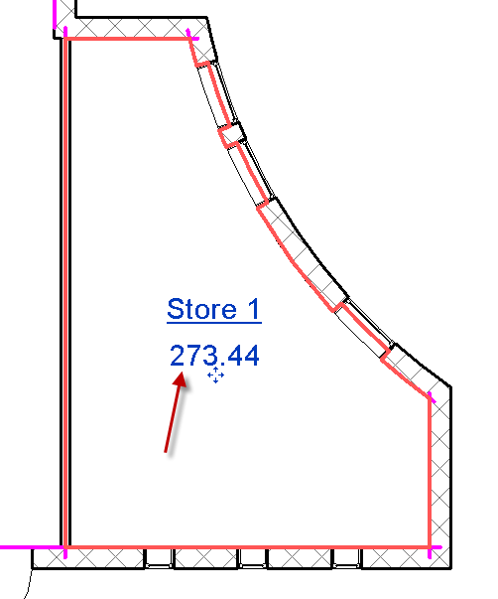
Notice the area is 273.44
Notice where the boundary lines are…….
Now change the area Type…
Area Type: Store Area
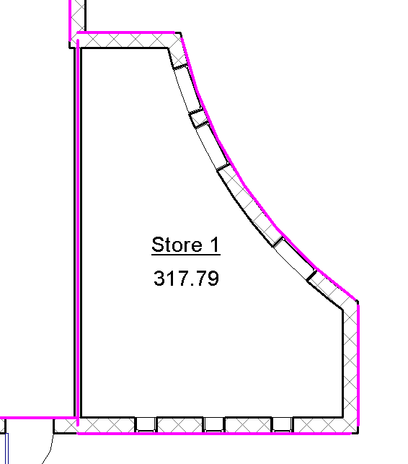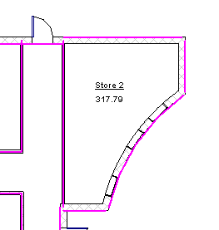
Check out the Area change! 317.79! Why? When you have Store area, you have to pay for all of the area! There are industry rules for how spaces are measured. Let’s say Store 1 was rented at $1000/sq ft. Which number would you want to use???
Repeat process for Store 2 in top, right corner.

Now the building “Core”. This is where stairs, escalator or an elevator would go. Notice where the magenta lines are….
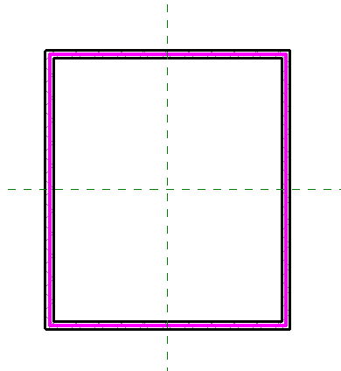
Area….area
Name it “CORE”
Area Type: Major Vertical Penetration
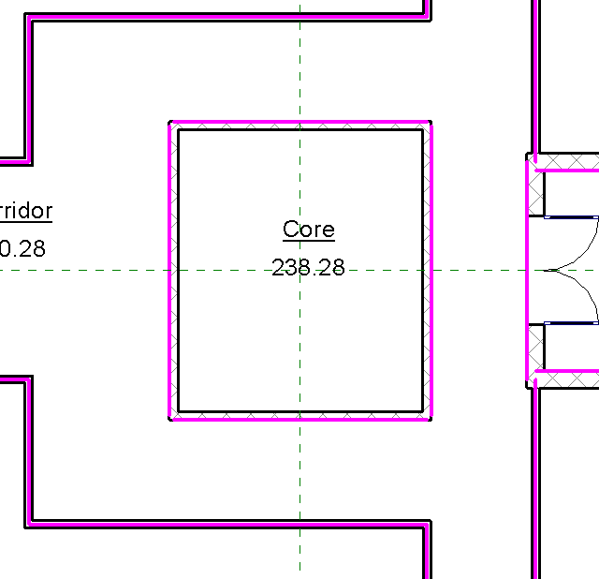
Notice changes in boundaries! This is Revit applying the industry rules for areas when they are adjacent.

Area Color Fill Plan
We can add color to the Areas based on their Area Type
Annotate
Color Fill Legend
Place on drawing to the right of the floor plan
Space Type: Area Rentable
Scheme 1
Ok
Done!
Show how to 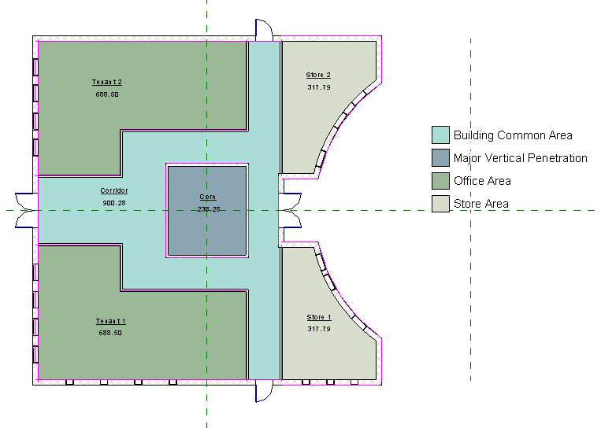

Show how to change colors:
Architecture
Room and Area
Color Schemes
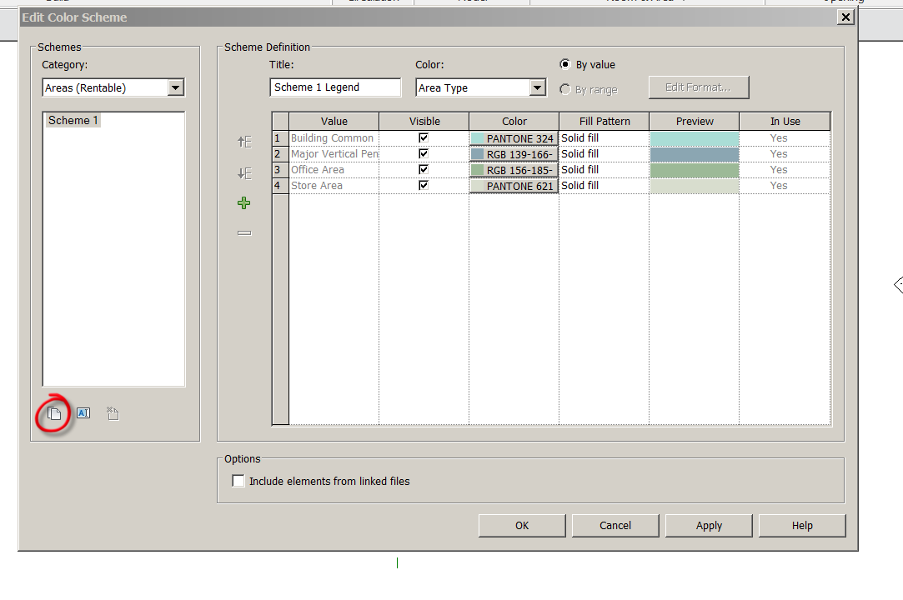

New scheme
Name it SHS Scheme
Apply new colors

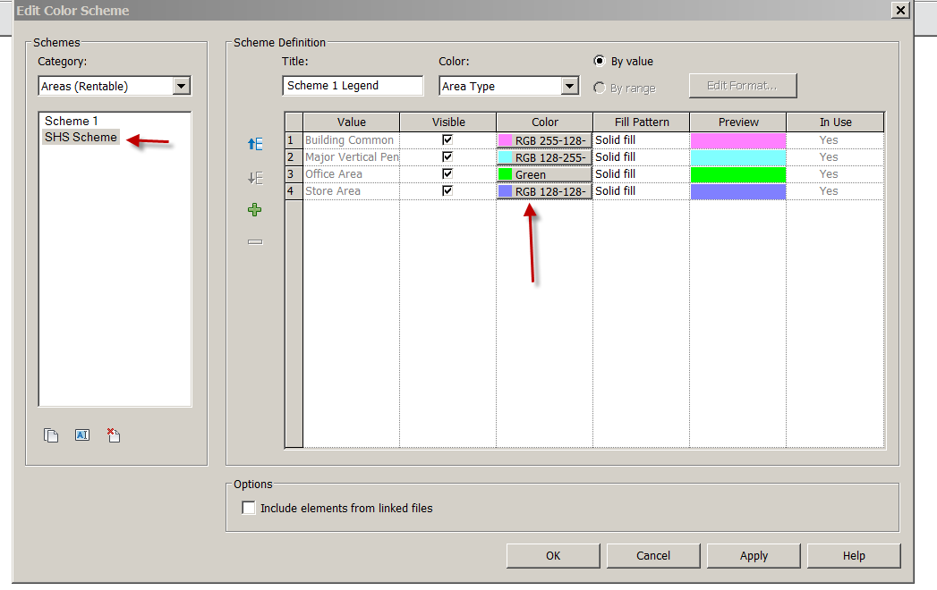

Ok
Pick on Legend
Edit Scheme

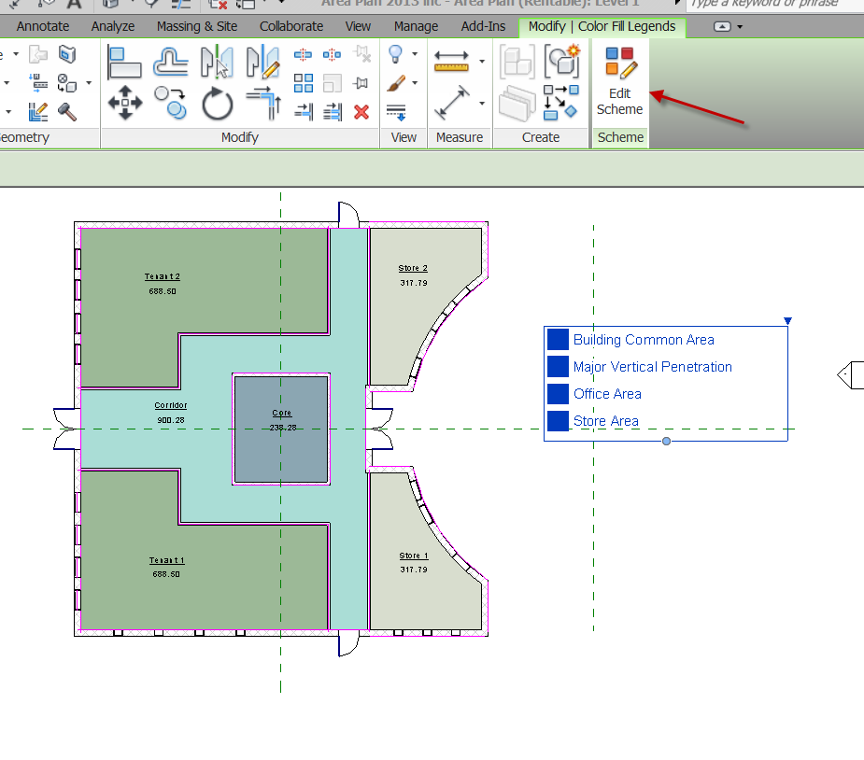
Pick SHS Scheme
OK
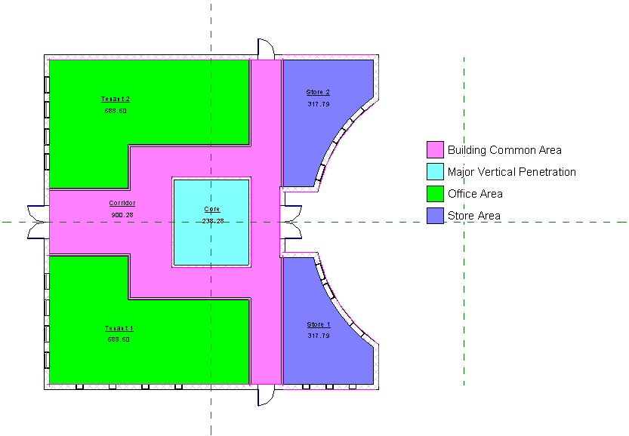
You can make as many schemes as you want!

Area Schedules
You can quickly create a schedule of the Areas
View Schedules Schedules/ Quantities
Areas Rentable
OK
Choose:
Name
Area
Area Type
Perimeter
Add
OK
Good!

Let’s total the Area Types….
Sorting and Grouping
Area Type
Check Footer
Title count totals
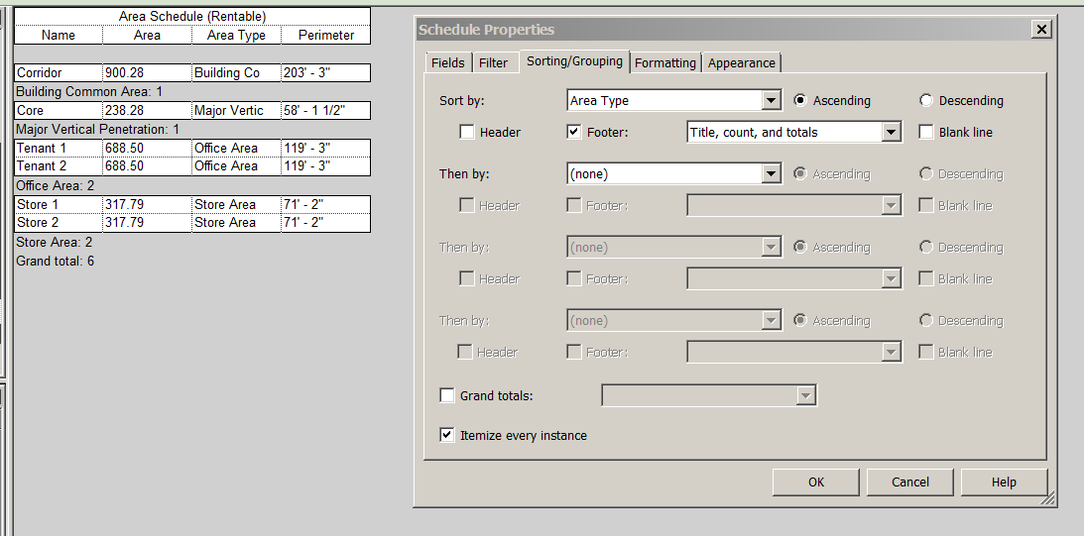
Formatting
Area Check Calc Totals
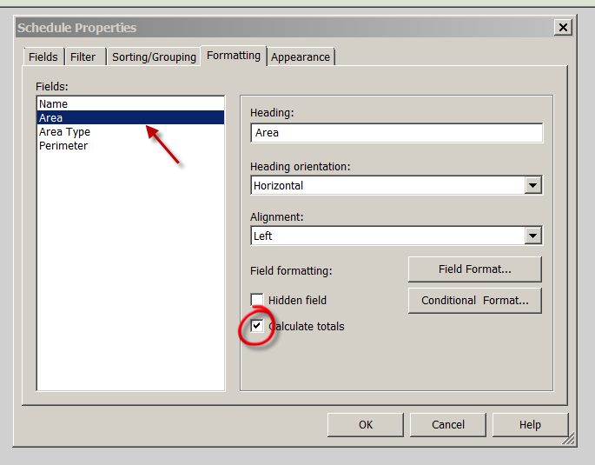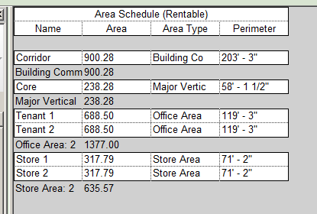

Place the Area plan and Schedule on a B- sized sheet.
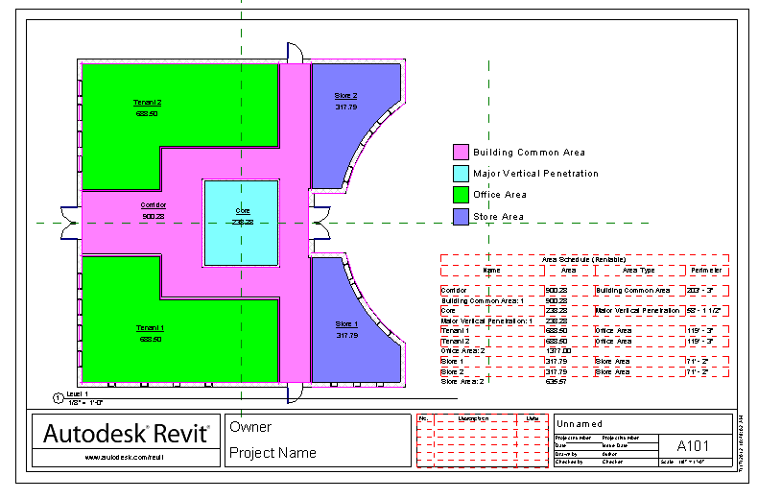

So we learned how to quickly organize areas to give us information based on industry standards.

Curtain Systems

Curtain systems are not walls, and they are not windows. Like walls, they can define space and separate the exterior from the interior. They are typically not load-bearing and are not cut for doors or windows. Like windows, they can usually include mullions and have glazed panels. Unlike windows, curtain systems are usually assembled on site as a single unit.

A typical curtain system comprises a wall, panel, grid lines, and mullions, and you can change these elements individually. This affects the entire curtain system. For example, to resize the system, you need to change the length of the wall. To switch panel types, you need to select a panel. To change grids, you select the grid.

You can add curtain systems with the wall command, or you can use a specific curtain system command.

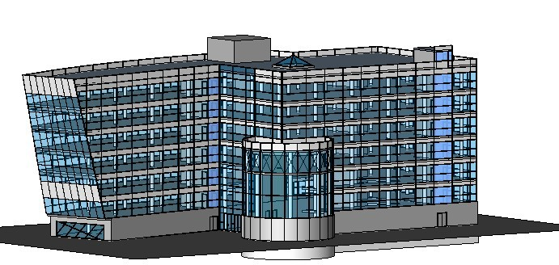

Flat Curtain System

In this lesson, you further develop the building information model by creating a flat curtain system at the entrance of the model.

Creating an Entrance

In this exercise, you create a curtain system using the wall command. This type of curtain system is also referred to as a curtain wall.

Provided Training File
■ Click File menu ➤ Open…..2017CurtainWalls.rvt
1 In the Project Browser, expand Views (all) ➤ Floor Plans, and double-click Ground Floor.
2 Zoom in to Grid F where it meets the arc in the floor.

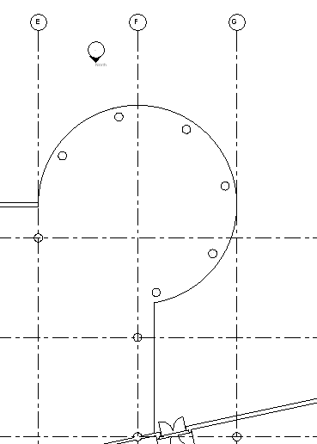

This floor edge will be the entrance to the building.

Creating a curtain system using the wall command

3 On the Architecture tab of the Ribbon, click Wall….Architectural Wall
4 In the Type Selector, select Curtain Wall: Curtain Wall 1.
5 Start the curtain system where shown.

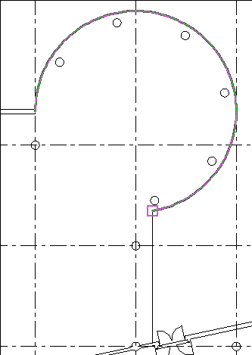

6 Move the cursor down along the edge of the floor, and finish at the outside face of the exterior wall as shown.

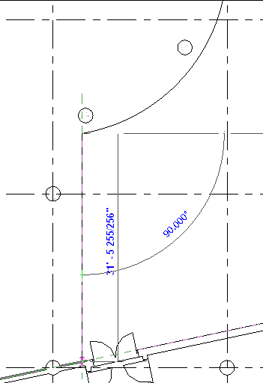

7 Zoom in to the join between the curtain system and the exterior wall.

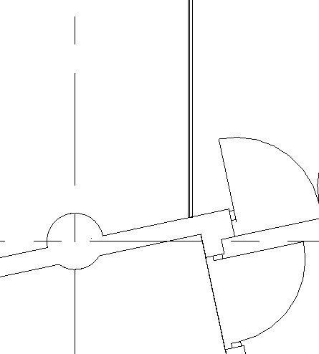

8 In the Project Browser, expand Views (all) ➤ 3D Views, and double-click Southeast Isometric.
9 View Cube: NE
10 Zoom in to the curtain system you just added.

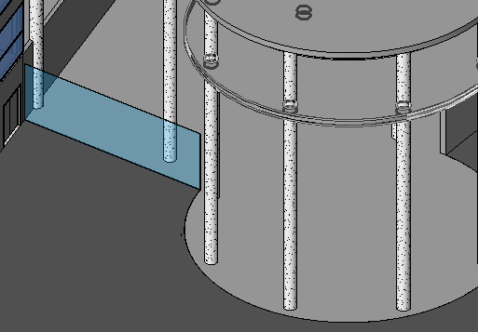

11 Select the curtain system…Properties
Note that a curtain system created from the wall command has similar properties to other walls:
base constraint, top constraint, top and base attachments, and room bounding. You want the curtain system to attach to the roof.
12 In the Element Properties dialog:
■ For Constraints ➤ Top Constraint, select Up to level: TOP OF ROOF.

■ For Top Offset, enter 4'0".

■ Apply

The curtain system is now at the same height as the other existing curtain systems.

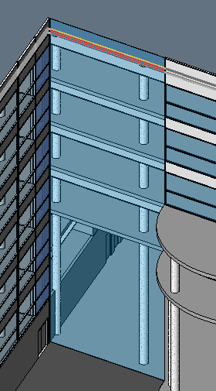

13 The curtain system is a single glazed panel; you are going to subdivide the panel into several smaller panels, using curtain grids.

Adding curtain grids

14 In the Project Browser, under Floor Plans, double-click GROUND FLOOR.
15 On the View tab of the Ribbon, click Elevation….Elevation…Building Elevation (properties)
16 Place the elevation symbol in front of the curtain wall and click Modify on the Ribbon.
17 Click the elevation arrow to display the crop boundary, and resize the crop boundary as shown.

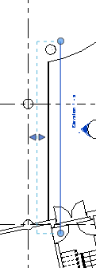

18 In the Project Browser, right-click Elevation 1 - a, and click Rename.
19 Enter Entrance Elevation, and click OK.
20 In the drawing area, double-click the elevation symbol arrow to open the new elevation view.
21 Architecture…. . Curtain Grid.
22 Move the cursor along the edge of the wall, and click to place a horizontal curtain grid 4'0" above the ground floor level line.

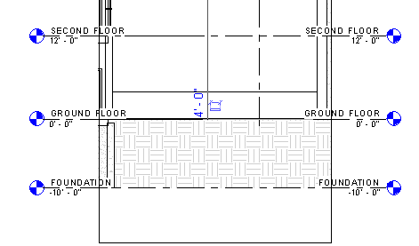

23 Place another grid 5'0" above the first grid.

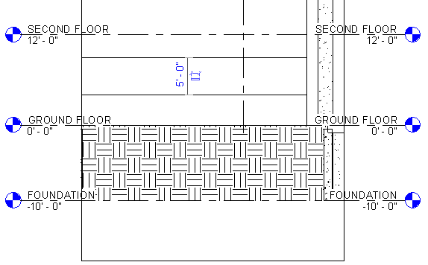

24 Place another grid so that it snaps to the SECOND FLOOR level line.
25 On the Ribbon, click Modify.
26 While pressing CTRL, select the 3 grid lines you just placed. Pick the 2nd Floor grid line first to make the process easier.
27 Click Edit menu ➤ Clipboard…Copy
28 Click Edit menu ➤ Paste ➤ Paste Alignedtoselectedlevels
29 In the Select Levels dialog, while pressing CTRL, select SECOND FLOOR, THIRD FLOOR, FOURTH FLOOR, FIFTH FLOOR, SIXTH FLOOR, and SEVENTH FLOOR, and click OK.
The selected grid lines are now at each of these levels.

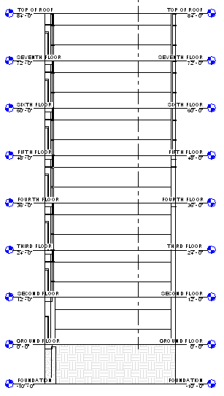

Save the file as: FirstLastCurtainWall.rvt

30 Architecture…. . Curtain Grid.
31 Place the cursor on grid 2 so that it highlights. Click to create a vertical grid.
This divides the curtain wall vertically into 2 panels, one larger than the other.

32 Move the cursor along the GROUND FLOOR level (left of the vertical grid line) until it snaps to the midpoint of the larger vertical panel. Click to place another grid line.

TIP To be sure that the curtain grid is at the midpoint of the panel, watch the tooltips and the Status
Bar.

33 Architecture…. Modify.

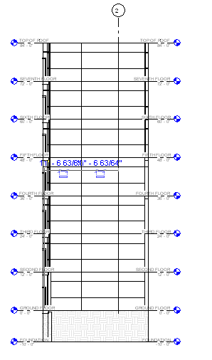

Next, you add a doorway to the curtain system. Instead of using the Door command, you set up a doorway on a curtain panel, and then you replace that panel with a curtain system door panel.

Try Placing Door
Ground Floor in Browser Architecture….Door…..Single door. Place in wall.
Did the door go in? Problem?

Adding the doorway

34 Zoom in to the ground floor level in the Entrance Elevation view.
35 Select the left vertical grid line, and on the Options Bar, click Add or Remove Segments.
You enter an editor that lets you select segments of the grid line to remove them.

36 Select the lowest segment of the left grid line, and then select the segment above it.
The segment line style changes to dashed.

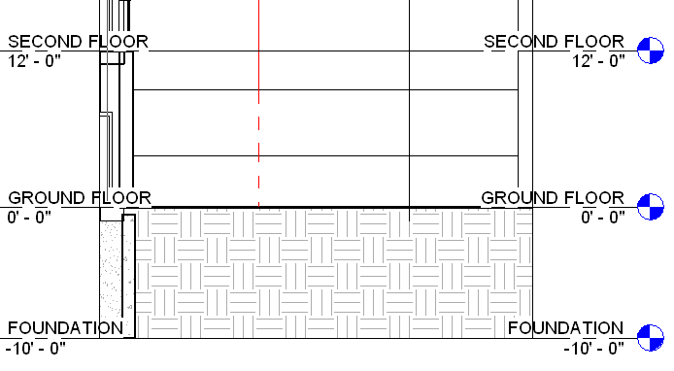

37 Click in any white space to exit the editor.
The two segments are removed.

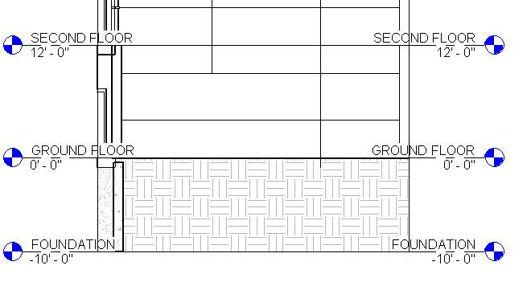

38 Using the same method, remove the horizontal segment that intersects the vertical segment removed in the previous step.

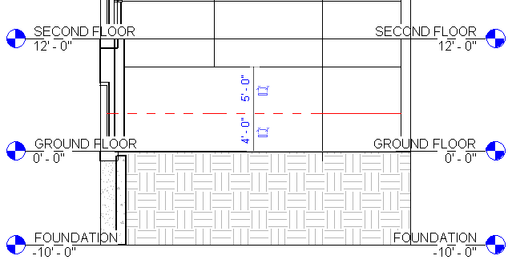

39 Architecture…. Curtain Grid.
40 On the Options Bar, select One Segment.
41 Place 4 vertical grid lines as shown.

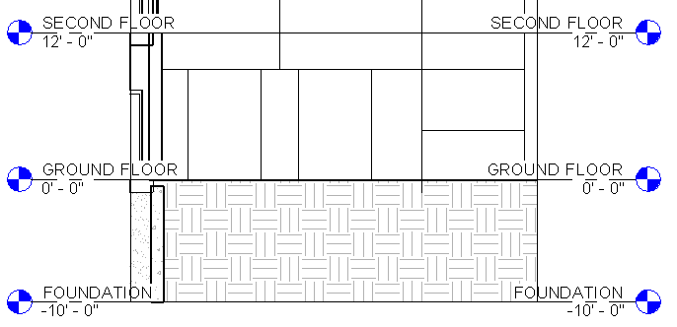

42 Place dimensions as shown. Remember, the line you pick is the line that moves. Pick the 1’6”
lines first!

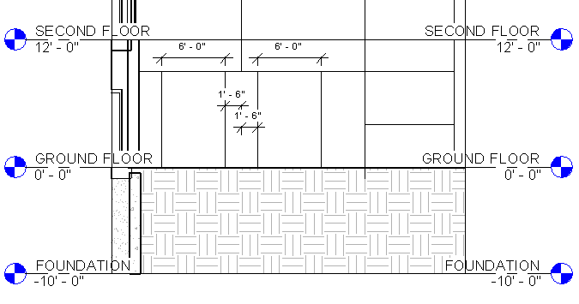

TIP You may need to adjust your zoom settings to view the dimensions.

43 Delete any dimensions.
44 You now have two 6-foot wide panels between smaller rectangular panels.

45 Select the horizontal grid line that is 4'0" above the ground floor.
46 Click Add or Remove Segments on the Options Bar.
You are going to add more segments to an existing curtain grid.

47 Click the horizontal grid line between the smaller panels. The line style changes from dashed to solid to indicate a grid segment has been added. Do not click between the 6-foot panels.
Use the following image as a guide.

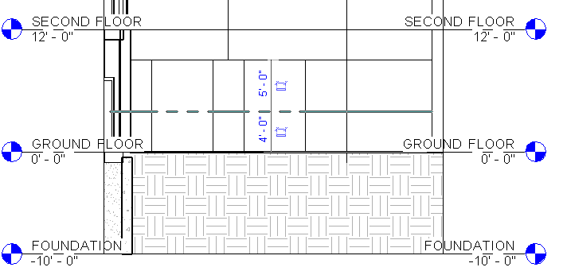

TIP The middle grid lines are centered between the long vertical grid above them. To get the horizontal grid to display between the vertical grids, click once to the right of the long grid and then click once to the left of it.

48 When the grids are placed (line style have changed to solid), click in any white space to exit the editor.

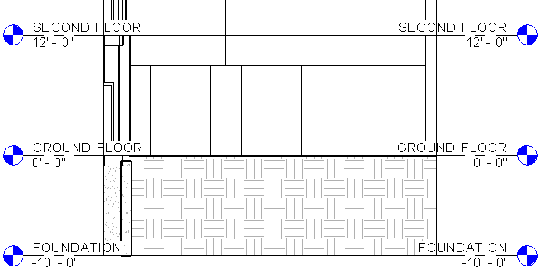

Next, you replace the 2 larger 6-foot panels with curtain system doors.

49 Insert➤ Load Family.
50 Doors….Curtain Wall-Store Front-Dbl.rfa….Open
51 Select the left 6-foot panel. You will have to press TAB to highlight it. Watch the Status Bar to be sure you are highlighting the panel.
52 On the Type Selector, click Curtain Wall-Store Front-Dbl: Store Front Double Door.
The panel changes to a double door.

53 Use the same method to replace the other panel with a double door.
54 On the Ribbon, click Modify.

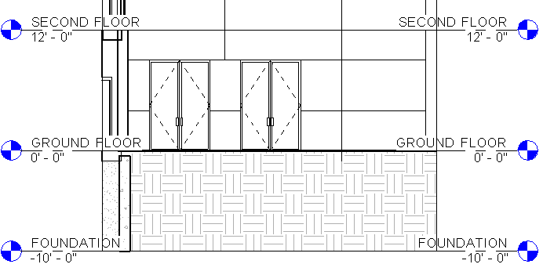

These panels schedule as doors, not as curtain panels. They are part of the curtain panel category.

55 In the Project Browser, under Floor Plans, double-click GROUND FLOOR to see the plan view door swings of the curtain wall doors.
Now, on the new curtain system you added, you replace some of the transparent panels with solid ones.

Save your file as: FirstLastCurtainWall.rvt

56 In the Project Browser, under Elevations, double-click Entrance Elevation.

57 On the View Control Bar, click , and click Shaded. This changes the graphics style of the view.
Next, you change panels in front of ceilings from glazed to solid.

Changing panels

58 Zoom in to the FIFTH FLOOR level.
59 Select one of the panels below the FIFTH FLOOR level line.

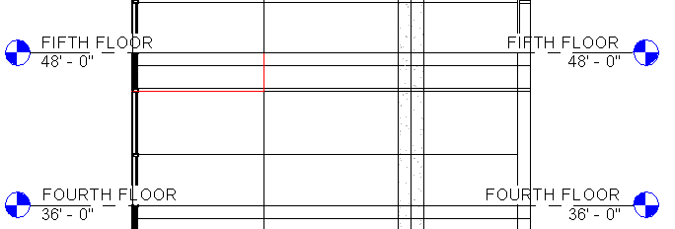

60 On the Type Selector, click System Panel : Solid.
The glazed panel is changed to a solid panel.

61 With the panel still selected, click P r ope r t i es
62 In the Element Properties dialog, click Edit/New to open the Type Properties of the panel.
The Offset property specifies the distance from the centerline of the curtain wall. Thickness specifies the depth of the panel, and Material specifies the shading and patterning.

63 Click OK twice.
64 Replace the two adjacent glazed panels with solid panels.
65 The glazed panels display in blue, and the solid panels display in white.

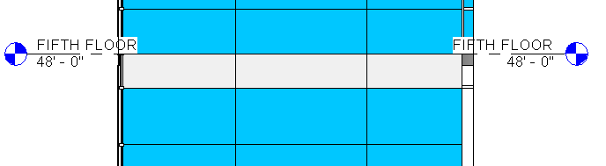

66 Change the remaining glazed panels in front of ceilings to solid panels.
67 A little trick! Modify….Match TypeProperties (paint brush)..Pick the solid panel….now pick the panel next to it. This avoids having to TAB TAB TAB to cycle to what you need (curtain panels. DISCUSS

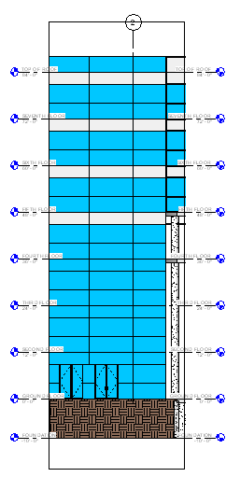

68 Save your file as: FirstLastCurtainWall.rvt
This completes the exercise for creating an entrance.

Adding Mullions to the Curtain System

In this exercise, you place mullions on curtain panel grids.

Training File: Open FirstLastCurtainWall.rvt

1 Architecture…. Mullion.
2 In Ribbon, select Grid Line Segment.
3 Place a mullion on the grid segment at the ground floor immediately to the right of the right set of doors.

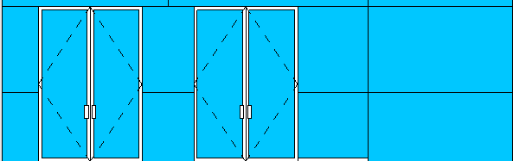

4 On the Options Bar, select Grid Line.
5 Place a mullion on the horizontal grid that is 4'0" above the ground floor.

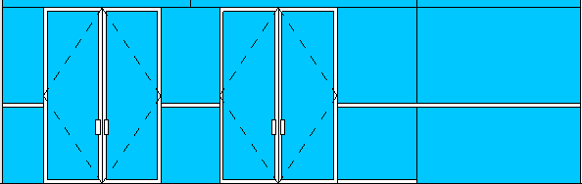

6 On the Options Bar, select All Grid Lines.
7 Place the cursor on any empty grid segment on the curtain system and click.

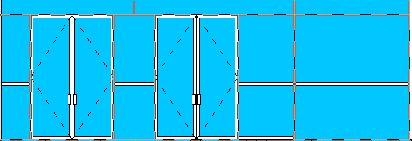

Now all empty grid segments have mullions on them; however, there are a few that you do not want, so you remove them next. The two mullions below the doors are not necessary, because their width reduces the size of the doors…..and people would trip over them entering the building!

Removing mullions

8 Zoom in to the set of doors.
9 Pick the mullion below the doors
10 Delete the mullions below them.

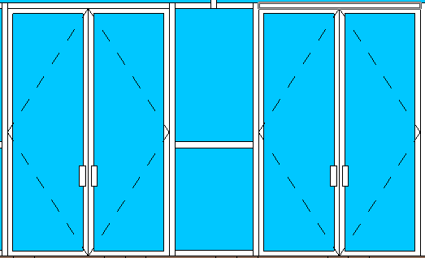

Mullions can change their joins to other mullions. You are going to change some mullion joins.

Changing mullion joins

11 On the View Control Bar, click Model Graphics Style ➤ Hidden Line.
12 Select the vertical mullion above and between the set of double doors.

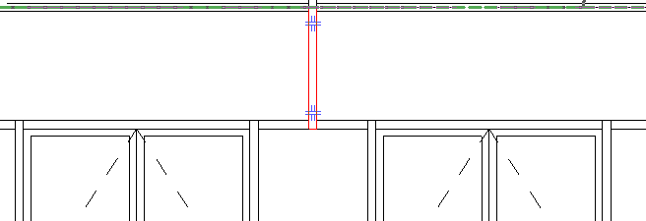

Two mullion join controls display.

13 Click the lower mullion join control.
The bottom of the mullion meets the top of the horizontal mullion.

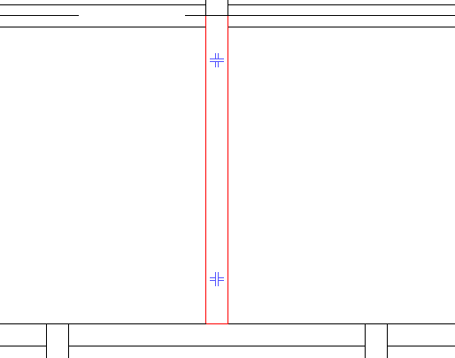

14 Click the top mullion control.

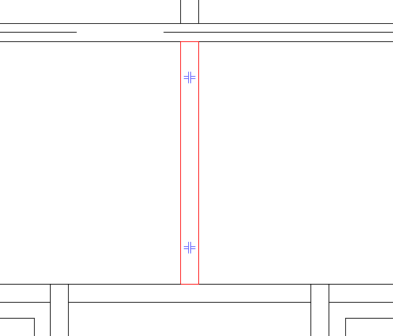

The top of the vertical mullion now meets the bottom of the horizontal mullion above.

TIP After selecting the vertical mullion, you can also right-click, and click Join Conditions ➤ Break at
Join to break the mullion at both joins.

15 On the Ribbon, click Modify.
16 In the Project Browser, double-click Southeast Isometric.
17 Save the file.

This completes the exercise for adding mullions.

This also completes the lesson on creating a flat curtain system. You learned how to create a basic curtain wall system and how to subdivide it with grids. You also learned how to modify grids and change panels. Finally, you learned how to add mullions and change their joins.

Save your file as: FirstLastCurtainWall.rvt

Curved Curtain System

In this lesson, you create a curved curtain system near the entrance of the model that was just completed. You also create a custom curtain panel for the system. Finally, you add both predefined and custom mullions to the system.

Adding a Curved Curtain System

In this exercise, you add a curtain system using the wall command. The curtain wall is sketched as an arc.

Training File: Open FirstLastCurtainWall.rvt

1 In the Project Browser, under Floor Plans, double-click GROUND FLOOR.
2 Zoom in to the circular space above the entrance that was just completed.
3 On the Architecture… Wall.
4 In the Type Selector, select Curtain Wall : Curtain Wall 1.

5/6 Properties (yea…I skipped a number…)
■ Under Constraints, for Top Constraint, specify Up to level: FIFTH FLOOR.

■ For Top Offset, enter 4'0".

■ Click Apply

7 On the Ribbon, click (Arc Start-End-Radius).
8 Start the wall by clicking at the left edge of the circle at the centerline of the intersecting wall.

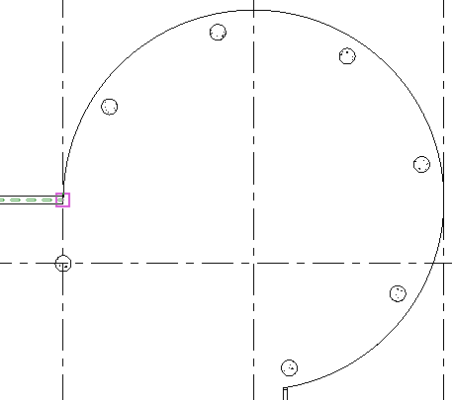

9 Place the second point at the lower right side.

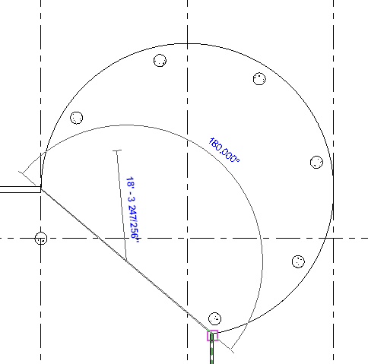

10 Finish the wall by clicking at the top of the arc.
(look for midpoint…like an OSNAP)
Check it out in 3D. See the arc wall? NO?

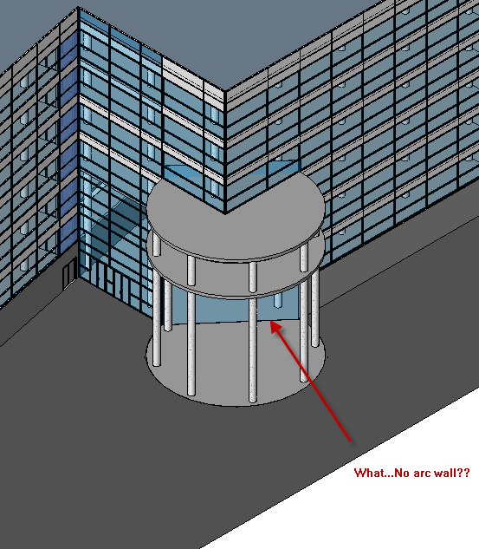

Back to Ground Floor

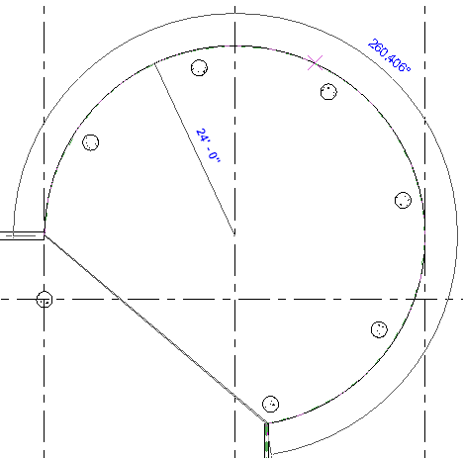

The curtain wall displays as one flat panel between the first and second points placed. Next, you place grids on the system. The curtain grid command snaps only to the curved arc. You are going to use one of these snaps points.

11 Architecture….Curtain Grid.
12 Snap the cursor to the midpoint of the curved arc and click. Watch the Status Bar at the bottom left corner of the screen to ensure you are at the midpoint.

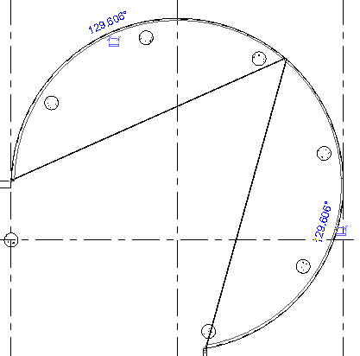

13 Continue to place more grids by using the snap points on the arc. Divide the halves into quarters, eighths, and then sixteenths. It gets easier as you attempt smaller segments.
14 In the Project Browser, under Elevations, double-click East.
15 Zoom in to the cylinder, and snap the cursor to each level line and click to add horizontal curtain grids. Do not add a grid on the GROUND FLOOR level.
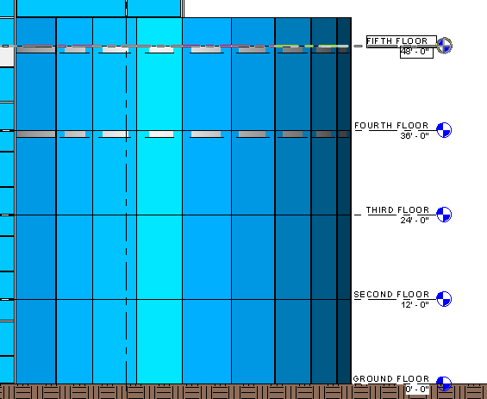

16 Next, you change some panels in the system.

Using walls as panels

17 Using a selection box, select the bottom layer of panels. Remember to click to filter out all other elements from the selection except Curtain Panels.
18 In the Type Selector, select Basic Wall: Generic - 12" .

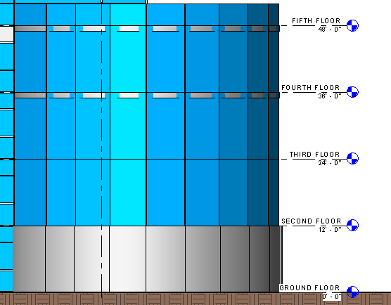

19 Save as: FirstLastCurtainWall.rvt

This completes the first exercise for creating a curved system. Next you create a custom panel and add it to the system.

Demo: Structural Components in Revit

Objective: Students will be able to setup a basic steel structure with concrete floors and footings utilizing Revit software. Students will be able to identify structural steel components such as columns, beams, braces, footings, and concrete/steel flooring.

The setup: Grids
When setting up a steel structure, start with Grids. They are set up horizontally with letters from left to right and vertically with numbers top down. The top, left corner will be Grid A1.
Architecture or Structure Tab
Grid
Make the grid line from bottom to top, vertically. Name the Grid “A”
Grid
Use the “pick lines” tool and offset grids B, C, D, E 25’0” apart
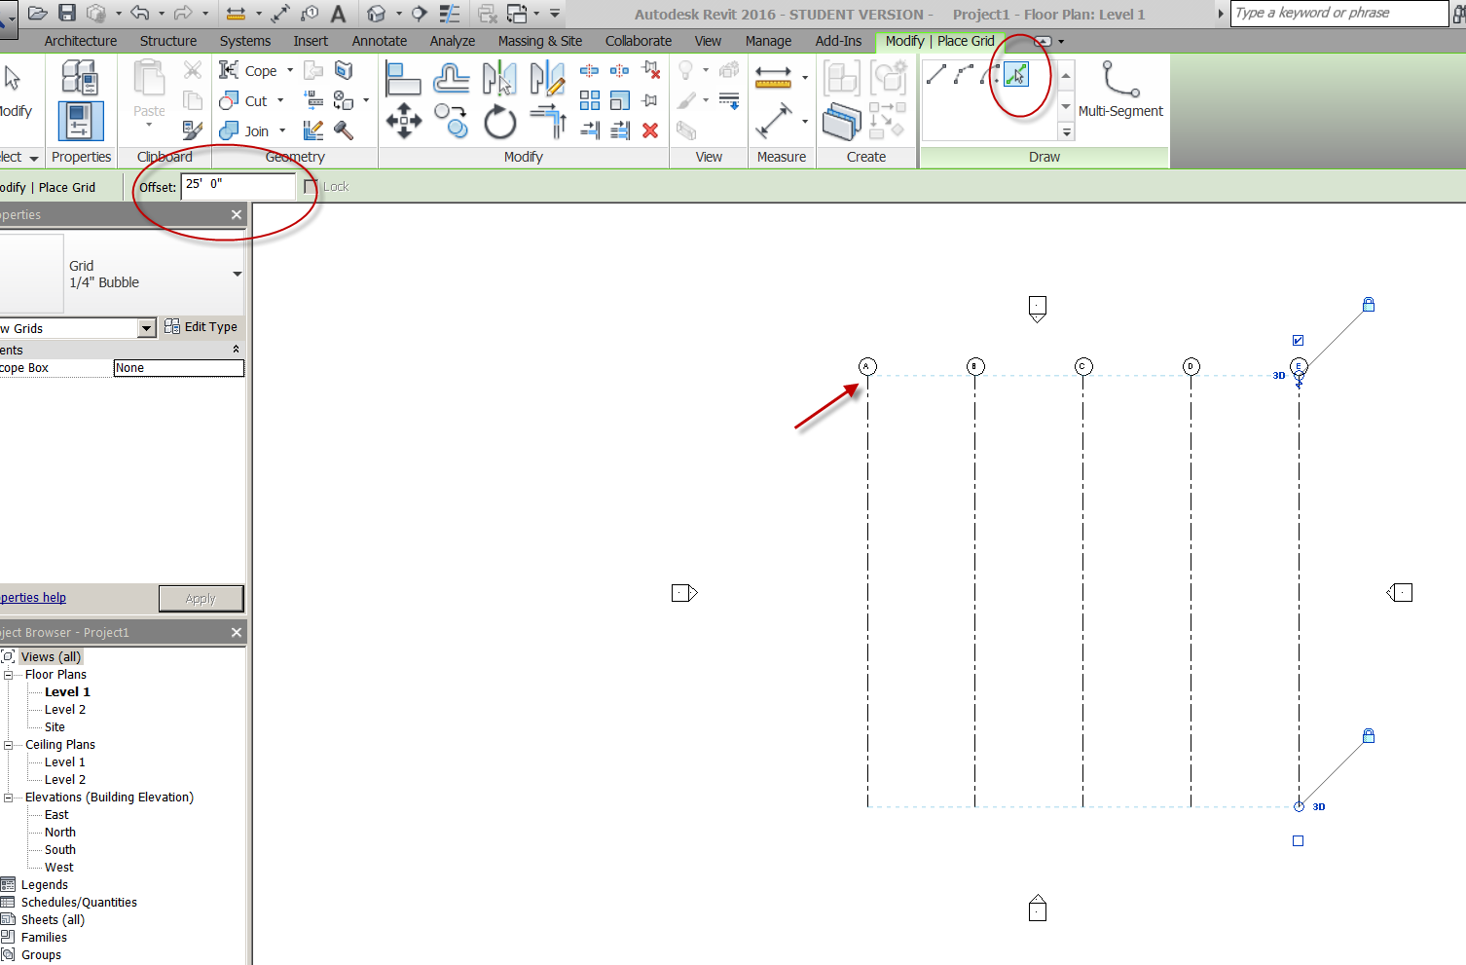

Grid
Create a horizontal grid from right to left
Name it “1”
Use “pick lines” tool to offset Grids 2, 3, 4 20’0” apart
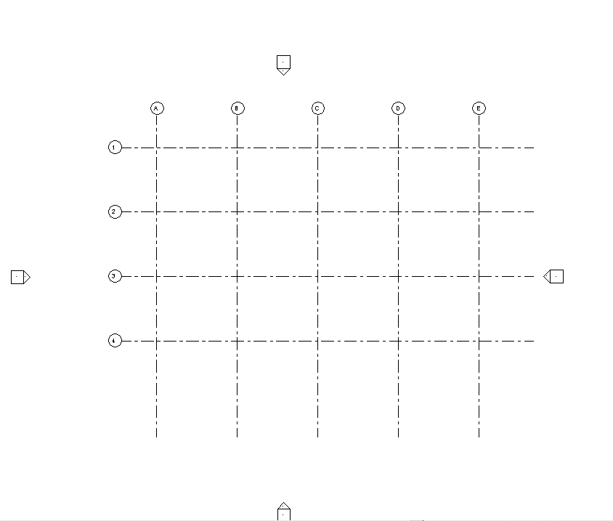

Show toggle for turning on Grid bubbles on opposite side of grid line
Show “edit type” on grid line to add grid bubbles on end 1
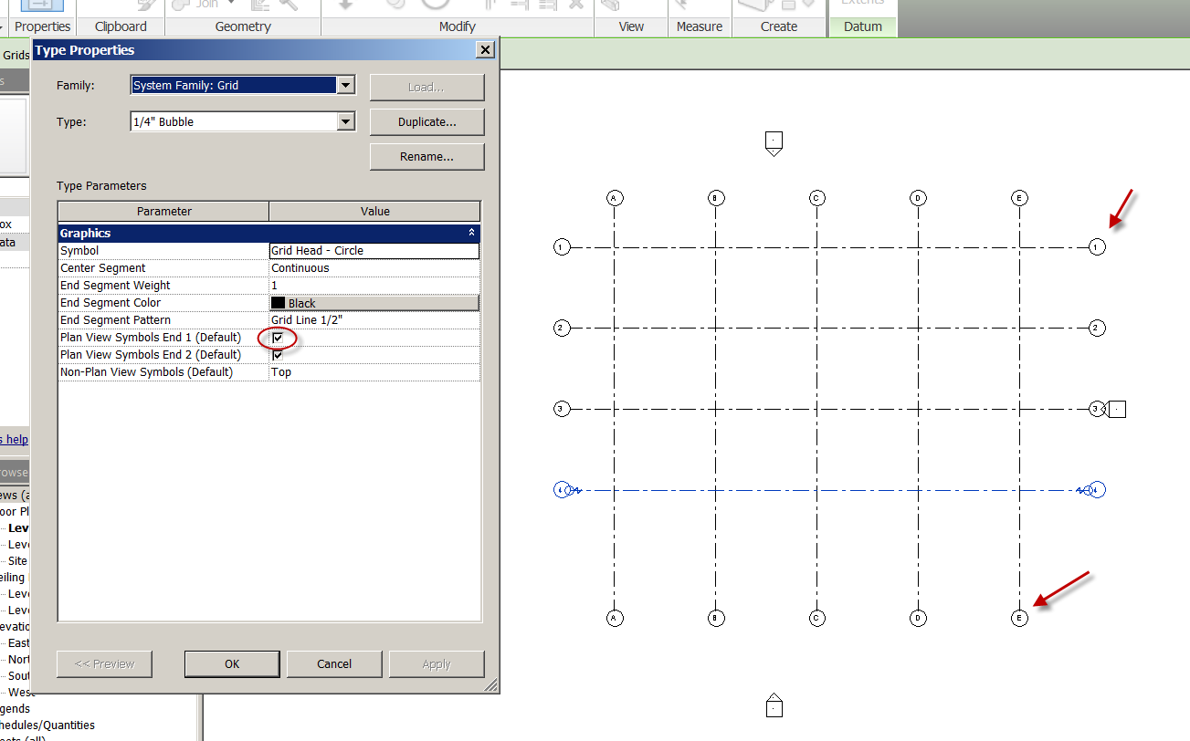
Structural Columns
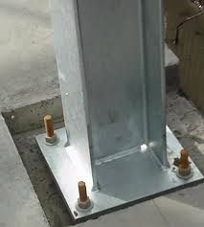
Note: Structural Columns are generally placed from top-down
Specify Height/depth in option bar BEFORE adding column
Floor Plan Level 2 (to place columns between Level 1 and Level 2)
Structure
Column
We’ll take the W10x49
Depth: Level 1 (get it….top-down?)
Place the column at Grid A1
Go to level 1. Is it there?
Cut a section to see the column. You may need to turn off the lineweight to see it clearly
Set the Display to Fine
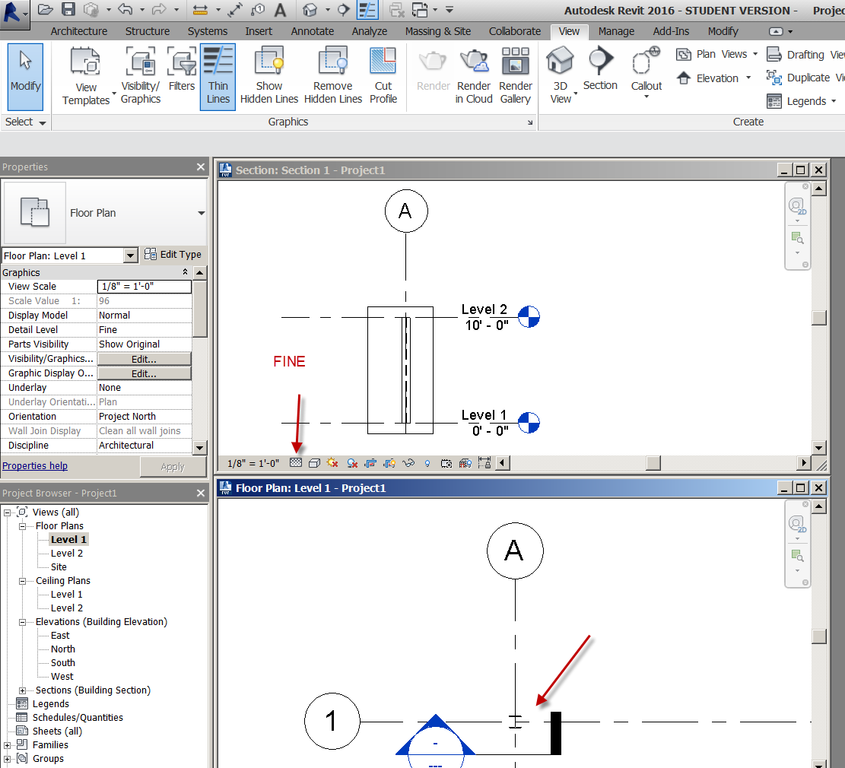

Back to Level 2
Let’s place the columns “by grid”….it’s faster!
Structure
Column
W10x49
At Grids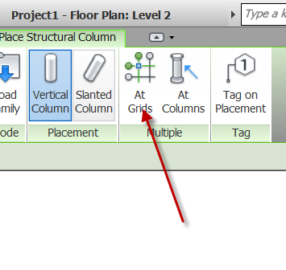
Use a crossing window to select the grids (bottom right to top left). You can hold the control key to select the remaining grids not picked up by crossing.
Depth: Level 1
Green Check
See in 3D!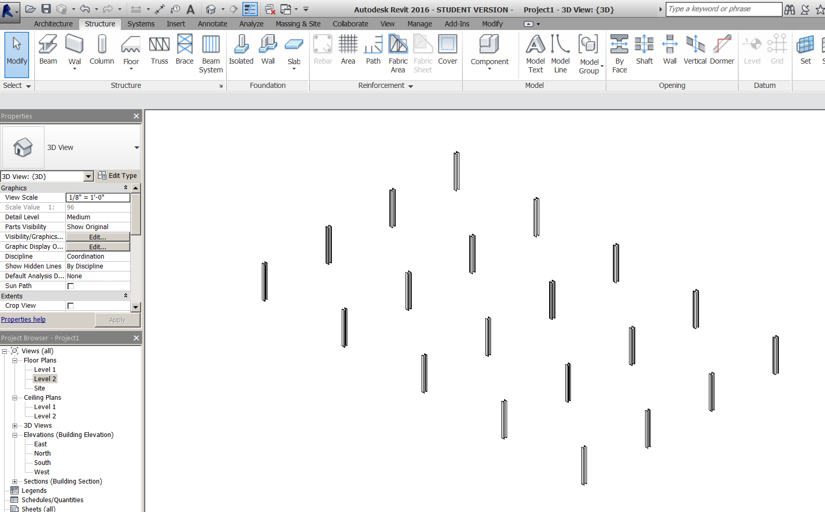

Add Footings for Columns
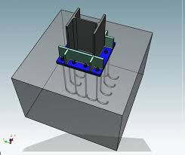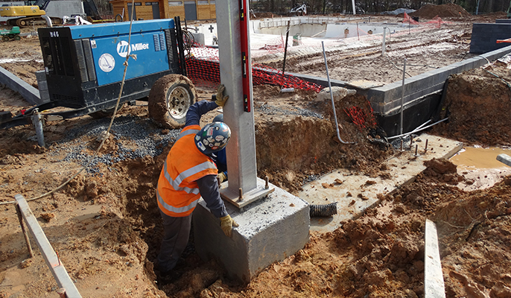
Floor Plan Level 1
Structure
Isolated
Sat “YES” to load family
Structural foundations….Footing rectangular….Open
Edit type….duplicate
Name it F3.0
Make the sizes: 3’0x3’0x1’0
Place at grids…..Finish
Note: You will not be able to see them because they are below Level 1!
Set Level 1 view range to view 2’0” lower
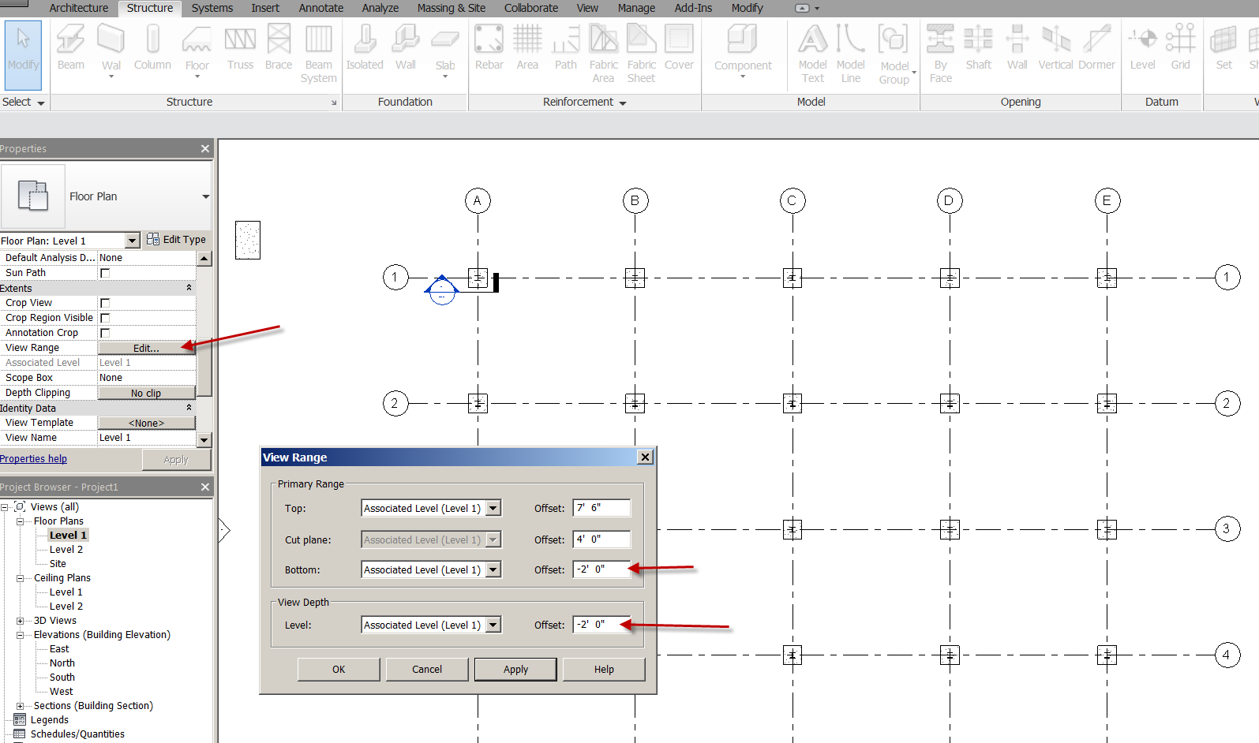

Save as structure1.rvt
Foundation Plan
Duplicate with Detailing Level 1
Name it “Foundation Plan”
Confirm the view Range is set to -2’0” (so we can see the footings)

Creating an exterior wall
Architecture
Wall
Basic wall generic 8” Masonry
Height: Unconnected 20’
Draw the wall 1’1 outside the grid line

Creating the footing
Structure
Foundation panel
Select: Foundation wall: Bearing Footing 36x12
Place on/attach to exterior walls
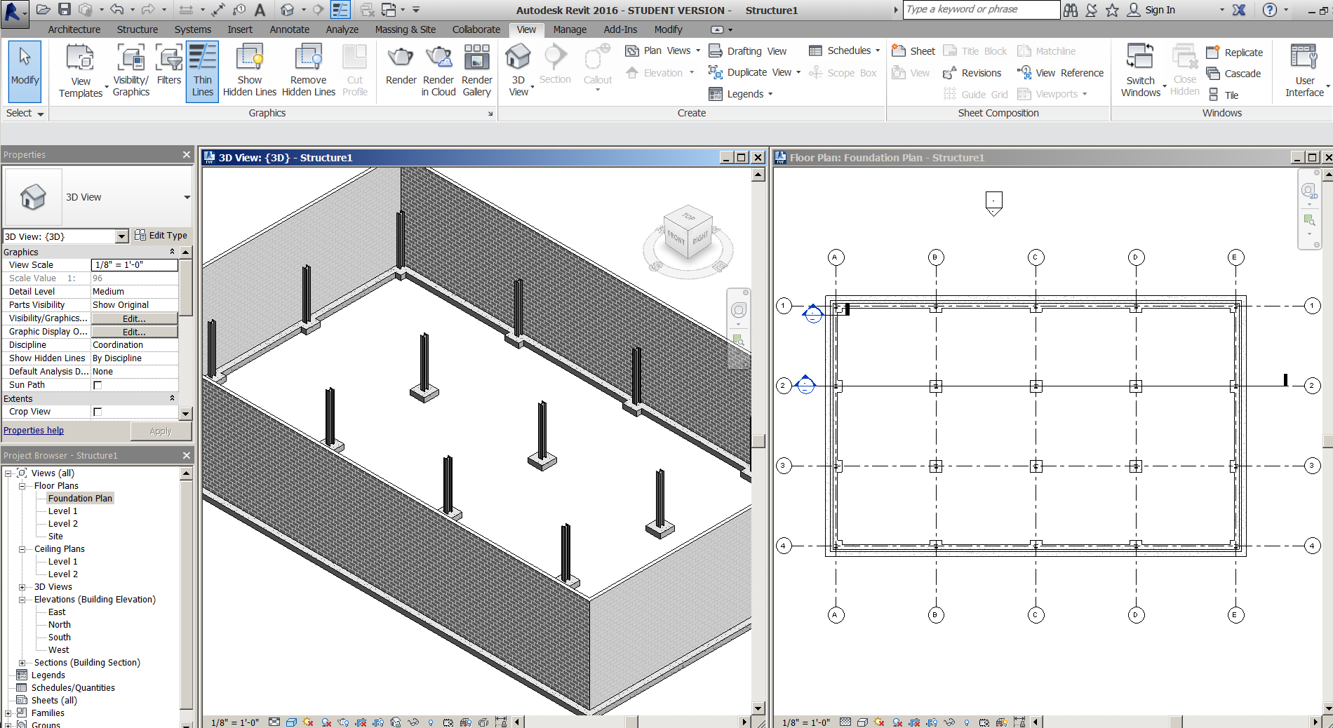
Save as: structure2.rvt

Creating Beams
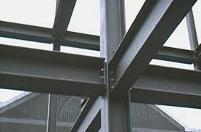
Level 2
Set view range to -2’ depth, like we did on foundation. The beams will be between level 1 and Level 2.
Set display to Fine
Structure
Beam
W12x26
Draw a beam from Grid A1 to B1
Draw a beam from Grid A1 to A2
OK
Show “change reference” button to extend beams to web instead of flange.
Continue to draw beams horizontally and vertically between gridlines.
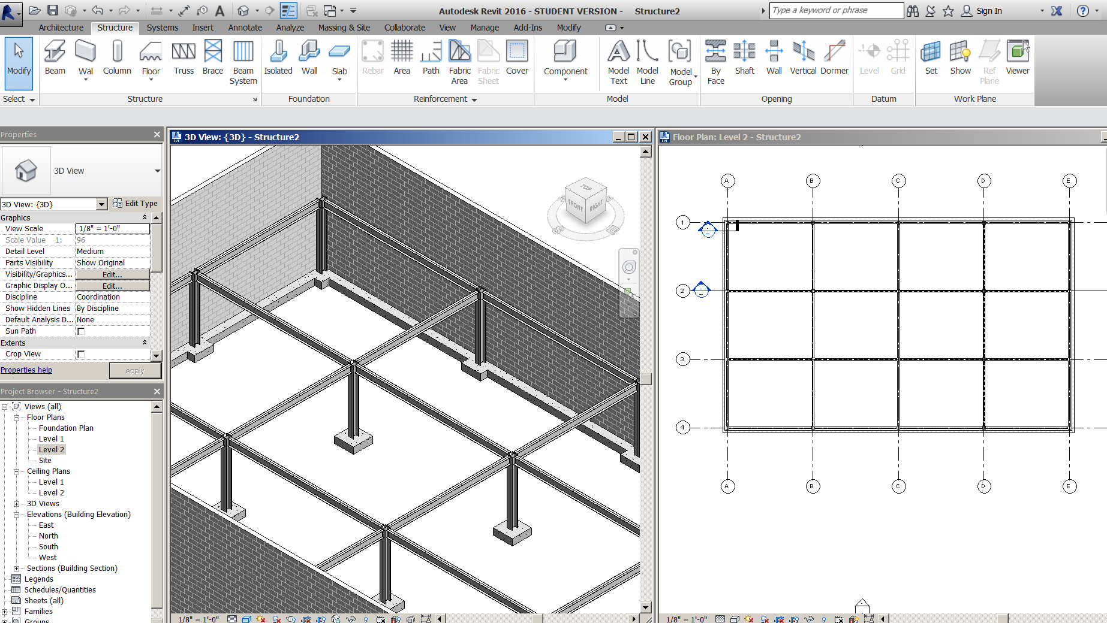

Creating a Beam System
Insert
Load family…structural framing….steel…..W-Wide Flange
W8x31….OK
Structure
Beam System
Automatic Beam System….W8x31
Fixed distance: 5’0
Pick inside top, left area between Grid A1 and B2. Note direction of beams
Set Elevation at 0
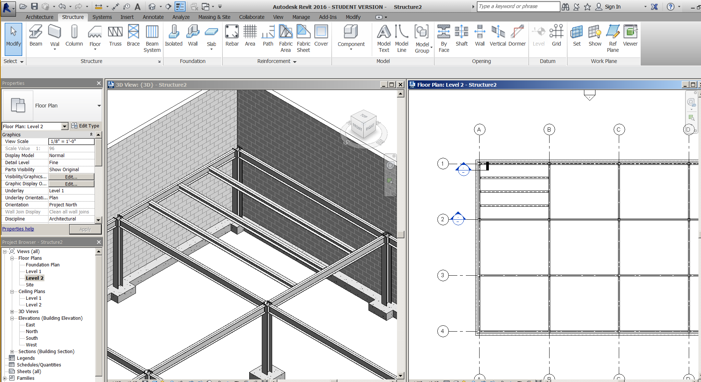

Create the rest of the beam systems (do not try to do all at once)
Note: No beams should be spanning the entire building!
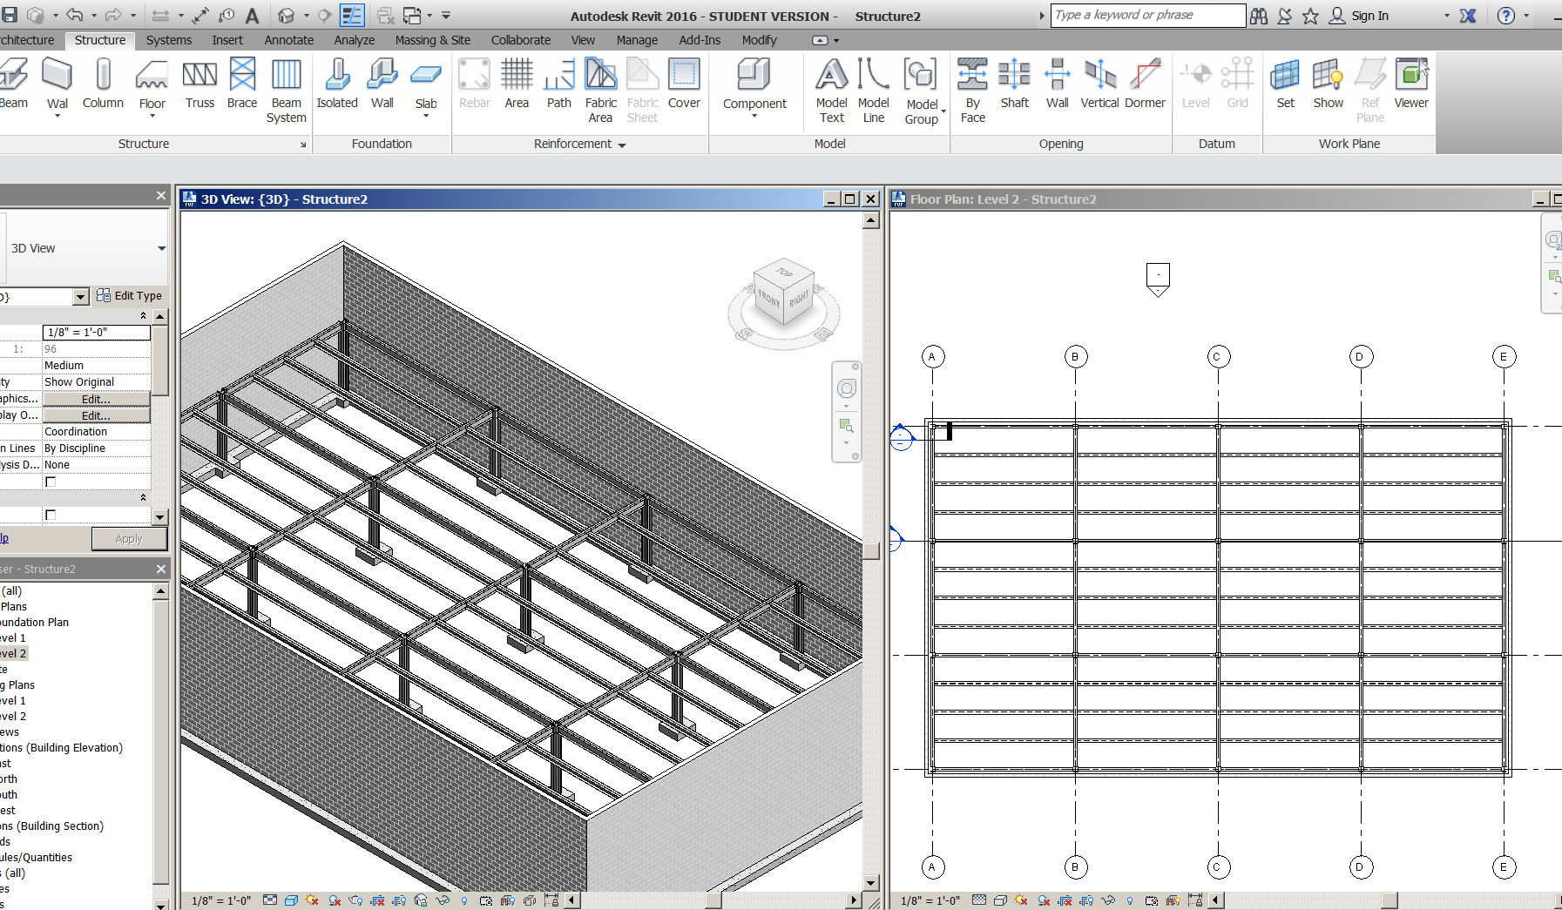

Creating the Structural Floor
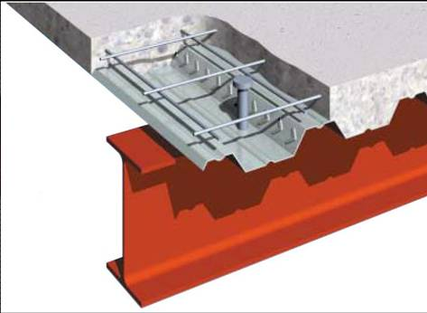
The structural floor is made of a metal deck w/ concrete poured on top.
Level 2
Structure
Floor: structural
3” LW Conc on 2” metal deck
Offset 5” (the thickness of the deck)
Make the boundary to the face of wall, not to gridline.
Cut a section to show the flooring and steel structure
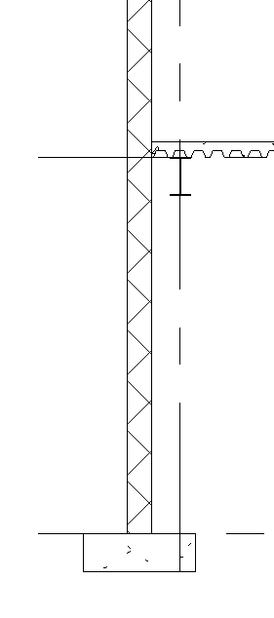
Save as: structure3.rvt
Creating Framing Elevations
Framing elevations are generally used to create (diagonal) bracing.
Level 1
View….. Elevation…..Framing Elevation
Note: these work differently than regular elevations
Pick a spot on Grid B between Grid 2 and 3
See how the framing elevation snaps to it?
Go to elevation View
Display: Fine

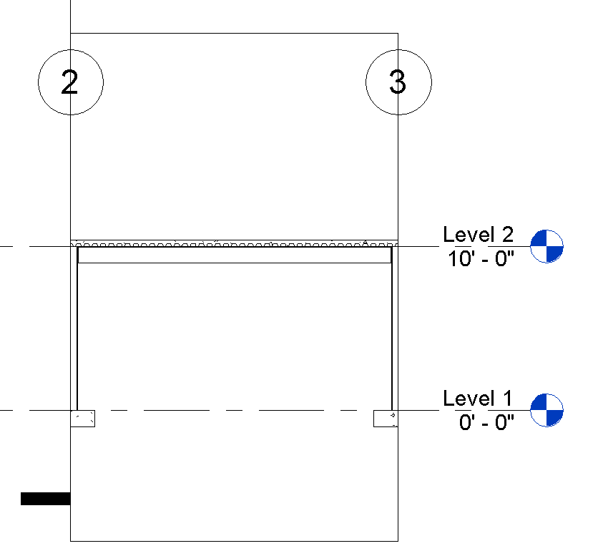
Note only one bay in the grid is selected! The framing elevation is ready for “Bracing”

Bracing
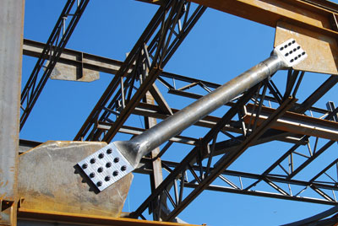
In Elev 1a you just created:
Insert….load family….Structural framing….Steel….
LL-Double Angle……2L6x4x3/8LLBB
OK
Structure
Brace
Create at 45 degree angle
Show in 3D (no connection brackets yet)
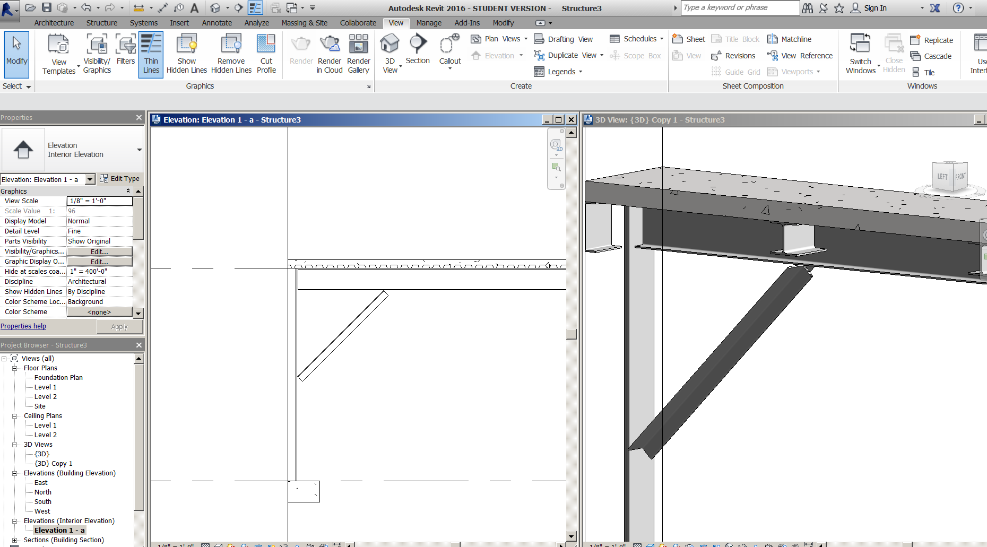

PROJECT 1: AutoCAD to Revit

Using the provided AutoCAD file as an underlay, turn the AutoCAD “As-Built” into a Revit file. The file is named Old School As-Built.dwg

Bill (teacher) demonstrates process.

Discuss Linking CAD vs Import CAD

Importing CAD: Becomes embedded in the Revit file and it maintains no link to the AutoCAD file…so if there is a change to the original AutoCAD file…..The imported CAD file will not change. You would have to erase the CAD file….then re-Import the CAD file.

Link CAD: Maintains a “link” to the original AutoCAD file…..so if the original AutoCAD file changes, it just need to be re-linked to be updated in the Revit file.

Colors: Invert. AutoCAD generally has a black background and Revit generally has a white background. Inverting colors can be a good idea to get a more legible look.

Link the CAD file in. Show Query

Show VV…..Import Categories. See layers?

Make a small change in AutoCAD file….save it.

Back to Revit.

Insert…Manage Links…CAD Format…Reload…OK….see updated Change? That’s the process.

Importing CAD

Show putting CAD drawing on a drafting view…..then drafting view to sheet. Show attempt at reloading link…can’t!

Exterior Walls are 20’ high 2x6 core
Flat Roof is 2X12 at 16’ high
Ceilings are 12’high 2X4 T-bar
Interior walls are 12’0” 2X4 2-hr
Interior doors are 7’6 high
Foundation is a 6” concrete slab with 12”X12”X24” deep footings at the columns
There may be mistakes on the AutoCAD drawing, but you need to create the Revit model it AS IT IS.

Save as:
FirstLastOldschoolAsBuilt.rvt

Keynotes

Types of Keynotes

Element. A keynote can be applied to an entire element, such as a wall, detail component, or door.

Material. A keynote can be assigned to a material that has been painted on a surface, and to materials assigned to the component layers of an element. Material keynotes are not supported for the insulation drafting tool, the detail components line and filled region, or wireframe views.

User. This option provides a way to use commonly used notes or phrases to address documentation issues. These additional user notes must be added to the provided keynote text files or included in one that you create. See Adding Additional Categories.

Assigning Keynote Values to Materials

- Keynote selection can be applied to materials. Keynotes are assigned to materials on the Identity Tab of the Materials dialog. To access the Materials dialog, click Manage tabSettings panel (Materials).
- When materials are assigned a keynote value, the objects that use these materials inherit the keynote value accordingly.
- A great deal of time can be saved if the materials of a project have their keynote values applied before you apply keynote tags to materials. See Changing Material Identity Data.

Assigning Keynote Values to Elements

- All elements have a Keynote Type parameter. These can be supplied in advance using the Type Properties dialog (see Element Properties), or selected when the tag is placed.

Assigning Keynote Values Using Tags

- After you apply a keynote tag to an element, you can select the keynote tag and click over the keynote value or empty value to open the Keynotes dialog. Select the desired keynote for the element.
- Note If you click OK, Revit Architecture uses the keynote value that is currently selected. If you click Cancel, the keynote value remains empty.
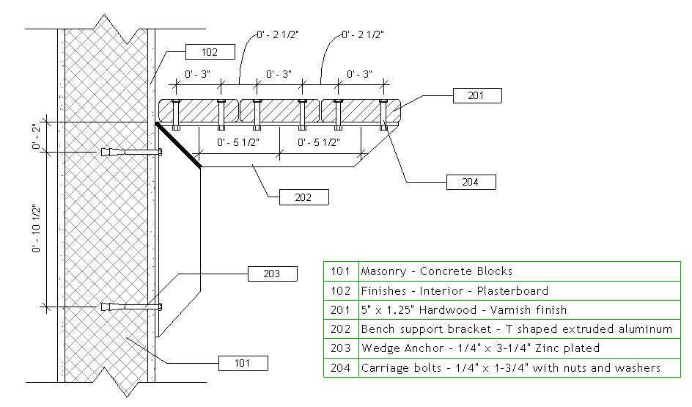
See CSI Masterformat.pdf for categories on the common drive
The Keynote File
(It’s just a little .txt file)
Note the 1 tab between the items
Note the last number is the group heading
Example: Concrete Forming 03 11 00 is under Concrete Forming and Accessories 03 10 00
Concrete Slip Forming 03 11 13.13 and Concrete Shoring 03 11 13.16 are under
Structural Cast-in-Place Concrete Forming 03 11 13
It’s an organizational system….

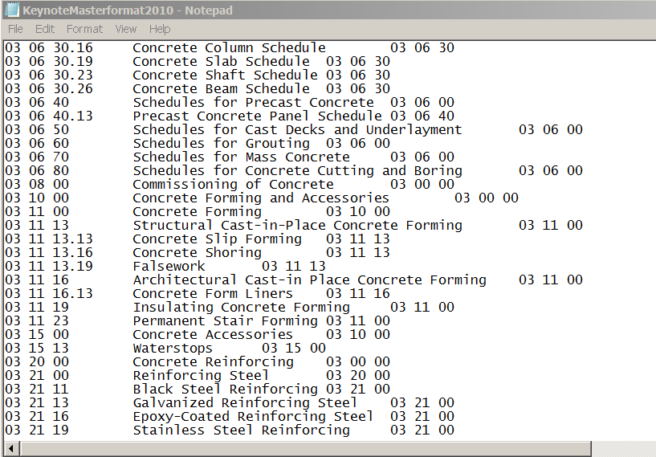
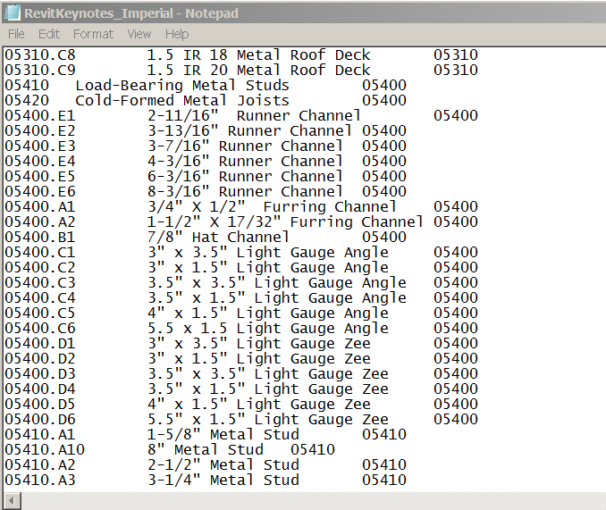

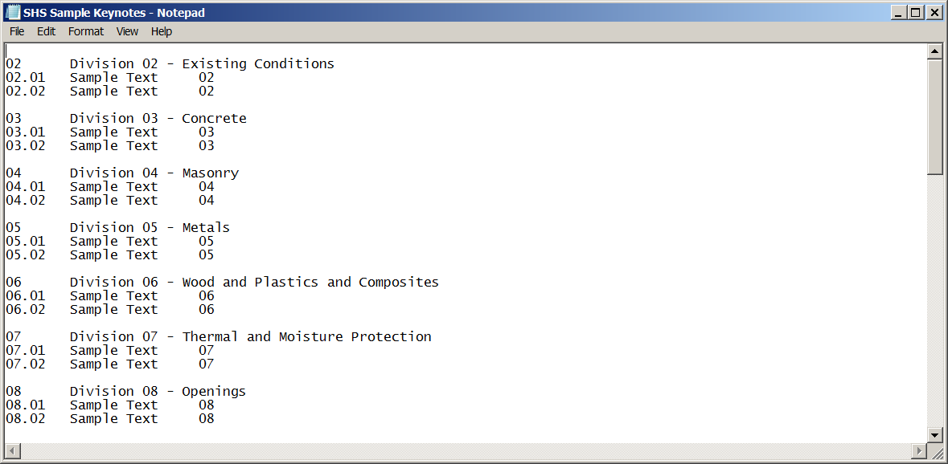
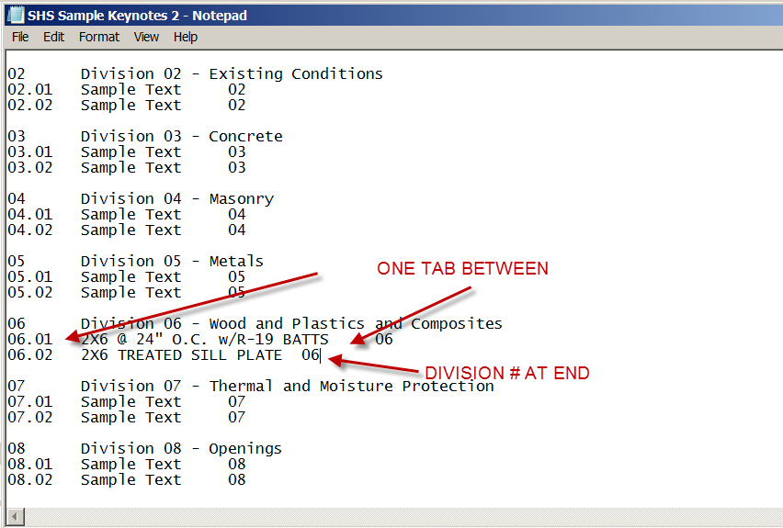

Let’s get started!
Open Revit2017Foundation2.rvt
Copy SHS Sample Keynotes.txt into your My Documents folder

First we need to point to the Keynote file we want to use.
Annotate
Tag….Keynote
Keynote Settings
Browse….point to SHS Sample Keynotes.txt into your My Documents folder
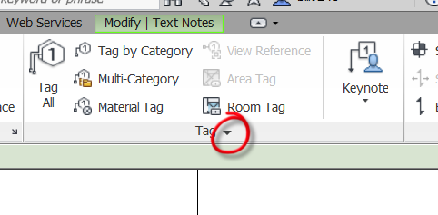
Choose path to Keynote file
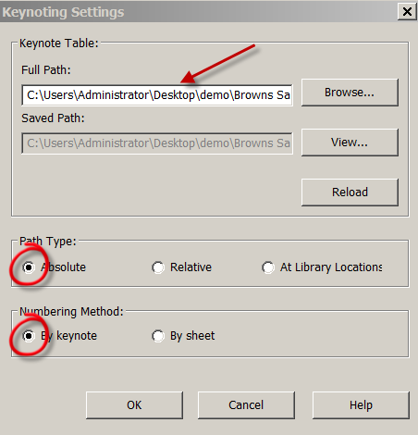

Go to the Section view that is cutting thru the exterior of the building. It should look like this:
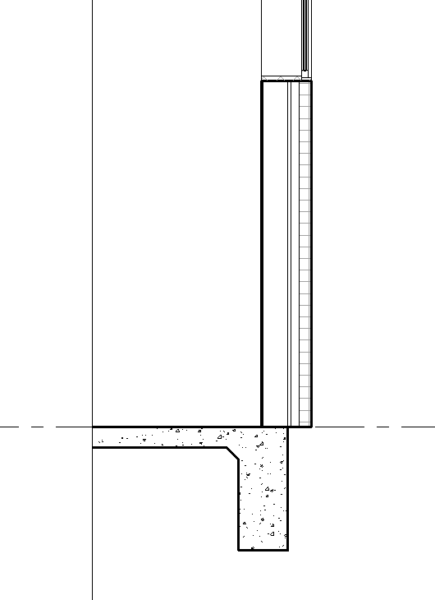
Add a 2X6 metal stud
Annotate…Component….Detail Component…..Load Family….Detail Items….Div 5 Metals….054100-Structural Metal Studs Framing….Chanel Studs-Section…Open
Pick the 6” section (turn off the lineweights to see better)
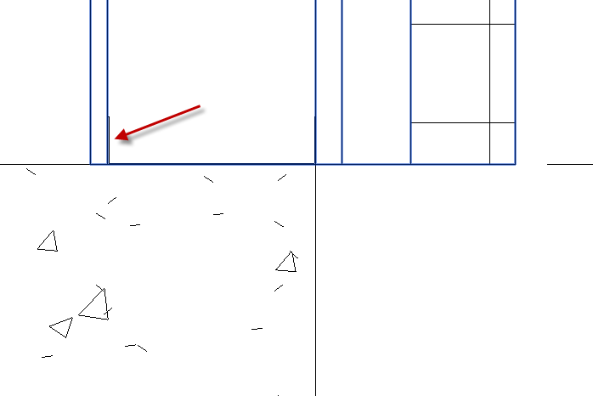

Pick on the 6” Channel Stud
Properties….Edit Type
Keynote…Pick it
Open Division 5. See our file?
The info we want is not there.

Open the Keynote File SHS Sample Keynotes.txt
Add the text 6" C-Channel Stud @ 24" O.C. in Division 05.01
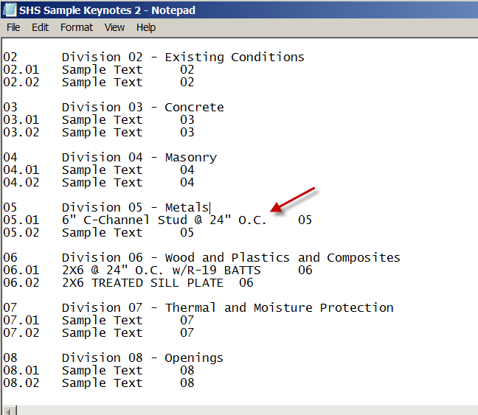
Save the file
Close it (you shouldn’t leave it open)

Pick on the 6” Channel Stud again
Properties….Edit Type
Keynote…Pick it
Open Division 5. See our file?
The info we want is not there. What happened????
Annotate…..Keynote Settings….RELOAD!

Now try it again
Pick on the 6” Channel Stud ….again
Properties….Edit Type
Keynote…Pick it
Open Division 5. See our file?
Ah….there it is! Pick 05.01
OK
We just created an “Element Keynote”
Any other 6” Channel Studs we bring in will have that Keynote
SHOW
Change the View Scale to 1”=1’0”
Annotate….Tag….Keynote….Element Keynote
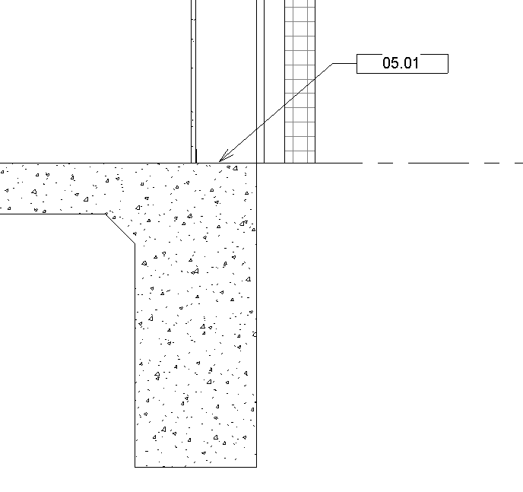

User Keynote
You can create a keynote that is not associated with an object.
Open the Keynote File SHS Sample Keynotes.txt
Add the text Paint Dunn Edwards DE2345 in Division 09.01
Save the file
Close it
Reload it

Annotate…..Tag…..Keynote….User Keynote
Point to the edge of the wall
Division 09.01
OK
Let’s do one more
Create 6” insulation in the 6” wall pocket
Annotate….Insulation….Width: 6”
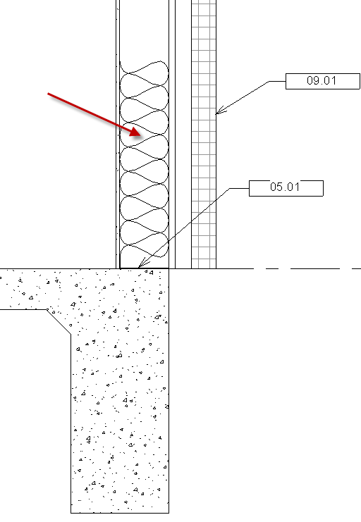
Now pick insulation
Notice no opportunities for Edit Type!
So what kind of Keynote will we have to use???
Open the Keynote File SHS Sample Keynotes.txt
Add the text 6” BATT INSULATION in Division 07.01
Save the file
Close it
Reload it
Annotate…..Tag…..Keynote….User Keynote
Point to the insulation
Division 07.01
OK
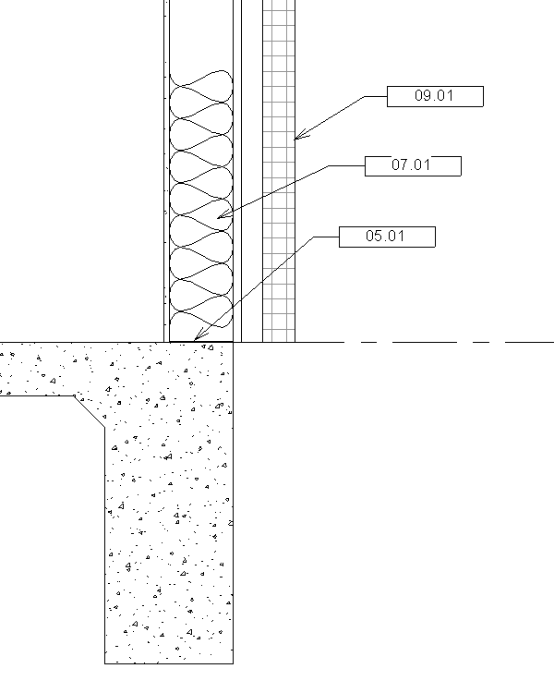

Creating the Keynote Legend
Place the section on a sheet if it is not already there. Mine is on sheet A602 Wall Sections

View
Legend
Keynote Legend
Name it “Keynotes” OK
Notice Key Value and Keynote Text are ready to go in the schedule! OK
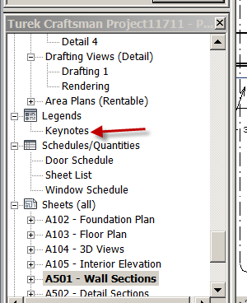
Open sheet that has the Wall Section
Place the Keynote Legend on the sheet!

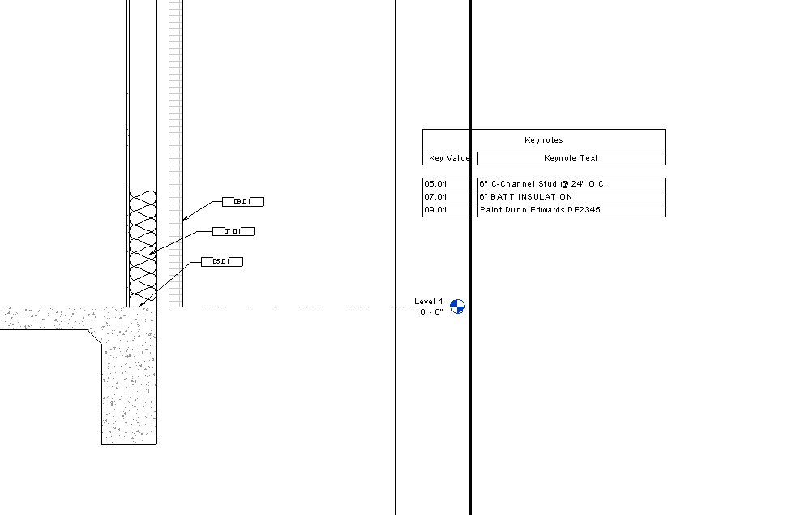

Try dragging the Keynote Legend to another Sheet
Note that it goes on…..but do we really want Keynotes on a sheet that does not have specific keynotes?
Open Keynote Legend in Browser
Properties
Filter
Edit
In Keynote Legend Properties, click Filter by Sheet
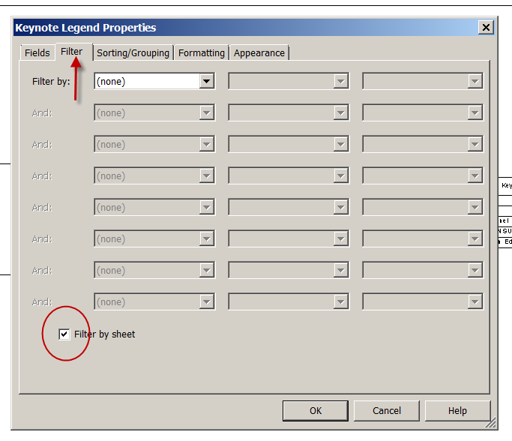

Now check it out! Get it?? If you don’t do it this way, you will have every keynote in the project on every sheet!

Grouping

Grouping is similar to blocks in AutoCAD. You can put items together and :Group” them, so they come in as one smaller object.

Open Revitdemo 16.rvt

We will start by making a “group” with no special challenges…..

Floor Level 1
In a Bedroom, bring in a Double Bed, Chair and Desk.
Set them up in a Typical Layout
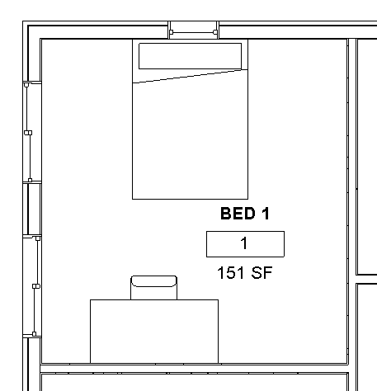

Select the Double Bed
Modify Furniture pull-down comes up
Create
Create Group
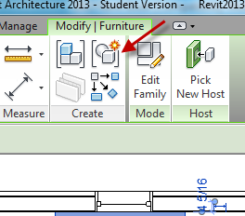
Name it Typ Double Bed Layout
Check open in Group Editor
OK
+Add
Select the Desk
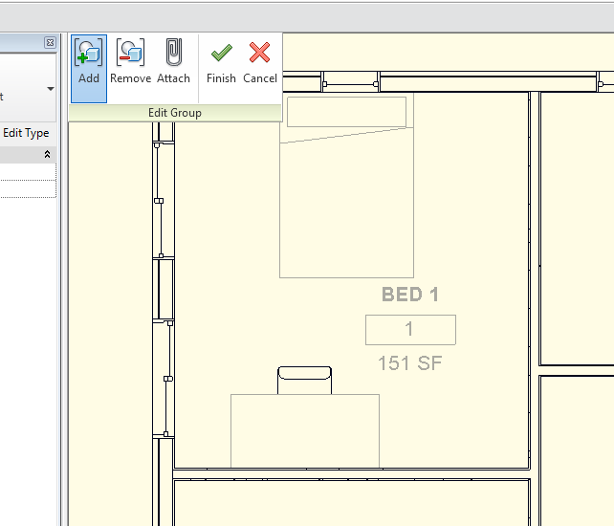
Select the Chair….notice when you add it, the component grays out.
Finish
Select the group you should see a dashed box around the group
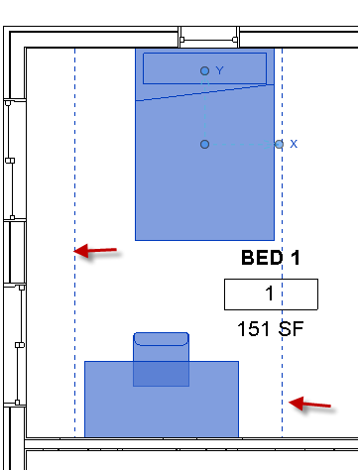
See it is ONE “object”, that can be used over and over again, like an AutoCAD block.

Use it….
Architecture
Model Group
Place Model Group
Place the Group in another Bedroom
(Note: you can Rotate the group)

Editing the group

Let’s make a design change….. swap out the double beds and replace them with King Beds.

Select the group
Group
Edit Group
Pick the bed
Properties
Pick the Queen Bed
Finish
See all the groups change??

Now let’s eliminate the chair
Pick the group
Edit Group
Pick the chair
-Remove
Finish
Note: All we have done is removed the chair from the group……note the chairs were not deleted….
Undo that….so the group has the chair

Edit group
Pick the chair
Delete the chair
Finish
Note the chairs are gone in all the groups!
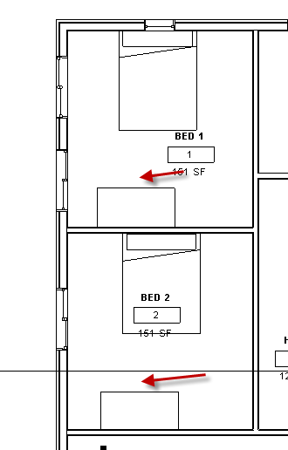

Adding to the group

Component
Place a component
Pick a dresser
Place it
Pick the group
Edit Group
+Add
Pick the dresser
Finish
All the groups update!

Note: All the groups update in the ENTIRE PROJECT…..FYI

Creating a “Smart” Furniture Family

Families can be created or found that work in one instance but sometimes need to be modified. What if we only had one size of window, and had to create a new window each time we wanted a different size? We would be AutoCAD! Revit allows you to create modifiable families, so you have the ability to change certain selected properties (like width, length, thickness, radius, etc) to meet your needs. We will create a simple table. We will be able to adjust its length, width, height, top thickness, and base thickness. The strategy of family creation will be emphasized.

File….New…..Family….Furniture.rft (.rft are family templates)
Open
Show reference planes
Cen FB
Cen LR
Ref level

Floor ref level
Make 4 ref planes parallel to axis
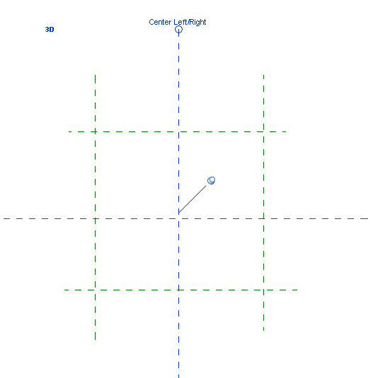
Dim EQ to center planes
Dim overall width (do not worry about size)
Dim overall length (do not worry about size)
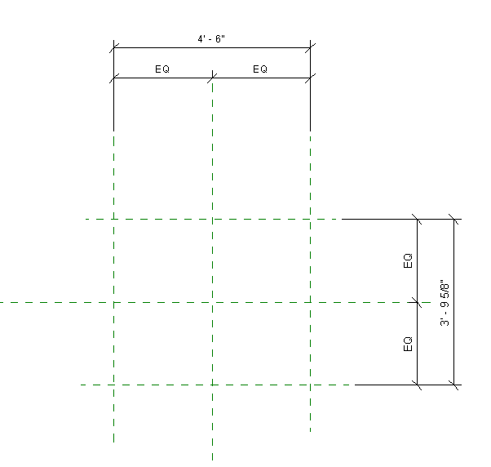

Note: We have not created any geometry yet

Front view
Reference plane
Create Top reference plane
Name it “TOP”
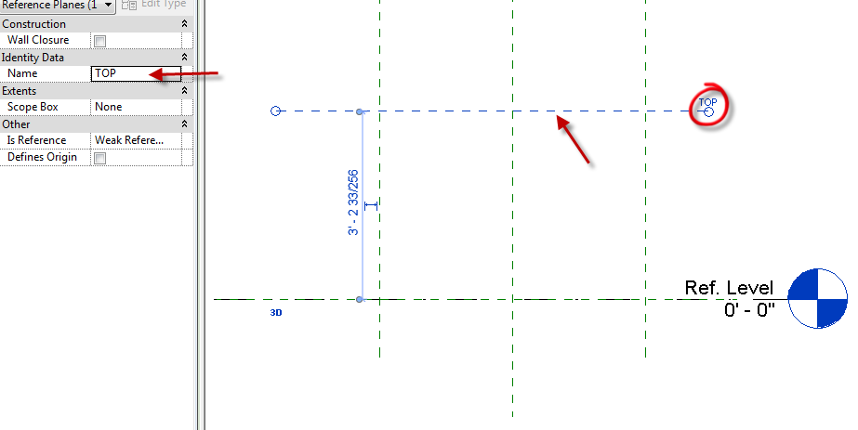
Create Bottom of Top reference plane (a little below “TOP”)
Name it “BOT”
Create a horizontal reference plane between BOT and Ref Level
Name it “TOP OF BASE”

Note: We still have not created any geometry yet

Dimension from: TOP to Ref Level ref plane (tab to get it)
Ref Level ref plane (tab to get it) to TOP OF BASE
TOP to BOT
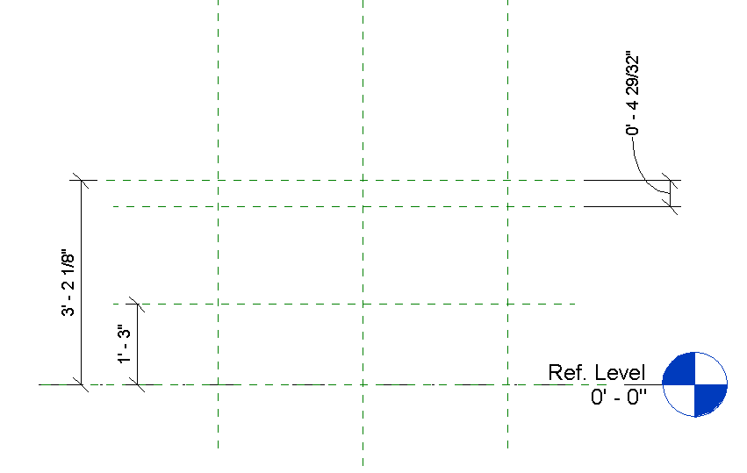
Move reference planes around. See dimensions change?
Concept: We will be moving the reference planes when we adjust the sizes of our table. The geometry of the table will be locked to the reference planes.

Family Types
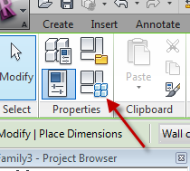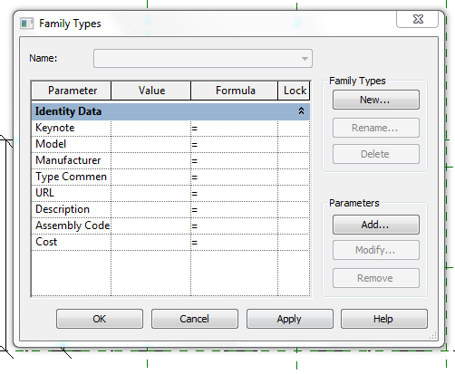
Notice there are no dimensions here (yet)
Cancel
Floor ref level
Select the overall length dimension
Label…add parameter
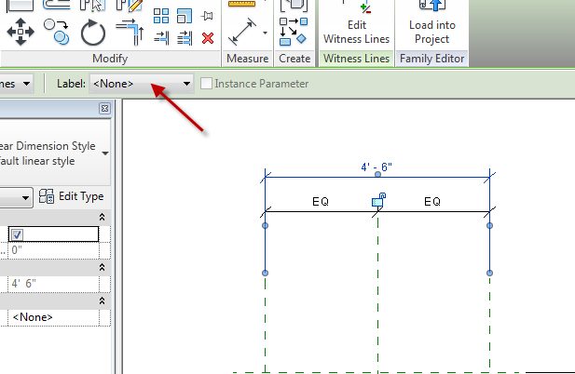
Name it “LENGTH”
Group: Dimensions
OK
Select the overall depth dimension
Label…add parameter
Name it “DEPTH”
Group: Dimensions
OK

Types
See 2 dimensions? LENGTH and DEPTH
Change Length to 6’
Change Depth to 4’
Apply
See ref planes move and dim update. Notice they moved equally from the center planes?
Change Length to 5’
Change Depth to 6’
Apply
This is called “FLEXING”
Cancel

Front view
Select Height dimension
Label…add parameter
Name it “HEIGHT”
Group: Dimensions
OK
Select top thickness dimension
Label…add parameter
Name it “THK”
Group: Dimensions
Select base thickness dimension
Label…add parameter
Name it “BASE HEIGHT”
Group: Dimensions
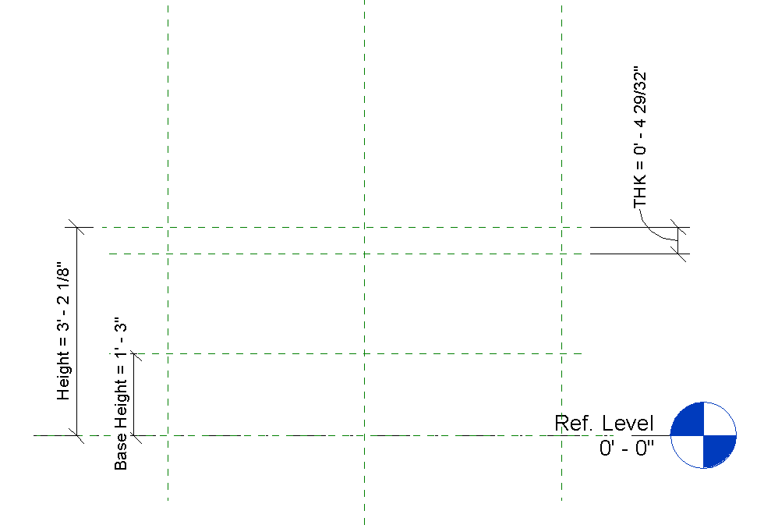
OK
Family Types
Base Height: 1’ Apply
Height: 4’ Apply
THK: 1”
See the ref planes move?

Note: We STILL have not created any geometry yet!

File
Save as:
Family
Table Ref Layout

OK…Let’s create some geometry

Floor ref level
Create
Set (you must do this first)
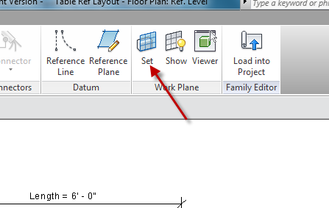

BOT OK
Forms
Extrusion
Make a rectangle inside the ref planes
Align and lock the rectangle to the 4 ref planes
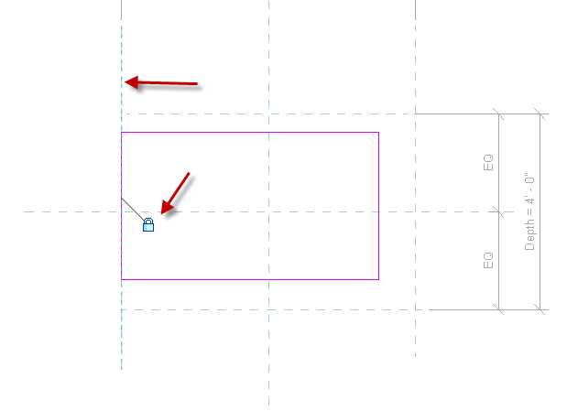

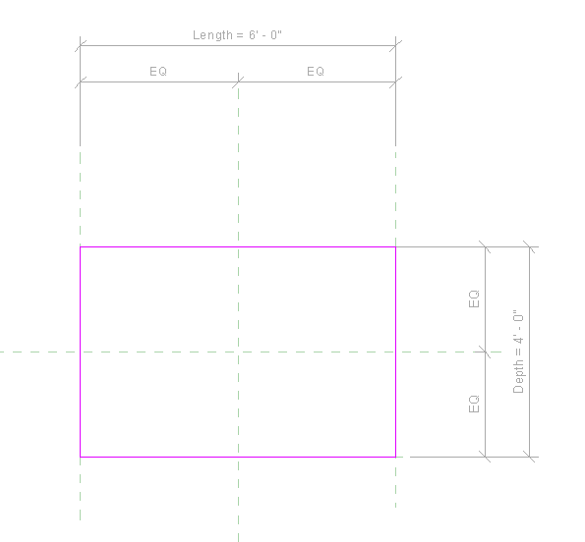
Green Check
Front view
Drag the top down with the blue arrow and lock the rectangle to the TOP ref plane.
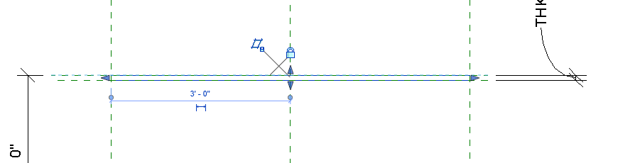

See in 3D…SD

Types
Depth to 2’
Length to 4’
THK to 2”
Apply
See the change?

Try:
Family Types
Depth to 4’
Length to 8’
THK to 3”
Apply
See the change?
This is called FLEXING the model. If your model did not change, you need to review the process you used and troubleshoot.

Select the top extrusion

Properties
Material: Glass
3D
SD
See material?

Now let’s do the trapezoidal base

Floor ref level
Make (interior) parallel ref planes about where the base might be
Dimension the same way we did the Top, with EQ’s and overall dimensions
Name overall dim as “BASE LENGTH”….dimensions
Name overall dim as “BASE DEPTH”….dimensions
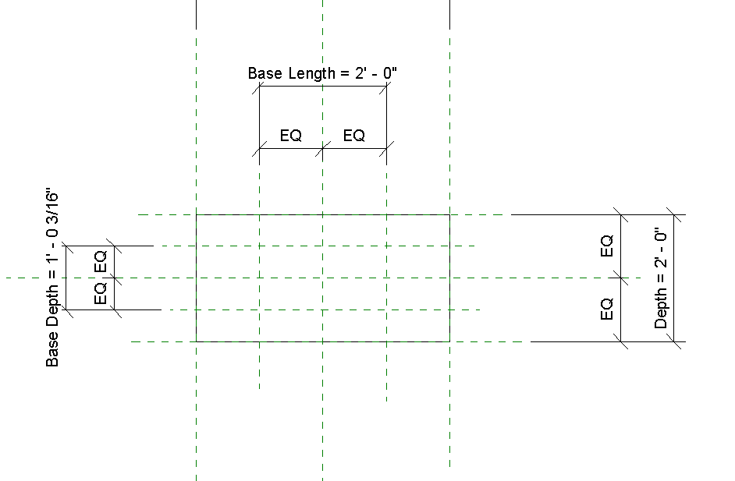

Create
Set
Level: Ref Level
OK

Create
Blend
Make rectangle
Lock sketch lines to ref planes
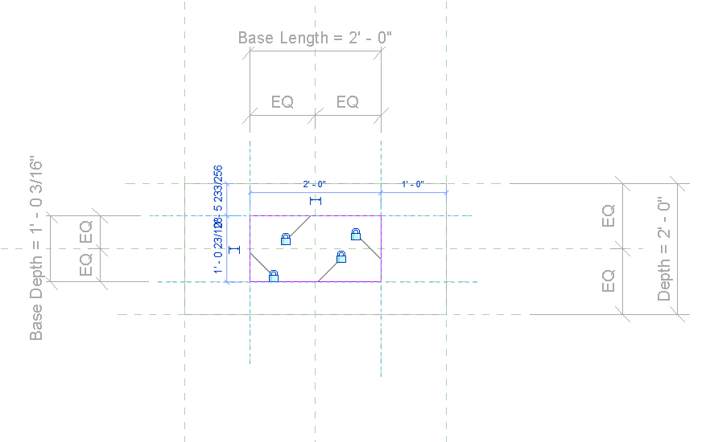
Depth: 1’ (will be adjustable)
Edit top
Offset 3”
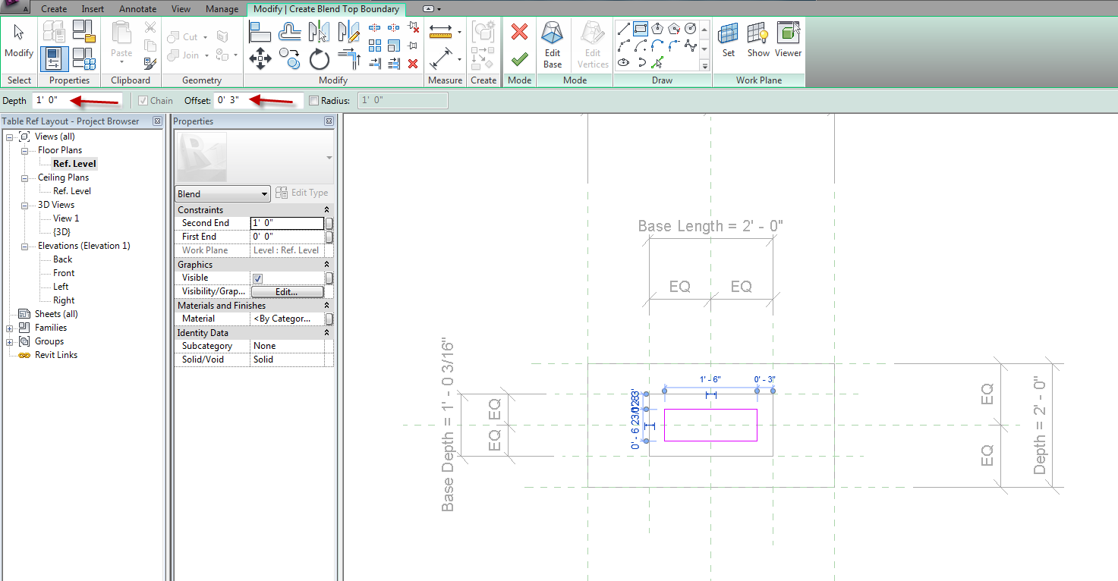

Use existing lines to create smaller box
Green Check
Front view
Align and lock top of trapezoid to TOP OF BASE ref plane
Modify
Align
Pick Ref Plane….Pick top of lend
Lock it
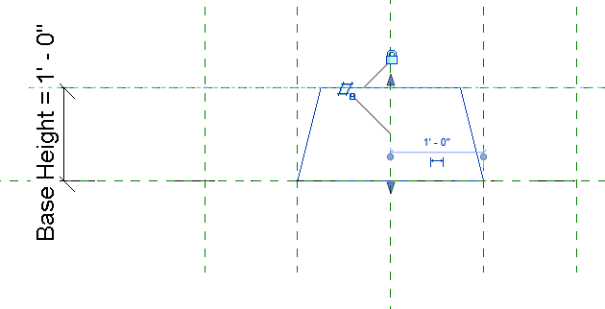

Time to FLEX!
3D
Types
Base height: 6”
Apply Did it flex?
Base Length: 3’
Base Depth: 2’
Apply Did it flex?
OK

Front view
Pick base (trapezoid)
Properties
Material (we will create our own)
Default….duplicate
Name it: COPPER
OK
Shading: pick a copper color
OK
Green Check
3D view
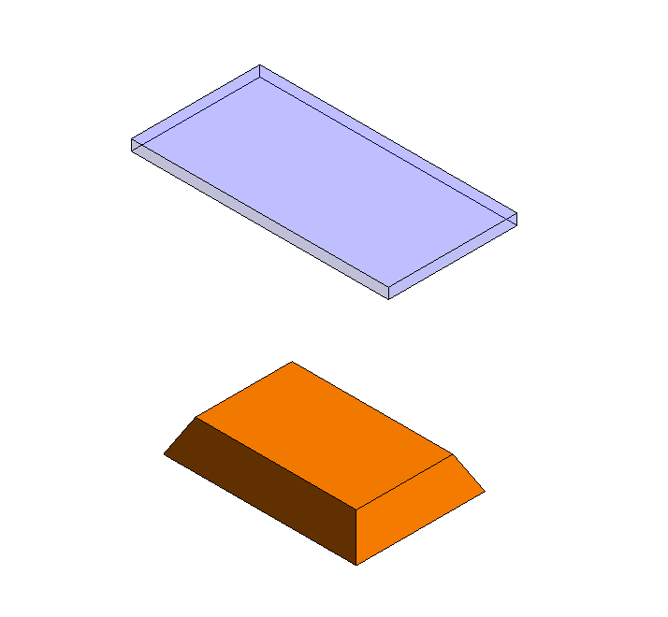

Center piece of table

The center piece will be a revolution (like a turned-spindle)
Front view
Architecture
Set
Center Front/Back
Forms
Revolve
Axis Line
Make along center…vertically
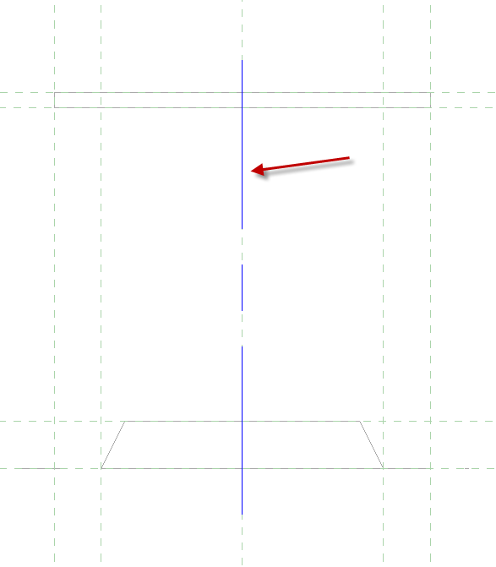
Lines
Create ½ (profile) object between BOT and TOP OF BASE planes on left side of axis
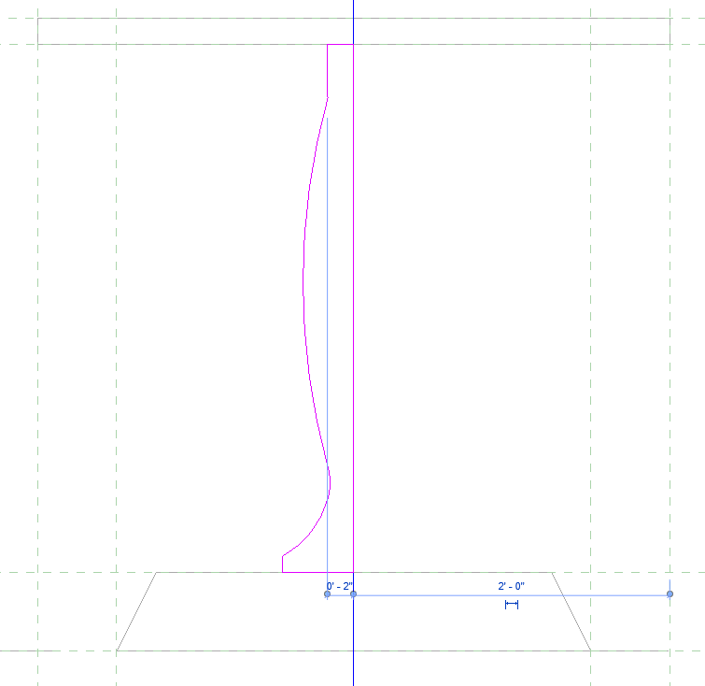
Align and lock the top line of sketch to BOT
Align and lock the bottom line of sketch to TOP OF BASE plane
Properties
Material: Red Aluminum
Double Click on Red Aluminum
Set Shading to Use Render Appearance
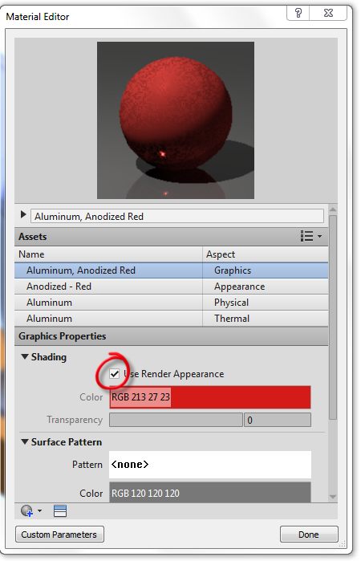
Done OK
Green Check
3D view

Flex it…all of it
If it works in the family, it will work in the project.
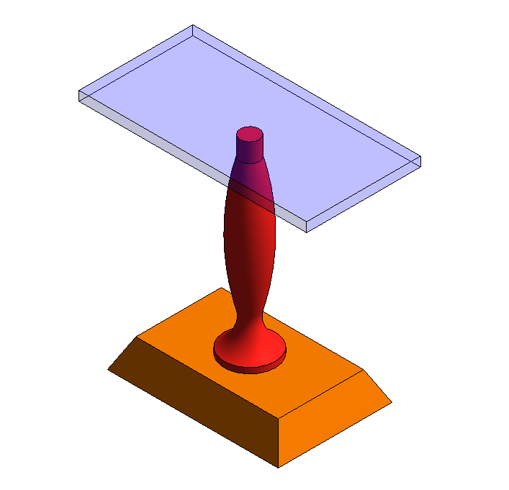

Visibility Settings
You can control what objects you see from particular Views. Example: We may not want to see the revolution from Plan View…..too busy, especially at the smaller scales.
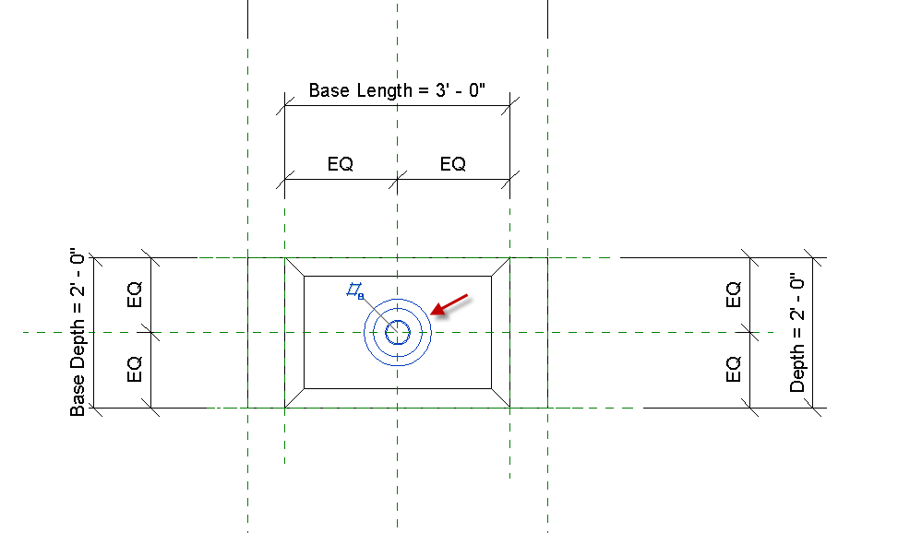
Let’s turn off the revolution from Plan View:
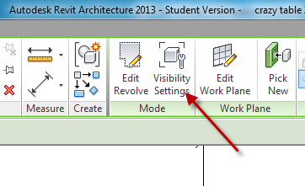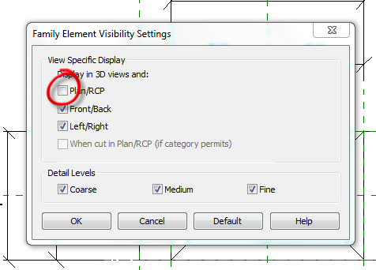
Pick the revolution
Visibility Settings
Uncheck Plan RCP OK
Discuss Detail Levels Hiding too

Save it as: CRAZY TABLE.rfa

Types

Let’s Create 3 “types” of Crazy Table: Small, Medium, Large
Family Types
New
Name it: SMALL OK
THK: 2”
Length: 2’9”
Heigth: 4’0”
Depth: Length/2 (in Formulas)
Base Length: Length-1 (in Formulas)
Base Height: 9”
Base Depth: Base Length-1 (in Formulas)
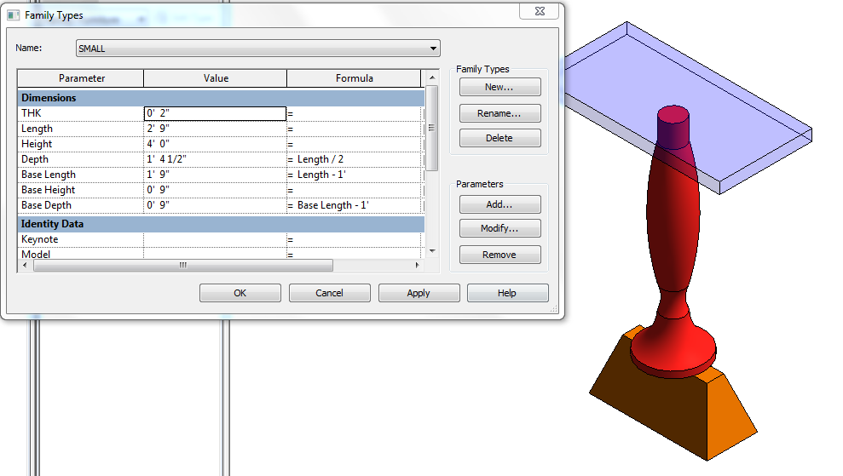

Family Types
New
Name it: MEDIUM OK
THK: 2”
Length: 5’0”
Height: 4’0”
Depth: Length/2 (in Formulas)
Base Length: Length-1 (in Formulas)
Base Height: 1’0”
Base Depth: Base Length-1 (in Formulas
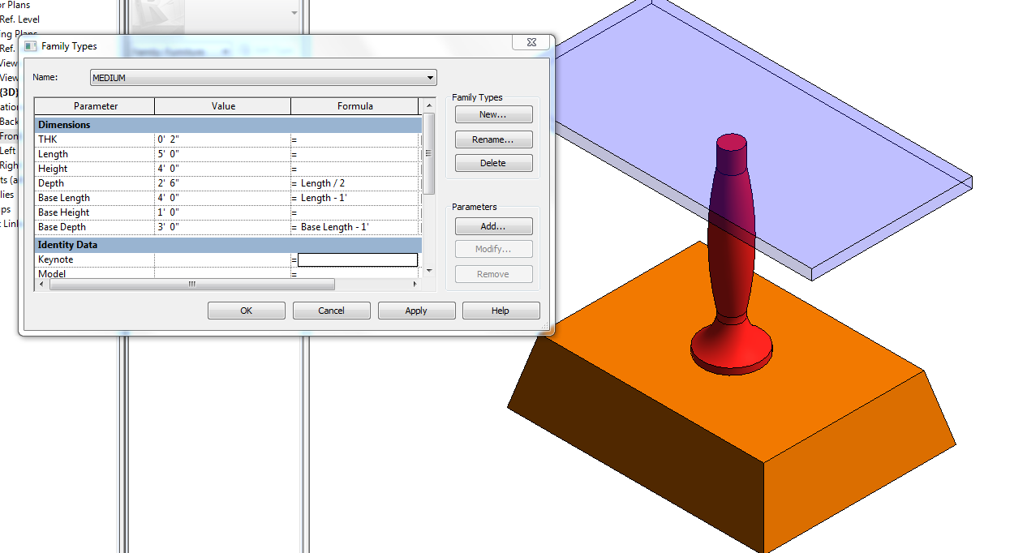

Family Types
New
Name it: LARGE OK
THK: 2”
Length: 7’0”
Height: 4’0”
Depth: Length/2 (in Formulas)
Base Length: Length-1 (in Formulas)
Base Height: 1’0”
Base Depth: Base Length-1 (in Formulas
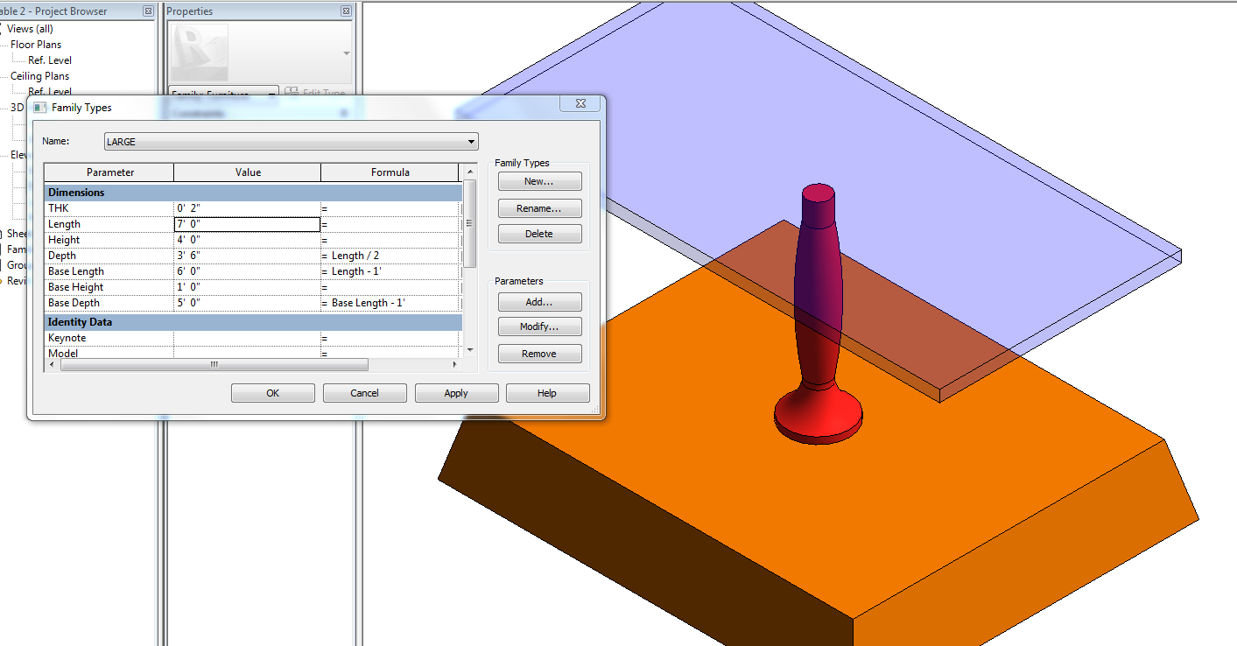

Make some Height changes…Discuss design…GIGO!
How could you adjust formulas?
How could you control sizes (revolution stretching….)

Save it as: CRAZY TABLE.rfa

Load into Project

Component
CRAZY TABLE
Load into Project
Place it…It will be a Component
Properties
Edit/new
Duplicate
This is where you can set up even more sizes for the table. Notice you have options to change sizes based on the PARAMETERS we set up. When we change the parameters, we are actually moving the reference planes….which move the objects locked to them.

You have learned to create a furniture family with modifiable parameters and materials. You learned to create extrusions, revolutions, blends, lock geometry to reference planes, and FLEX the model to check to see if your parameters work.

Material as a Parameter: Family

File….Open
Open “CRAZY TABLE”
Select table top
Edit Extrusion
Properties
Material
Pick the far, right box
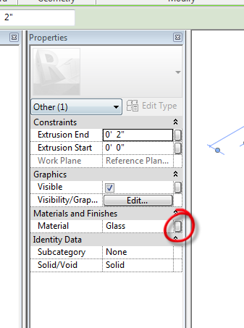
Associate Family Parameter box comes up
Add parameter
Instance (bullet)
Group/Parameter under Materials and Finishes
Name it: Table Top Material
(notice type of parameter is grayed out)
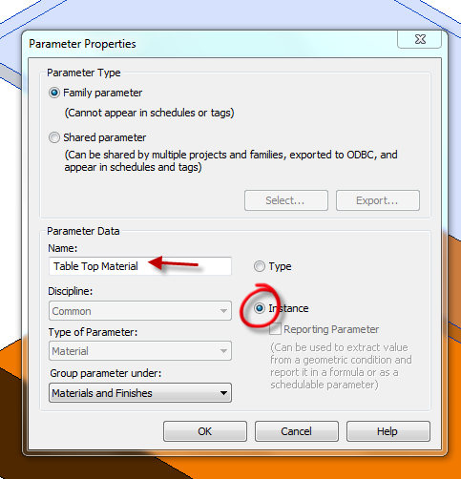
OK…OK
Save it as: Smart Table w/ material parameter
Load into project
Bring in “Component”
3D….SD
LC on object…
Properties
See Material Parameter?
You can make the top any material you want that is loaded in the project.
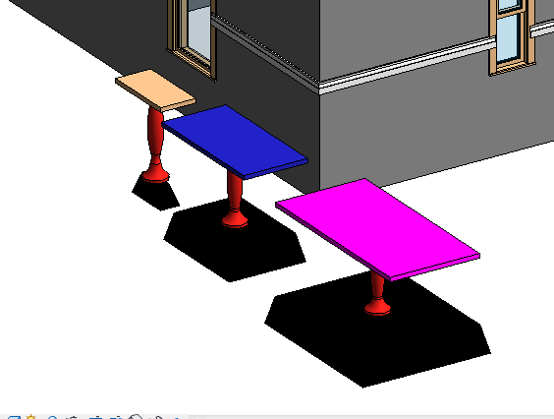

Discuss advantages of having material as a parameter when multiple materials are in a family or the material will be changed in the project often.

Families: Steps to Creating Families

- Sketch it
- Do the math
- Make the associations (formulas)
- Create the parameters
- Instance or Type
- Add the formulas
- Draw the reference geometry
- Dimension the reference geometry
- Turn the dimensions into labels
- Flex it
- Draw the masses and linework
- Align and lock the linework to the reference planes and reference lines
- Flex it

Phasing

Objective: An introduction to PHASING in Revit. We will use Revit phasing to do a little bathroom remodel. The remodel will be to make the Men’s Restroom bigger, eliminate the Closet next to the Women’s Restroom.
Open Phasing Demo 2017.rvt
Manage
Phases
There are 2 out of the box: Existing and New Construction
Show Phase Filters (they define how objects will show graphically)
Escape out of phasing.
Show that all the elements in the model were drawn in “New Construction”
The “Existing” phase is in a time BEFORE the building was built….get it???

Setting up Phases
Manage
Phases
Rename “New Construction” to “AS-Built”
“Demo” after As-Built
“Bath Remodel” after Demo
OK

Creating “Phased” Floor Plans
RC on Level 1
Duplicate w/ Detail
Rename to Level 1 As-Built

RC on Level 1
Duplicate w/ Detail
Rename to Level 1 Demo

RC on Level 1
Duplicate w/ Detail
Rename to Level 1 Bath Remodel

Set up Phasing in the Views
Level 1 As-Built
Properties
Phase: As-Built
Phase Filter: Show All

Level 1 Demo
Properties
Phase: Demo
Phase Filter: Show Previous + Demo

Level 1 Bath Remodel
Properties
Phase: Bath Remodel
Phase Filter: Show All

Demolishing
Back to Level 1 Demo
Modify….Demolish
Pick items to demolish:
Men’s Bathroom fixtures
2 Closet walls
Women’s west wall (note doors go too)
Wall between Men’s and Women’s

Level 1 As Built….still the same
Level 1 Bath Remodel…..note demolished elements are gone!

Creating the New Elements
Still in Level 1 Bath Remodel
Create a new plumbing wall at ref plane “New wall”. RC …”create similar” with the other plumbing wall.
Notice it is black. That is the phase filter.
Pick on the new wall. See phase created: Bath Remodel.
Use the “Create Similar” technique to make the Men’s toilet, sink, towel holder. Bring in the Urinal (there is one loaded)
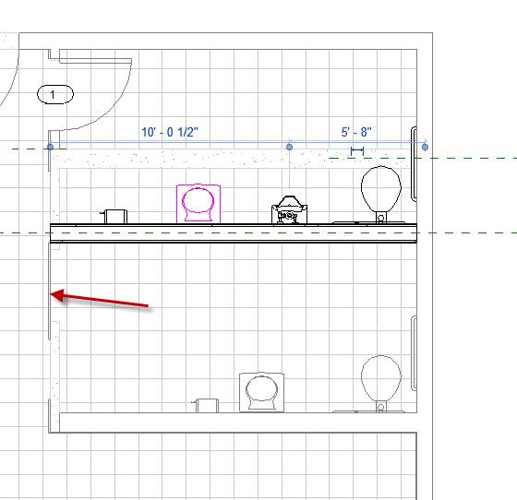
Note we have no West wall at Women’s and part on Men’s….we demolished it, remember?
Select Men’ s wall….RC….Create similar
Make the wall.
Note the join issue at the bottom. Joins are a little weird in phasing…
Here is a little trick to fix it:
Select wall
RC on blue grip at end of wall
Disallow join
Now you can drag or Align the wall.
Add the Women’s door

Notice the tile floor has a gap (where the old wall was)
RC on Floor……yes, you guessed it…..create similar. Place floor….align the tiles.
(Yes, we probably should have demo’d the tiles under the new wall….)
Architecture….Rooms…Add rooms. Name them Men’s, Women’s
Note: Rooms do not copy over in Phasing…….for obvious reasons……

We would use “User Keynotes” to give instructions about the demolished items and instructions to place the new walls, fixtures, flooring, etc.
Creating Custom/Shared Parameters

As you create and use families, you may find the parameters listed or are available to you are not complete. You have a length and width parameter, but need one that is not listed.
You can create a “shared parameter”…that can be added to ANY family, regardless of category. The parameter is stored in an external file, ensuring consistency across families and projects.

We will start by making a Window Schedule (with a few challenges)

We will create a custom parameters called SHGC, U- Value, and VT. They will be numbers. We will create a yes/no value for LEED CERT. We will create a parameter for “Oracle #” (a client database number)

We will then apply it to our window schedule

We will then apply it to a window family.

We created the window schedule previously.

Open Revitdemo16.rvt

Adding Parameters

Let’s say there is a field you need that is not in the schedule: we will use the bold/underlined parameters above…..

Manage
Shared Parameters
Create
Let’s place in on the desktop and call it DWE Shared parameters 2.txt (there should be a good place on the network drive normally to store this file)
Save
Groups…New
Enter name DWE Window

Note: You can set up many groups in the DWE Shared Parameters 2.txt file. Examples might be: Sustainable Design Parameters, Electrical Parameters, Specialty Equipment Parameters, Annotation Parameters. Each group can hold a bunch of your custom parameters

Parameters….New
Name: Oracle #
Show Discipline
Show Type of Parameter
We will take “Common” and “Text” on this parameter
OK….OK
You have created a “shared parameter”!!
Parameters….New
Name: SHGC
Show Discipline
Show Type of Parameter
We will take “Common” and “Number” on this parameter
OK

Parameters….New
Name: VT
Show Discipline
Show Type of Parameter
We will take “Common” and “Number on this parameter
OK

Parameters….New
Name: U-Value
Show Discipline
Show Type of Parameter
We will take “Common” and “Number” on this parameter
OK

Parameters….New
Name: LEED CERT
Show Discipline
Show Type of Parameter
We will take “Common” and “YES/NO” on this parameter
OK….OK

In Window Schedule
Add Parameter
Shared parameter
Select
(Edit will path to a different location)
Pick Oracle #

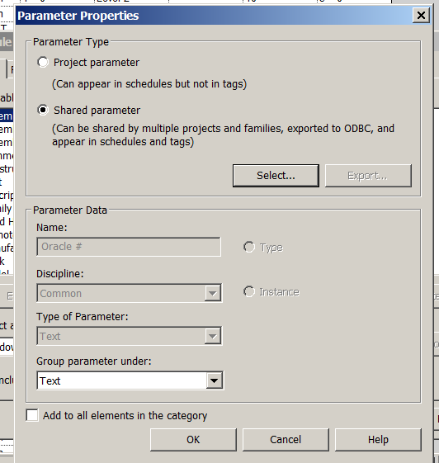

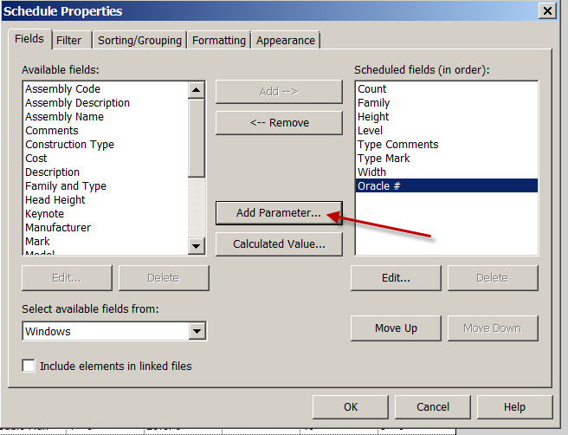
Continue adding the shared parameters…
Group under Green Building Properties
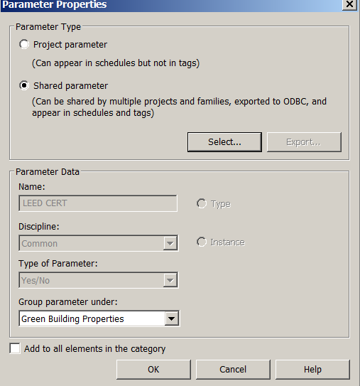

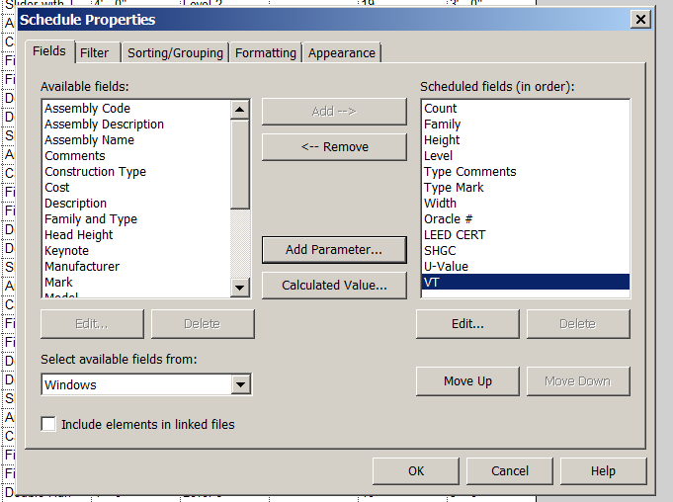

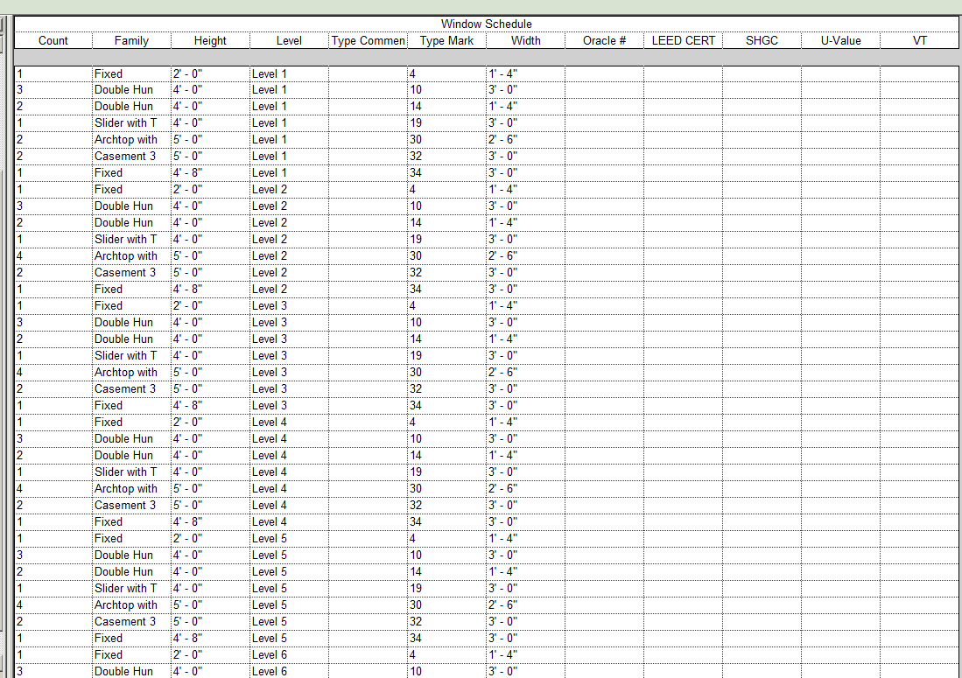

Let’s use it.

Floor Plan Level 1
Select a Window FG3656 on East wall
Edit type
See the parameters out of the box? (remember that)
Cancel
Edit family
Yes
Family Types
Note the Parameters….Remember??? These are your “out-of-the-box” parameters
Parameters : Add
Shared Parameter (Family will not show in schedules)
Discuss “Type” and “Instance” choices
Select
See LEED CERT
Put under Green Building Properties
OK….OK….
See LEED CERT Parameter you created??
Do the others
Add the data
Question: Would SHGC, U-value, VT, Oracle # be instance or type????
OK
File
Save as
Family
Save the Family as DWE 3656

Putting company info in name distinguishes your smarter company family from the “out-of-the-box” families. Some firms have a special folder for their company developed families, so when upgrading, locating the company files is easier.

Load into project
Swap the window with the DWE window

Back to the Window Schedule

Discuss shared parameters in families before schedule is made

Discuss Project Parameters

You have learned to create a custom parameter called a “Shared Parameter”. You learned that shared parameters can be put in schedules and families. You know the shared parameter file is a .txt file and can be updated with new groups and new parameters as time goes on. The shared parameter file can be used on future projects too.

PROJECT 2: Coffee Tech Institute (CTI) Tenant Improvement/Phasing

You have been hired to change the provided building FirstLastOldschoolAsBuilt.rvt into a Tech school and Coffee shop. Coffee Tech Institute!

The concept of taking an existing building and making modifications is called a “Tenant Improvement” or “TI”.

You have been provided the existing building Old School As-Built.dwg as an AutoCAD drawing.

You have been provided a sketch by the client of the basic program for CTI.

From the As Built Revit model, you will:

Create the “As-Built Drawings of the building in Revit

Provide a “Demo Plan” w/ keynotes and revision clouds

Design the new building to hold the rooms desired by the client.

Design the “Coffee Town” Coffee shop with custom families with custom parameters.

See Client Need sheet.

Create an Energy Model for your building to get mechanical loads. Note: EnergyPro file Mitsubishi AC Example and LG AC Example Library will help with setting up zones and HVAC Units. They are Library examples…pretty close to what we have.
Provide a bubble Diagram with zones in colored pencil and HVAC Unit surrounding the zones.

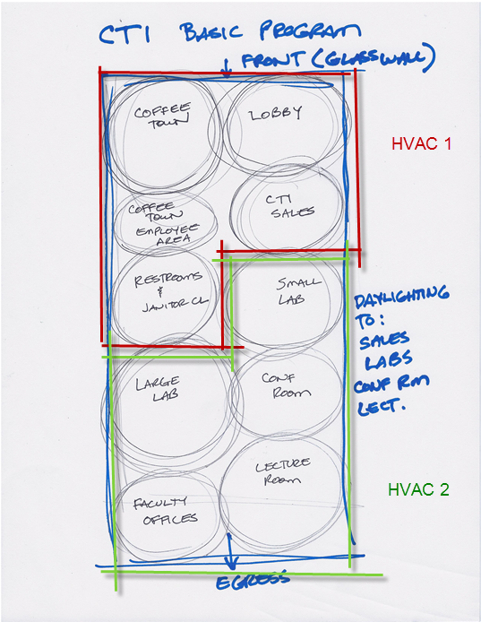
Coffee Town

Coffee town tracks all of their fixtures with a “CT#”
Every fixture in Coffee Town should be assigned a CT#. You will need to create a “shared parameter” file for the specialty equipment you will put in Coffee Town.
The client also wants a parameter that states the fixture involves food preparation (like a toaster). You will need to create a shared parameter called “FOOD PREP” and give it a Yes/No option.
The client wants the Specialty Equipment Schedule to total up the cost of the fixtures when they put the prices/cost in.
You will be required to provide a Specialty Equipment Schedule (for the CTI phase) with the following parameters:
Family FIXTURE NAME
Cost COST
Count QTY
Description DESCRIPTION
Manufacturer MANUFACTURER
Mark ITEM #
Model MODEL #
Url URL
FOOD PREP FOOD PREP
CT# CT#

Create the Following Drawings:

- Floor Plan: AsBuilt
- Area Plan: CTI phase
- Specialty Equipment Schedule, Door, Window, Plumbing Fixture, Curtain Panel,and Room Schedules: CTI phase
- Floor Plan: Demo phase (include rev clouds and keynotes).
- Floor Plan: CTI phase (include rev clouds and keynotes).
- Expanded Floor Plan: Coffee Town. Tag all custom fixtures with custom specialty tag. CTI phase
- Presentation Plan CTI (by department)
- Exterior Elevations CTI
- 3D Views (NE, NW, SE, SW) CTI phase Complete
- Roof Plan: CTI Phase. ID “Cool Roof”, AC Units, and Roof drain plan
- Energy Modeling Zone and Room Load Reports

See checklists for each drawing!

CTI Phasing for Tenant Improvements

Set up Level 1- As Built
Level 1-Demo
Level 1-CTI

Manage
Phases
We will ignore “Existing” for now
Rename New Construction to “As-Built”
Insert “Demo” Phase after As-Built
Insert “CTI” Phase after Demo
Your phases should be:
1. Existing
2. As-Built
3. Demo
4. CTI
(Note Past and Future in Phasing box)
Level 1 As Built
RC….View Properties
Phase Filter: Show All
Phase: As Built

Level 1 Demo
RC….View Properties
Phase Filter: Show Previous + Demo
Phase: Demo
You should use the Demolish tool in this (Demo) view!

Level 1 CTI
RC….View Properties
Phase Filter: Show Previous + Demo
Phase: Construction

Coffee Town Parameters

Coffee Town tracks all of their fixtures with a “CT #”
Every fixture in Coffee Town should be assigned a CT#. You will need to create a “Shared Parameter” file for the Specialty Equipment you will put in Coffee Town.
The client also wants a parameter that states the fixture involves food preparation (like a toaster). You will create a Shared parameter called “FOOD PREP” and give it a Yes/No option.
You will be required to provide a Specialty Equipment schedule with the following parameters:
Family FIXTURE NAME
Count QTY
Description DESCRIPTION
Manufacturer MANUFACTURER
Mark ITEM #
Model MODEL #
Url URL
FOOD PREP FOOD PREP
CT# CT#

FAMILIES FOR COFFEE TOWN

The small café (Coffee Town) will need the following “specialty equipment” families built:
- 1 3-Gallon Coffee Urn
- Soda fountain 5 head
- Espresso Grinder
- Cappuccino Dispenser 2 head
- Countertop Display Refrigerator
- Cold Beverage Dispenser
- Dining Table(s): Rectangular with 3” SQ Legs: 3 sizes. Get the chairs from Autodesk SEEK. Create a “GROUPS” for the table and chairs. Dining Table will have an instance- based material parameter.
Spec Sheets to be provided. Check X:/Green Building/Coffee Town Fixtures

Pastry Case Unit (Find this from a Manufacturer online)
Cash Register (Find this on RevitCity)
Surveillance cameras Get this from Autodesk SEEK. (I know they are ceiling fixtures….I will see them in the schedule)
Coffee Town (not Café City) tags will look like this:
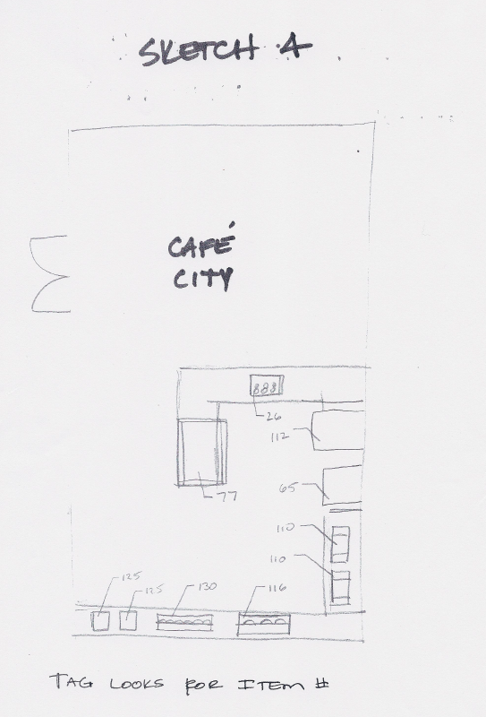
Grouped computer furniture in CTI Labs

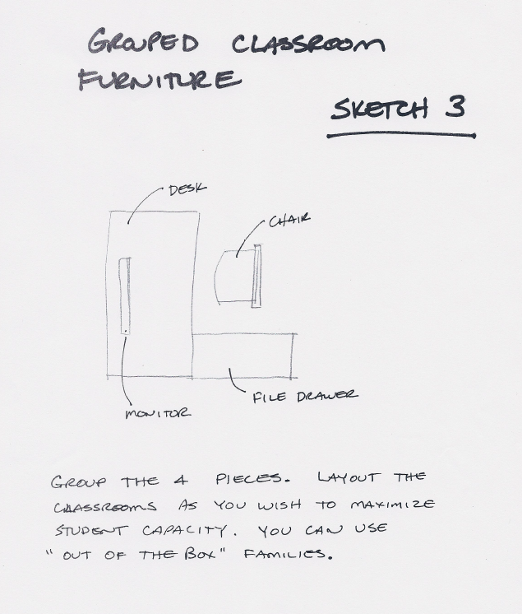

Make it 5 pieces….add the provided CPU and monitor on top of the desk (so I can see it)

Dimensioning in Revit

Floor Plan Level 1
Annotate
Dimension (arrow)
See Types:
Linear Dimension Types
Angular Dimension Types
Radial Dimension Types
Diameter Dimension Types (new to Revit 2013)
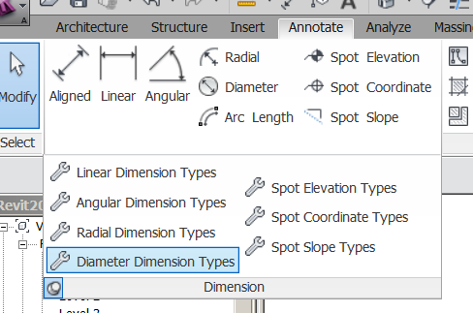
SHOW PUSH PIN

See buttons:
Aligned
Linear
Angular
Radial
Diameter
Arc length

We will customize a Linear Dimension Type
Properties
See loaded types

DO NOT CHANGE EXISTING STYLE!!!!

Edit Type
Duplicate
Name it “FirstLast 3/32 Arial
OK
We are now working on the “clone”
Units Format (pick shaded box)
Uncheck “use project settings”
Rounding: To nearest 1/4”
Check suppress 0 feet
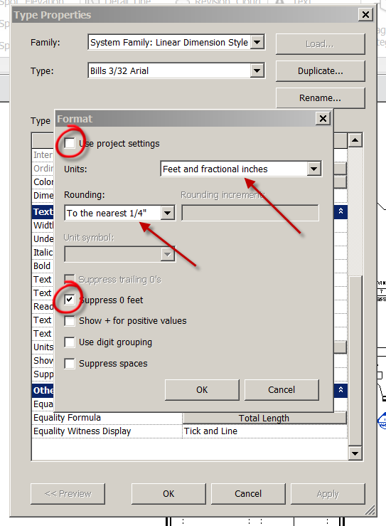
OK
Centerline symbol: centerline
Centerline Pattern: Center ¼”
Centerline Tick mark: Diag 3/64
Tick Mark: Diag 3/64
Dim line snap distance: 1/2"
Tick Mark line weight: 7
Lineweight: 1
Text Offset:1/64”
Width factor: .8
Notice text size is 3/32. We’ll take that
Notice text font is Arial. We’ll take that too.
Apply
OK
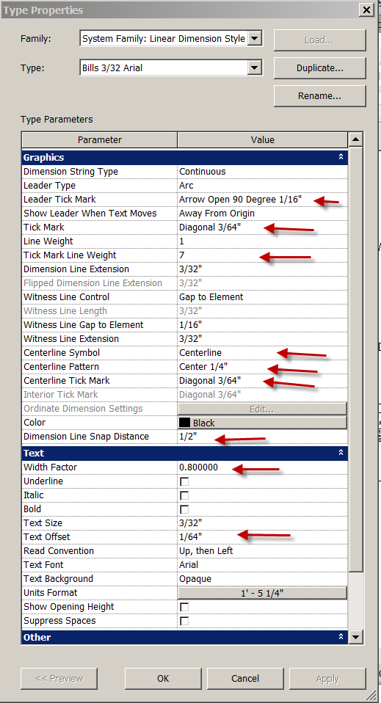
NOTE: If the Type Properties dialog box is being “uncooperative”, drag the top of the box (between Parameter and Value)to the left to make it stop flipping!

Dimension
Aligned
Change element Type
Select FirstLast 3/32 Arial
Individual References

Discuss Wall faces, wall centerlines, center of core, faces of core

Face of Core
Dimension the front wall.
How does it look?
Note: You can change dimension styles on the fly. (Show)
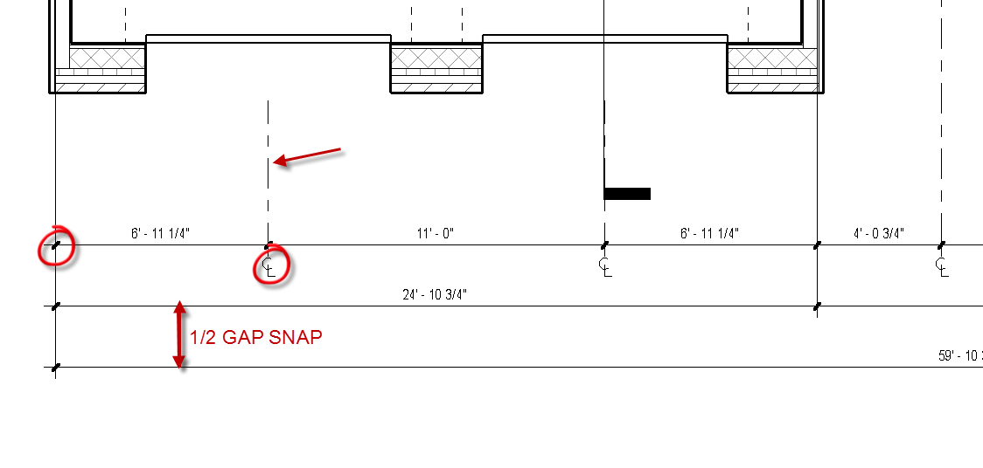

Creating Materials in Revit 2015: Basics
Manage
Materials (icon)
Note the existing “out of the box) materials
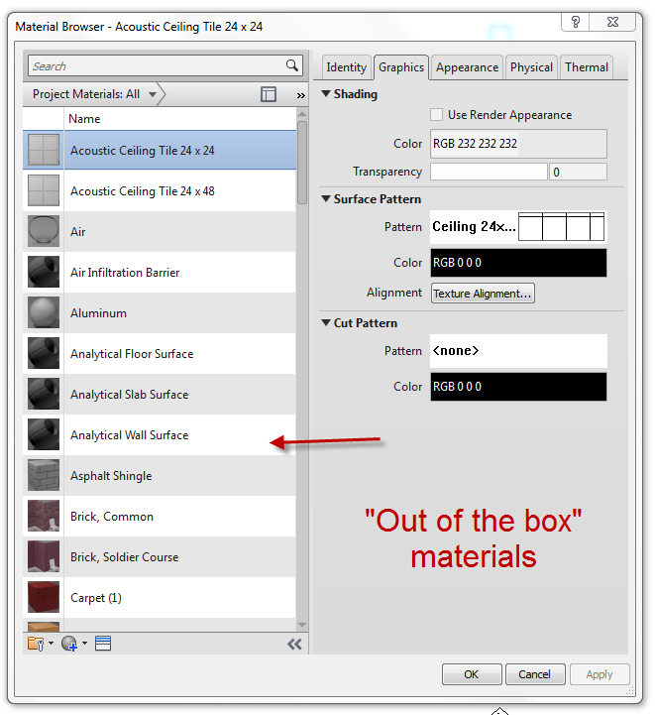

We will make a few custom materials in this demo…

Hit the circle with the + sign at the bottom of the palette
Creat new material
“Default New Material” is created. It has no color, surface pattern, render appearance or filled in parameters. Perfect to start from scratch with!
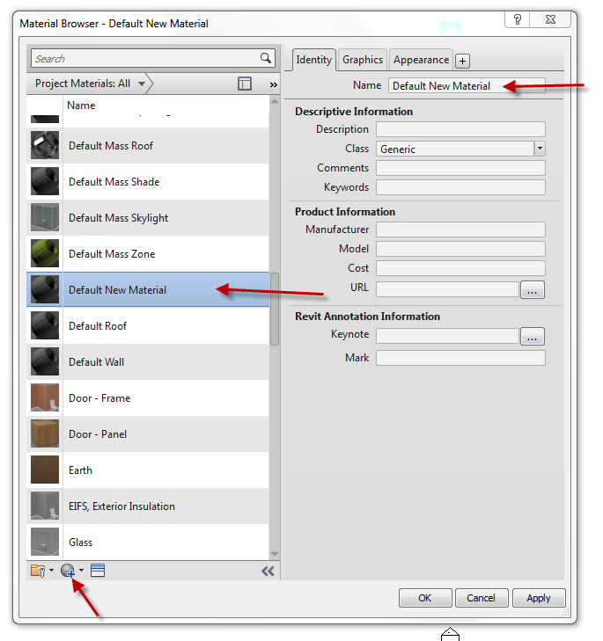

We will start by creating a teal carpet
Find a good teal carpet swatch on the internet…save as a .jpg or .png
RC on Default New Material….Rename
Name it SHS Teal Carpet

Identity Tab
Description: Bolyu Ocean Teal 348 Carpet
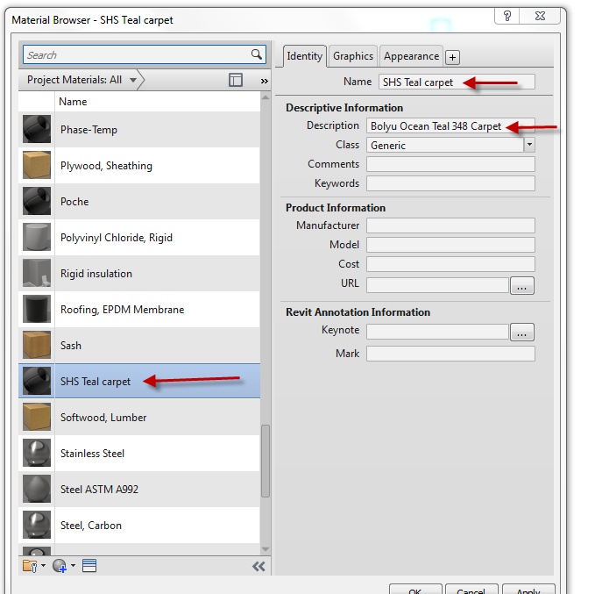

Graphics( tab)
Shading Color: Pantone….3265
OK
OK
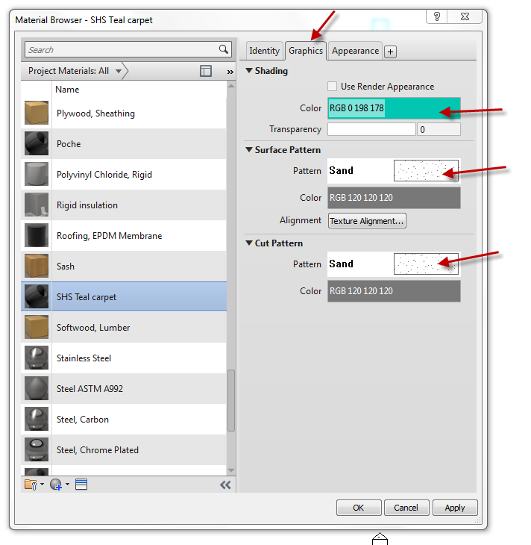

Appearance
Open Information arrow to see contents
Name: SHS Teal carpet
Image: Assign captured Teal Carpet image.
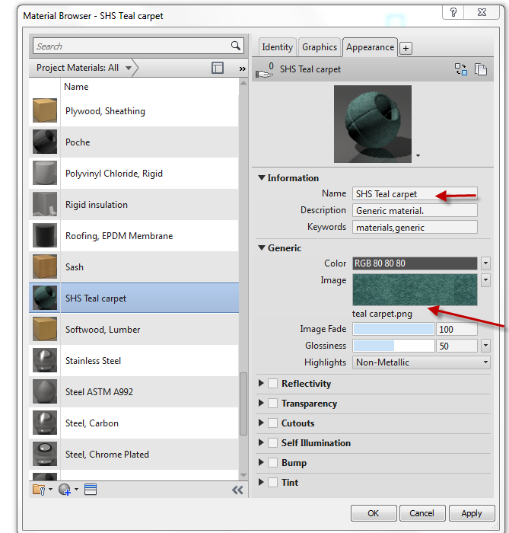
OK…one down!

Let’s make a Terrazzo material. Remember….we are just making the materials. We have not applied them to floors, countertops, etc.
Manage
Materials
Create New Material
Identity: name it SHS Terrazzo (from Default New material)
Description: Western Terrazzo 78C
Graphics (tab):
Shading: Pick a color resembling your terrazzo. Since it is multi-colored, it won’t be perfect.
Surface pattern: Concrete
Cut Pattern: Concrete
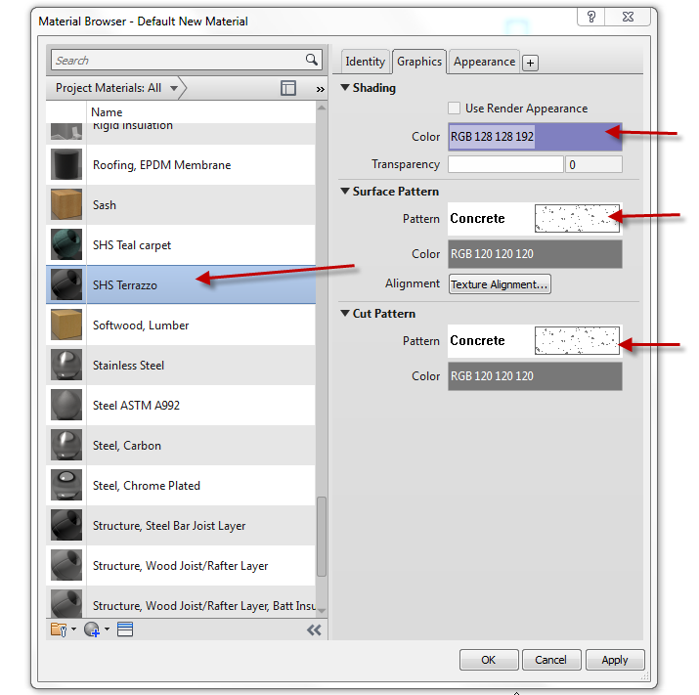
Appearance
Name: Terrazzo
Image: Captured picture of Terrazzo
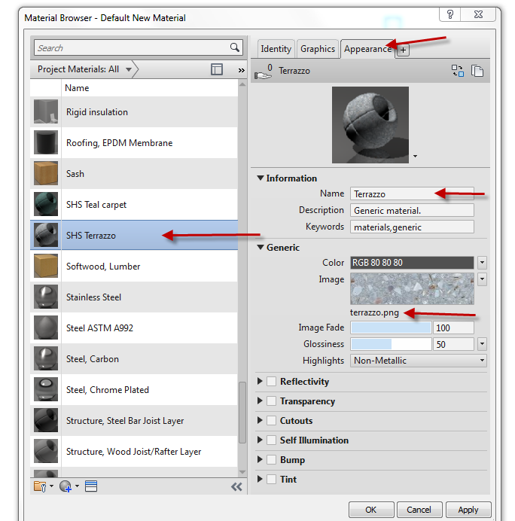
OK

Let’s do one more….
We will make a 4” Terracotta colored Ceramic Tile
Manage
Materials
Create New Material
Identity: name it SHS 4” Terracotta Ceramic Tile (from Default New material)
Description: 4” Terracotta Ceramic Tile
Graphics (tab):
Shading: Pick a color resembling terracotta. I used Pantone 7526 OK
Surface pattern: Model (button) …4” tile. Explain the difference between drafting pattern and model patterns. Remember…model patterns are “true size”.
Cut Pattern: Drafting…Crosshatch
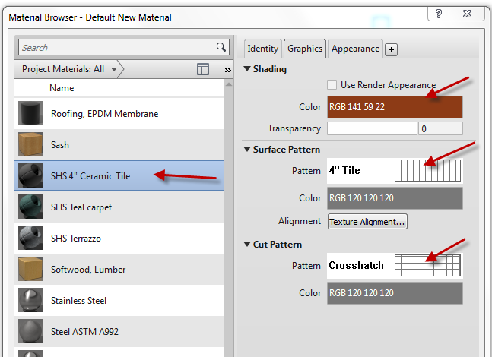
Asset Browser
Open Appearance Library
Ceramic
3” Square Terracotta (close enough!)
Hit arrow to right
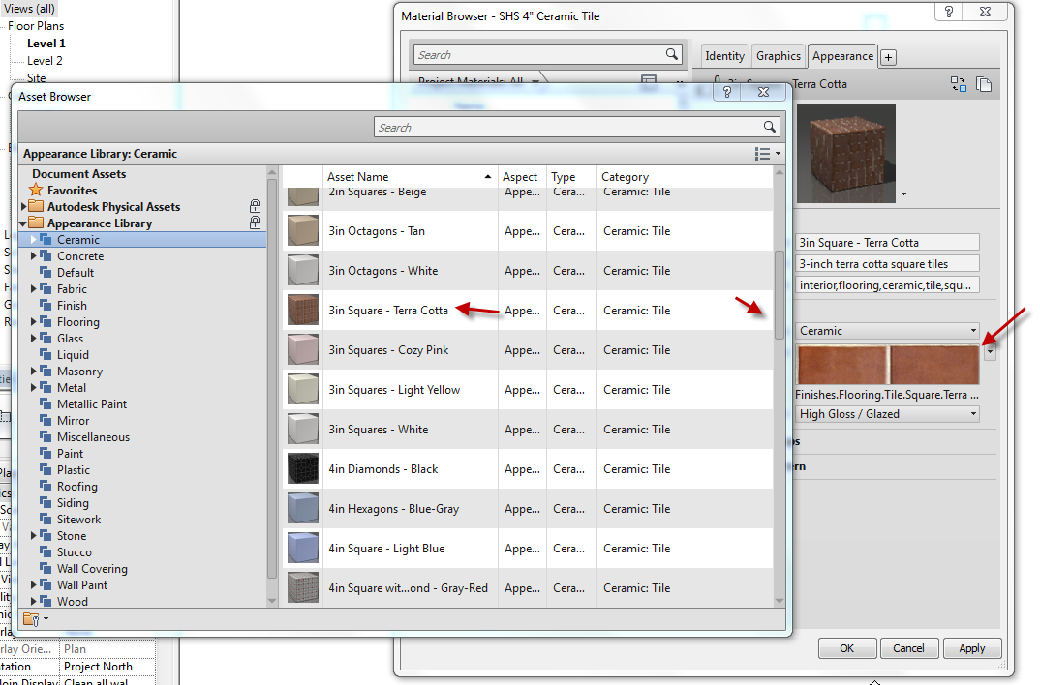

See appearance??

So you can use the “assets” in Revit, or create your own Render appearances!
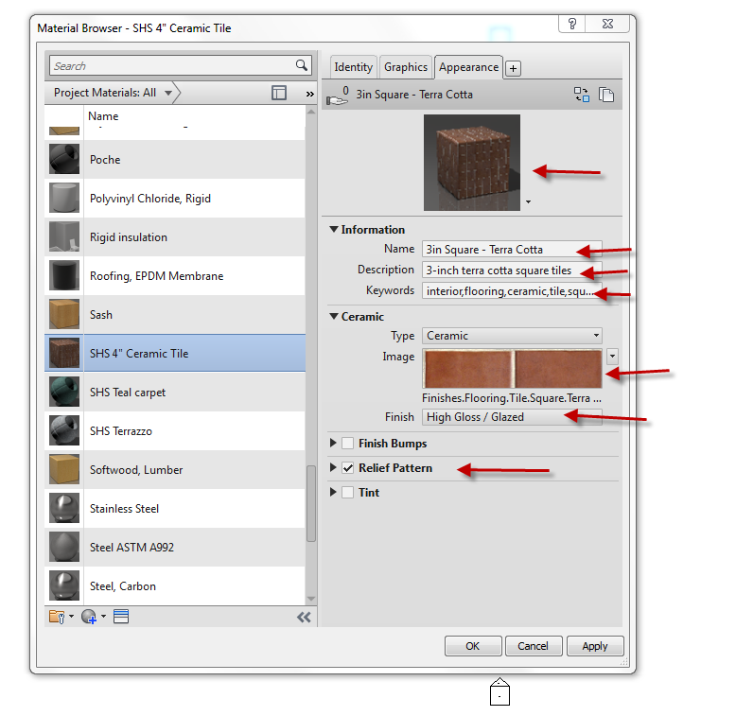

Material Browser Controls
These double arrows close the properties info
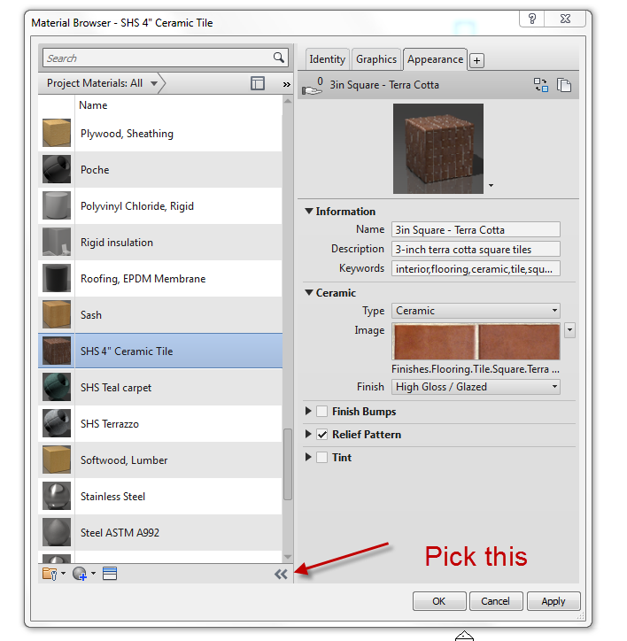
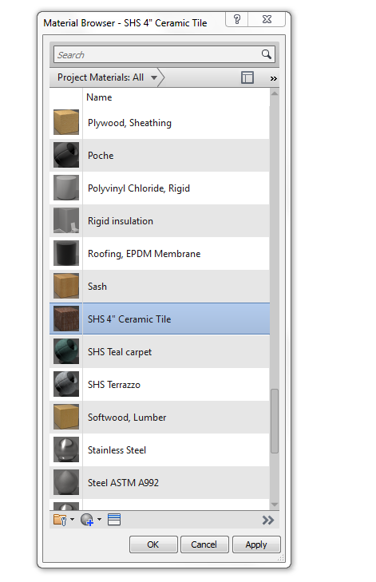
Note the arrow direction changed… and just the materials list is showing.
These double arrows control what you are seeing in the materials palette. The default is:
Show all
List View
By name
32X32
Play with the settings!
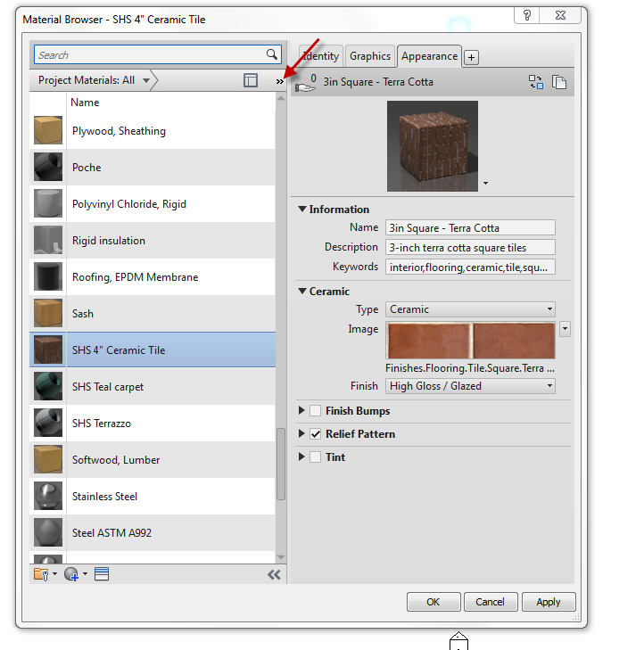
Pick this one. It opens the Asset Browser materials (below materials).
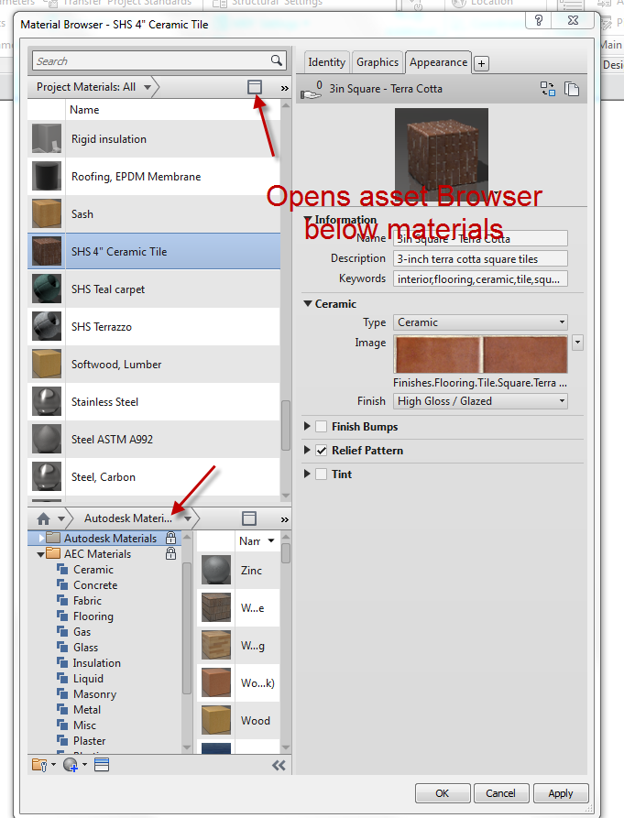
Changing the scale of the picture you created as a material
Carpet is an easy one to bring in at the wrong scale.
SHS Teal carpet
Appearance
The carpet is too detailed. It would look cartoonish as a floor in our model…..
Pick on image…see image texture??
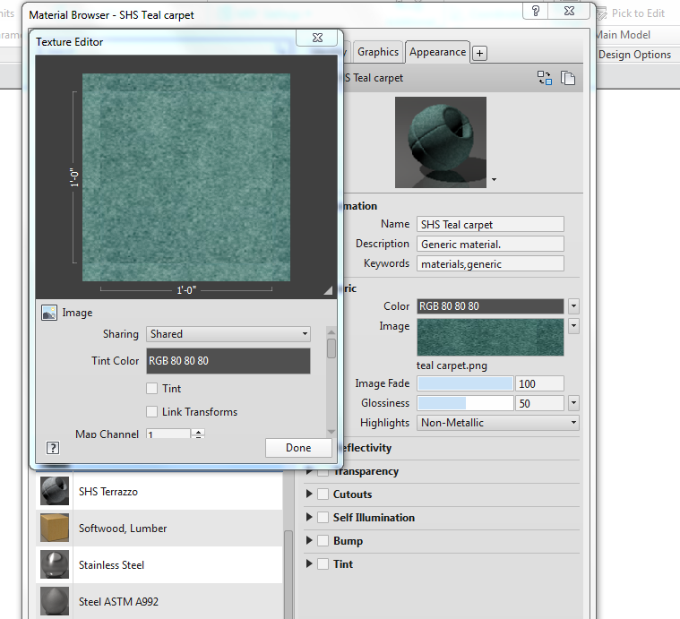
That is the picture that would be repeated in a 1’X1’ area of your floor.
Drag texture editor box down so you can see the editing options.
See size X?
SAee size y?
Let’s change to 48 (from 12). Now that same image would fill a 4’X4’ space.
Done!
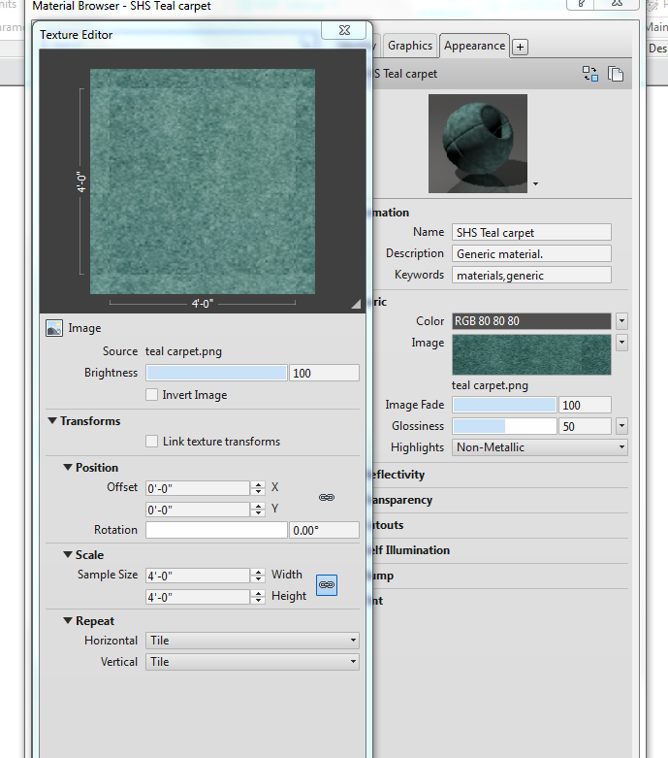

Material Tags: Label Your Smart Materials With Smart Tags

Creating intelligent materials and tags can save you a lot of time and headache annotating your drawings. Coordination can be amazingly controlled with a little work up front. We will first create a smart material tag, then create some objects with smart materials, then smart tag the smart objects!

Ceiling Plan Level 1
Pick the ceiling over the garage
Change it from a 2X4 Compound to a GWB on Mtl stud
Edit Type
Structure Edit
Finish: Gyp Wall Board (pick material)
Material Editor comes up
Gyp Wall Board
Pick pencil to right
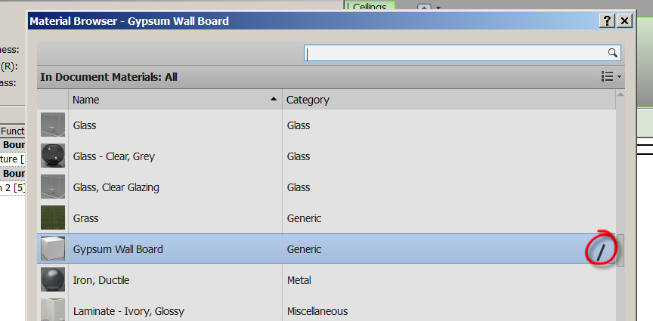

Material Editor comes up
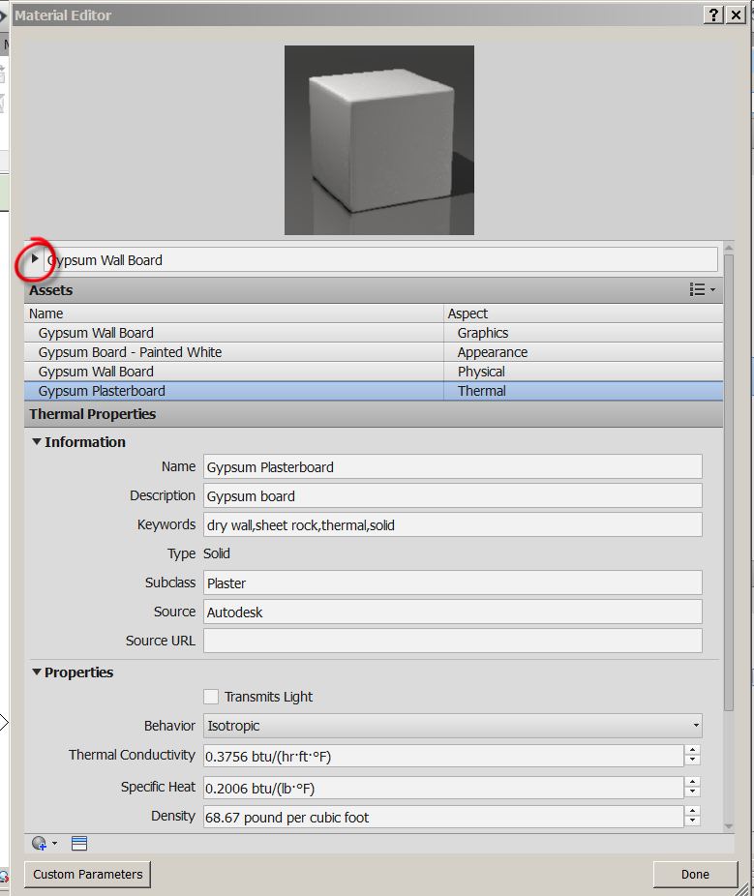
Pick the arrow to the right of the material name
Descriptive Editor comes up

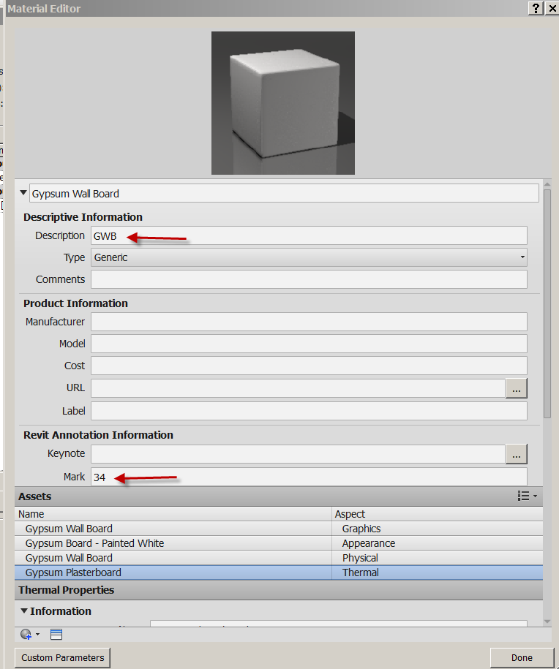

Set Description to GWB
Set Mark to 34

Note: We will use these two parameters when we tag our materials
GWB is the material
34 is the color

Graphics
Set Gyp Wall Board Graphics
Color: Orange
Surface Pattern: Sand (so we can see a little texture at ceiling)

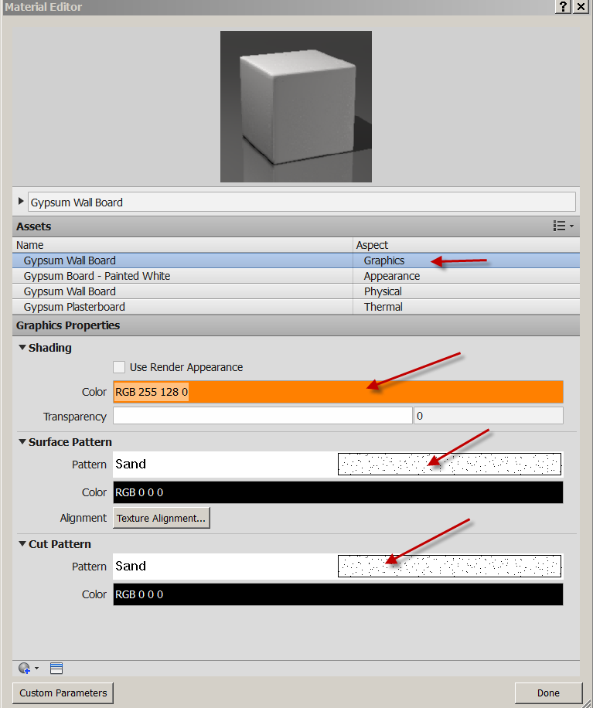
Done
OK…OK….OK
You have created a smart material!

Annotate
Material Tag
Check Leader
Material
Pass mouse over ceiling (attempt to material tag the ceiling)
It tags “GWB” ….remember?? Smart….but not done.

Making the Custom Material Tag
Select on “GWB”
Edit Family (or you could have double-clicked on the tag)
Open material tag for editing: Yes
LC on Material Description
Edit Label
See sample Text?
Note Parameter Name: Description
See Category Parameters on left? These can be labels.
Cancel

Making a Custom Tag

Let’s create a custom material tag that looks for 2 parameters: Description and Mark
Description will be the material abbreviation and Mark will be a color code number.

Still in the family Editor….
Pick on Material Description
Edit Label
MTL for Sample Value (we will have 3 letter acronym for materials)
OK…

We need to see the reference planes to properly set up out text…

VV
Annotation categories
Check Show Annotation cat in view
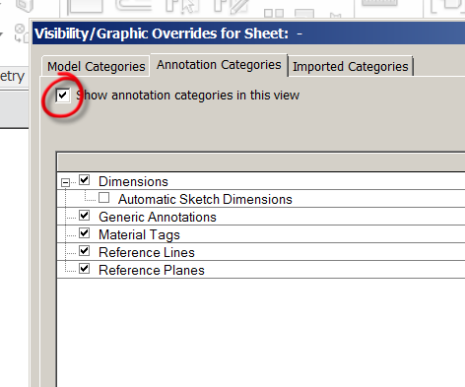
See ref planes, dims come on

Horiz Align: Right
Our first label is done.
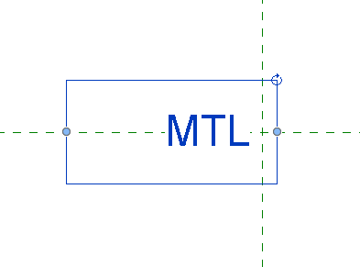
Create
Label
Click into space to the right of Description
Under select parameter: choose Mark
Hit green arrow to send to Label Parameters
Sample Value:123
Left Justify
OK
Make surrounding boxes work so 2 parameters do not run into each other…but are close together.
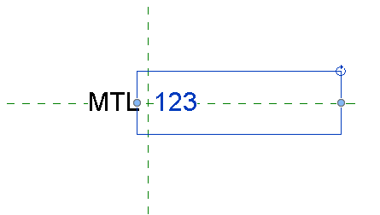
Save the tag as SHS Material Tag in your Families folder
File
Save as
Family
SHSMaterialTag.rfa (family files are .rfa)
Load into Project

These two labels are what the tag is looking for. If we give our materials this information, the SHS Material tag will pick it up!

Now let’s tag the ceiling:
Pick the first material tag
Properties
Switch to your SHS Material Tag
See the GWB 34 ???
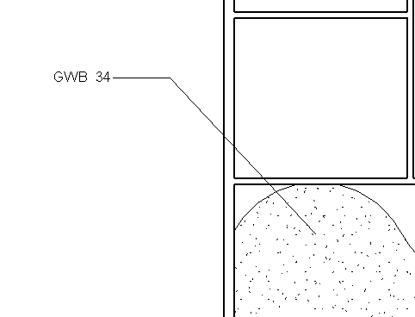

The tag is looking for “Material Desc” and “Mark”, which our material has!
(you may need to modify the family to keep the letters/numbers spaced properly)

Consider the drawing coordination issues solved if you create smart materials and tag them smartly….

You have learned to create a custom material, apply information to the parameters of the material that will be picked up by annotation tags. You applied the material to a system family (ceiling). You have learned what an annotation tag is and how it works. You created your own tag to “hunt” for chosen parameters.

Applying Smart Material Patterns to Floors

Patterns and Materials

Model vs Drafting
Model:
* Represents ACTUAL element appearance on building. Brick, Ceramic Tile, etc.
* They scale with model
* You can Move, Rotate, Align, Dimension to create size
Drafting:
* Represents in symbolic Form
* pattern stays same size regardless of the size.

What does this mean?
Drafting Pattern: Let’s say you put a (common) gyp-plaster drafting pattern in a space at 1/8” = 1’0”…. There might be 1000 dots in the space.

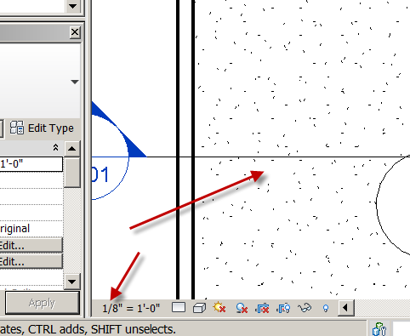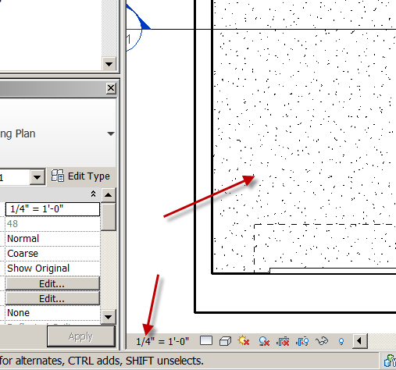

If you change the scale to 1/4”=1’0”, there would be 4000 dots and the pattern would look muddy.

If you changed the scale to 1/16”=1’0” you would have 250 dots and the space would be less “dotty”.
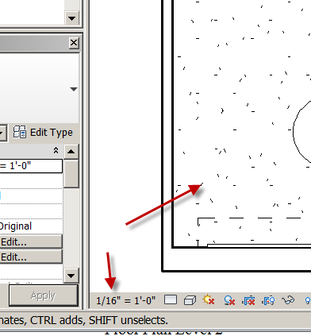
Hint: If you have a very dark area (that has a pattern applied to the material) in you view, the drafting pattern is the culprit. You may need to turn the pattern off or ½ tone it.
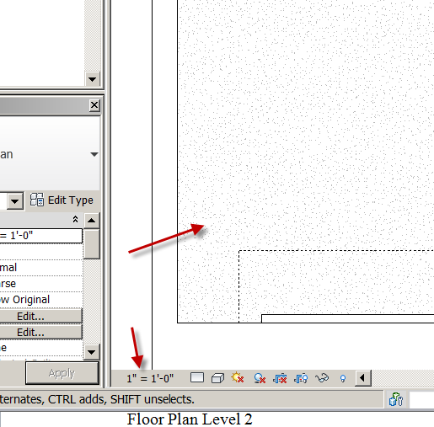

Model Pattern: The Smarter of the two. They are “real size”. Let’s say you put 1’0” square tiles in a 100 square foot room. Yes math wizards…that’s 100 tiles! If the scale is 1/8” = 1’0”, there will be 100 squares in the room. If the scale is 1/16” = 1’0”, there will be 100 squares in the room. If the scale is 1/4” = 1’0”, there will be 100 squares in the room.

Floor Plan Level 2
Pick the floor we created previously
Properties
Change to Wood Joist 10” Ceramic Tile
Edit Type
OK
Structure: Edit
Pick on Tile Mosaic Pencil
Surface Pattern: Find the 12” Tile…OK
Make an annoying green color…OK
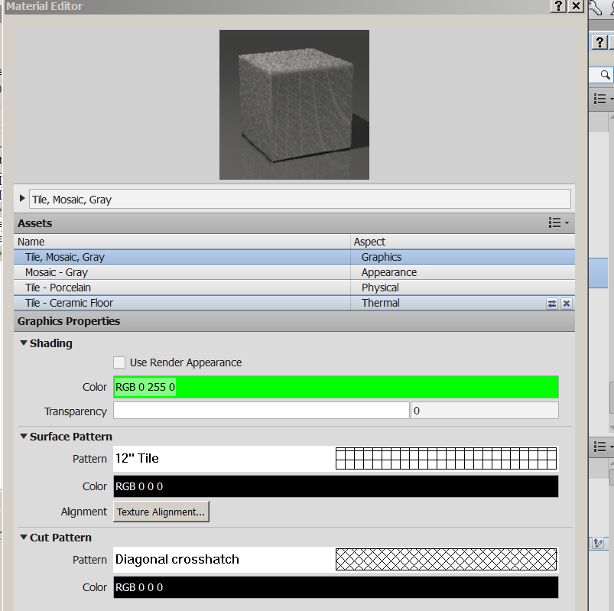
Identity
Description: CT
Mark: 13
Done
OK
OK..OK
See the tile floor?
SD…yucky green??
HL

Tag it

Annotate
Material Tag
SHS Material Tag
See the CT13 display??

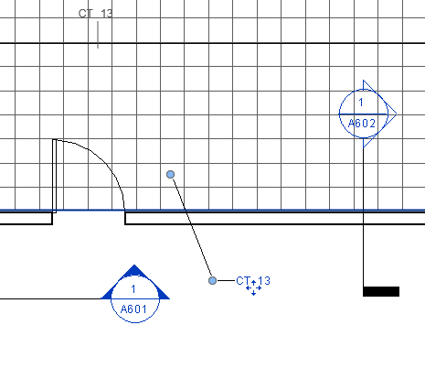

Save as revit2014demo21.rvt

Creating Fill Pattern

You can create your own custom “fill patterns” by leveraging your AutoCAD .pat files.
Manage
Materials
Tile Mosaic Grey Pencil
Pick Pattern
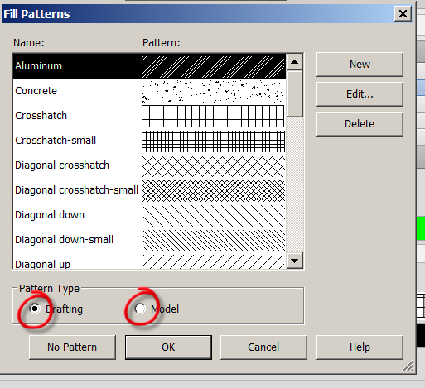

See the materials on the left?
See the Surface pattern on the right?
Surface patterns are applied to Materials.
Some patterns are “Drafting Patterns”…and some are “Model Patterns”
Cancel…Done
You should be in the Materials Editor
Make a new Material
Default….New Material
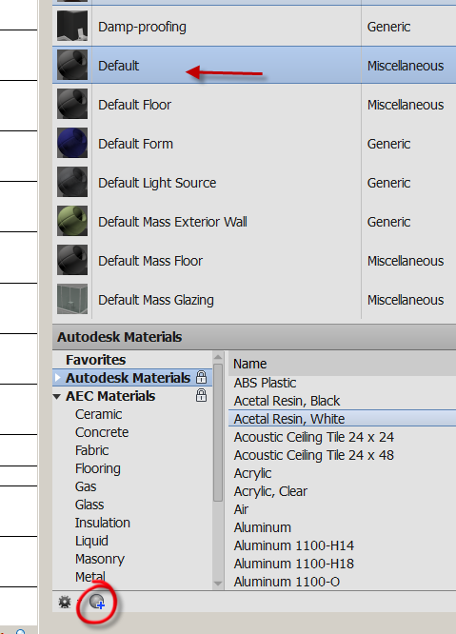
Name the material: SHS TEST MATERIAL……OK
Surface Pattern hit none
Check Model
New…..Check Custom……Import
Fldstn MODEL
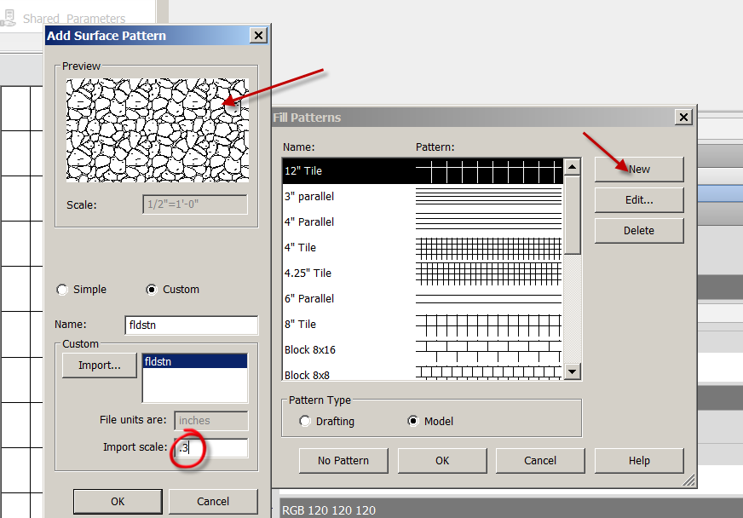
OK…OK…OK…Done
Any AutoCAD pattern can be made into a Drafting Pattern in Revit.
If you want to make the AutoCAD pattern a Model Pattern, you must add the following line after the title of a custom hatch…like this:
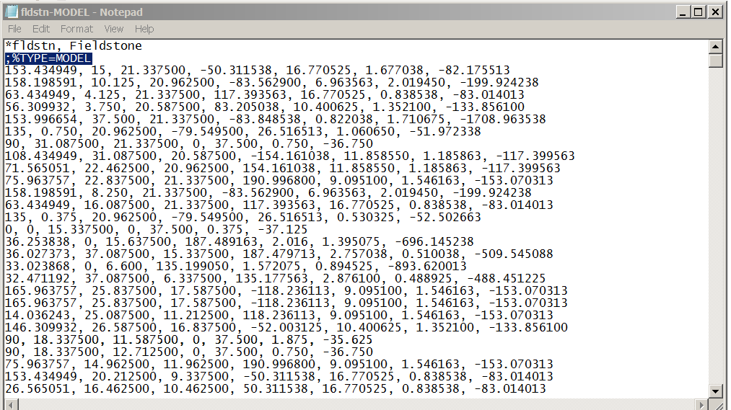
Here is an example of an AutoCAD pattern file that is converted to a model pattern for Revit:
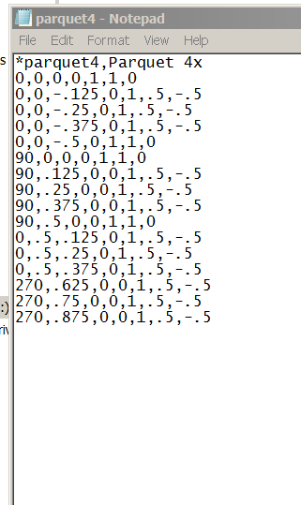
Notice the first 2 lines……and the save name.
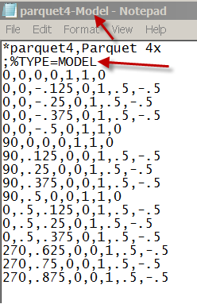
Notice the first 3 lines…..and the save name!
OK…back to the pattern:
Path to the model pattern you created
Open
Rename it if you like…or keep the same
See Import Scale? You can change….
OK
See the new Pattern in the Fill Patterns box?
OK
The Surface Pattern is assigned to the material.
Note: This pattern will NOT appear in a rendering
Let’s test it:
Create a generic wall, with the scale of the drawing at 1/8”=1’0”
Modify
Paint
Pick the SHS TEST MATERIAL
Paint the wall.
Note: If the pattern is too dense or too sparse, you will have to change the scale of the pattern! Bigger scale numbers make the pattern bigger….. decimal numbers make it smaller.
See it OK?
Note the number of patterns….
Now change the scale to ¼”=1’0”
Note the SAME number of patterns!
I assume you have A LOT of AutoCAD hatch patterns….so you now have A LOT of Revit patterns!

Scope Boxes
Scope Boxes control the visibility of datum planes (levels, reference planes, and grids) in views whose cutting plane intersects the scope Boxes. Scope Boxes are particularly useful to control the visibility of those datums that are not parallel or orthogonal to a view. Huh????
When you add grids, levels, and reference lines to a project, they can display in more views than you may want. For example, you add grid lines to a plan view, the grid lines appear in all plan views of the model. You may not want this effect and want to localize the appearance of the datums to certain views. This is exactly what a Scope Box is for: to limit the range in which those levels and grids appear.
Open Revit2017demo16.rvt

Building Section 8 (the one going thru the center of the building)
Level 1…See Section Line annotation?
Level 2…See Section Line annotation?
Level 5…See Section Line annotation?
Level Roof…See Section Line annotation?

Let’s say we do not want to see the Section Line annotation over 30’0” (our Level 4)

Level 1
View
Scope Box
Name: Scope Box 1 (we will take that name)
Height: 30’0”
Make box around sectioned area to include Section Line annotation
Select in white space to exit
Pick on Section Line annotation
Properties
Under Extents….Scope Box. Set to Scope Box 1
Apply (nothing happens yet…)
Select in white space to exit
Level 2. See Section Line annotation? Yes
Level 6. See Section Line annotation? No
Level 4. Will we see Section Line annotation???
Level 5?

View Templates

Can I freeze the same stuff on multiple levels?

Open Revit2017demo16.rvt

You should have several floors

Put doors in all the Floors/Levels

Floor Level 1
VV
VH the doors
View (from pull down)
View Templates
Create a New Template from Current View
Name it: Freeze Doors View Template
OK
V/G Overrides Model:Edit
See doors turned off?
Set how you want it in the View Templates box
OK

Floor 2
Notice doors are visible…
View
View Templates
Apply Template to Current View
Select Freeze Doors View Template
Apply
OK
Notice doors are gone and anything else the template turned off….
Floor 3
View Templates
Apply Template to Current View
Notice Architectural Plan is default (FYI)
Select Freeze Doors View Template
Change View template back to Default View template

DISCUSS How could you use view templates on your projects? Presentation Plans, Electrical, Floor Plan w dimensions, Exterior Elevations w presentation graphics, Section views, 3D Sections, etc.

Creating Custom Linestyles

Open Revitdemo17.rvt
You can create your own linestyle ala hidden, phantom, etc
There are loaded line patterns like solid, center ¼, and Dash. We will make a line pattern…which will be used in a new linestyle.
Manage
Additional settings
Line Patterns
There are actually quite a few out of the box!
We will make a property line with a longer line in the “line-dash-dash” pattern.
Pick “Double dash 5/8”
Edit
See Line pattern Properties box?
Notice there is a space between each element AND one space at the end.
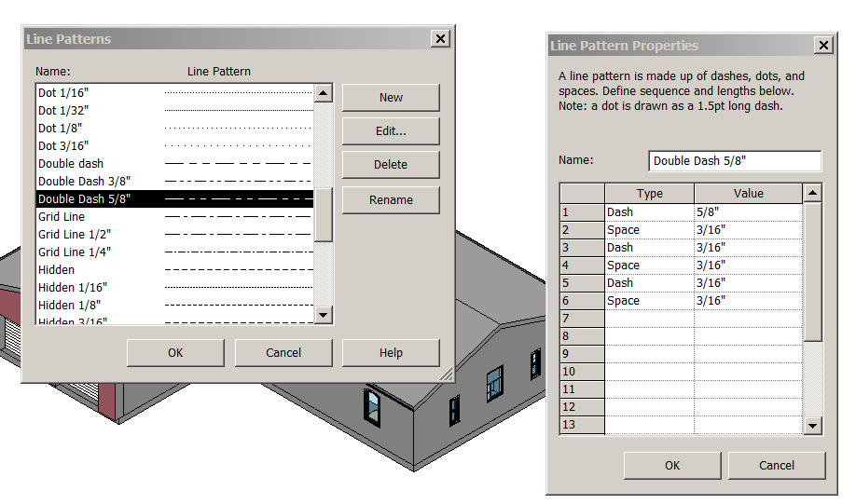

Cancel Double dash 5/8”
New
Name it Double Dash 1”
Dash 1”
Space 3/16” (space is your only choice)
Dash 1/8”
Space 3/16”
Dash 1/8”
Space 3/16”
OK…OK
Applying a Line Pattern to a new Linestyle
Manage
Additional Settings
Linestyles
New
Name it 1” by 7 weight prop line
OK
Change Lineweight Projection to 7
Change Line Pattern to Double Dash 1”
OK
You now have a CUSTOM linestyle!
Turn off the topography
Modify
Linework
Linestyle: 1” by 7 weight prop line
Pick 2 of the the property Lines. Make sure lineweights are on. See the change?
Undo that linework command.
Here is another way: Adjust the “Object style” of the property lines
Manage
Object Styles
Open Site
Property Lines
Change it to our new Double Dash 1”
Note: Changing an Object style changes it in the ENTIRE PROJECT!
D O N E !

Annotation Family

There are 2 ways to get an annotation family that does not exist:

- Edit an existing family to make it do what you want
- Create a new one from a template

We have already Edited an Existing family when we made our SHS Material Tag. We started with the out of the box Material Tag(which hunted for Description), and added a label for Mark.

Let’s try a better Room Tag that just shows Room name and Area, without that gap between the labels…

Open Revit2017demo16.rvt

Pick a Room tag (not the Room)
See the gap?
Edit Family
This part is a little tricky….Notice the box is not showing that surrounds the room number….
VV
Annotation Categories
Check Show Annotation categories in this View
OK
Delete the box lines and number label (101)
Move the Volume and SF up (it’s OK that they are over each other)
File
Save as …Family
Bills Room Tag (you can use your own name!)
Save
Load into Project

Select the (bad) Room Tag
Properties
Bill’s Room Tag w/Area
Now try Bill’s Room Tag
Now try Bill’s Room tag w/Volume (the room does not have volume data yet)

Change all the Room tags at once
Select a “bad” room tag
RC…Select all instances….visible in view
Change to Bill’s Room Tag w/Area

Let’s try a Ceiling/Base Finish Tag (a Room tag)

Pick Room Tag
Edit family
Let’s make a tag with:
Room Name
Ceiling Finish….Sample Text: 2X4 GYP
Base Finish……Sample text: base profile

Delete the area label
Architecture
Label
Ceiling Finish
Architecture
Label
Base Finish
Center the labels

Save as: Bill’s Ceiling-Base Finish Room Tag
Load into project
OK

Try the tag…see the ??

Garbage in…Garbage out….

Select the Room (not the tag)
Properties….Identity Data
Base Finish: Painted 1” cove molding
Ceiling Finish: 5/8” GYP PAINTED
OK
Architecture
Room and Area
Tag….Room Tag
Pick “Bill’s Ceiling-Base Finish Room Tag”

Remember…you only have to make the family ONCE! Just load it into your project of even have it pre-loaded in the company template file.

Create a NEW annotation family from a template

All families started from a template. There are many templates setup to assist you in making a family. Show annotation, title block, and model families available.

New
Annotation symbol
Generic Annotation
Open
Zoom in to read text note….delete it
Architecture
Lines
Circle
Make it .125” R
Make a 1.5” line horizontally starting at 3:00
Draw lines to split the circle into quadrants
Architecture
Filled Region
Properties….Edit Type
Solid Black is what we want….OK
Make a region in the lower-left quadrant…Use Pick lines and Trim
Green Check
View…Thin Lines

Architecture
Text
Place the text above the horizontal line
Name it PONY WALL HEIGHT
Save as Pony Wall annotation
Load into Project

Annotate
Symbol
Place the Pony Wall annotation
It’s not “smart”, but can be used in any project…

Smart Tag

Let’s create a useful SMART window tag. One that will give us the width and height of the window in inches. A 1’8”(20”) by 3’4”(40”) window would be a 2040 on our tag.
File
New
Family
Annotation
Window Tag
Open
Label….Type Name
Sample Text: WD” X DP”
Place it above the horizontal ref plane
Label….Family Name
Sample Text: Window Type
Place it below the horizontal ref plane
File
Save as: SHSWindowWHTag
Load into project

Tag a window with your new tag. Remember, you can move tags!
Annotate
Tag by Category
Pick a window
See it!

You have learned how to create an annotation family from a template, edit an existing annotation family to make it look for what YOU want, and create “smart” and “dumb” annotation.

Sweeps

Open Revitdemo4.rvt (we just need a few walls for this one)
South Elevation
Wall
Wall Sweep
Pick wall
LC to place
See it in 3D
It’s a rectangular extrusion coming out of the wall

South Elevation
Wall
Reveal
Pick wall a bit higher
See it in 3D
Get it?

Select wall sweep
Properties
Edit Type
See Cornice (default)?
See Profile:Default ?
The default profile is a rectangle
See Material: Default (look familiar?)
Cancel to get out of Element Properties
Delete the sweeps
See the walls clean up.

Creating a Profile

File
New
Family
Profile
Open
Picture the vertical line as a wall
Picture the horizontal line as a ceiling or floor (let’s say floor in this case)
We will create a simple base molding profile:
Lines
We will work in the upper, right quadrant
Create base profile with lines
File
Save as
Family (note the .rfa file extension)
Base Molding X421
Load into Project

Here is another way:

Most of these shapes have already been created in AutoCAD by the manufacturers.

Creating a Profile from an AutoCAD file:

File
New
Family
Profile
Open

Insert
Import CAD
Pick basemoldingob1001.dwg or find your own .dwg file
Colors: Invert
Positioning: Auto Center to Center
Open
See it?
Using the Align command, move the dwg file so it looks like this:
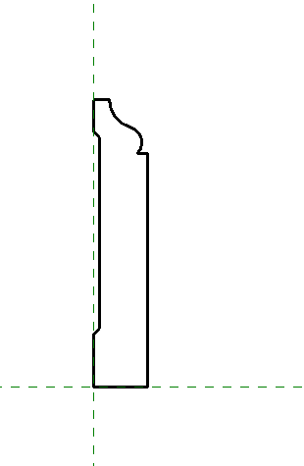

Use the pick lines tool to create the profile…it will work!

Now hide the CAD file

VV
Imported Categories
Turn off Imports in Families

Check by using filter to see that the link is not showing

Save as: OB1001.rfa

Creating the new Sweep

South Elevation
Wall
Wall Sweep
Element Properties
Type Properties
Duplicate
Name it: OB1001 Sweep
Profile: Base Molding OB1001
Material:
Make an off white color:
Default
Duplicate
Name it: PT101
Shading: Pick an off white color
Identity
Description: PT
Mark: 101
Comments: OB1001 Molding
Ok…OK…OK
Place the sweep on the right wall
See in 3D
Turn lineweights off to see better
RC
Change Orientation (flip)
Do side wall (East Elev) too
Show align tool to join
3D to see

Reveals

Now let’s create a Reveal:
First let’s make a simple profile shape we can use in the reveal
File
New
Family
Profile-Reveal
Open
Note the subtle wall inference ☺
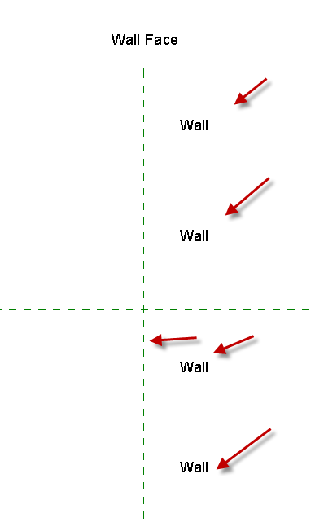
The reveal needs to go into the wall
Make a simple cove shape (closed) starting from the wall face.

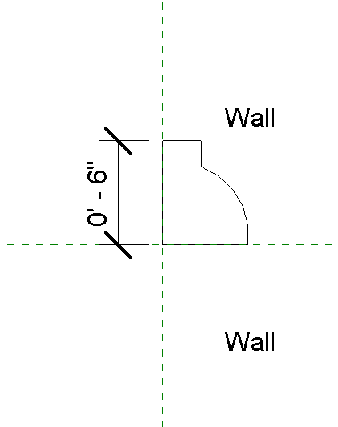

Save as Simple Cove Shape.rfa

Load into project
South Elevation
Wall
Reveal
Element Properties
Type Properties
Duplicate
Simple Cove
OK
Note no material….
Set profile to “Simple Cove Shape”
OK
Place on wall
See in 3D
Place sweep on East wall
Try to match
See in 3D
Show: Modify…..Geometry…..Edit Wall Joins
Show grips to edit sweeps around doors and windows

Create crown molding in small room on right side of building…on all 4 walls…under the ceiling. Show align tool to accurately place.

Drafting Views

Revit needs a place to put .dwgs, .jpgs, etc. Drawings and images that are not attached to the building model. Drafting views provide this opportunity.

Open Revit2013demo6.rvt

I have 2 items that need to go into my Revit drawing, condiment.dwg and Elevation Concept.jpg.

View
Drafting View
Name it: Concept Elevation Views
Scale 1-1/2”=1’0” (it’s a scan)

Insert
Image
(Be aware of LARGE file size!)
Open
Place in screen
See it?

Create a new sheet
D size
Drop Drafting View on sheet
You can change the scale by activating the view, just like other Revit views.

Create a new drafting view. Name it”Condiment Bar”
Scale:1”=1’0”
OK
Let’s bring in an AutoBAD file.
Insert
Import CAD
Name it Condiment Bar Details
Scale: 1” = 1’0”
Ok
ZA to show (sometimes they come in out of the view area)
Also, toolbar on top, right corner of drawing area has zoom tool.

VV
Imported categories
See layers? They can be turned on and off ala AutoCAD layer control
Cancel
Drag onto a sheet
You can bring in standard AutoCAD details into Revit this way. Details that are not attached to the building model. You can even create sheets of standard details and save them to your template file for use on each project!

Note #1: You can do a full or partial explode when bringing in .dwg files…just look for the boxes at the top of the drafting view. You can also delete layers in that view.

Note #2: Revit CAN NOT import a Microsoft Word .doc ☹

Note #3: Revit CAN NOT import a .pdf ☹

Note #4: Revit CAN import .bmp, .jpg, .jpeg .png .tif files. If you can get your image into one of those fomats, Revit WILL import it.

Did I mention to watch your file size when importing images?? They can make a manageable project a nightmare by making the file oversized!

Creating a Custom Title Block

Reviewing a finished ARE25 E title block

Show completed Revit Title Block (sample)
Edit Family
Note: See Label: Client Name
Note: See Label: Project Name
Note: See Label: Sheet Name
Note: See Label: Sheet Number
Note: See Label: Date
Note: See Label: Scale
Note: See Label:File path (on left edge)

Note: See “Text” (detail to come): Consultant address

See rest of text and labels…
Note: See border lines ½” from left, 33” long
Consider offset w/ border/title block lines

The outside lines should not print!!

Remember, Labels propogate to entire project…on all title blocks.

Close the family. Do not save.

Let’s create a custom title block

File
New
Family
Title Block
E – 42X30
Open
Dimension to title block lines to show 42X30 size (that’s the PAPER)
Delete the dimensions
Lines
Wide Lines
Offset .5” from title block lines
Make rectangle inside border
Create 2.5” wide title block on right using wide lines
Create wide lines to break up border into “blocks”

Label: File path
Place on lower, left corner. Make sure box is long or your filenames will be a problem. Explain.
Label: Sheet Number
Place in lower, right corner
Change sample value to A-101…center justify (CJ)
Time to save. Save as FirstLastEborder. It will be a family file.

Text:SHEET 1 OF MANY CJ
Note: Text is too big! We have been using ¼” text.
Text Note 1
Properties
Edit/New
Duplicate
Name it 5/32 Text note
Change size of box to stretch horizontally
Discuss FG font, Industry Standard, what do WE want?

Label: Sheet Name
Sample name: FLOOR PLAN
Stretch box
Text: Sheet Title just above FLOOR PLAN
Create a thin line to box it in
Let’s add a client logo:
File….Import….CAD Format
Acme logo.dwg
Open
Add it to top of title block
Let’s add an Norco College logo
File….Import….Image
Norco Logo.jpg
Open
Drop it below the Acme logo

Save the file as FirstLastEBorder.rfa

Have a Revit file with a lot of sheets already created, open.
Load into project
Swap out our title block for the generic Revit one.
Go to the next sheet
Pick the generic Revit title block
RC…Select all instances… in Entire project
Switch for FirstLastEBorder
Check to see if they all switched….YES!

Note drawing titles and sheet #s updated

Enter a project name in one sheet (note blue text)
Name it : Career Technical Institute
Enter a project Number: 2
Author: Your name
Checker: Mr. Brown

So far so good…try changing address. (note red text)
Can’t change it….Why??

Settings
Project info
Project Address >Edit
Put address here DISCUSS
Client name: Norco College
Project issue date: 06-07-14
Project Status: TI

Back to FirstLastEBorder
Label
See category parameters?
If labels are entered, info will be picked up in the title block…. GIGO!!

Creating Custom/Shared Parameters

As you create and use families, you may find the parameters listed or are available to you are not complete. You have a length and width parameter, but need one that is not listed.
You can create a “shared parameter”…that can be added to ANY family, regardless of category. The parameter is stored in an external file, ensuring consistency across families and projects.

You will start by making a Window Schedule (with a few challenges)

Create custom parameters called SHGC, U- Value, and VT. They will be numbers. Revit already has similar parameters, but some windows can’t be changed from the default values. Type parameters.

Create yes/no values for EGRESS, LEED CERT and LOW E. Instance parameter.

Create a parameter for “Oracle #” (a client database number). Text. Type parameter.

We will then apply it to a window family that you will make.

We will then apply it to our window schedule

Adding Parameters

Let’s say there is a field you need that is not in the schedule: we will use the bold/underlined parameters above…..

Manage
Shared Parameters
Create
Let’s place it in your USB drive and call it FirstLast Shared parameters.txt (there should be a good place on the network drive normally to store this file)
Save
Groups…New
Enter name FirstLastWindow

Note: You can set up many groups in the FirstLast Shared parameters.txt file. Examples might be: Sustainable Design Parameters, Electrical Parameters, Specialty Equipment Parameters, Annotation Parameters. Each group can hold a bunch of your custom parameters

Parameters….New
Name: Oracle #
Show Discipline
Show Type of Parameter
We will take “Common” and “Text” on this parameter
OK….OK
You have created a “shared parameter”!!
Parameters….New
Name: SHGC
Show Discipline
Show Type of Parameter
We will take “Common” and “Number” on this parameter
OK

Parameters….New
Name: VT
Show Discipline
Show Type of Parameter
We will take “Common” and “Number on this parameter
OK

Parameters….New
Name: U-Value
Show Discipline
Show Type of Parameter
We will take “Common” and “Number” on this parameter
OK

Parameters….New
Name: LEED CERT
Show Discipline
Show Type of Parameter
We will take “Common” and “YES/NO” on this parameter
OK….OK

Follow the same pattern for the remaining Shared parameters.

In Window Schedule
Add Parameter
Shared parameter
Select
(Edit will path to a different location)
Pick Oracle #

Continue adding the shared parameters…
Group under Green Building Properties

Let’s use it.

Floor Plan Level 1
Select your custom window
Edit type
See the parameters out of the box? (remember that)
Cancel
Edit family
Yes
Family Types
Note the Parameters….Remember??? These are your “out-of-the-box” parameters
Parameters : Add
Shared Parameter (Family will not show in schedules)
Discuss “Type” and “Instance” choices
Select
See LEED CERT
Put under Green Building Properties
OK….OK….
See LEED CERT Parameter you created??
Do the others
Add the data
Question: Would SHGC, U-value, VT, Oracle # be instance or type????
OK
File
Save as
Family
Save the Family as FirstLastWindow

Putting company info in name distinguishes your smarter company family from the “out-of-the-box” families. Some firms have a special folder for their company developed families, so when upgrading, locating the company files is easier.

Load into project
Swap the window with the FirstLastWindow

Back to the Window Schedule

Discuss shared parameters in families before schedule is made

Discuss Project Parameters

You have learned to create a custom parameter called a “Shared Parameter”. You learned that shared parameters can be put in schedules and families. You know the shared parameter file is a .txt file and can be updated with new groups and new parameters as time goes on. The shared parameter file can be used on future projects too.

Model Text (the 3D Text)

You have the option in Revit to create 3D text for signs, labels, etc. the text is “plane based”.

Create a wall
Place a work plane at front of the wall….name it “Front surface”
South Elevation
Architecture
Model Text
Ref Plane: “Front surface”
OK
Type: “CAREER TECHNICAL INSTITUTE”
OK
Place it on wall

Select text
See Model Text 24” Arial in selection bar?
Properties
Edit Type
Duplicate
Name it 36 Tahoma Bold
OK
Set text size to 3’0”
Set font to Tahoma
Check Bold
OK…OK
See in 3D
SD to see shaded
Note the text is grey (it was made out of the default material)
Select text
Properties

Material (it’s an Instance Parameter…DISCUSS)

Make a new material
Name it RED
Shading: Choose a red color
OK….OK….OK
Yes…it’s red!
RC…Element Properties
Set depth to 2’0” (it’s an Instance Parameter too)
OK
See depth change?

Note Blocks

Note Blocks (also called an Annotation Schedule) are a list of construction notes.

You can create a note block and place it on a sheet.

The “trick” is to load a generic annotation family into your project, then assign parameters to the family.

We will add a parameter called “Key #” (that will be our tag #) and a parameter called “Construction Notes” (that will list ummmm construction notes)

File
New
Annotation Symbol
Generic Annotation
Open
Family Types
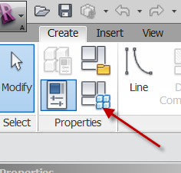
Parameters
Add
Check INSTANCE (explain)
Name: Key #
Type of Parameter: Text
OK
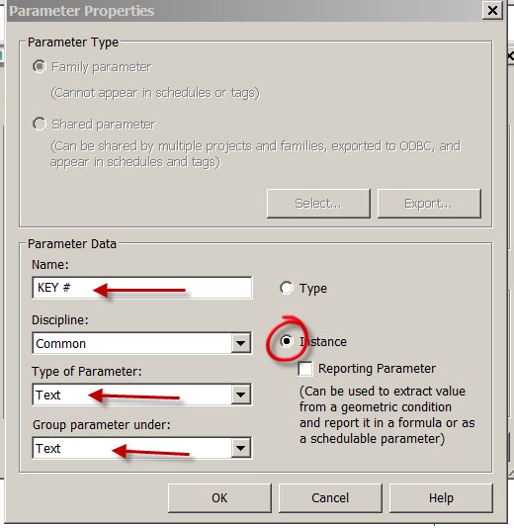
Add
Check INSTANCE (explain)
Name: Construction Notes
Type of Parameter: Text
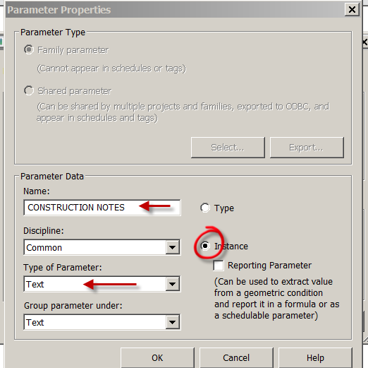
OK…OK

Delete the red text
Create
Label
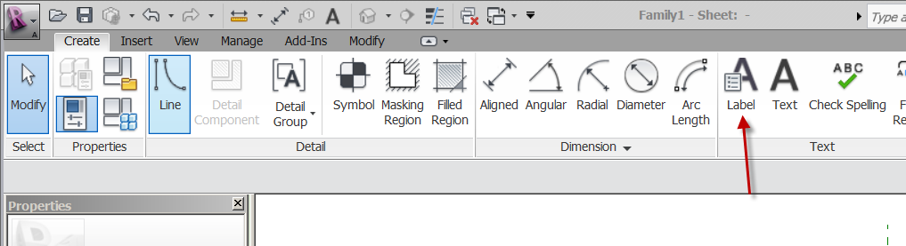
Place at intersection of planes
Key # >
Sample Value: A
OK
Create a hexagon around the A
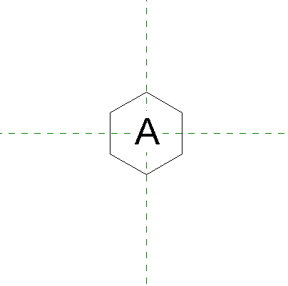
Save as: SHS Key # tag
Load into project

South Elevation
Annotate
Symbol
SHS Key # tag
# of leaders: 1
Place the tag
Stretch the horizontal line to the window
LC on tag
Properties
Note we are in INSTANCE parameter (explain)
Key #: A
Construction Notes: Bullet Proof Glass
Apply
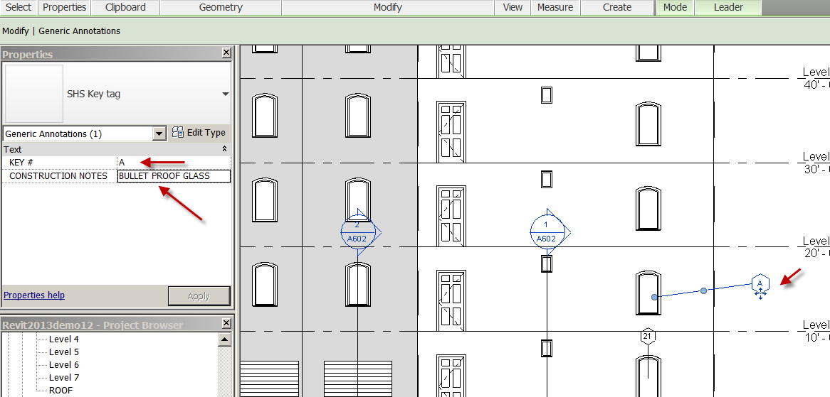
Notice A is in the tag…but there’s more….

View
Schedules
Note Block
Select: SHS Key # tag
OK
Key #.... Add
Construction Notes….Add
OK
See the note block with our key # and Construction Notes?!

Back to South Elevation
Select our key # tag (with the A inside)
Copy
Paste
Move the copy to the window above
LC on the tag
Element Properties
Key #: B
Construction Notes: One-way glass
See Note Block…updated? YES!

Go to Ext Elev’s Sheet
See the key # tags on the South Elevation?
Drag the Note block near it..on the sheet.
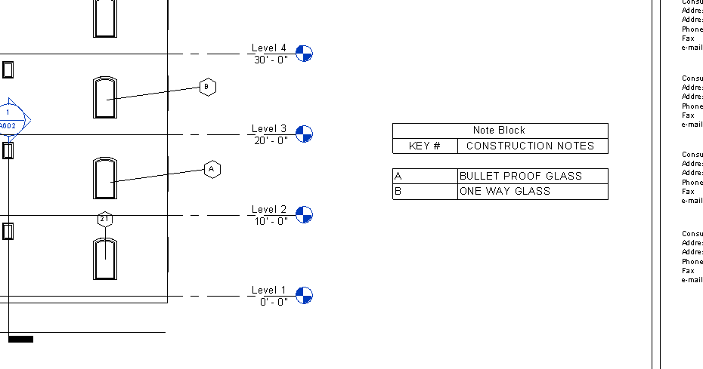

Is this a good option to Keynoting??

Purging

You can purge unused items in Revit to make your drawing smaller in size.

Save you drawing as Revit2013demo27.rvt
Check the size by doing a File: Save as
Mine is 5516KB

Manage
Purge Unused
Open Annotation Symbols
See checked boxes?
Those are unused in Revit. Note you have hundreds of unused families!
You can ONLY purge unused items….
OK
File
Save as: Revitdemo27Purged.rvt

Do a file save as again to see the new file size….
Mine is 3724KB…a significant difference!!
Like with AutoCAD, purging …especially with large files can speed up your project and lighten the file. You can always load the families again if you need them. Don’t purge often….your file saving advantages reduce on each purge.

Detailing: Referring to Your Revit Details

Open Revit2017Foundation3.rvt
Open Wall Section thru the building (mine is Wall Section 2)

We have created a wall section and a detail of the footing/wall joining:
See Detail 0 in Browser?
Sheet A603?
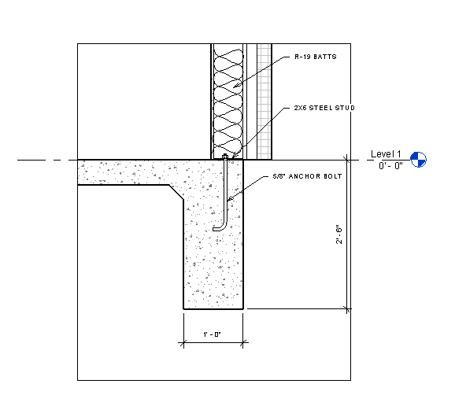

Go to another part of the building where the detail would be the same as the first…
View
Section…Detail Section
Check Reference other View
See your choices?
Choose Detail 0 (1/A603)

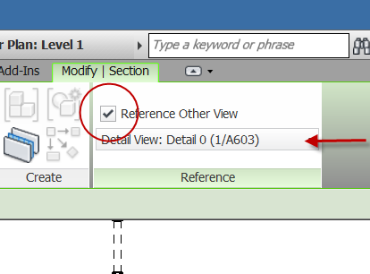
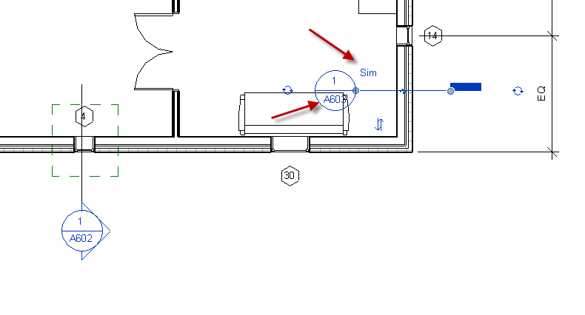
Note Revit does NOT make another Detail view (see Browser), but puts a smart annotation with “SIM” next to it.

Pick the Detail…go to view…

Detailing: Referring to Your AutoCAD Details

Make a Drafting View (It will hold your AutoCAD file)
View
Drafting View
Name it Condiment Bar
Scale: 1-1/2”=1’0”
OK

Insert
Import CAD
Get the condiment bar.dwg
Colors: Invert
Positioning: Center to Center
Open
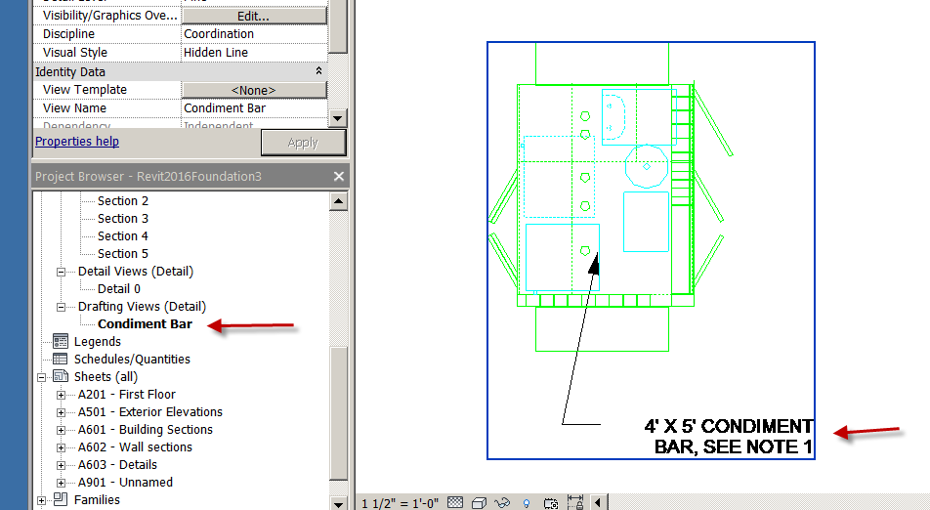
Insert it in the drafting view
Zoom to fit
Put on our detail sheet we just created.
Note: It is Detail 2 on Page A603

Floor Plan Level 1
View
Callout
Detail View
Scale
1-1/2”=1’0”
Check Reference Other View
Pick Drafting View Condiment Bar
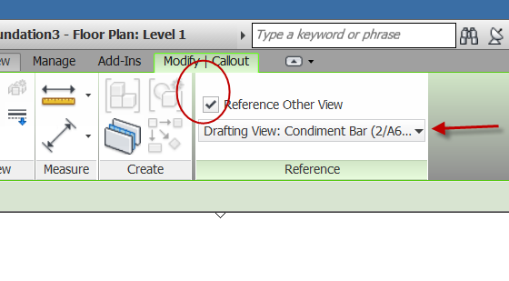
Make the callout anywhere (you could surround a generic box)
Note the bubble is smart
Select Callout bubble
Go to view
See?
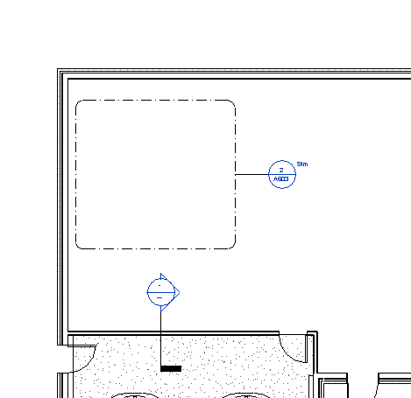

This is how you would tell Revit how to refer to your “dumb” AutoCAD details in the drafting views!

You have learned how to bring your AutoCAD drawings into Revit and have Revit refer to them “smartly”. You learned how to have a Revit detail refer to another Revit detail…avoiding duplication of standard details.

Key Schedule

OK….Schedules can have the same characteristics. A room schedule might have 100 rooms with the same floor, ceiling, and base finishes. Rather than add all this info for ALL 100 ROOMS (yuk)….you can define keys that automatically fill in the information (better).

If a room has a defined key, then as that room is added to a schedule, the fields in the schedule automatically update

You define keys using “key schedules”

When you create a key, it is listed as an Instance Property for the element.

When you apply a value for the key, the keys attributes are applied to the element.

Let’s try it………..Open revit2017demo16.rvt
It should have rooms in it ….but no data added to the rooms yet.

View
Schedules
Schedule/Quantities
Rooms

Check Schedule keys
Name: Room Style Schedule
Key Name: Room Style (def)
OK
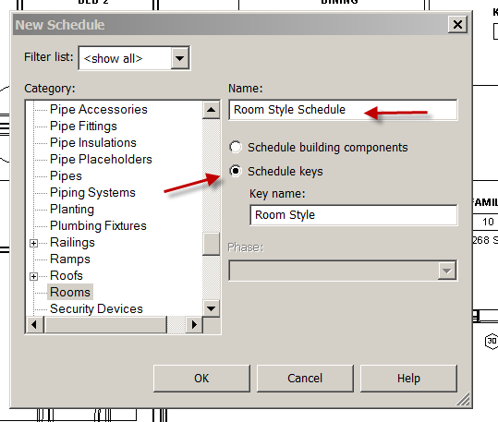
“Key Name” is already there….
Add the Base Finish, Ceiling Finish, Floor Finish, and Wall Finish
OK
See the small schedule??

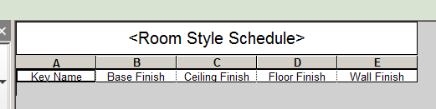

Insert Data Row (Each row creates a new value for the key)
Insert Data Row
Insert Data Row
Insert Data Row
You should have 4 rows
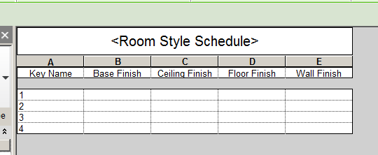

Change the Key #’s to Key Names:
Sleeping
Living
Service
Corridor

Key Name Floor Finish Ceiling Finish Wall Finish Base Finish
Sleeping Carpet GYP PL235 WOOD
Living Hardwood GYP PLAM MDF
Service Tile 2X4 ACT PL234 Vinyl
Corridor Linoleum 2X2 ACT PL101 Vinyl

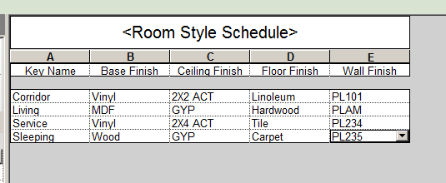

OK….Lets test it…
Floor Plan level 1
Let’s try it on BED 1

Select the room
Properties
See the choices in the Identity Data??
Set the Room Style to “Sleeping”
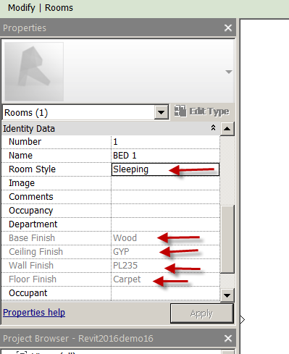

That’s pretty cool!!!

Create a Room Schedule
Make Parameters:
Room Style
Name
Area
Base Finish
Ceiling Finish
Floor Finish
Wall Finish
OK

Show adding Room Style to schedule
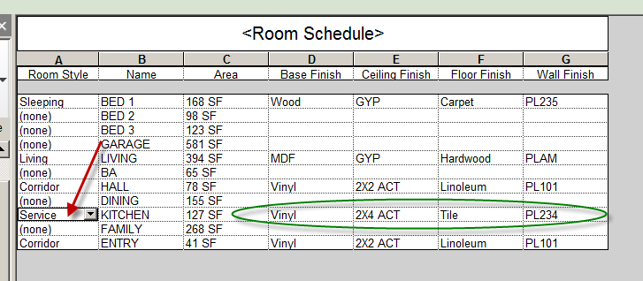
Room Style would be a hidden field on the Room Finish Schedule once to are done inputting info.

Creating a Mechanical Equipment Family: Trane RTU

You are to create a Trane RTU (Roof Top Unit) Dehumidifier.
You will use the Mechanical Equipment.rfa template. It is not ceiling or wall based.
It will require 3 additional parameters in addition to the ones “out of the box”. The shared parameters will be: Trane #,BTU, and Microprocessor Controls. They should be “Type” parameters. Add the model # and Microprocessor Controls maker provided in the drawing.
When I load the family into the project, I want three Trane sizes of this model:
Type Size
15 ton: L=36” W=30” H=40”
12.5 ton: L=34” W=28” H=40”
10 ton: L=32” W=26” H=40”
So I want to be able to change types, and have the sizes change automatically! I want to also be able to add information …..a Trane # and a BTU once it is in the project.
I want the letters “RTU” to display on the plan view, but NOT be 3D text
I want that round fan at the top to be symbolic lines shown only in plan view (pay attention to your reference plane.
Allow me to adjust the base (unpainted galvanized part) height
Your family will be flexible to adjust overall Length, Width, and Height. See sketch.
Save the file as TRANE Your Name.rfa on my USB Drive.
You may want to try to insert your family into a dummy file to make sure it works before you give it to me.
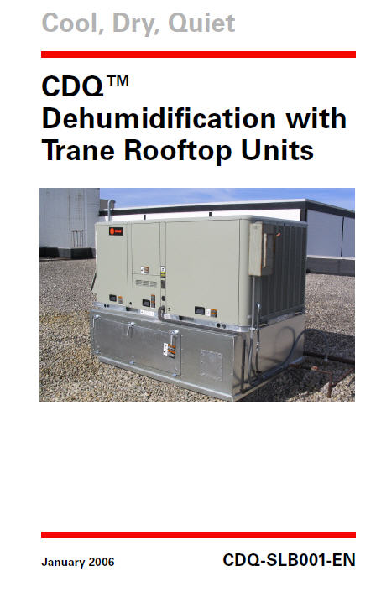

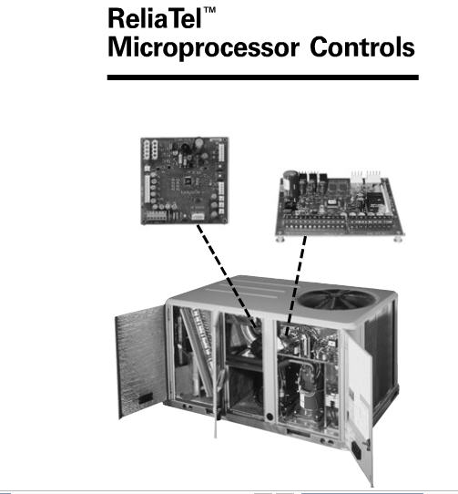

Plumbing Fixtures to LEED Standards

The object of this lesson is to assign parameters to your Revit plumbing fixtures in a way that allows you to calculate the amount of water your building is using and compare it to the LEED “baseline”.

Manage
Project Parameters

Baseline rate Number Type Group Under: Plumbing Category: Plumbing Fixture
Fixture Rate Number Type Group Under: Plumbing Category: Plumbing Fixture
Fte Number Type Group Under: Plumbing Category: Plumbing Fixture

Plumbing Fixture Schedule Flow WE1

Flow Fixture (Family)
Type Comments (this is where we will put FLUSH or FLOW, to filter)
Baseline rate
Fixture Rate
Fte
Baseline Usage for Fixtures (formula….Baseline rate*Fte)
Actual Rate for Fixture (formula….Fixture rate*Fte)
Model
Manufacturer
URL
Description
Cost

Note: baseline rate, fixture rate and fte are project parameters.
User will have to add FLOW in the type comments of the flow fixtures.
In Type Properties, user will have to enter Baseline rate for the fixture
In Type Properties, user will have to enter Fixture rate for the fixture
In Type Properties, user will have to enter fte for the fixture
Baseline Usage will calculate and total.
Actual Rate for Fixture will calculate and total.
Goal: To increase water efficiency within buildings to reduce the burden on municipal water supply and wastewater systems.
Goal: To employ strategies that in aggregate use 20% less water than the water use baseline calculated for the building.
Flow items would be showers, tubs, lavatory faucets, kitchen sink faucets, pre-rinse spray valves.

Plumbing Fixture Schedule – FLUSH WE1
Flush Fixture (Family)
Type Comments
Baseline Rate
Fixture Rate
fte
Baseline Usage for Fixture
Actual Rate for Fixture
Model
Manufacturer
URL
Description
Cost

Note: baseline rate, fixture rate and fte are project parameters.
User will have to add FLUSH in the type comments of the flow fixtures.
In Type Properties, user will have to enter Baseline rate for the fixture
In Type Properties, user will have to enter Fixture rate for the fixture
In Type Properties, user will have to enter fte for the fixture
Baseline Usage will calculate and total.
Actual Rate for Fixture will calculate and total
Goal: To increase water efficiency within buildings to reduce the burden on municipal water supply and wastewater systems.
Goal: To employ strategies that in aggregate use 20% less water than the water use baseline calculated for the building.
Flush items would be water closets and urinals (in commercial).

The Baselines:

Toilets: 1.6 gallons per flush
Urinals: 1.0 gpf
Private Lavatory faucets: 2.2 GPM
Public Lavatory faucets .5 GPM

FTE for this project:

6 FTE (employees)
40 FTE (customers)
Total: 48 FTE (24 men, 24 women)

Uses per FTE:
Toilet: Men 1 Women 3
Urinal: Men 2 Women 0
Lav (duration: 15 sec): 3

The Research:
Find and apply plumbing fixtures to your project. Use OOTB plumbing Fixtures or find manufacturer’s like Kohler or American Standard.
2.64 people in average US household. This program is for 2 people.
Research low flow toilets, showerheads, kitchen faucets, lavatory faucets, pre-rinse spray valves

Tankless Hot Water Family: Noritz NC380

Water takes a lot of energy to heat 24/7. A “Tankless” heats water only on demand, hence saves energy. Tankless Hot Water heaters also take up very little space….they hang on the wall.

The family will start out as a Face-based Generic Model, then be converted to a Plumbing Fixture family. There is not a faced-based Plumbing fixture template. Generic Models can be turned into other family types.

Custom Parameters (all type parameters) for the face-based Revit family:
H, W, D
Weight (number)
Flow Rate in GPM (number)
Energy Star (Yes/No)
Gas (Yes/No)
NSF and ASME Certified (Yes/No)
Thermal Efficiency % (%)
Standard Parameters are:
Manufacturer
Model Number
URL
Type mark
Cost
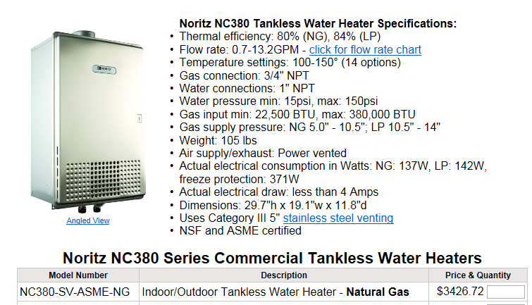

Solar Panel Family

You will create a Sharp NU U235 Solar Panel. See provided Spec Sheet.
You will create the family utilizing the “Faced-based generic model” template to the correct size of the panel.

Create the geometry with size parameters. A “Generic Model” is good to start with because they can be turned into any other family…

Family Catagories and Parameters
Change from Generic Model to Mechanical Equipment

I need an angle parameter so the panel can be tilted off the primary axis. DEMO
Family Types
Parameters: Add
Name: Panel Angle
Type Of Parameter: Angle
Instance
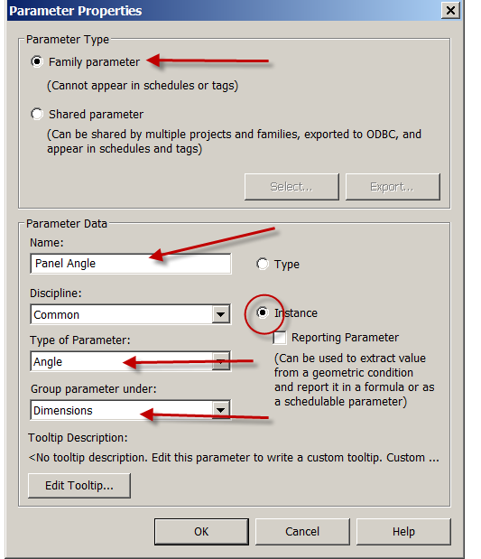

OK…OK

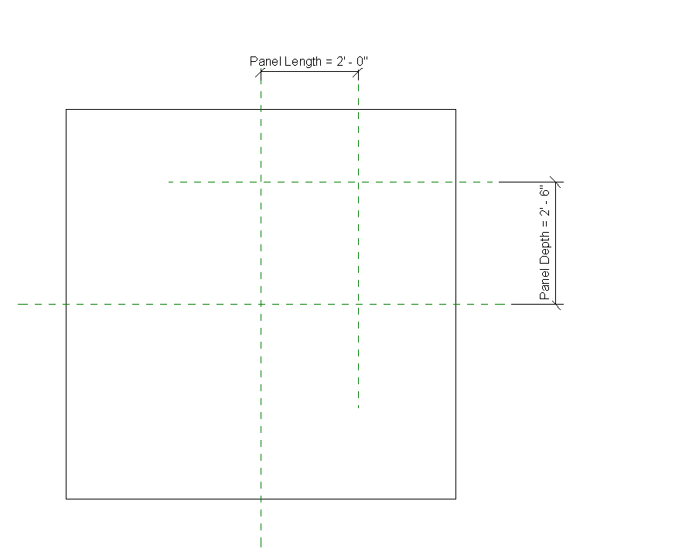

Set The panel angle to 15 degrees in family Types
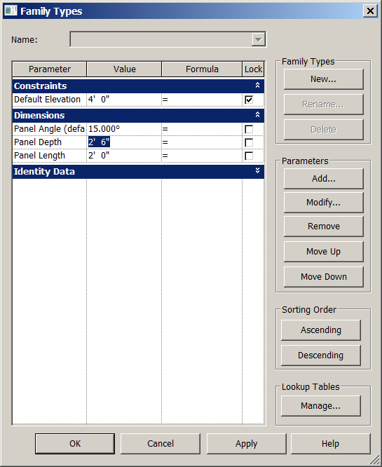

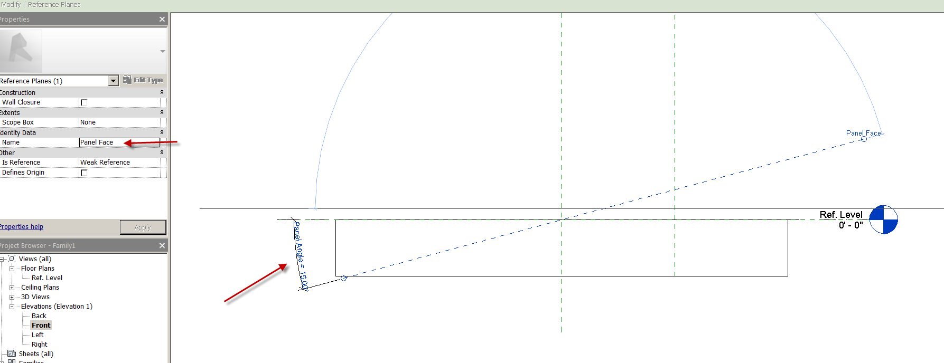
Assign the parameter to the angle dimension and name the reference plane

File: save as Solar_Panel_1.rfa

Front View

Create reference planes as shown….better ideas welcome!
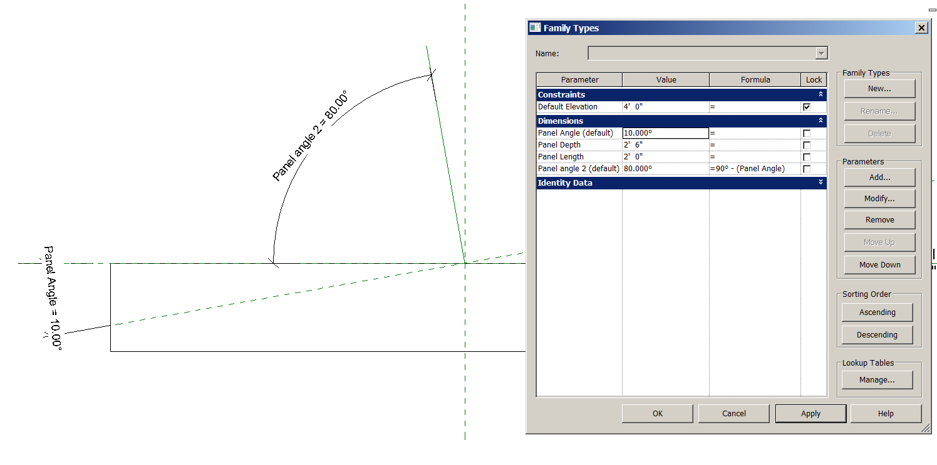

Set the reference plane to center Front Back

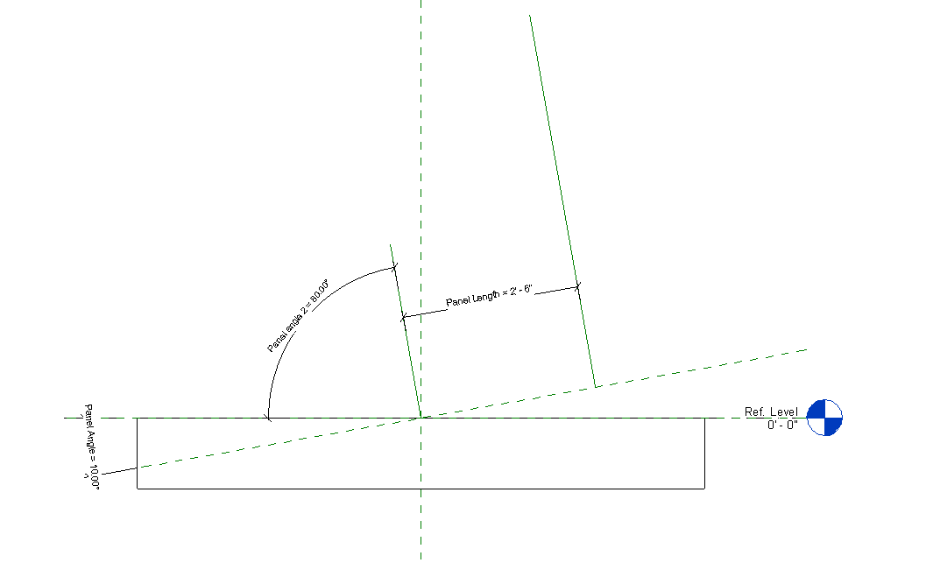
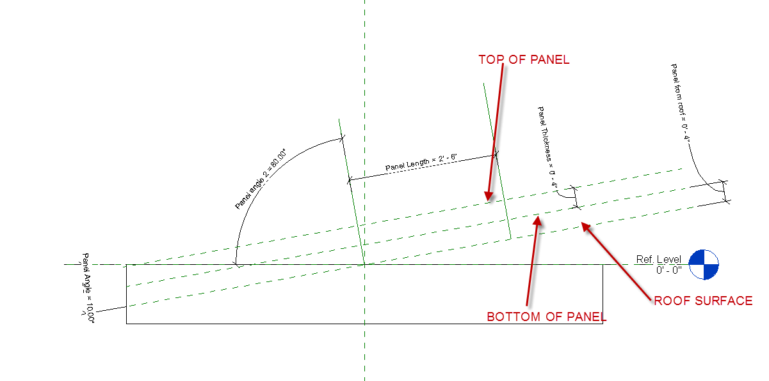

Drag the geometry to the reference planes…lock

Let’s test it!...

Change the angle to 12 degrees…to 8 degrees

Change the Panel Length….

Change the panel thickness

Change the Panel from Roof

Are the reference planes working??

Let’s add the geometry (the easy part)

Pick and lock the reference planes

Trim

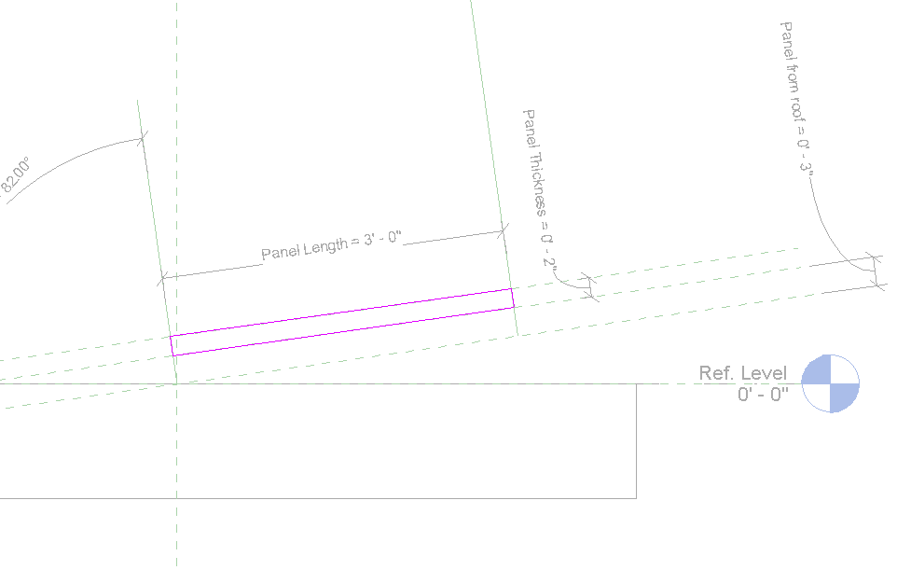

Green Check to finish sketch

Floor Plan Ref Level 1

Drag and lock the model to the reference plane
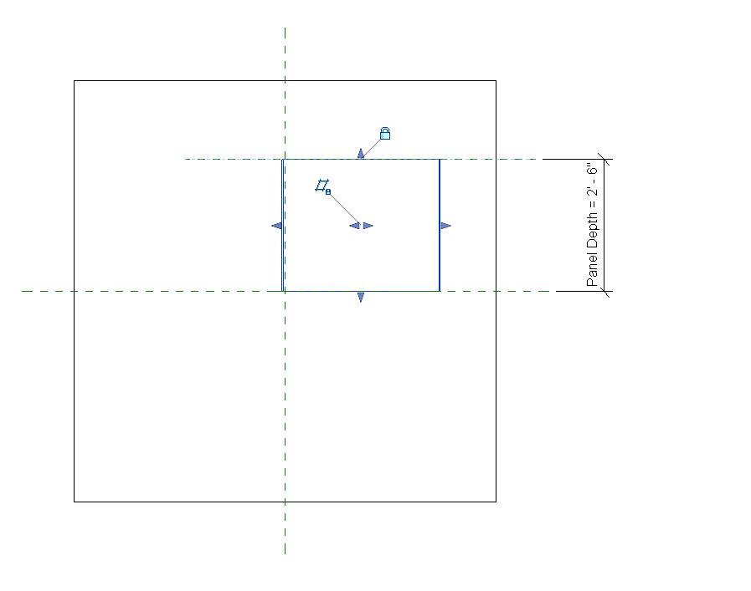

Create the Cell Pattern in the Material you use for the panel. Drafting or Model pattern is OK.

Flex it to see if all parameters work’

Create the Parameters for the Solar Panel

Family Types
Parameters Add
Check Shared parameters
Select
Create (if you do not have a shared parameter file yet)
Name it FLSharedParameters.txt
Save
Groups…New

Parameters…New

Add these shared parameters under a group called MECHANICAL. All will eventually be “TYPE” parameters.

Name Discipline Type Of Parameter

MAX POWER Electrical Wattage
CELLS Common Integer
TYPE OF CELL Common (text)
OUTPUT CABLES Common (text)
WEIGHT Structural (weight)
MAX LOAD (PSF) Common (number)
CABLE LENGTH Common (length)
NOCT HVAC (temperature)

OK….OK…OK

Now that the Shared parameters are created….you add them to the Solar panel by adding parameters

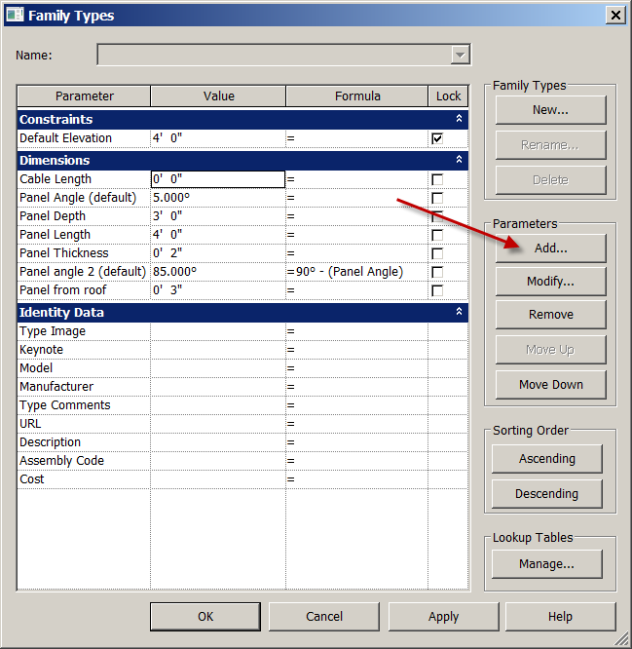

Remember…they will all be Type parameters

Add data to the following OOTB parameters as well as the shared parameters so the information is in as the family is loaded into the model.

Parameters…Add….Shared Parameter…select

Pick each shared parameter in the Mechanical group

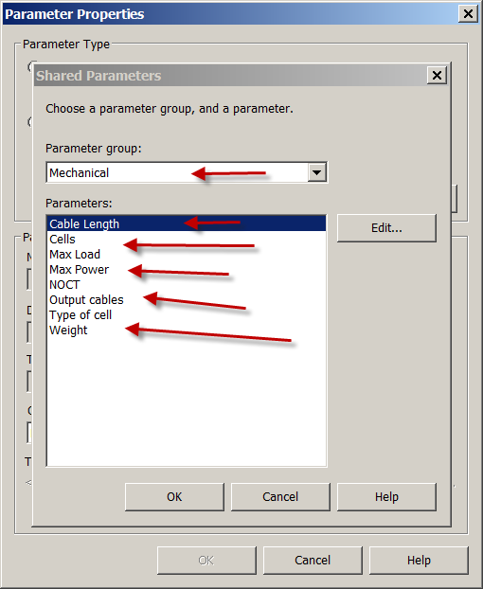

Model
Manufacturer
URL
Description

Save as FIRSTLASTSHARP U235.rfa

Load into project.

Make sure you choose “Place on Face” when placing panels

Solar Panel Family Part 2: Creating a Custom Annotation Tag

Open Revit model containing the FIRSTLASTSHARP U235.rfa

Annotation
Tag by Category
Yes
Annotations
Mechanical
Mechanical Equipment Tag
Open

See it?
VV…Annotation…..check Mech Equip tag

Select Solar panel
See MARK?
Place a P1 for Mark.
See P1?

We want to create a tag that holds “MARK” and “MAX POWER”. Mark will be an identification number or letter unique to each panel.

Pick tag
Edit familyvv
VV
Annotation catagories
Check reference planes…OK

Label
Edit Label
See Mark?
OK
Making smaller Label
Pick Label
Properties
Edit Type
Duplicate
Name it “FL 1/16”
Set text height to 1/16
Move label above horizontal ref plane
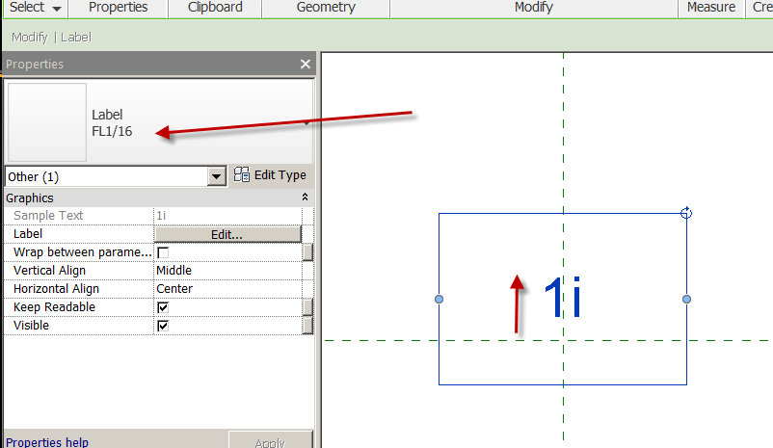
Creating a new custom parameter label from a shared parameter
Create
Label
Place in screen
Add parameter (shared)
Select
MAX POWER
OK…OK
Green Arrow
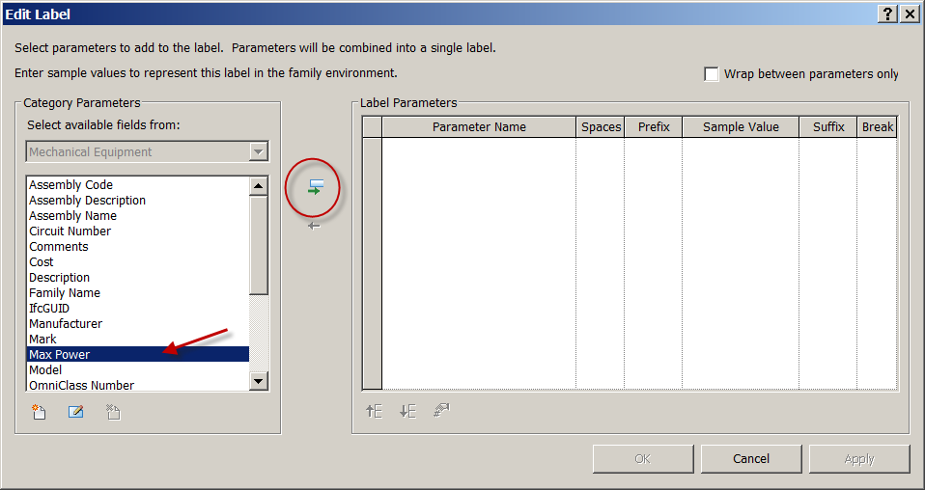
Sample Value: 555
#/hand icon at bottom
Uncheck “use project settings”
Unit Symbol: none
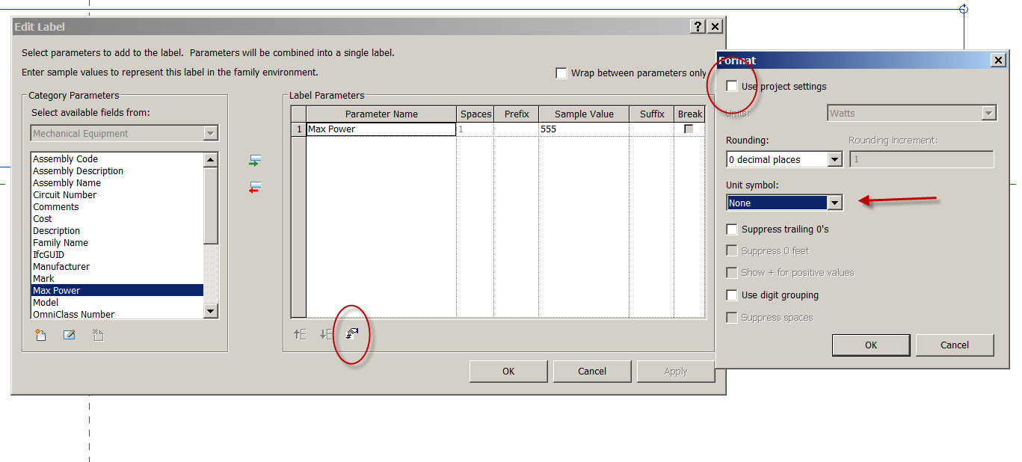
OK…OK
Make it a 1/16 label too
Place it under the horizontal ref plane

Create Polygon around
Create
Line
Polygon (just a little bigger than sample text)
Make line across middle (horizontally)
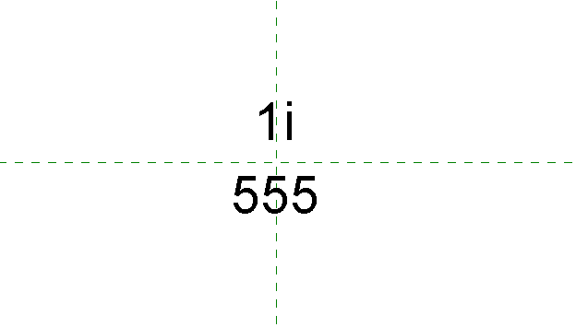

Save as “FirstLast Solar Panel Tag”

Load into project
Tag the solar panel with the new tag.
Pick another panel
Mark: P2
Tag it.

Solar Panel Schedule
View
Schedule
Schedule
Mechanical Equipment
Add: Mark, Power, all the other parameters assigned on first sheet.
Formatting
Max power
Check calculate totals
Sorting and grouping
Check grand totals
Sort by Mark
Place on your custom E sized title block.

Revit Resources

Santiago Architecture’s website
http://www.green-architecture-corona.com/

Autodesk Education Community
This is where you can download Revit 2014 and AutoCAD 2014 for free. It is a 3-year license. Your computer will need at least 2 GIG RAM and a compatible video card. It takes a couple of hours…minimum.
http://students.autodesk.com/

Revit City….for Revit content. (You will need to sign up….it’s FREE)
Note: you can download Revit families at Architecture…..you do not need Revit to download them. Just download to a USB drive or CD.
http://www.revitcity.com/index.php

Autodesk Seek
This is Autodesk’s place to get additional families. Families from this site are generally pretty good.
http://seek.autodesk.com/

AUGI-Revit
This is a great place to get your questions answered. Note the “Student Support” section!
http://forums.augi.com/forumdisplay.php?f=93

SDC Revit Books
http://www.sdcpublications.com/Textbooks/Autodesk-Revit/74/

BIM User Group Inland Empire (BUGIE)
This site will give you information about the monthly Revit User Group meetings in Rancho Cucamonga/Ontario
http://www.meetup.com/bug-ie

South Coast Revit User Group (SCRUG)
This site will give you information about the monthly Revit User Group meetings in Orange County
http://www.meetup.com/SC-RUG/

Lynda.com Online Revit tutorials
This site will give you pretty good hands-on Revit tutorials in several skillsets. Monthly fee is reasonable. I am a subscriber.
http://www.lynda.com/CAD-training-tutorials/1665-0.html?category=revit-architecture_416

